GRAEME’S

NEW AND IMPROVED!!!

GREAT BIG ENCYCLOPEDIA

- OF EVERYTHING -

(and nothing)

Containing illustrated answers to the questions posed in all those quizzes he sent around for some reason

Preface to the Second Edition

Ha!

I always wanted to write something big and important-sounding like “Preface to the Second Edition”.

Anyway, this is the whole schmeer again, but this time with over 300 new pages, 200 new questions, about 35,000 new words, scads of new pictures, and this new Preface.

So in total the collection is somewhere between 1,300 and 1,400 pages and probably about 140,000 words.

So there you go.
A Word of Explanation

Some of you will recall that for some reason I developed a passing mania for sending quizzes around to you all, 50 questions each, and then sometimes, but not always, supplying the answers.

I found it fun to assemble all those quizzes in one document along with illustrated answers. It puts everything in one place, and gives you all something to remember me by. A lot, actually. Over 1,050 pages and approximately 100,000 words.

As I look over this big mess o’questions, it’s obvious that I posed them only on topics of interest to me, which I guess is inevitable since I only asked questions to which I already knew the answers. Therefore, you’ll see a bias towards history, literature, science, technology, politics, nature and natural history, a little bit of pop culture, a little bit of music and art, and quite a lot about war and geopolitics. With one exception, there isn’t anything at all about law, which is, as you know, the subject in which I display the least aptitude. You’ll see a bunch about navies and airplanes (you won’t like that, but eat your broccoli). A few about sports. Overall, I guess a lot of “guy topics”.

Though I consulted the internet here and there to flesh out the answers, and make sure I was remembering correctly, I tried to keep it as much off the top of my head as possible. Thus you’ll see a general lack of specificity when it comes to numbers and dates – “around 1500”, “about 500,000 pounds”, “just after WW I”, that sort of thing. I don’t think precision on such things is really the point. This is general knowledge stuff, and a general but accurate sense of the flow of things should do. Of course, some dates one simply remembers – June 6, 1944, for example. Or years like 1215, 1588 and 1969. Same with numbers, like 186,000 MPS, the speed of light. If I could remember exactly I set it out, and if not, you get a ballpark estimate.

The fun part is of course the pictures. I have to assume that cutting and pasting from the internet has resulted in several thousand breaches of copyright law, but as long as we don’t sell or distribute this thing, I assume I can avoid prosecution.

Yes, I do realize none of you will ever actually read any of this, but it was fun to do.

1. What did Eratosthenes calculate in about 240 BC, using nothing more than geometry and the angle of sunlight shining down in different Egyptian cities on the Summer Solstice?

The circumference of the Earth. The ancient Greeks knew well that the planet was a sphere, if it wasn’t then ships wouldn’t disappear over the horizon, but how big? Using the angle of light as it fell in two different spots, it was simple to figure out how many degrees of the circle one point was from the other.

Here’s how it works. Eratosthenes observed that at high noon on the summer solstice, the sun in a town in Egypt called Syrene was precisely overhead. A stick stuck vertical in the ground would cast no shadow. This happens to be the case for any point located along the Tropic of Cancer, which Syrene was (or near enough). Knowing that, all you had to do was go to another town, in this case Alexandria, and plant a stick vertical in the ground on the Summer Solstice and measure the length of the shadow that the stick casts at high noon. The length of the shadow and the length of the stick give you two sides of a triangle. You can then complete the triangle on paper, and measure the base angle of the sloped side, which corresponds to the angle of the Sun’s rays hitting the stick. Say the base angle is 83 degrees (that is, the triangle has a steep slope, as you’d expect given Alexandria isn’t that far from Syrene). That’s the angle at which the Sun is hitting the stick.

Now you subtract the base angle of the sloped side, in this case 83, from the angle of a vertical object, which is 90, and that leaves you with 7. This means that Syrene must be 7 degrees away from Alexandria on the globe. In fact, the figure arrived at by Eratosthenes was 7.2 degrees.

OK! So 7.2 degrees is 1/50 of a full circle (7.2 x 50 = 360). That means the distance between Syrene and Alexandria is 1/50th of the globe, so you just multiply that distance by 50 and voila! The circumference of the Earth!

He was only off by a couple of hundred miles.

He also figured out that the Earth is tilted on its axis.

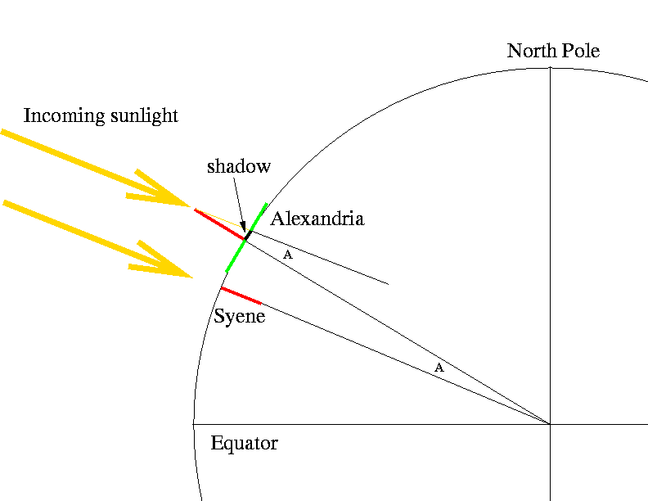
2. Who famously wheeled on the crowd and bellowed “Sic simper tyrannis!” (Thus always for tyrants)?

John Wilkes Booth, as he leapt down to the stage of Ford’s Theatre, having murdered Abraham Lincoln. The fall broke his leg, and in his flight from the scene Booth sought out the first doctor he could find, a physician named Mudd. Furious patriots thought Mudd a traitor for treating Booth, and thus “Your name is Mudd” has nothing to do with dirt. It means you’re reviled, like the poor doctor, who was imprisoned for aiding Booth, as if his sacred duty as a physician permitted any other act.



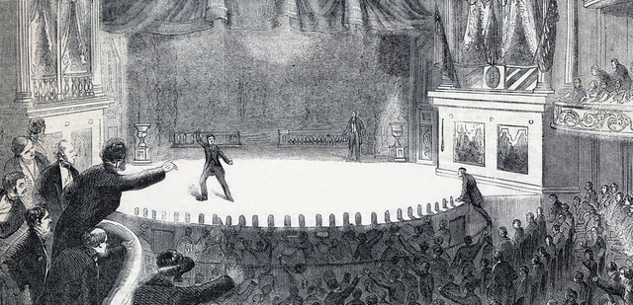
3. Who fought at the Battle of 73 Easting?

An “easting” is a coordinate on a map in military parlance, and 73 Easting was a barren place in the middle of the trackless Iraqi desert, at which the US 2nd Armored Cavalry encountered and decisively routed elements of Saddam’s elite Republican Guards, during Desert Storm in 1991. The Iraqis had pretty good tanks, T-72s, nasty things on paper, but they may as well have been made of cardboard for all the trouble they gave the M1s, which brushed them aside with contemptuous, terrifying ease.




4. Is a sponge an animal or a plant?

It’s classified as being in the animal kingdom, but it’s really a bit of both. Its individual cells cooperate, but it isn’t really a single organism, but rather a “colonial being”. You can grind up a sponge, and it will slowly reassemble itself, its constituent parts unharmed. It has no central nervous system, no brain, no systems of any kind.

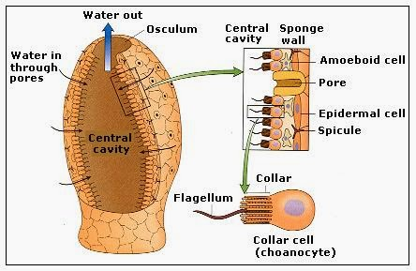

5. What process produces pumice stones?

Pumice is the product of volcanoes. Molten rock ejected high in the air depressurizes, cools and hardens, the bits solidifying around trapped bubbles of air. That’s why pumice floats. it’s full of air pockets.



6. What are diatoms, and what has that got to do with growing petunias?

Diatoms are tiny little creatures, technically algae, that form hard cell walls made of silica. When they die their hard exteriors remain. They can be quite beautiful when viewed under a microscope, but if you mix them in with planting soil they become lethal to insects - their silica cell walls are jagged and tear through insect exoskeletons. Diatomaceous earth is thus an environmentally friendly sort of “mechanical” insecticide.

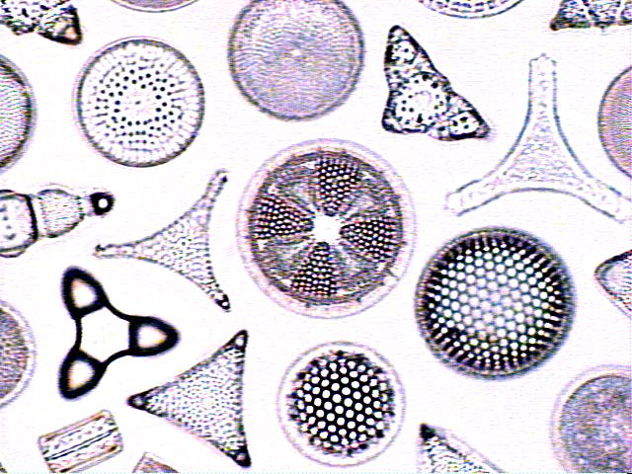

7. Why is 1666 known by historians as Annus Mirabilis (Year of Miracles)?

1666 was the year the great plague hit England, and everyone at public institutions like universities was sent home to ride it out. Nobody knew what caused plague, but it was obvious that it could be communicated somehow between people. Isaac Newton, sent home from Cambridge with nothing to do, invented the reflecting telescope, solved the mystery of colour as a product of white light, invented the math we call differential and integral calculus, and used this new math to revolutionize physics with his theory of universal gravitation.

He was still in his early 20s, I think only 21 or 22. A miraculous year of achievement.

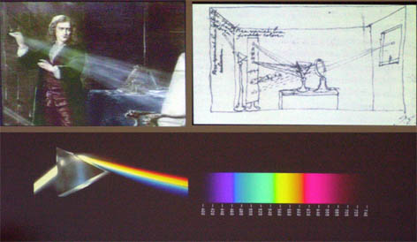

8. If you were standing fast watching thousands of guys running at you yelling something that sounds like “ah-YIP!!”, what must you have been?

A soldier in the Union Army during the civil war. Confederate soldiers, the better to frighten their enemies, would holler this strange call, nobody really knows what, exactly, there being no recording devices, but it’s described as a sort of “ah-yip” sound. That was the “Rebel Yell”. Veterans were recorded purportedly reproducing the yell in the 1930s, but it’s not certain they were doing it accurately. On film they made a sort of YAAAAAOOOOOOOOOW sound:

http://www.smithsonianmag.com/videos/category/3play_1/what-did-the-rebel-yell-sound-like/?no-ist

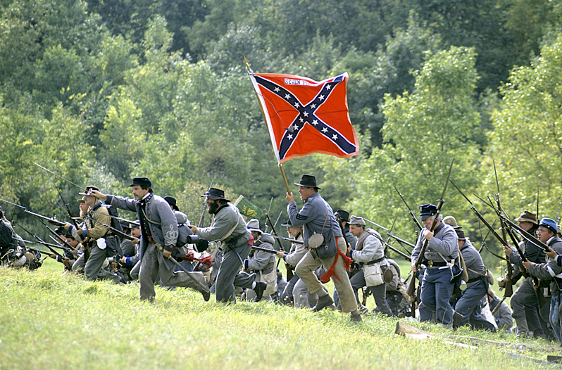
9. What is the earthquake zone that circles the Pacific called?

The Pacific Ring of Fire.

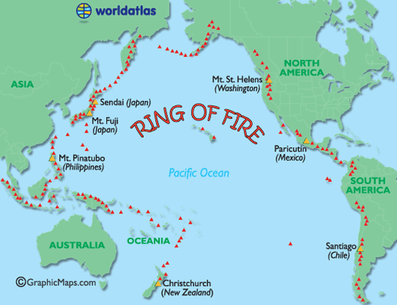

10. What is an isthmus?

A narrow body of land between two bodies of water, like the Isthmus of Panama.

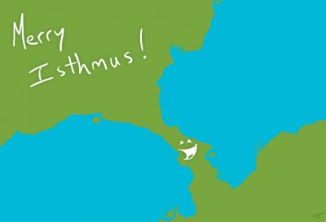

11. What is a peninsula?

A finger of land jutting out into the sea.

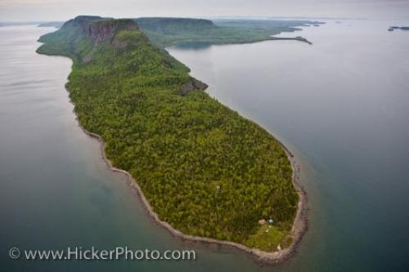

12. What is an estuary?

The brackish tidal pool where a river meets the ocean.



13. Will the landmass that is present day California break off the continent one day and sink?

Nope. Two plates, floating on the molten rock below, meet in California, and when they shift you get earthquakes, but the westernmost plate can no more sink than any other landmass.

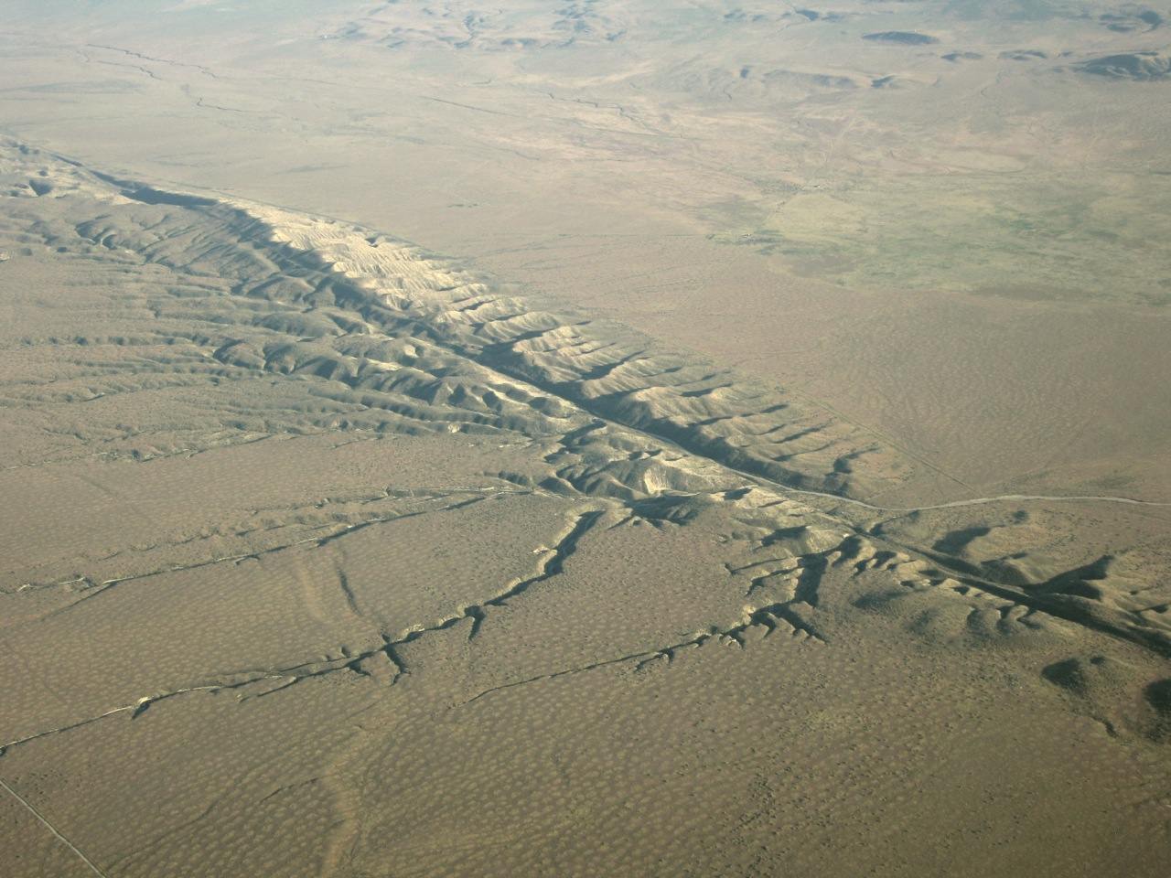

14. What was Teddy Roosevelt’s first big civilian job?

Police Chief in NYC, and a legendary one a that.

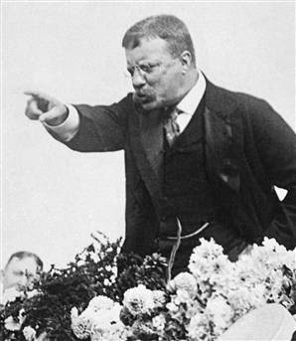

15. What did Frank Whittle invent?

He invented the jet engine, in England just before WW II, but couldn’t much interest the Royal Air Force in helping him develop it. A plane without a propeller old boy? Stuff and nonsense! In time the RAF saw the potential, and a jet fighter using Whittle’s engines was fielded just before the end of the War - the Gloster Meteor (top). As is often the way in human affairs, while Whittle was trying to woo the RAF, a German named von Ohain was also working on a jet engine, which was fielded in a combat role in 1945 – as the power plant of the ME-262. The two jets never met in combat. The Americans weren’t far behind, deploying Lockheed’s superb P-80 (bottom) in May 1945 just about on the eve of VE Day - it was the best of the three fighters, capable of 600 MPH. Just because you’re so interested, Whittle’s engine was “centrifugal”, while von Ohain’s was “axial”.

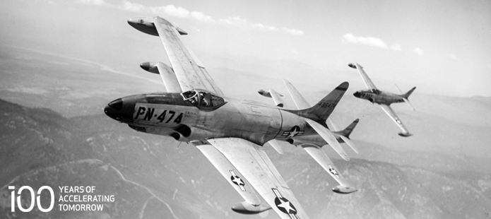

16. Of what animal (besides us) has it been said that it’s the only thing smart enough to know true fear, yet feel none?

Killer Whales, the ultimate apex predator, which have been known to kill Great While sharks for what can only be described as sport.

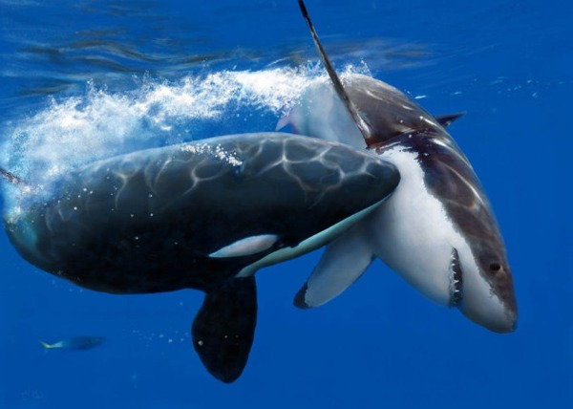

17. Why would Utah have been a better locale for a team named Raptors than Toronto?

A particularly nasty member of the raptor family was unearthed in Utah. “Utah Raptor” is actually the basis for the “velociraptors” portrayed in Jurassic park. Real velociraptors were nasty, but much smaller. Raptors, it is now thought, may have had feathers.



18. In what limited sense does the actual behaviour of dinosaurs fossilize?

Their footprints, fossilized, reveal aspects of how they lived; we can tell that raptors hunted in packs, and about how fast they sprinted, and we can tell that the big sauropods like apatosaurus traveled in herds, with the big adults on the outside and little ones near the centre.

We can also find nesting grounds, full of fossilized eggs, that show that at least some species nested in colonies much as some birds do today (another link between birds and dinosaurs).

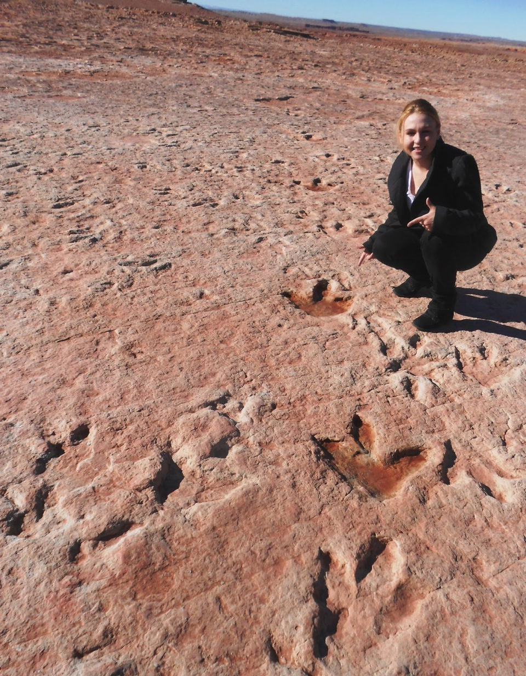

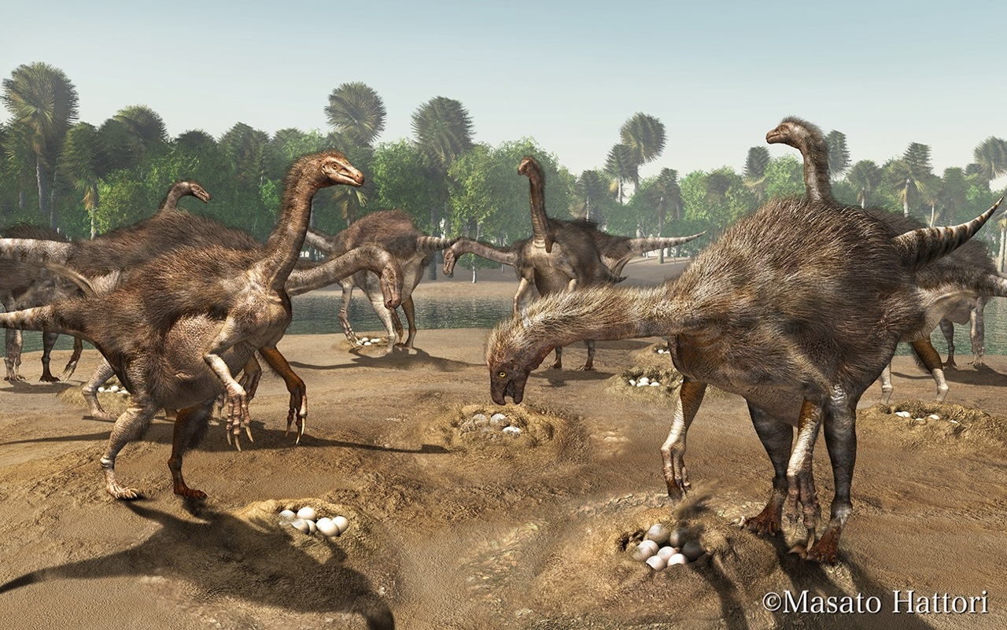

19. Who first described the rings of Saturn?

A fellow named Christaan Huygens, around 1655. He was quite the guy, and also invented the pendulum clock.

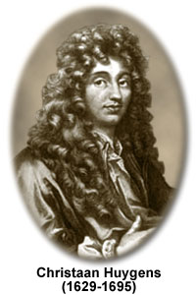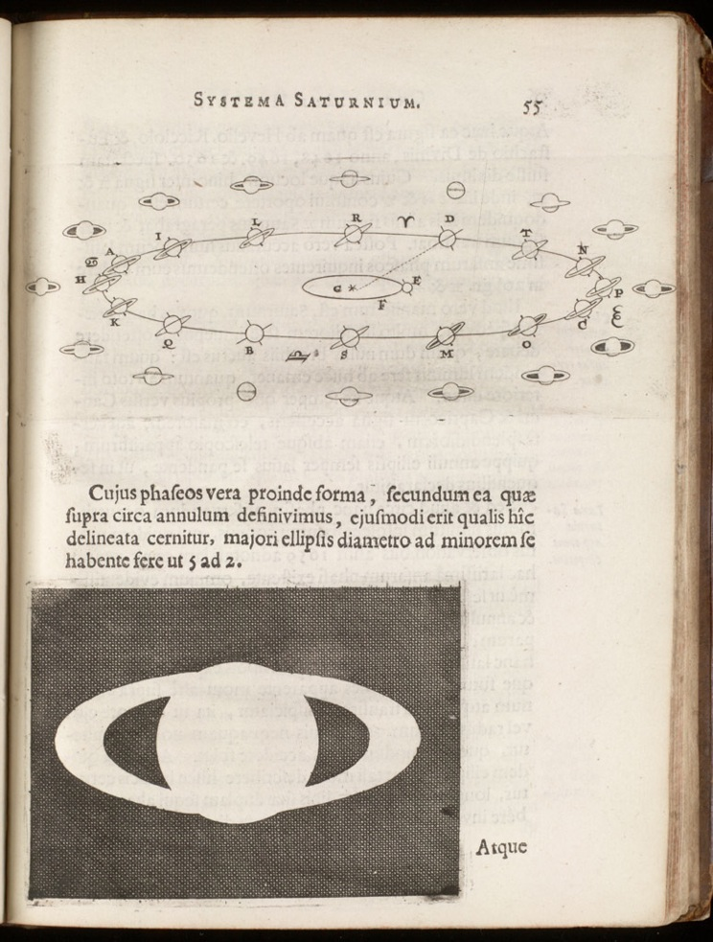
20. Where would you find the Valley of the Mariners?

On Mars, named after the Mariner Probe that first photographed it close up. It’s an enormous crack in the surface of Mars, so big that the Grand Canyon would be a mere offshoot tributary by comparison. It is the only surface feature of Mars that correlates with any of the dozens of engineered canals that Percival Lowell was sure he was observing, and meticulously sketched night after night as he studied Mars through his telescope.



21. Is an existential threat all that serious?

Uh-huh. It’s a threat to your very existence. When people like Vladimir Putin or Benjamin Netanyahu talk about responding to existential threats, put your fingers in your ears and get under your desk, because that means they fear extermination and are going to do something before it can happen. Like bomb Iran’s nuclear facilities, sparking WW III, say.



22. What is known colloquially as a Flying Fox?

Fruit Bats. They’re great big things for something that can fly, and unusual in that they are active in the day, and, by virtue of eating fruit, don’t need to hunt insects using sonar. That’s something to look up - do they even have sonar, or has it atrophied away? Not sure!

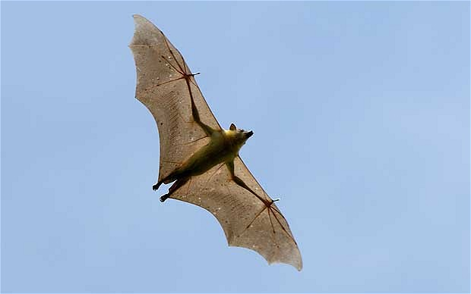

23. Who was Charles Whitman?

One of the first notorious mass killers, a Marine corps trained sniper who climbed up a to a high observation deck at the Tower of the University of Texas at Austin, and proceeded to blow people’s brains out. He killed 16 and wounded 32 more (the paper below was wrong), which whatever else we must conclude, was horrifyingly fine marksmanship. His autopsy revealed a brain tumour, which may have affected his behaviour.



24. What is Occam’s Razor?

It’s the scientific principle that holds that between two possible explanations for an observed phenomenon, the simplest is the most likely. When you hear hooves, it’s likely horses, not zebras. Named for Franciscan Friar William of Occam.



25. What does it mean for something to “come under the rubric of” something, and why “rubric”?

It just means “come under the heading”, or “in the category”, sometimes. “Rubric” derives from the Latin “Rubrica”, meaning “red”; in those wonderful hand made Bibles that monks laboured on in the Middle Ages, the colour red was often used for chapter headings, or for emphasis. These were called “illuminated” Bibles.

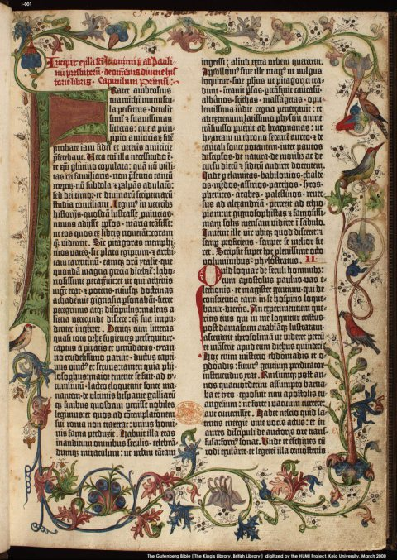

26. What phenomenon is simply and irrefutably demonstrated by a Foucault Pendulum?

The rotation of the earth on its axis. A pendulum, recall, is a very stable thing - its momentum keeps it swinging in one direction. Suspend a big pendulum over a circle, and it will eventually cover the whole 360 degrees as the world spins under it. There’s a cool one in the science museum in Chicago.

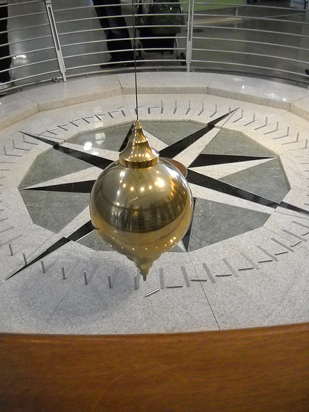

http://www.youtube.com/watch?v=iqpV1236_Q0

27. What happened on Kristallnacht?

The “night of the broken glass”, when Nazi thugs shattered shop windows and vandalized Jewish establishments. This sort of coordinated racist attack was not uncommon in Europe, and went by the name “pogrom” (from the Russian). Homes, hospitals, everything with Jewish associations was attacked, while tens of thousands were rounded up and sent to concentration camps. November, 1938.



28. What happened at Wannsee, and what’s that got to do with relations between Israel and the Arab World?

Continuing our happy Nazi theme, Wannsee was the site of the conference at which leading Nazis met to formulate the “final solution” - the mass extermination of European Jews. Wannsee is a suburb of Berlin. The Wannsee Conference occurred in January 1942.

The Final Solution, the Holocaust to us, was the last in a long line of attacks on Jews, and the final impetus for the Zionist movement, which called for the creation of a safe haven in a Jewish homeland. After the war, Jews flocked to Palestine to create their homeland, and I’m sure you know the rest of the story up to today.



29. What came to be known as “Canada’s Hundred Days”?

In just over three months at the end of WW I, the Canadian Corps, now established as the shock troops of the British Empire, whipped forty-seven German divisions, about 700,000 men - roughly a quarter of the German army. Our Canadian Corps numbered about 100,000. It is little appreciated today that the Canadian infantry has repeatedly distinguished itself as perhaps the finest, toughest and most disciplined fighting force extant, in both world wars, Korea, Bosnia, and Afghanistan. Even the Waffen SS, Hitler’s terrifying corps of fanatics, feared Canadians.

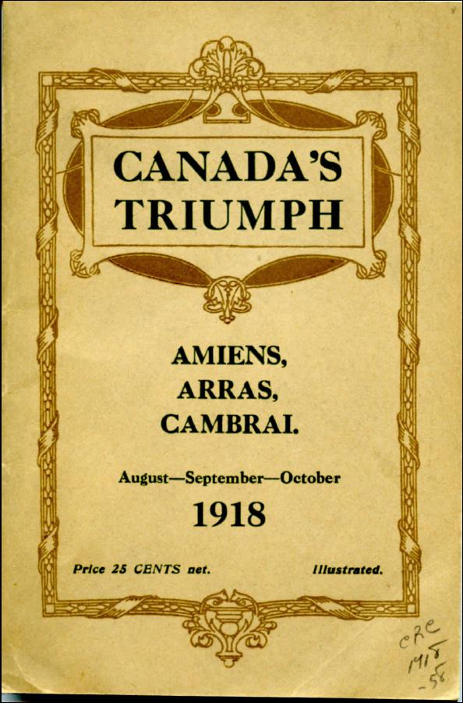
30. What English warship lent its name to all subsequent vessels of its type?

“Dreadnought”, meaning “fear nothing”, was a revolutionary development in warship design, the first modern battleship, an “all big gun” design with 12 inch rifles in her rotating turrets and plenty of armour, yet fast by virtue of being powered by steam turbine.

Her design was initiated by the great “Jackie" Fisher, First Sea Lord of the Royal Navy, and when she was launched in 1906 she immediately rendered all other surface warships, of every navy - all of them, including England’s own - hopelessly obsolete. The result was a huge international race to build “dreadnoughts”, particularly between Britain and Germany, in the run-up to WW I. Fisher is one of the most important figures in naval history - a genius.

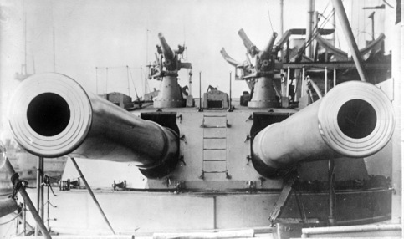
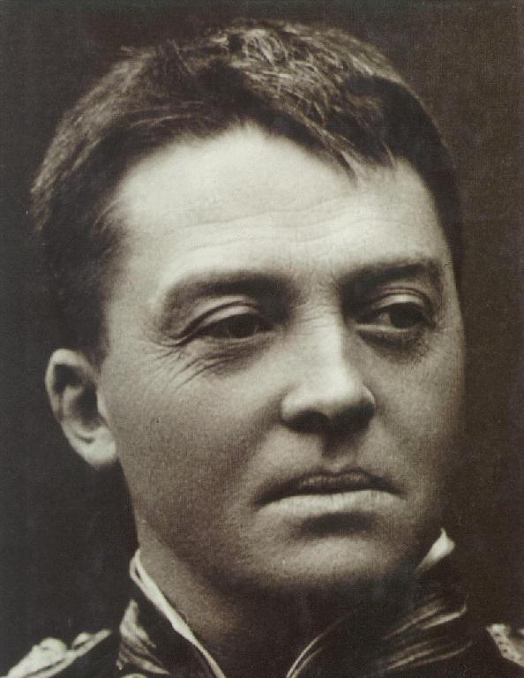

31. What features are especially characteristic of primates?

We did this one already! Binocular vision and opposable thumbs. Even wee ones like the Marmoset.


32. What’s the largest reptile still in existence?

The Nile Crocodile is the biggest reptile left, though some sources say it’s a different species of croc, the “saltwater” crocodile. Take your pick. The biggest ever measured was about 20 feet long and weighed over a ton. Lengths of 15 feet and weights of a thousand pounds are nothing unusual. Astonishingly, crocs are capable of explosive speed, and can run faster than a person over a short distance; this even though they are “sprawling” reptiles, with legs that stick out from the sides, as opposed to the extinct dinosaurs, which stood upright, like birds, and horses.

All surviving reptiles are either sprawlers, or completely legless.

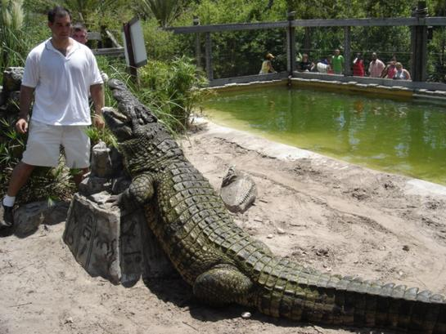
33. What is the significance of island chains known as The Solomons, The Gilberts, The Marshalls, and The Marianas?

These were island chains that were occupied by the Japanese throughout the Pacific in WW II, and re-taken at enormous human cost by the US Marines, one after another, in a campaign strategy known as “island hopping”.

The Marianas – the island chain of Guam, Saipan, and Tinian - brought mainland Japan within the range of massive B-29 bombers, and in the battle to defend the islands, the Japanese Imperial Navy’s aviation arm was savaged, destroyed almost utterly, and never recovered as a viable fighting force. The destruction was so lopsided that the air battle became known to US Naval aviators as “the Great Marianas Turkey Shoot”.

The Japanese, bereft of experienced pilots and front line aircraft, would switch to Kamikaze tactics in the battles that followed, most notably at Okinawa, the largest amphibious operation in history (yes, bigger than D-Day - almost nobody knows this).

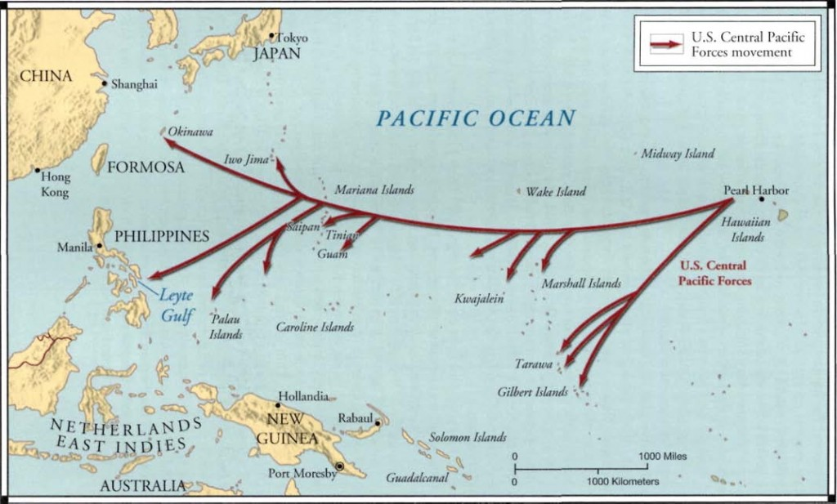

34. What geological feature has vanished, leaving behind only the Aleutian Islands to hint at its existence?

The Aleutians are the long chain that stretches from Alaska into the Northern Pacific. During the last ice age (well, actually, we’re still in an ice age, enjoying a respite called an “interglacial”, though we’ll see what global warming does to the natural cycle), the accretion of enormous ice sheets on land, up to two miles thick in some places, meant that sea levels were dramatically lower. There’s only so much water on Earth, you see, and while trees and other natural processes break down and re-synthesize water molecules, the raw quantity is always pretty much the same, and always has been. So pile up water on land, sea levels go down, last time by several hundred feet! This meant that many geographic features that are now under the sea - like the Grand Banks of Nfld. - were once high and dry, and the Aleutians are the peaks of large islands that once sat south of a natural bridge joining Alaska to what is now Russia. It is thought that humans first migrated to North America over this land bridge, or perhaps came across on the short hops between the large islands, though intriguing new evidence challenges this conventional wisdom.

Oh, if there’s only so much water, where did it come from? Comets, according to one theory. They’re mostly water, and in the early days of the solar system would have bombarded the Earth. This cometary bombardment is why you can find water on the Moon. If not comets, well, it’s hard to say. Recent analysis suggests that most of our water is actually older than the earth itself, so it must have come from somewhere.


35. If you ran into a Hadrosaur, would you be in an awful jam?

Nah, Hadrosaurs were big herbivorous dinos, the Cretaceous equivalent of cows. Commonly referred to as “duck-billed” dinosaurs, they were numerous and successful but their similarity to the two legged predatory dinos was purely superficial, the result of posing them wrong, up on two legs, in museums back in the day. Safe as milk.

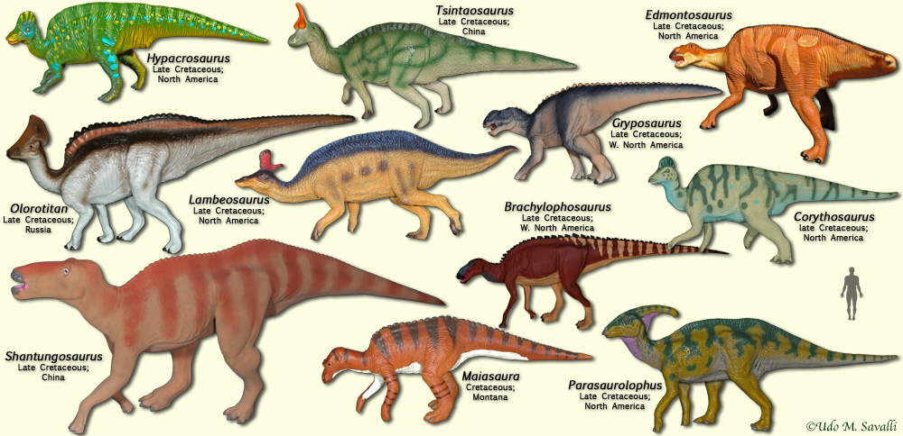

36. Who was Frank Serpico, and what did he do?

A legendary NY City Cop who exposed widespread corruption in the Police Department in the early 70s. They made a movie about him starring Al Pacino.



37. Who designed Central Park in NYC?

The great pioneering landscape architect Frederick Law Olmsted, who also designed parts of the grounds for the magnificent Chicago World’s Fair of 1893, and several other parks in Chicago, among many, many projects. Just about everything in Central Park, every pond, hill and tree, is there by design. Olmsted believed in public access to urban green spaces, a novel idea at the time - he more or less invented the public municipal park.




38. Where is the Hale Observatory?

Mount Palomar, California, is site of the giant 200 inch telescope of the Hale Observatory, which first captured light in the late 1940s, and revolutionized our understanding of the universe. The mirror was manufactured by Corning, and casting this enormous piece of glass was a technological challenge of unprecedented complexity. There are more powerful telescopes today, but the Hale is sort of like the Empire State Building, the Hoover Dam, and the Golden Gate Bridge - its mystique endures.

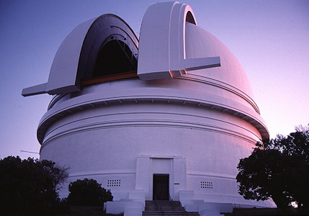

39. Can you name a four-legged apex predator that is a surprisingly good and enthusiastic swimmer? Can you name two?

Polar Bears are superb swimmers, and can go for miles in frigid arctic water. More surprising is that Tigers are also excellent and enthusiastic swimmers - your pet cat may fear getting dunked, but not Tigers.



40. What country used to be called Siam?

Thailand!

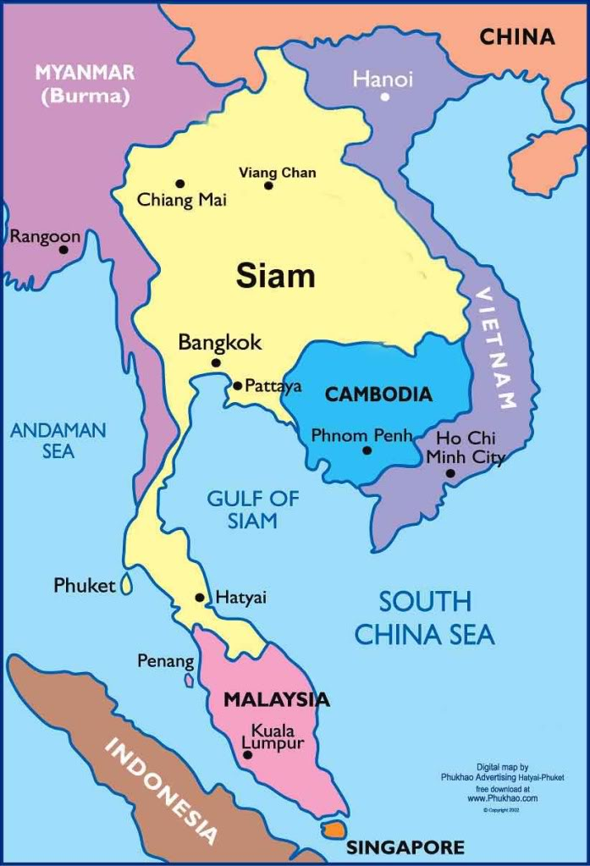

41. If you had to fly into combat, would you rather be in a Sopwith Camel or a Supermarine Spitfire?

If we’re talking about going into combat against each other, oh boy do you want the Spitfire. The Camel was a wood and fabric WW I biplane capable of about 110-120 MPH, and was armed with two machine guns. The Spitfire was a 400 MPH WW II stressed metal monoplane armed with eight machine guns (later 4 machine guns and two very powerful 20mm cannon, as seen below).

Measured against their contemporaries, both were the peak of their breed, and both are iconic, but there is nothing - nothing at all, not even a Mustang, nor any other machine of any kind, if you ask me - that quite has the aura of the Spitfire. It alone could defeat the best German fighters in the high summer of 1940 when all of history balanced on a knife edge; yes, the Hawker Hurricane, rugged and reliable, actually racked up 75% of the kills during the Battle of Britain, but Hurricanes went after the bombers. Spitfires took on the ME-109s, keeping them off the backs of the Hurricane squadrons. Continually improved, the Spitfire remained a first-rate fighter throughout the war, and while logic dictates that the FW-190 was just as good, and the Mustang even better, nope, the heart clamours for Spitfires. The Mustang may have won the air war over Germany, but the Spitfire saved Western Civilization at its darkest hour. It doesn’t hurt that it is also the most beautiful machine ever fabricated – bar none.

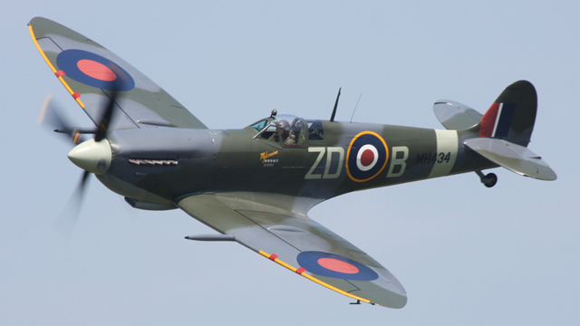

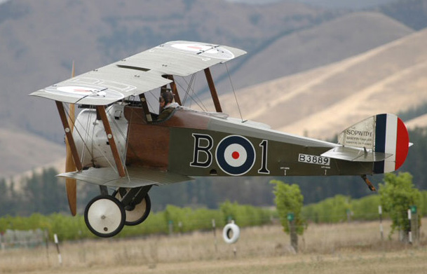

42. Why did Toronto name the island airport after some guy named Billy Bishop?

He was a Canadian pilot during WW I and one of the top aces of the war, credited with 72 kills. Some historians think this number is exaggerated - it’s often a matter of confusion whether you’ve actually shot something down in the melee of air combat, and this was an era before gun cameras could provide confirmatory evidence. This is why Manfred von Richthofen - the “Red Baron” with 80 confirmed kills in WW I, the record - often landed near the wrecks of his enemies, gathering physical evidence of his kills.

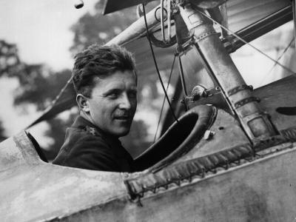

43. What was the “Spruce Goose”, and on whose dime was it built?

Howard Hughes was an avid pilot, though by all accounts a really lousy one, and founded Hughes Aircraft. During WW II Hughes worked to develop a huge eight-engine transport plane that could carry troops across the Atlantic and land without runways if necessary, being a gigantic flying boat. The prototype was made largely of plywood, to save scarce aluminum, and while officially named “Hercules” its wooden structure earned it the nickname Spruce Goose. The plane was really huge, with a wingspan of 320 feet (the span of a 747 is about 200 feet), but it wasn’t finished before the war ended, and only the one prototype was built. This flew only once, a very short hop barely above the surface of the sea, piloted by Hughes himself just to prove it could fly. The Spruce Goose survives to this day and is on display in a special facility in Oregon.



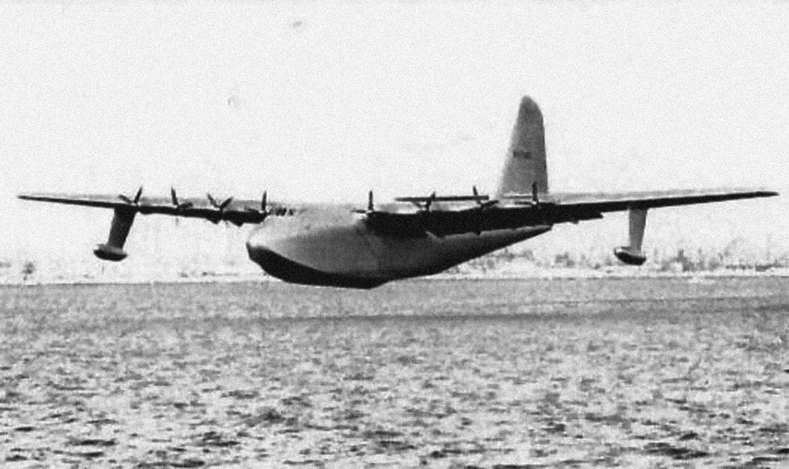

44. Has there ever been a US President who was undoubtedly a genius as technically defined?

Thomas Jefferson certainly had a genius IQ, they reckon about 150-160. But he’s not the only one. Jimmy Carter, Bill Clinton and Richard Nixon all had genius or near-genius IQ ratings, as did my favourite, Harry Truman. Genius is usually said to be 145 and above; Harry was 130 or so, but IQ isn’t everything - Nixon was over 140, and who would you rather have in the White House?

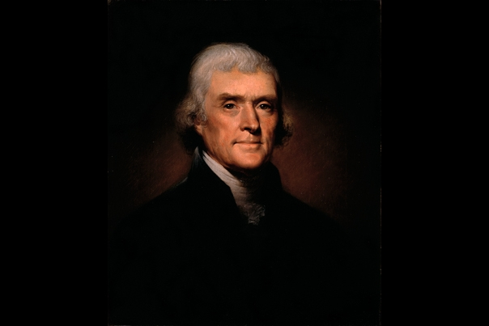

45. What are “perfect solids”?

Greek geometry postulated a set of ideal shapes known as “perfect solids”, such as the cube - also called “Platonic solids”. According to Wikipedia:

In Euclidean geometry, a Platonic solid is regular, convex polyhedron with congruent faces of regular polygons and the same number of faces meeting at each vertex. Five solids meet those criteria, and each is named after its number of faces.



46. What oath begins “First, do no harm”.

The Hippocratic oath, formulated by ancient Greek physician Hippocrates, and still sworn by Doctors to this day. One of my favourite moments in the Simpsons had Homer, undergoing a medical procedure, plead with his doctor “Remember your Hippopotamus Oath!”



47. What was an archaeopteryx, and what is so important about it?

One of the most famous fossils ever unearthed, Archaeopteryx was a small dinosaur that had feathers. Its discovery was a sensation, since it was just the sort of transitional creature, half reptile, half bird, that was predicted by Darwin’s theory of evolution.

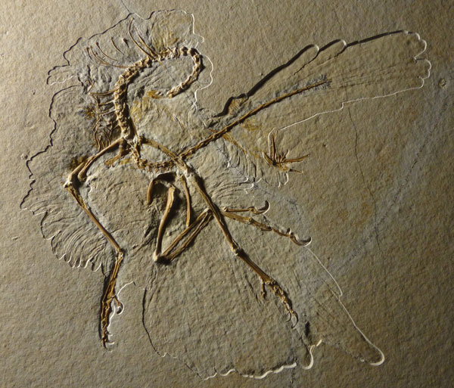

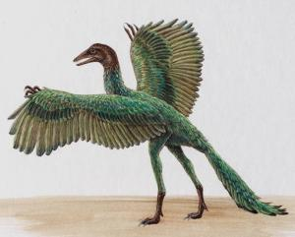

48. Who was Louis Leakey?

The great hominid paleontologist, and scion to a whole family of paleontologists, he worked in the Olduvai gorge in Ethiopia, and uncovered solid evidence of tool use by early hominids, one of which was named Homo Habilis, “Handy Man”, who we’ll encounter in another quiz.

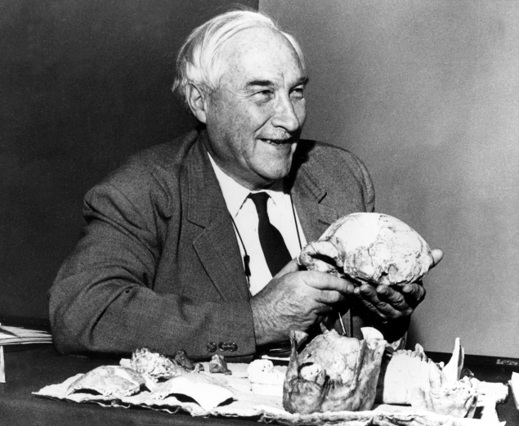

49. What city used to be known as Constantinople?

Modern day Istanbul was once the capitol of Byzantium, the Western Roman Empire, which held on until conquered by the Ottoman Turks in 1453. Constantinople was named after Roman Emperor Constantine the Great, who consecrated it in about 300 AD.

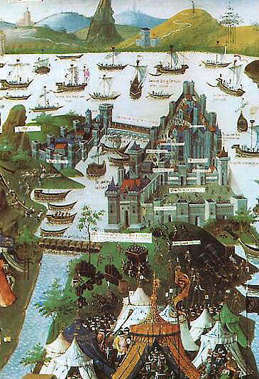
50. What city used to be known as Leningrad?

Leningrad was the name given to former Saint Petersburg by the Soviets following the overthrow of the Czars. Now that the Soviets are history, it is called Saint Petersburg again, honouring Czar Peter the Great who founded it around 1700.

It’s a gorgeous city, and famously survived a German siege during WW II that lasted almost 900 days.

