1. What is the significance of Trafalgar, Jutland, and Midway Island?

We’ve covered Midway and Trafalgar elsewhere; the Battle of Midway in 1942 turned the tide of the Pacific War in WW II, and Trafalgar was Nelson’s epoch-making rout of combined Spanish and French naval forces in 1805. Decisive sea battles that changed the course of history.

Jutland was a similar battle during WW I, though on the surface it seemed less decisive, and I would emphasize “seemed”. It is one candidate for the largest naval engagement in history (there are ways and ways of measuring this) and occurred in 1916 off the Jutland Peninsula of Denmark.

Prior to the outbreak of WW I, battleships were considered the ultimate symbol of national power and prestige, and were referred to as “capital ships”. Over a hundred years after Trafalgar, and despite the rivalry of the generally friendly Americans, England remained pre-eminent on the world’s seas. The Royal Navy had been the first to deploy a modern battleship, in the form of H.M.S. Dreadnought, and built a massive fleet of armoured warships, all generically referred to as “dreadnoughts”, that constituted the greatest concentration of naval might in world history. The Royal Navy was crucial to Britain’s maintenance of its empire, economy, and geopolitical standing.

In the early 1900s, though, Germany, not traditionally a naval power, began constructing a fleet of its own. This triggered a “dreadnought race” as England and Germany vied to build huge battleships of ever-increasing size and lethality. It worried the British very much; Germany didn’t need a navy to be the pre-eminent land power in Europe, but Britain depended on its navy for everything. For the Germans, their High Seas Fleet was, in a sense, a frill. In any future war they could throw it at the Royal Navy and see if it could knock Britain off its perch. If it succeeded, great, if it failed, that’s sad, but not a strategic disaster.

This meant the High Seas Fleet was what we strategists call a “risk navy”; you could put it all on double nuts and spin the roulette wheel. The Germans appeared to be planning to do just that, and indeed, German naval doctrine emphasized the coming apocalypse of “Der Tag’, The Day, when the two giant fleets would engage, and we’d all see what we would see.

As the war commenced, John Jellicoe, First Sea Lord, was a worried and cautious man. Rather than expose his vast fleet to grinding attrition amidst the minefields and submarines off the coast of Germany, he husbanded his strength in the great naval base at Scapa Flow, in Scotland’s Orkney Islands, and waited to see what the Germans would do. His first priority was that the RN remain a “fleet in being”. Great Britain could not afford to lose naval supremacy, pointless risks could not be taken, and it became a complicated chess match, a sort of blockade from a distance. The Grand Fleet, by its very existence, changed strategic calculations. The stark threat posed by Jellicoe’s forces served as a deterrent.

The Germans launched a few probing assaults with their battleships, shelling English seaside towns, in an attempt to provoke a response. Jellicoe, fearing traps, would not bite. He was intent upon waiting until the Germans made a major foray with the bulk of their fleet.

The Royal Navy’s blockade of the North Sea established a dreary status quo that the Germans were keen to disrupt, but despite all the hot-headed yearning in some quarters for Der Tag to finally come, the man in command of the High Seas Fleet, Admiral Reinhard Scheer, a frighteningly competent naval officer, kept a cooler head. Scheer didn’t want to confront the full might of the Grand Fleet. The Royal Navy’s combined strength was enormous, and overwhelming. Instead, he hoped to cut the British up piecemeal, wearing away at the Royal Navy in increments, precisely what Jellicoe was determined not to allow. Indeed, the German plan in the run-up to Jutland was to lure an unsuspecting Royal Navy battle-cruiser squadron into the teeth of the High Seas Fleet, which would destroy the English vessels before the Grand Fleet got wind of the foray and moved to intervene. Scheer also hoped to post U-boats in the approaches to Scapa Flow, to ambush units of Jellico’s force as they came out of port. What Scheer didn’t know was that the British had cracked the German naval codes, and knew of his plans.

At the end of May, 1916, Scheer made his move. Out came the bulk of the High Seas Fleet. As the Germans weighed anchor with the plan to take on a half dozen battle-cruisers, Jellicoe was already sailing South to meet them, with just about everything he had. Scheer didn’t know it, but Der Tag was upon him, whether he liked it or not.

Something like 250 warships of all kinds soon clashed.

The details are fascinating to me, but I’ll spare you. In a nutshell, the Germans turned out to be superb warship designers, and while their battleships and battle-cruisers took a vicious pounding, they stayed in the fight, whereas the RN’s capital ships tended to blow up catastrophically with all aboard. One of Jellicoe’s subordinate Admirals, a dashing character named Beattie, flung his battle-cruisers at the High Seas Fleet with visions of glory dancing in his head, only to watch several of those massive ships explode when hit. “There seems to be something wrong with our bloody ships today”, said Beattie.

A huge maneuvering struggle then ensued. Naval historians speak of the “run to the North”, Jellicoe twice “crossing the German’s T”, and Scheer’s “death ride of the battle-cruisers”. The fleets mauled each other severely.

The Germans sank more ships and inflicted more casualties than the British, and could thus claim “tactical victory”, but in the end it was clear that the Royal Navy was going to survive Der Tag, and still be the superior force when it was all over. The High Seas Fleet broke off the action, made its escape in the night (no radar back then), and limped back to port, its ships looking like they’d been riddled by giant shot guns.

Apart from a couple of tentative probes, they never came out again. Jutland was an experience they didn’t care to repeat. Within a few months of the battle, new units joined the Grand Fleet to make it an even more formidable force than it had been prior to the engagement, and Jellicoe continued his blockade, the status quo having been reasserted with a vengeance.

The famous turn of phrase at the time was that “the Germans had assaulted their jailor, but were put back in their cage”. Jellicoe, his Grand Fleet still very much a fleet in being, had avoided a geopolitical catastrophe, eliminated the German naval threat, and preserved for Great Britain the freedom of maneuver on the world ocean.

Sounds like a fairly decisive strategic victory to me, but the British public and its politicians had wanted another Trafalgar, and wanted to know why Jellicoe had failed to destroy the High Seas Fleet in detail. There was no denying that Jellicoe could have been more aggressive in his tactics at Jutland, but he, unlike Scheer, was not in the happy position of commanding a risk navy. As Churchill later wrote, Jellicoe was the only man alive who “could by himself lose the war in a single afternoon”.

To my mind, he never got his due.

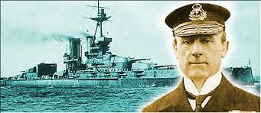

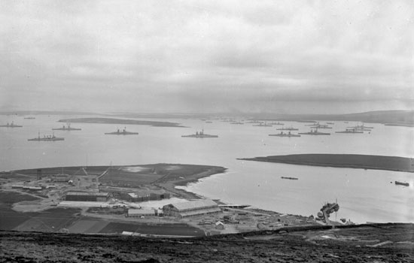

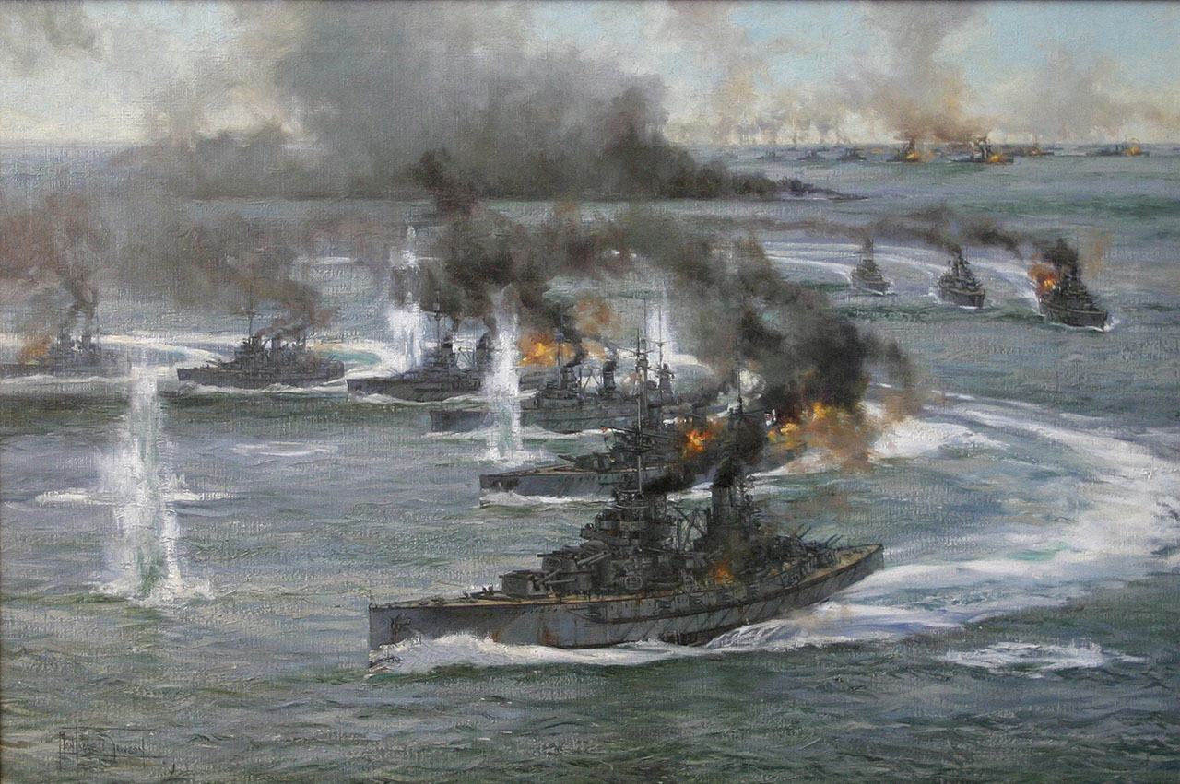

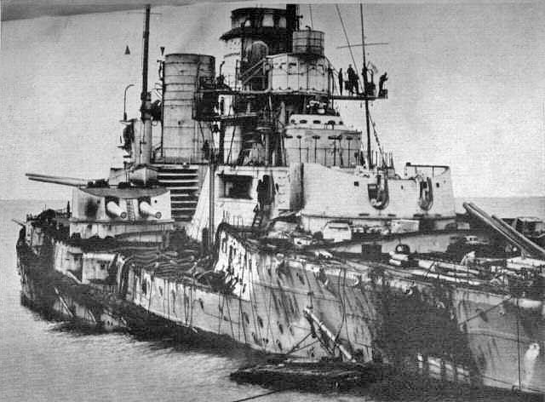

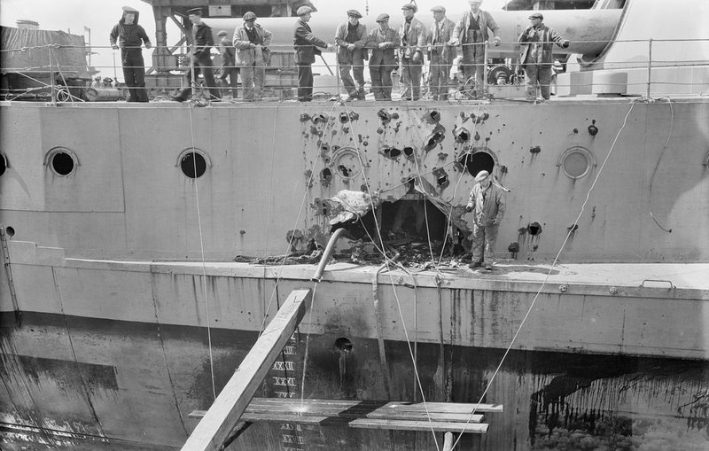
2. What (approximately) is the speed of sound at sea level? What name do we use to denote the speed of sound generally?

Maybe 720 to 740 MPH, depending on the conditions. The speed of sound, whatever its medium and actual speed, is “Mach 1”, after scientist Ernst Mach.

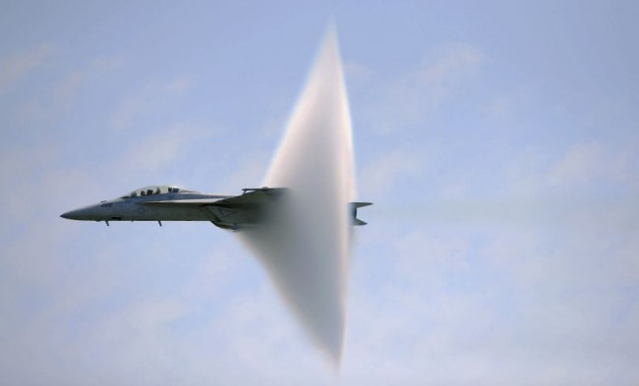
3. What is the speed of light? What can accelerate to speeds faster than the speed of light?

The speed of light is 186,000 miles per second, or 300,000 kilometers per second. The second part of the question is a trick. Under Einsteinian physics, mass increases exponentially as the speed of light is approached, and nothing which at present travels at sub-light speeds can ever break the “light barrier”. This does not preclude the narrow theoretical possibility that the Big Bang coughed out something that has always gone faster than light, and space itself is thought to have expanded many, many times greater than the speed of the light within it, under what’s known as Inflationary Theory. That’s why our most powerful telescopes can detect light from stars that must have moved out there so fast, it took over 13 billion years for their light to reach us.

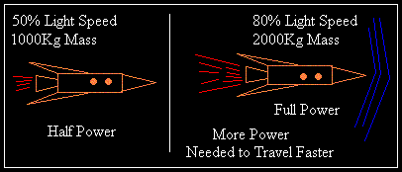

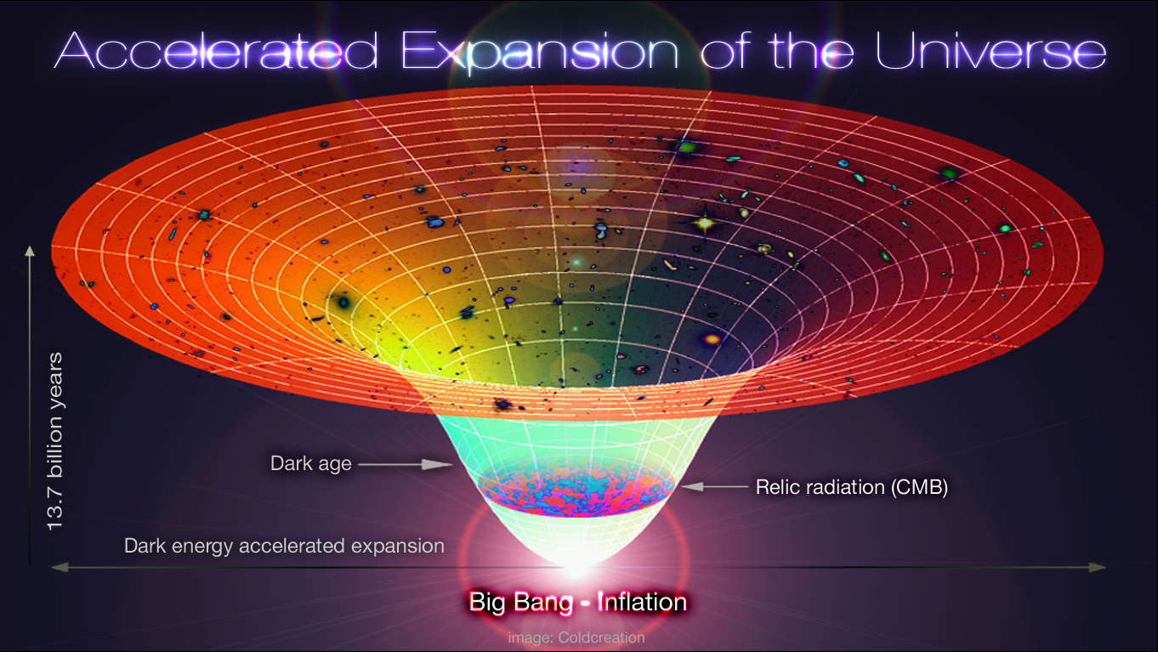
4. Why do I have the names of two ships, Imo and Mont Blanc, seared into my memory?

It must be Nautical Day here on Glenlake Ave!

The answer is, “cuz I’m from Halifax”. Want me to flesh that out? Oh, OK.

In both world wars, Halifax was a crucial staging area for the resupply of European allies. Huge convoys of freighters would form up in the inner sanctum of Bedford Basin, the largest natural harbour on Earth (I don’t buy the claims made for Sydney), and at any given time there’d be dozens of ships assembling themselves into convoys. There was, therefore, a tremendous amount of harbour traffic, and a crap-load of work for the harbour pilots.

Bedford Basin opens up off a slender inlet called “the Narrows”, and in December 1917 the Imo, a Belgian ship full of medical supplies, and the Mont Blanc, a munitions ship loaded to the gunwales with thousands of tons of high explosives, found themselves navigating through the Narrows in opposite directions. Accounts vary as to why, you can imagine the post-disaster inquiries and finger pointing, but they collided, Mont Blanc began to burn like a Roman Candle, and explosion became imminent.

The cargoes of ships aren’t widely disseminated in wartime, as there might be local spies looking to tip off the U-Boats as to which were the juiciest targets. Few knew what would happen if the fireboats, now hard at work, couldn’t stop Mont Blanc from burning. Many people in Halifax watched the drama through panes of glass, standing at their windows fascinated, oblivious to the danger. At the same time, people on the Dartmouth side of the Narrows were wondering why a bunch of sailors was tearing up the hills and yelling something incomprehensible in French. The crew of the Mont Blanc had tried to scuttle, but no one could have lived through an attempt to go below and search for the valves. The fire would incinerate you in seconds. So they paddled furiously ashore, and ran for the Dartmouth Hills, and you can’t really blame them.

When Mont Blanc blew, it detonated with a force measured in thousands of tons of TNT, just as we do with atomic weapons. The harbour floor was exposed. A huge tidal wave rushed out of the mouth of the Narrows and travelled so far that ships something like a hundred miles out could feel its heave. Plates were knocked off of shelves 60 miles away, in Truro. And North End Halifax was all but destroyed. About two thousand were killed outright, and 9,000 more wounded, a great many with terrible eye damage from the shattered windows they’d been looking through when the shock wave hit. My own grandfather, a haberdasher, was in the basement of a stout stone building, checking inventory. Baffled, he wondered if somebody had dropped a packing crate upstairs.

It was the largest man-made detonation in history prior to Hiroshima.

The night of the Explosion, about the worst snowstorm in living memory blew in and blanketed the shattered city in a couple of feet of freezing death, obscuring the survivors who were trapped in their collapsed houses. Nothing was recognizable any more. Where were the streets? Where had the buildings been, exactly?

The outside world was puzzled, then alarmed, when all telegraph and telephone communication from Halifax suddenly ceased. The lines were all cut. In a herculean effort that merits a telling in its own right, authorities in Boston got wind of an epic disaster of unknown proportions, and loaded up a relief train that carried most of what you’d need to deal with the emergency, including not just food and clothing and such, but medical staff and supplies.

Fighting through the blizzard, the Bostonians arrived about 48 hours after the explosion. More trains came from New England, full of building supplies, the necessities of everyday life, and construction workers. First order of business was to build a temporary city on the Commons. Not a tent city, mind you. Proper, if Spartan, apartments. Then on to restore the North End. They stayed for months.

In 1918 Halifax sent a huge Christmas Tree to Boston in thanks. The tradition was revived when I was a kid. Every December, the people of Halifax deliver a big green thank-you card to their friends in Massachusetts.

The effects of the explosion were asymmetric, and bitterly unfair. The Mont Blanc had gone up near the North End, where the poor and working class lived. Post-blast it looked like Nagasaki up there. Then the shockwave, heading for the South End, was deflected up and around Citadel Hill, and the rich folk where I grew up suffered mainly broken windows and other repairable damage.

Sixty years later they were still teaching us about it in school. There were signs of the explosion everywhere, if you knew what to look for. When I was a kid, we’d hike into the woods across from the other side of the peninsula to look at what we were told was one of those signs, a twisted, nondescript shaft of metal, just lying there on the ground. Word was this was the remains of the anchor of the Mont Blanc, blown clear across the peninsula to land there, a distance of two and a half miles. It weighed over a thousand pounds.

This is one urban myth that’s actually true. That really was the anchor shaft of the Mont Blanc. When they developed the area, they mounted it on a plinth.

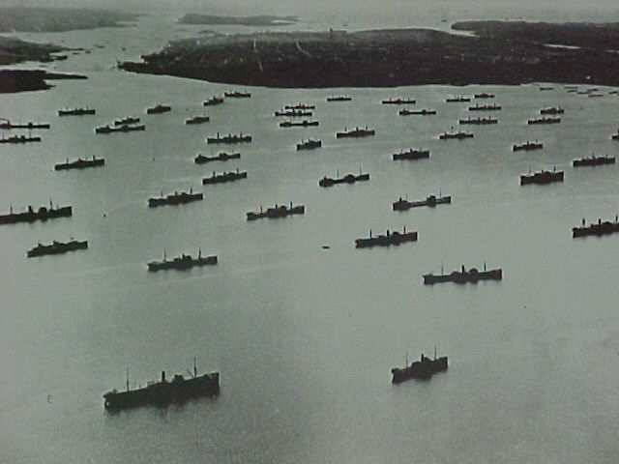

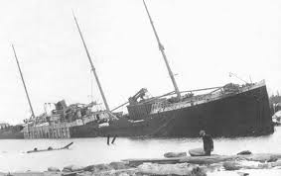

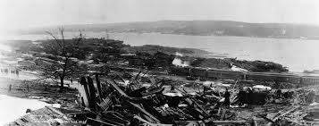

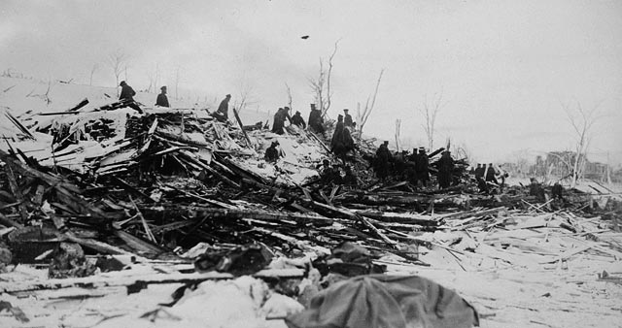
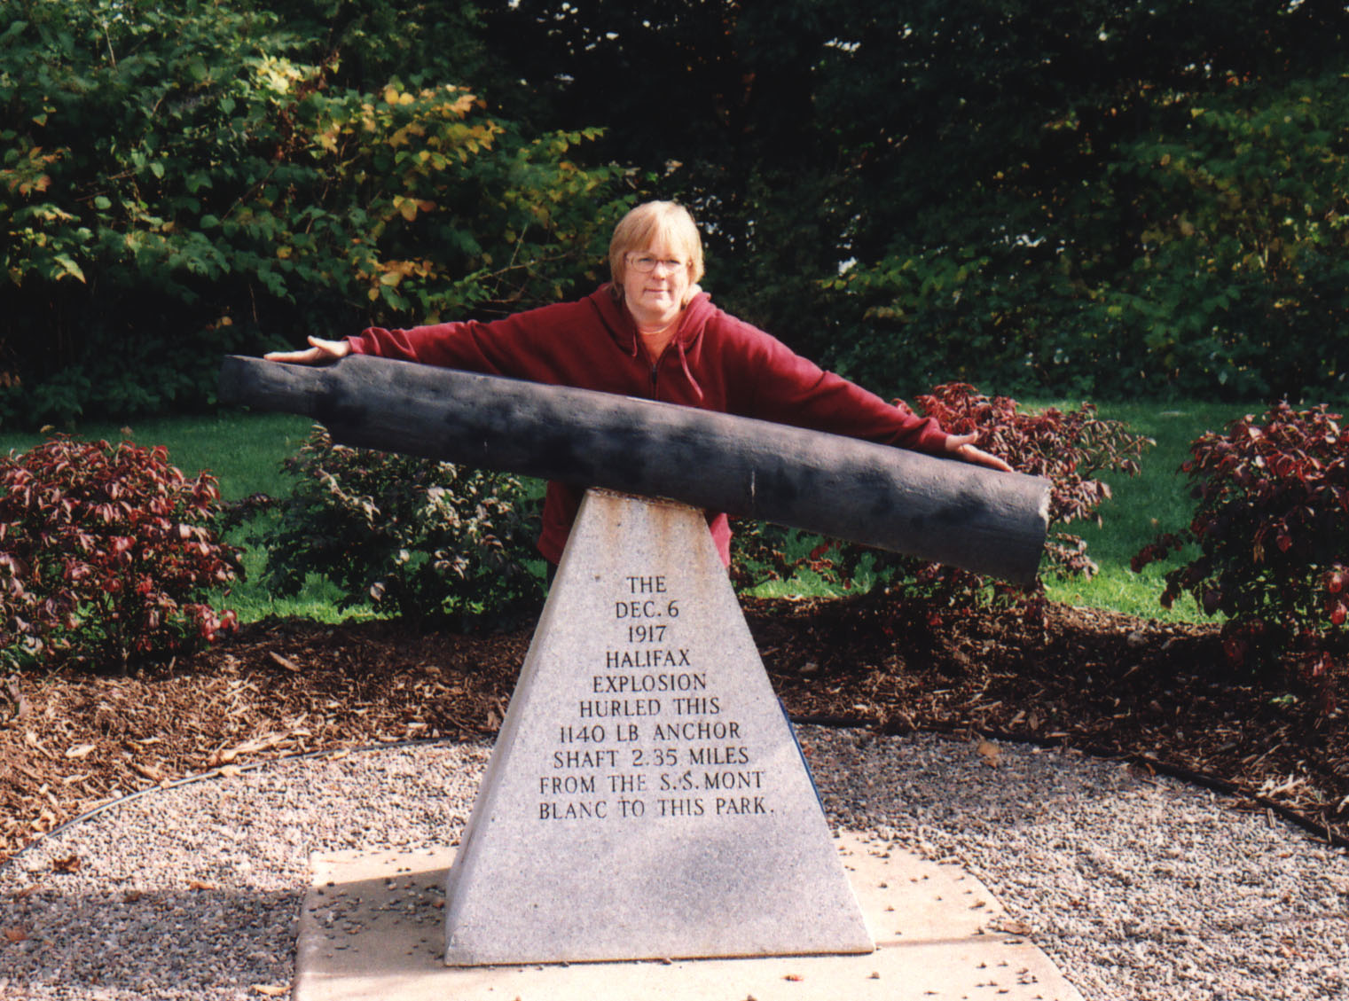
5. Name at least three momentous events that occurred in 1968.

I’ll go with the Tet Offensive, the Prague Spring, and Apollo 8. Plenty to choose from, though.


6. Who, in July of 1969, would have been entitled to call himself the loneliest man alive (even if he never did)?

Michael Collins, pilot of the Apollo 11 Command module. As Neil Armstrong and Buzz Aldrin departed for the Moon’s surface, Collins had to stay behind so that someone would be able to pilot the Command Module to a docking with the Lunar Module when Buzz and Neil returned.

Collins was thus only the fourth man to see the far side of the Moon, (after the three on Apollo 8) and the first one who was all alone when he disappeared over the Moon’s horizon from our vantage point and became more cut off from his fellow humans than anyone had ever been, without even radio contact.

Collins insists he was busy, and unperturbed. Since he was a former experimental aircraft test pilot, nobody can think of any reason to doubt him. Those guys are cool as cucumbers, and monitor their dials and gauges. No time to gawk at the scenery. Still, what was it like to gaze down upon something which, as Scott Fitzgerald wrote in another context, was finally commensurate with our capacity for wonder? He was only 39.

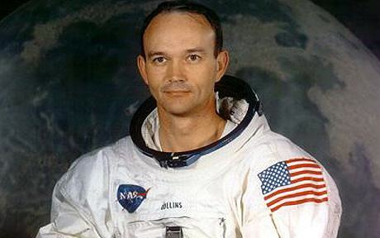
7. How is Stalingrad (now Volgograd) in Russia like Gettysburg in Pennsylvania?

Both were the sites of turning points that determined the outcomes of wars. At Gettysburg in 1863, Robert E Lee’s Army of Northern Virginia was routed in an epic battle of the US Civil War. The war wasn’t over, but it was decided.

At Stalingrad in 1943, the Soviet Army halted the German Blitzkrieg and surrounded a huge Nazi Army, destroying or capturing the entirety of its forces after a battle that had lasted over 5 months. The scale of the armies deployed to fight over this middling industrial town on the Volga boggles the mind. Over a million men were committed to each side. More than 2 million soldiers contesting something the size of, say, Hamilton.

850,000 Axis soldiers, 400,000 of them German, the rest from places like Romania, Italy and Hungary, were killed, wounded or captured. Just about the entire 6th Army Group. The Wehrmacht never recovered.

If it wasn’t for the Western Allies prosecuting the North African, Italian, and Normandy campaigns, as well as the massive strategic bombardment that tied down huge amounts of German resources, maybe Germany, fighting only on one front, could have rallied, and fought the Soviets to a standstill. Maybe. The Russians insist, however, that it was they, not us, who defeated Nazi Germany, and they very much have a point.

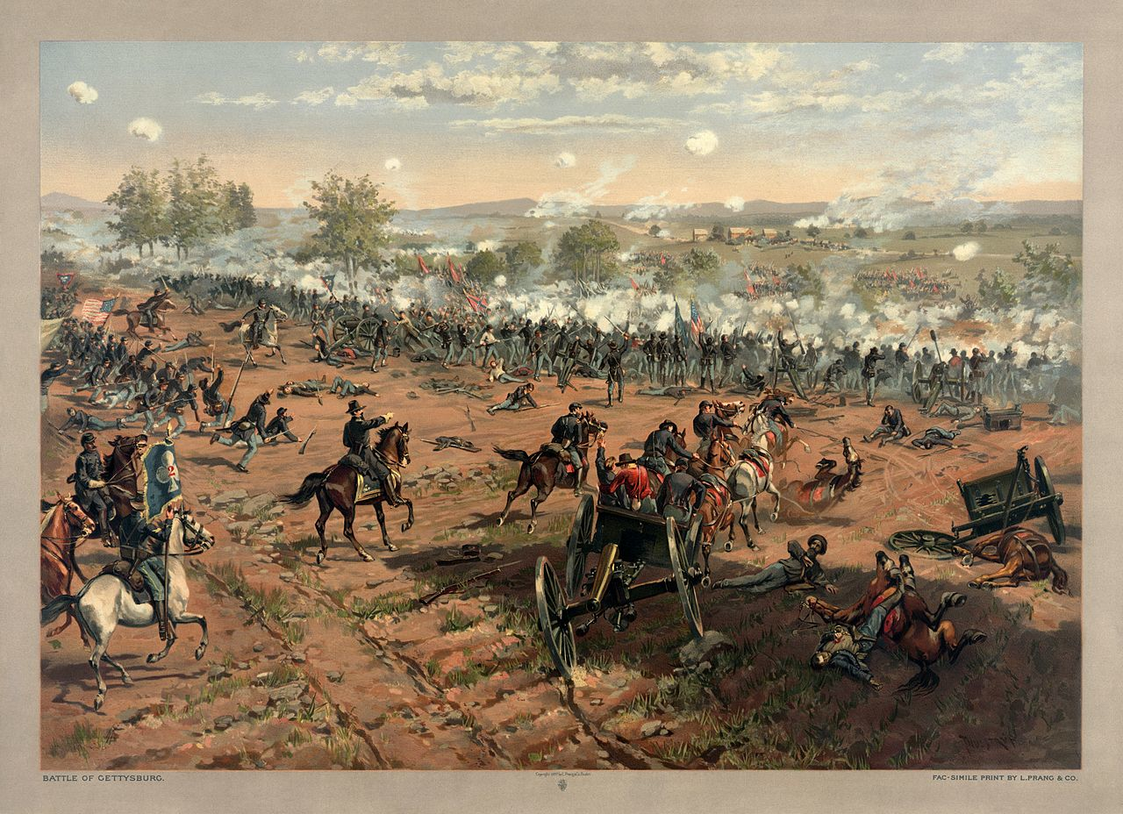

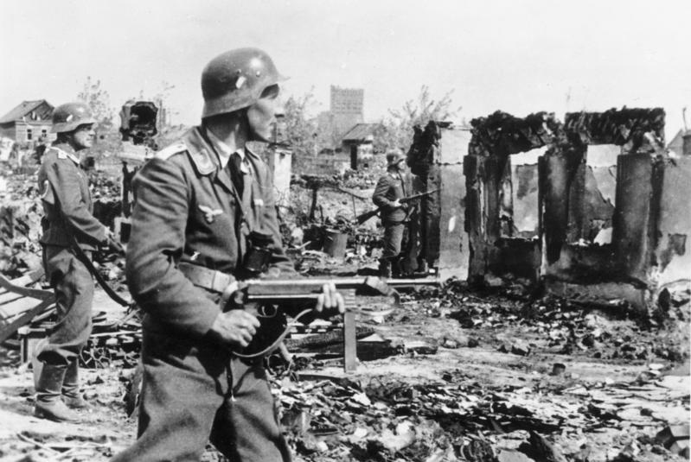
8. What was the name of the last Russian Royal Family?

Romanov. Czar Nicholas II, toppled by the Communist Revolution, was the last of the old guard. He and his family were taken prisoner, and the Communists hummed and hawed about what to with them. The Romanovs had close family ties with the British Royal Family, and might have been sent to exile in England, or some other friendly country. Eventually it was decided no, better to just shoot them. Tidier that way, no?

Here’s to the new boss. Same as the old boss.

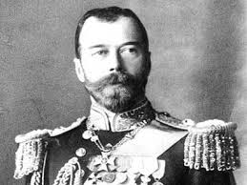

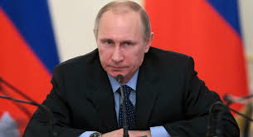
9. What, and when, was the “shot heard round the world”?

Various events have been given that label over the years, including an epic home run by Bobby Thomson that won the NY Giants the pennant in 1951. Also the killing shot that Gavrilo Princip inflicted upon Austrian Arch-Duke Ferdinand, setting in motion the events that would explode into the First World War.

However, the phrase is from a poem by Emerson, and refers to the first shot fired in the American revolution, at Concord, Massachusetts.

By the rude bridge that arched the flood,
Their flag to April’s breeze unfurled,
Here once the embattled farmers stood,
And fired the shot heard round the world.

Emerson, "Concord Hymn"

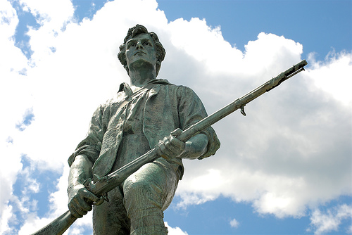

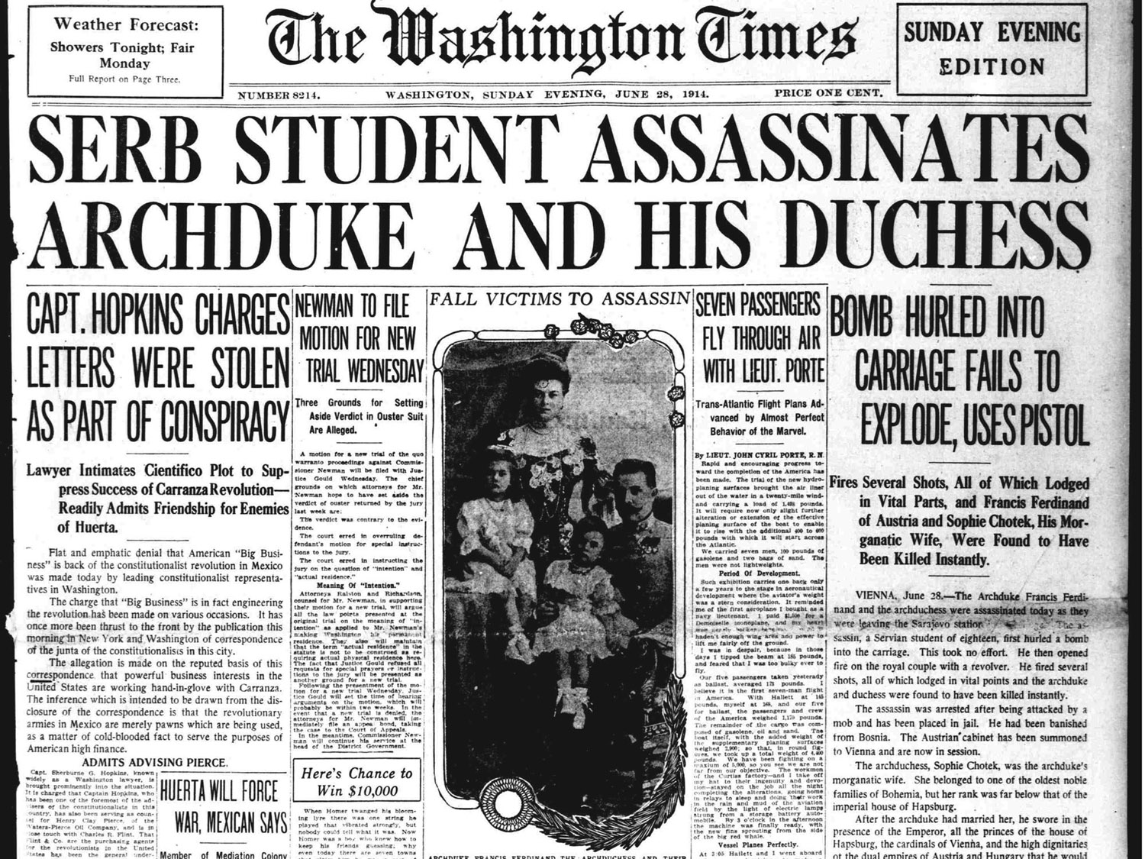

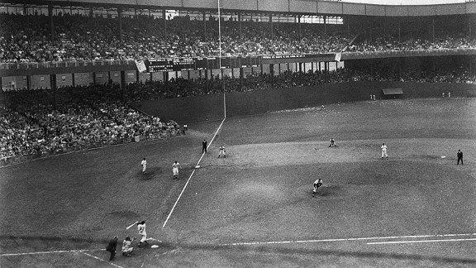
10. What, atomically speaking, is the simplest and most common element in the universe?

Hydrogen, one proton, one electron, no neutrons, Atomic Number 1.

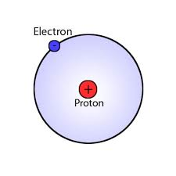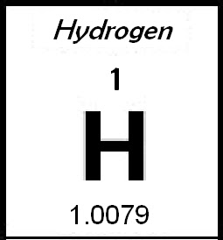
11. What happened about 65 million years ago?

Man, we’ve done this to death by now, right? The impact that caused the Cretaceous mass extinction and wiped out the Dinosaurs.

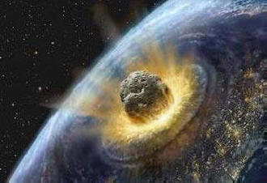
12. What was the Marshall Plan?

George Marshall was a high-ranking General during WW II, and joined Harry Truman’s cabinet as Secretary of State after war’s end. Things were already getting chilly with Russia, and we wanted some healthy European allies. We also didn’t want to leave Europe, and Germany particularly, in a shattered and humiliated state. That sort thing sows the seeds for still more war.

Thus emerged the Marshall Plan, a massive US aid effort aimed at the reconstruction of Europe. Beginning in 1948, The Americans poured the equivalent of 160 billion 2015 dollars worth of aid into Europe.

It was a rip-roaring success, and perhaps the cardinal historical instance of an act done in enlightened self interest


13. When was the Battle of Britain?

If you’ve read this far, you know darn well it was in the Summer of 1940.

Still, gives me a chance to paste in another image of airplanes!!

Here, a Spitfire is set upon by its German equivalent, the Bf-109. Probably Galland, Molders or Wick, one of those guys.

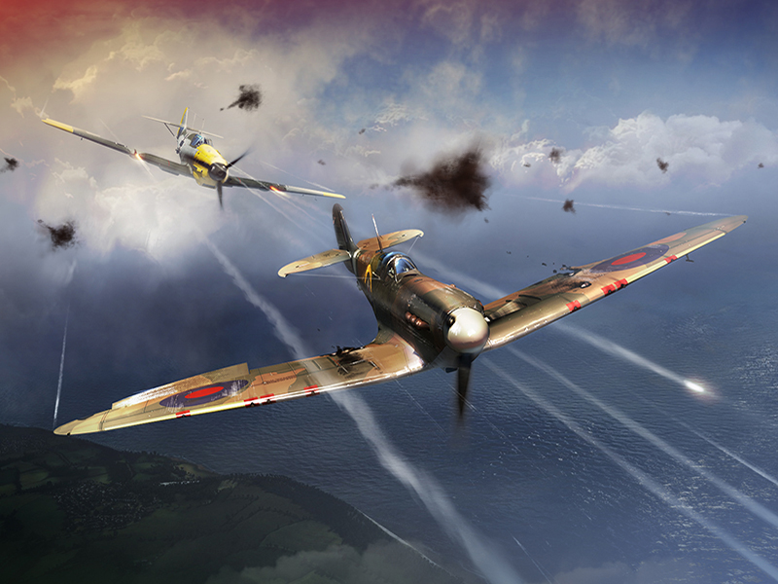
14. What event in 1912 shook society’s confidence in our ability to master nature with technology?

The century following the defeat of Napoleon in 1815 had been one of relative peace (at least in Europe), prosperity, and amazing technological and scientific progress, particularly during the 40 years that followed the 1871 Franco-Prussian War. In America they called it the “Gilded Age”, and in Europe it was the “Belle Epoque”. The spirit of the times was one of optimism and an expectation of relentless progress, perhaps best exemplified at the Chicago World’s Fair in 1893 (I must get around to the 1893 Fair at some point in here).

In 1912, the latest and greatest product of our technological prowess was RMS Titanic. The largest moving object ever created at the time of her launch, the 50,000 ton Titanic seemed to be a perfect example of our mastery over the elements, and the triumph of our science. She was, after all, virtually unsinkable.

The loss of Titanic was thus a shock to the system. Were we hubristic? Over-reaching? Had nature just taught us a lesson? Maybe we couldn’t do anything. Maybe progress wasn’t relentless. Two years later, the First World War began, and nailed a spike through the heart of the Belle Epoque. At the time, many wondered whether the sinking of Titanic had been a grim portent.

All good things come to an end.

In many ways the preceding decades of peace had been little more than an interlude during which happy illusions could be cultivated and enjoyed. Perhaps Titanic had been the flagship for those illusions, a totem of a sort of willful blindness, while behind the scenes, all through the Belle Epoque, the rival powers of Europe had been arming themselves to the teeth, consolidating alliances with each other, and preparing for conflagration. The British Empire, the German Empire, the Austro-Hungarian Empire, the Ottoman Empire, Russia, and France and her colonies, together built an elaborate set of rival power blocks tied together by treaty obligations. How could there not have been a war?

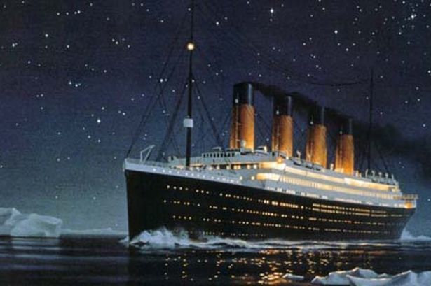

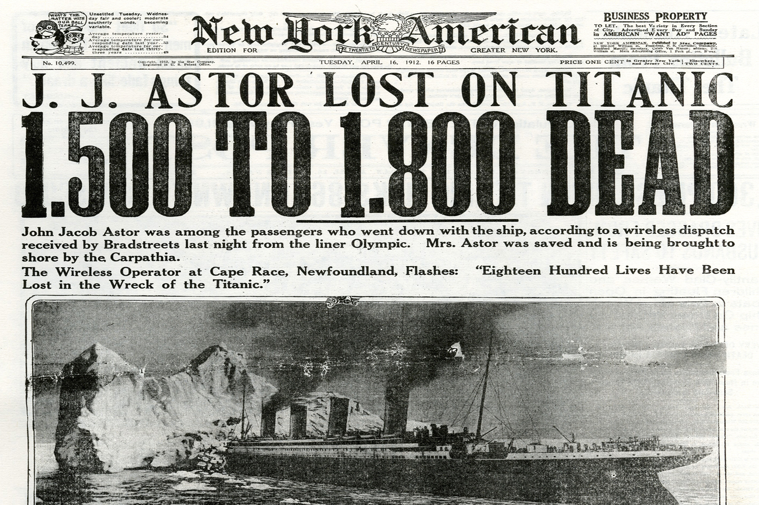
15. If You were at the Chicago World’s Fair in 1893, you almost certainly would have wanted to take a ride on something that had been invented as an attraction specifically for the fair. What?

See? I did come around to the Chicago World’s Fair, or “Columbian Exposition” as it was then billed. Chicago’s fair came on the heels of an earlier one in Paris, for which the Eiffel Tower, now an inextricable element of the Parisian landscape, was a controversial exhibit built to serve as the entrance to the fair. A lot of people thought it was ugly!

Planners in Chicago wanted to have something similarly grand and improbable at their fair, and commissioned an engineer named Ferris to construct a gigantic wheel for people to ride on. The Ferris Wheel stood 250 feet tall, and carried passenger cars big enough to hold 60-70 paying customers. It was a sensation, and helped the Chicago fair make it into the black.

What a fair it was. I could go on and on. They constructed a whole neo-classical city down on the lake, temporary structures done up to look like marble. The White City, as they called it, was full of huge exhibition halls, and had attractions like a moving sidewalk, and canals plied by electric boats. At night it was lit up by incandescent light, using Tesla’s A/C system, the first large application of outdoor electric light that anyone had seen. A beer tasting contest won Pabst its Blue Ribbon, and people munched on a new snack called “Cracker Jack”, wearing glasses with tinted lenses on sunny days. It was a thing of wonder and beauty, and by the time the fair was closed, after six months of operation, more than 27 million visitors had passed through.

I’d need a whole book to extol the wonders of that fair. If I had a Wayback Machine, it might be the first thing I’d visit. 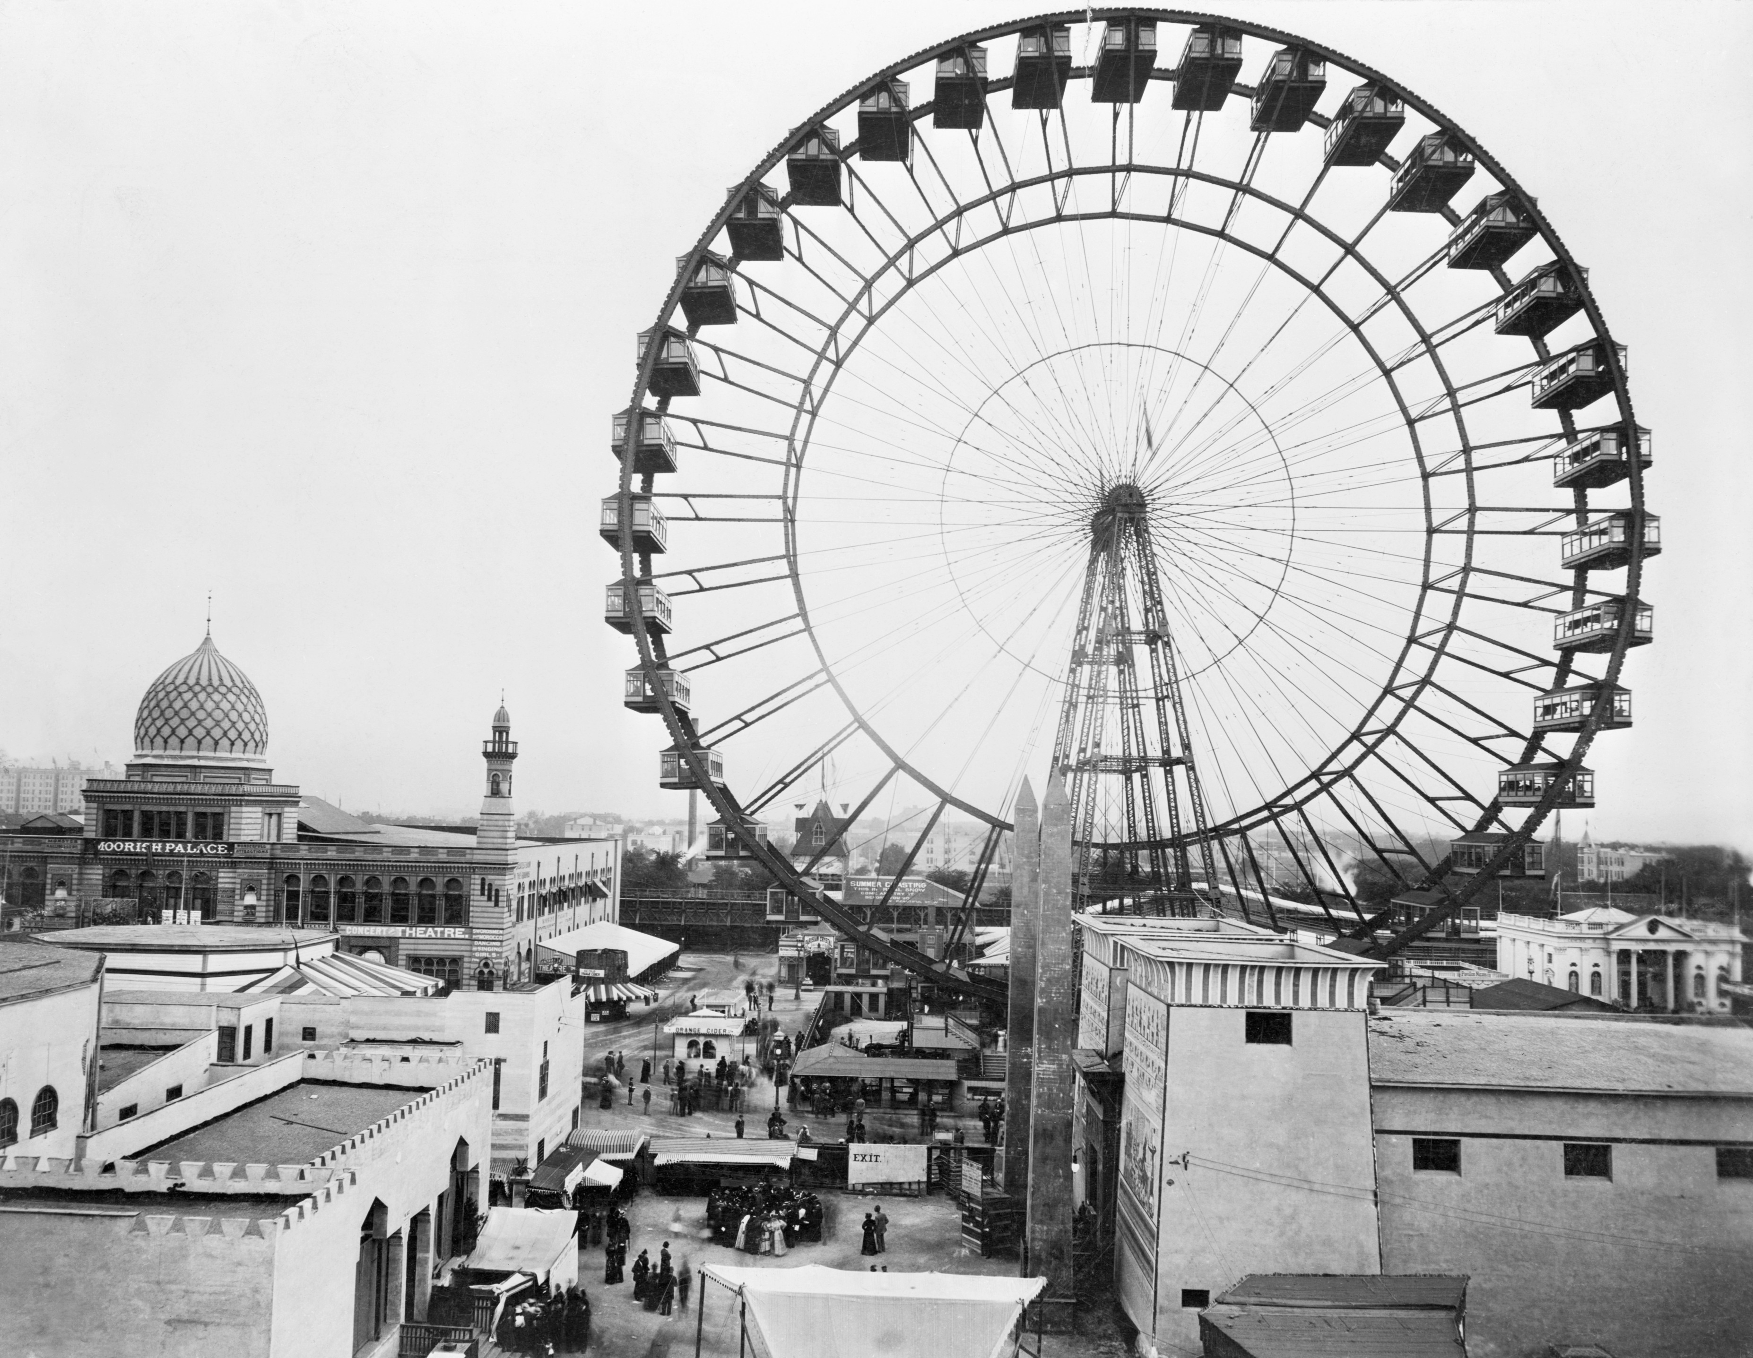

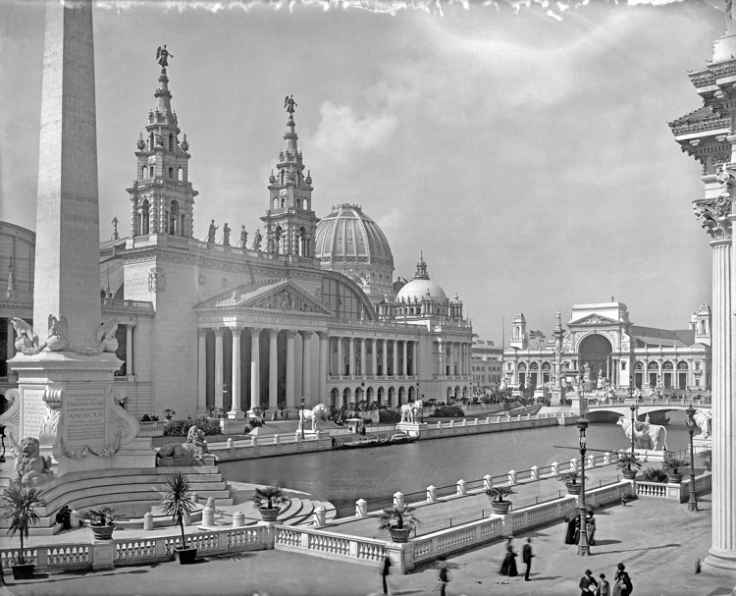

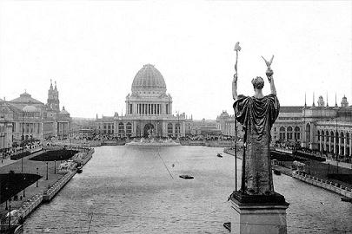

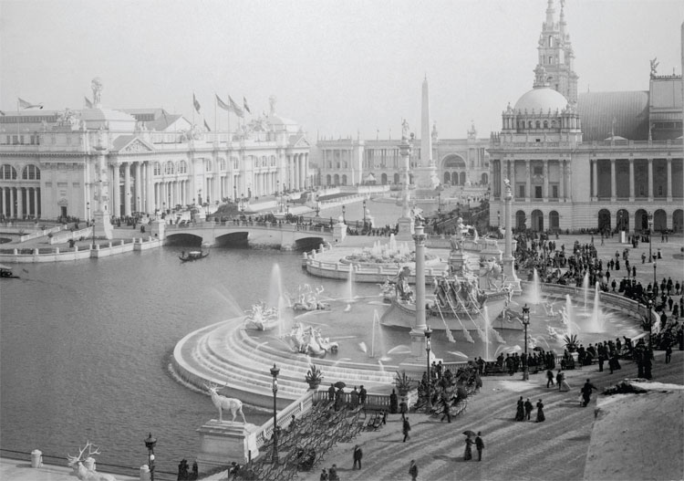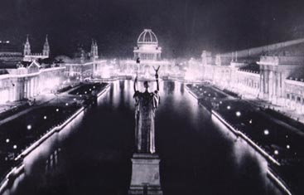

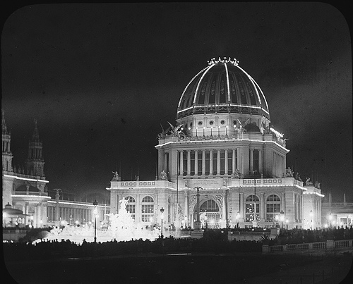

16.What’s Gerrymandering?

It’s the redrawing of electoral districts by politicians, designed to give them safe seats; they make sure that their district contains only voters who will vote for them. It leads to districts with strange and irrational shapes, as they struggle to draw the borders so as not to embrace the wrong sort of voters. This is a huge problem in the US, where a significant majority of Congressional seats are “safe”.

The name derives from a New England Governor named Gerry who, some time in the early 19th century, had his district drawn on the map in such a convoluted way that it looked kind of like a salamander. It was a Gerrymander!! Today they tend to look like Rorschach Test ink blots.

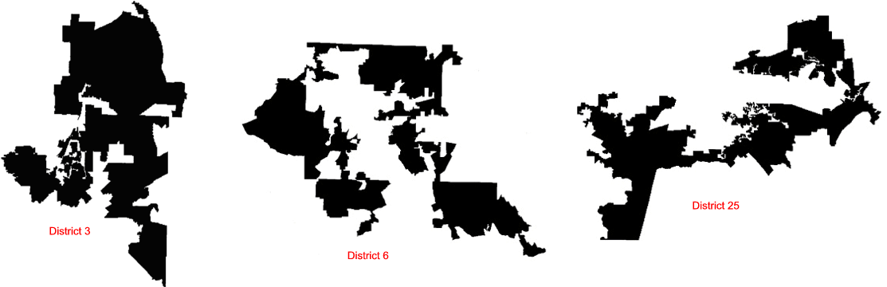
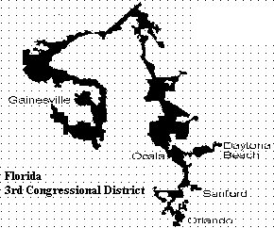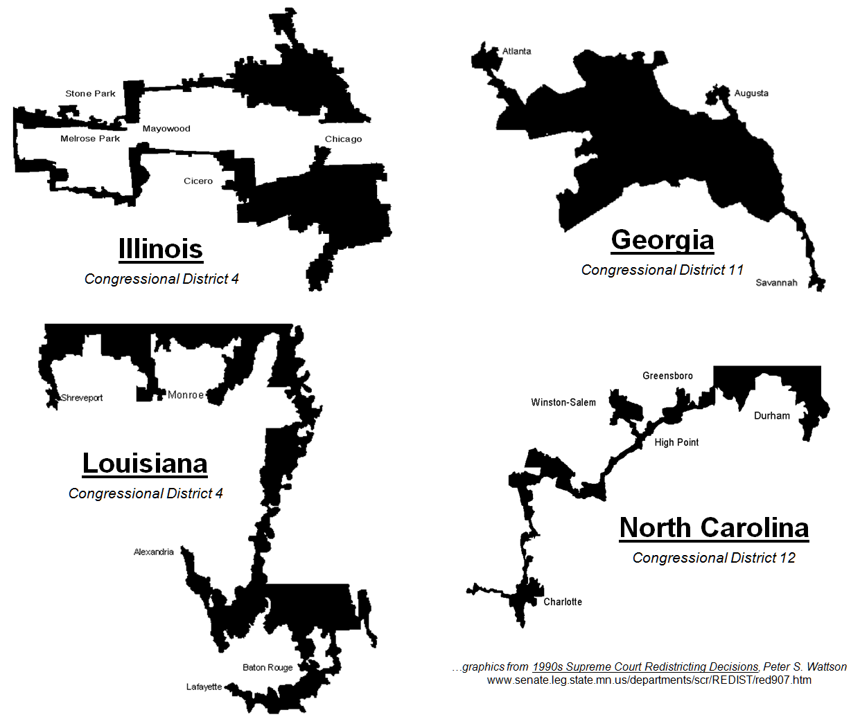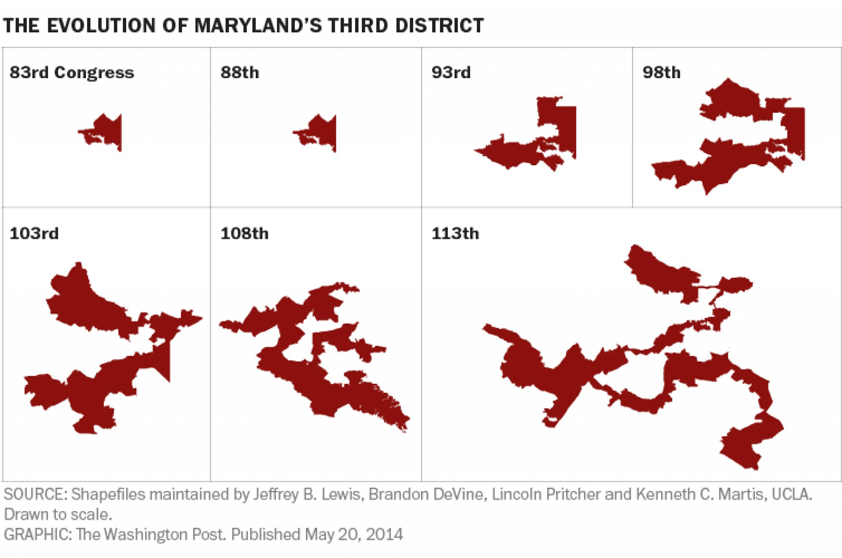
17. What is the tallest building in the world today?

The title is held at present by the Burj Khalifa in Dubai, which at over 2,700 feet has a spire about 1,000 feet higher than the new WTC 1 in New York.

The Saudis aim to top that with a building called the “Kingdom Tower”, which they say will be a kilometer high, about 3,300 feet.

Who knows what the Chinese are up to.

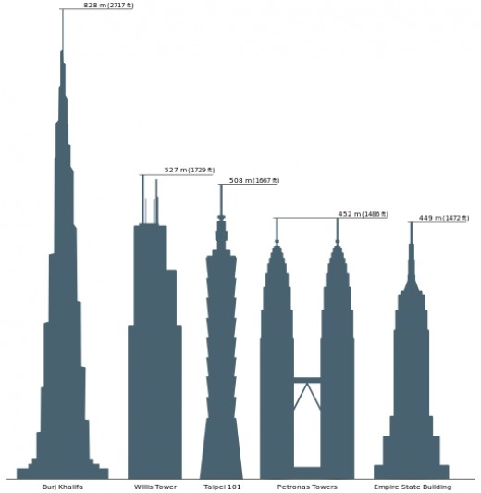

18. Who had the first “Eureka!!” moment, and why?

Archimedes, the ancient Greek scientist. He had been posed a difficult question: how do you measure the volume of a complexly shaped object? A local potentate named Hieron of Syracuse had asked because he wanted to know the volume of a golden crown he’d commissioned. He had given the goldsmith a gold brick of X weight, and the crown that came back weighed the same as the brick, but had the goldsmith cheated and used lighter silver mixed in, keeping some of the gold for himself? Had Hieron been bilked? If so, it would take a greater volume of silver to equal the weight of the gold, and the crown should be bigger than the original brick in total volume. So how do you gauge the volume of a crown?

The story goes that Archimedes cracked the problem when stepping into his tub. The water level changed and he realized in a flash that the volume of water displaced by an object, whatever that object’s shape, would be equal to the volume of the object itself.

Archimedes is supposed to have exclaimed Eureka!, which roughly translates to “I’ve found it!” Dump the crown in a bucket and we’ll see! Turns out Hieron had been cheated, too.

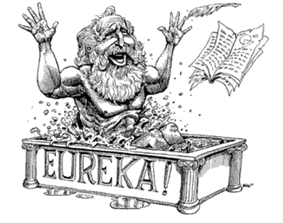
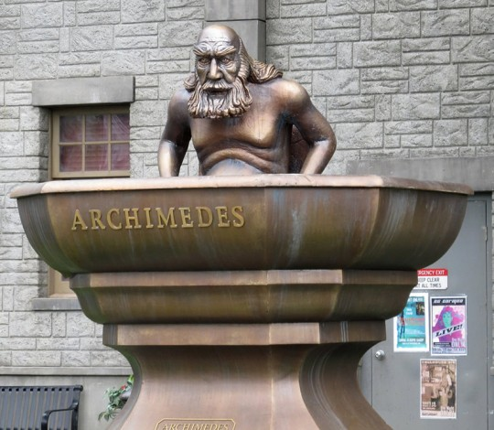
19. How old are the pyramids at Giza (roughly)?

About 4,500 years. When Antony and Cleopatra were vying with Caesar for dominance, they were closer in time to us today than they were to the architects of Giza. There’s an old Arab saying that goes something like “all men fear time, and time fears only the pyramids”.

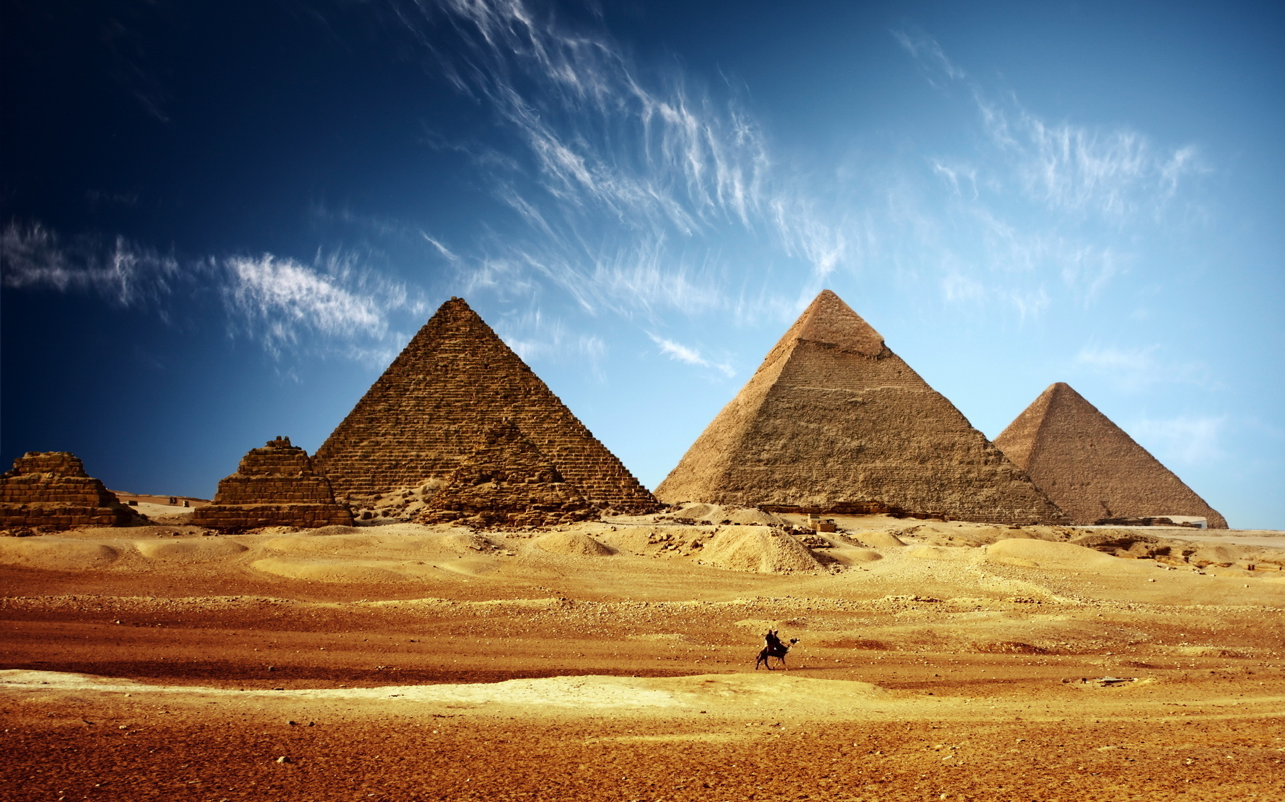
20. How long ago did the last wooly mammoth die?

The great Pleistocene extinctions in which Mammoth and all kinds of weird and wonderful things died off occurred only about 10,000 years ago. However, evidence now suggests that an isolated population lingered on at an arctic backwater called Wrangel Island, just North of Russia and near Alaska. The last Mammoth may have held out there until 1600 BC, at which point the Pyramids at Giza were already a thousand years old.

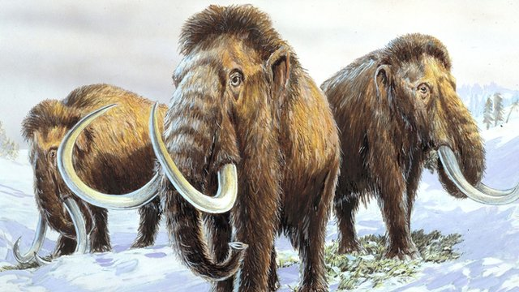
21. What happened at Thermopylae?

Thermopylae, the “Gates of Fire”, is where the famous Spartan King Leonidis and his army of three hundred was at the vanguard of an allied Greek force that held out against invading Persians under Xerxes I. A huge number of Persians is thought to have attempted the conquest, perhaps more than 150,000. This same Greco-Persian war (the Peloponnesian War) saw a force of Greek warships triumph over more than a thousand Persian triremes at the Battle of Salamis, another (hey! Who coulda guessed?) candidate for largest and most decisive sea battle in history. The Persians lost upwards of 300 ships, and shelved forever dreams of conquest in Greece and beyond. The impact upon the arc of Western Civilization remains incalculable.

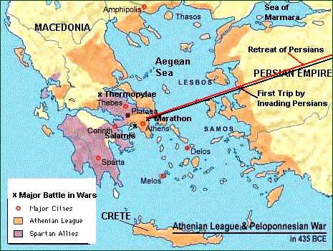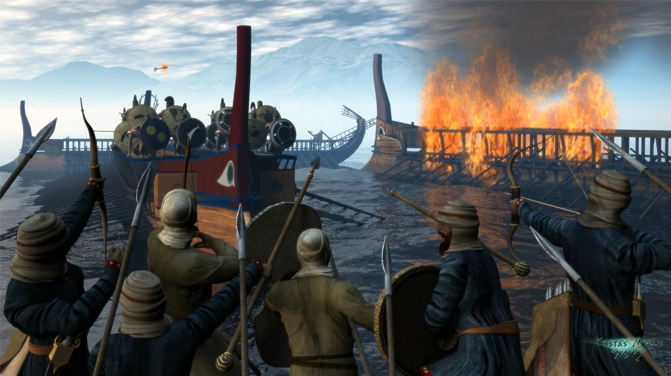
22. What ancient figure is said to have wept, because there were no worlds left to conquer?

Alexander the Great. The Macedonian boy-genius had, by his early 20’s, conquered territory stretching all the way East to include India, and was wondering what might lay beyond.

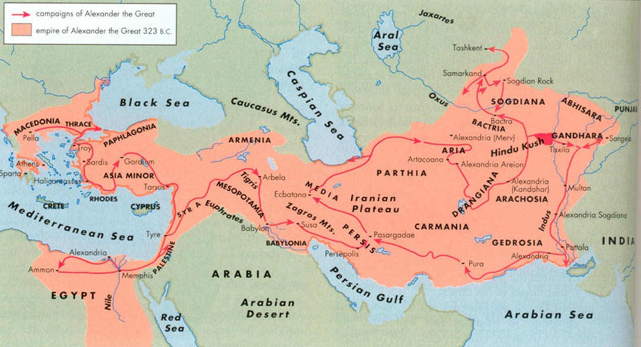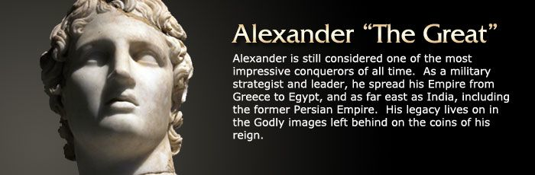
23. Why are there boulders as big as houses scattered all over North America in places where they don’t belong?

They’re called “erratics”, and they tend to sit in improbable spots, looking like some giant has tossed them there. They often aren’t made of local rock, and clearly came from elsewhere. Now, this is entirely baffling until you start to uncover evidence of great upheavals in the past when massive sheets of ice covered the land and ground inexorably forward, bringing with them anything they encountered. When the glaciers later retreated, they left their geological trash behind.

We still aren’t quite sure why ice ages wax and wane, but now that we can look at the surrounding geography with the proper lens, the evidence of their occurrence is everywhere, and overwhelming.

Maybe some day soon…

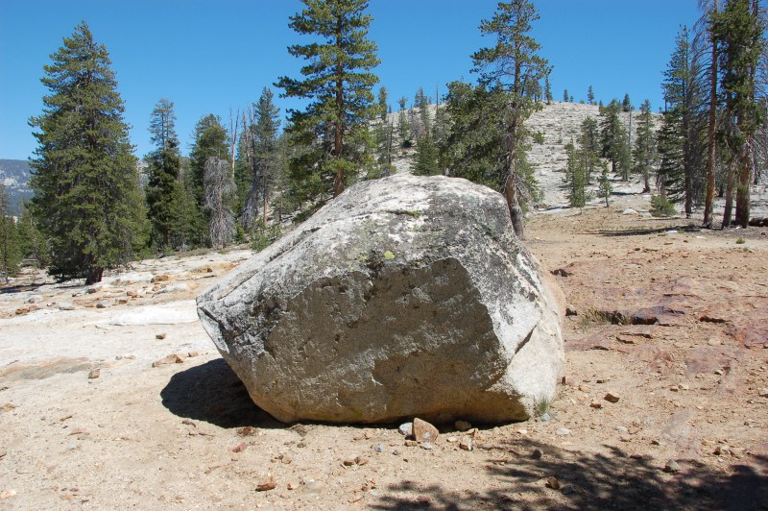
24. Who told the world that there had been a nuclear reactor meltdown somewhere East of the Iron Curtain?

The Swedes. When Chernobyl melted down in 1986, the Swedes were running their own reactors at the utmost level of safety and proficiency. There were sensors all over their plants to detect the products of nuclear reactions, which, if they could be found in the air, or on people’s clothing, meant they had a leak somewhere and needed to do something fast.

An employee at the Forsmark reactor north of Stockholm, Sweden’s second biggest reactor, tripped an alarm on the way to the washroom. Uh-oh. What was the source? Where was the leak? There must have been a few anxious moments when no source of the radioactivity could be found – everything was apparently running fine, no problems. Yet, instruments don’t lie. Something was leaking out of somewhere. Perhaps somewhere else, outside of Sweden?

So they analyzed the radioactive particles that they found lying all over the lawn around the plant, and realized they were the reaction products of a different sort of power plant from their own. They seemed to have resulted from processes common to Soviet style reactors, and then, the penny dropped.

The Soviets, who were trying to keep mum, realized the jig was up and admitted the meltdown was theirs.

Below is a recent photo of Claes-Göran Runermark, the fellow who first tripped the alarm.
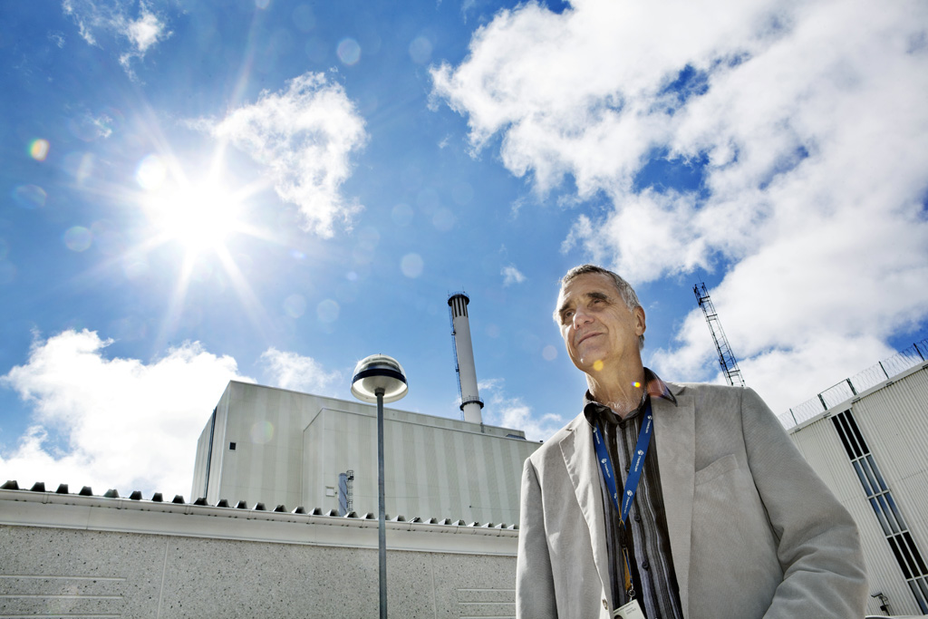
25. What was “the Bloop”?

The “Bloop” is one of the loudest sounds ever recorded by oceanographers. It was captured in 1987 on hydrophones monitored in the Pacific by the US National Oceanographic and Atmospheric Administration. It was like nothing ever recorded before, incredibly low in frequency and astonishingly powerful. Nobody had any explanation for it. Something down there had just made a huge and unprecedented noise.

Speculation ran rampant that the Bloop was the call of a giant and as yet unknown creature of the depths, but it’s now thought to have been the sound of massive Antarctic ice sheets grinding together. It sounds more like some sort of creature when it is sped up on replay, as it often was by proponents of the sea monster theory.

http://www.wired.co.uk/news/archive/2012-11/29/bloop-mystery-not-solved-sort-of

No giant monster. Frig. It had been fun imagining the existence of something huge like the Bloop Monster pictured below.

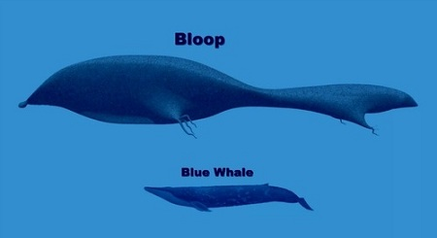

26. What’s so special about a guy named Yuri Gagarin?

Repeat question! He was the first man in space, launched by the Russians into a full orbit of the Earth in April, 1961.

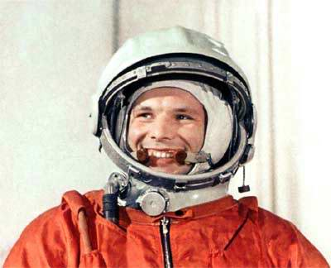
27. What was the name of the first artificial satellite to orbit the Earth?

Another Soviet first, it was called “Sputnik”. It didn’t do anything except transmit a beeping radio signal. That wasn’t the point. The point was that the Commies had a rocket big enough to launch a significant payload into orbit. This meant they certainly had the ability to put a nuclear warhead on top of a rocket and launch it on a ballistic trajectory right to downtown Poughkeepsie. And there it was, overhead, scooting by and beeping away. It might as well have been thumbing its nose at us while shouting “Nyah Nyah Nyah, Nyah Nyah Nyah”. We were losing the battle for the high ground! The Commies were taking over the sky above our helpless heads!!

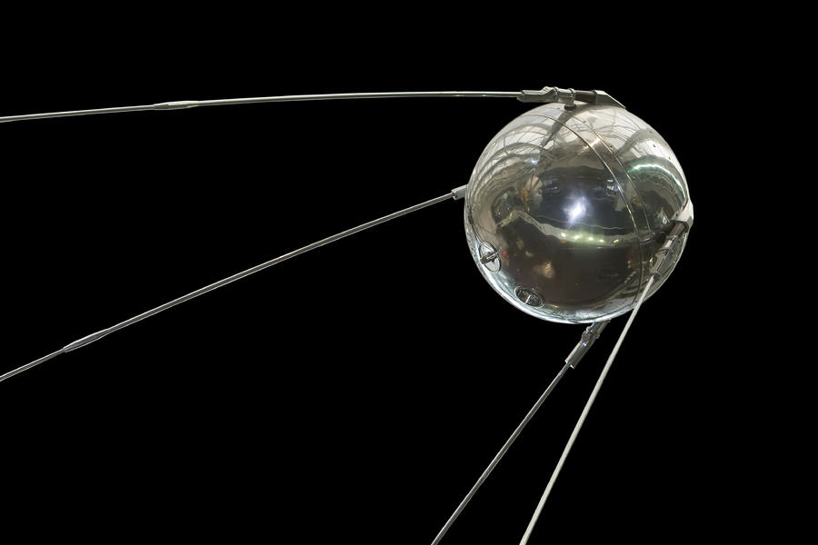
28. What was the number of the last Apollo mission?

Apollo 17 was the last. There were supposed to be more, and they were just beginning to do hard science, with new experiments. The later missions even had a sort of electric dune buggy to haul the Astronauts further afield to gather samples and deploy instruments. But Congress wanted to move on, and get back to the old budget priorities of pork and feathering nests in their districts. Moon shots cost serious dough, and anyway, why were we still going, we already beat the Russians there and won the Space Race. Why keep backing up and running across the finish line again?

Huh? What’s that? For science? F+#k science. Frigging egghead.

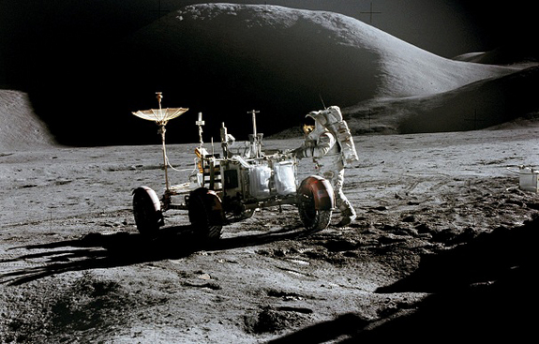

29. What did Alfred Nobel invent, prompting him to bequeath his fortune to create the Peace Prize that bears his name?

He invented Dynamite, as a safe way to deploy nitro-glycerin, then the chemical of choice when digging tunnels, mine shafts and such. Nitro-glycerin is extremely volatile and very very dangerous. The poor slobs who pulled the glorious mission of planting the charges, often poor immigrants, were about half as likely to blow themselves up as emerge unscathed. There had to be a better way, and Dynamite was it.

Nobel was a heck of inventor, who held hundreds of patents, and he was just fine with manufacturing weapons, too, but Alfred became dismayed at the way people kept calling him a merchant of death. Sure, his advanced explosives, like Dynamite and Gelignite, could be used as weapons. That didn’t make him a bad man. Did it?

It was almost an act of contrition when he willed his money to go towards the awarding of prizes for achievements toward peace, as well as in the sciences.

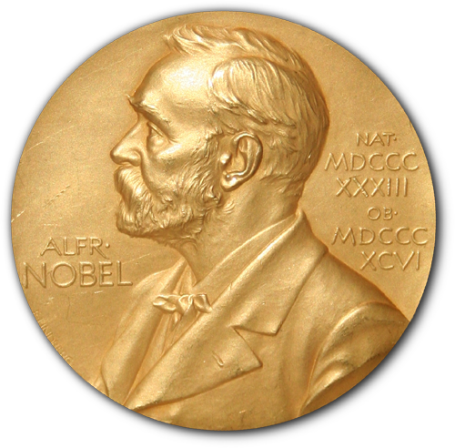
30. Molecular biologists named Watson and Crick figured out something momentous and fundamental – what?

They figured out the structure of the DNA molecule – the double-helix.

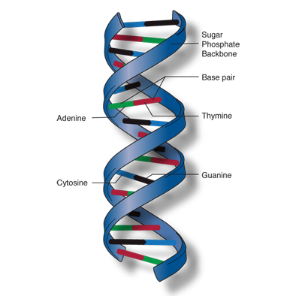
31. What was the first antibiotic?

Penicillin, which is derived from a fungus, and was observed to be killing off bacteria in a Petri dish where fungal spores had landed, quite by accident. Or so the story goes, as told by Alexander Fleming, the doctor who said he made this discovery in 1928.

The difference antibiotics have made in our lives is vast, but we have overused them. Bacteria have been kicking around this planet for over 4 billion years. They didn’t manage that by being unable to adapt, and they are now adapting to resist even our most powerful drugs. The race is on to develop new methods to keep bacteria at bay, new chemicals, genetically engineered predator cells, nano-bots, anything we can come up with. A return to a world in which a scraped knee could kill you just doesn’t bear thinking about.


32. What was a Stanley Steamer??

In the early days of the horseless carriage, cars to you and me, the best method of propulsion was a matter of debate. Early on there were some electric models. The Stanley Motor Carriage Company thought a better answer might be steam power. Their cars actually had boilers to produce steam that would make the pistons go up and down.

Internal combustion won out, of course, but for a while the Stanley company was quite successful, and the cars did work – one of them set a world speed record in 1906, when it took about 30 seconds to go a mile. That’s two miles a minute, 120 MPH!

Steam power wasn’t what we would call “green”, since you still burned fossil fuels to heat the boiler, but there is something quaint and appealing about the Stanley Steamers. If you have kids, you may have watched the Pixar movie Cars. In the little town where the protagonist ends up (Radiator Falls?), there’s a statue in the town of an important personage named Stanley. That’s a Stanley Steamer.

Today the name lives on as the trade-mark for a frickin’ carpet cleaning franchise.

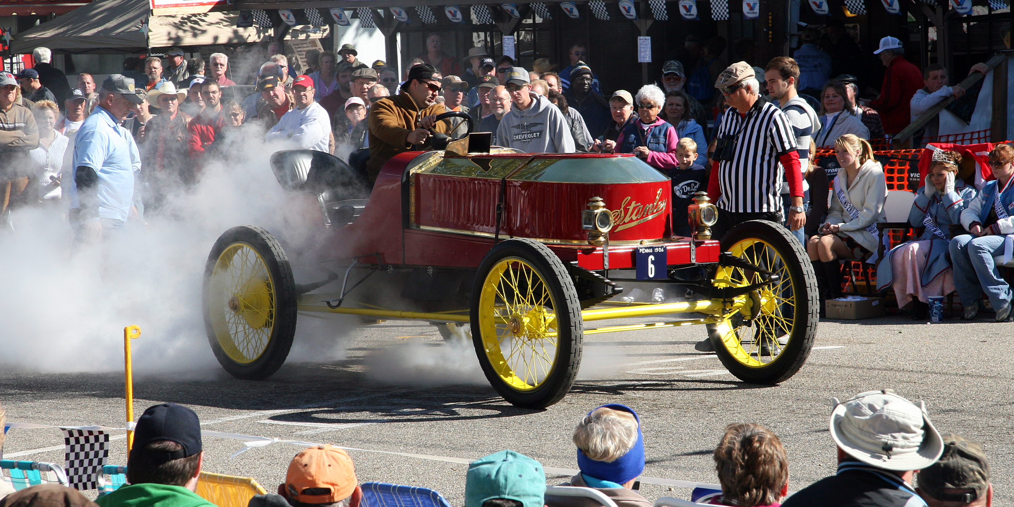
33. What does a group of monks claim to have stored for safekeeping in a little town in Ethiopia?

Believe it or not, the Ark of the Covenant. Yes, that Ark, the one that enclosed the original slabs of stone on which the Ten Commandments were transcribed by God, the box that contained the power of God and swept all before it as the Israelites warred with their enemies. The Ark that was stored in the Temple of Solomon, and disappeared after Babylon sacked the Temple over 2500 years ago. The one Indiana Jones was seeking. That Ark.

A journalist named Graham Hancock got interested in the topic, and before long became obsessed with it. He chronicles his efforts to trace the Ark’s movements in an entertaining book called The Sign and the Seal. Following a trail of various clues, old legends, local folk stories, and the writings of those who’d searched before him, he ended up in Ethiopia, in a town called Axum (or “Aksum”).

Ethiopia is an intriguing locale from this perspective because it once hosted a very primitive and ancient sect of Judaism – during a famine years ago, Israel airlifted most of them out. Were these the folk that carried the Ark to safety before the Babylonians could get their grubbies on it?

Hancock followed the bread crumbs all the way to the doorstep of an order of Christian Monks who were quite happy to tell him that yup, the Ark of the Covenant is right in that structure there. Could Hancock see it? Certainly not. What did it look like? You’ve got a Bible, don’t you? Look it up. Why do you never display the Ark? We need to protect the laity from it. You mean protect it from the laity? No, protect the laity from it. The Ark is powerful, and dangerous.

And there it sits. Others have tried to get the answers, including a writer for Smithsonian Magazine in 2007, see link below. His experience exactly parallels Hancock’s. Yes, yes, we have it here, all safe and sound. No, of course you can’t see it.

Have they really got the Ark? Probably not, of course, but they are quite sincere in their belief that they do. Also, no historian doubts that there really was an Ark in Solomon’s Temple, and no one would have dared destroy it. It must be out there somewhere.

http://www.smithsonianmag.com/people-places/keepers-of-the-lost-ark-179998820/?onsite_campaign=photogalleries&onsite_medium=internallink&onsite_content=Keepers+of+the+Lost+Ark&page=1

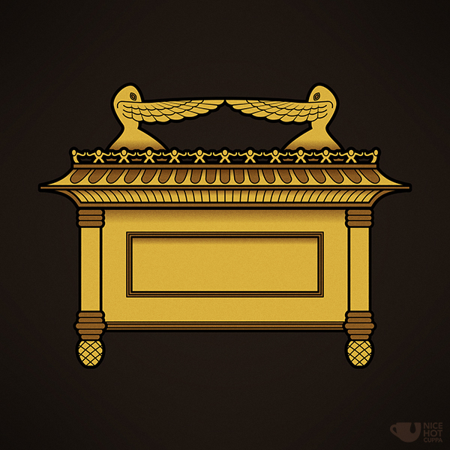
34. Why is a place called Runnymede so important to all of us in the Western World?

Runnymede is a marshy area beside the Thames river in London, and for reasons which elude me was the place selected by a group of nobles who, in 1215, confronted King John and told him he bloody well was going to sign a parchment called Magna Carta, Latin for “Great Charter”. It protected certain members of the upper class from illegal imprisonment, limited feudal payments to the Crown, and addressed a number of other grievances.

In itself it didn’t really accomplish much, but it was the example of the thing that mattered. A King, placed on his throne by the will of the Almighty and supposedly wielding absolute and arbitrary power, had been told to sit down, shut up, and sign. On the centuries-long road ahead, as the rest of Europe descended into absolutism and tyranny, the English repeatedly took measures to keep the Crown in check. They insisted on Parliaments to authorize taxes, fought a civil war and killed their king, Charles I, when he sought to reestablish Royal prerogatives – shivers down the spine of every monarch on the continent – and kept pushing back until they had created that most novel of concepts, a Constitutional Monarchy, in a realm governed by the Rule of Law, supreme over even the King.

Therefore, every freedom we enjoy today owes something to Magna Carta.

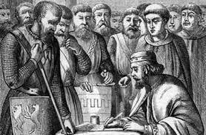
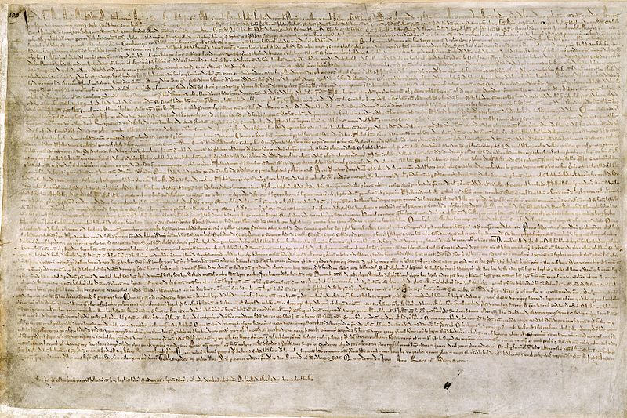
35. What was Ontario called before it became “Ontario”?

Upper Canada. The name lives on in the self-governing body to which we lawyers belong, the Law Society of Upper Canada.

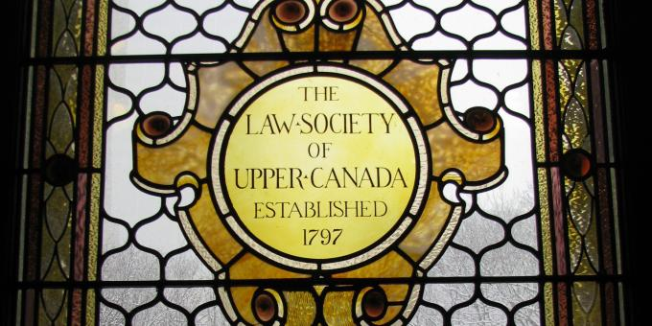
36. Why is NASA interested in getting to know more about Saturn’s biggest moon, Titan?

Titan is about big enough to be a small planet in its own right, and is the second largest moon in the Solar System. It has a thick atmosphere composed mostly of Nitrogen (like ours is) and its surface is covered to a large extent in rivers, lakes and deep seas of liquid methane. NASA is proposing to land – splash down? - a robot submarine to explore Titan’s oceans, a fantastic thought.

The interest arises in part from discoveries of strange microscopic organisms here on Earth that live in hostile environments that are too cold, hot, acidic, or dry to support life, or so we always thought. We call them “extremophiles”, and as we figure out how they work, we’ve discovered some exotic metabolic traits that lead us to wonder whether we’ve been too narrow-minded about the sorts of environment that could sustain living things. Does there have to be water? Methane might be capable of supporting life. Methane is a hydrocarbon, but also an organic solvent, just like water. Chemically, it’s plausible. For all we know there are weird armoured fish in Titan’s oceans, or maybe smaller things equivalent to terrestrial micro-organisms. If so, then we’d have proof that life can develop in conditions that we always assumed were too harsh, and that makes it a near certainty that life is elsewhere out there, maybe everywhere. Let’s go see!

http://www.nasa.gov/content/titan-submarine-exploring-the-depths-of-kraken/#.VO-8oSnFTKE

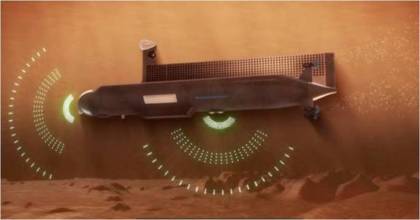

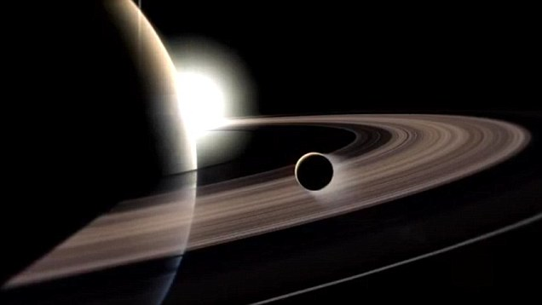

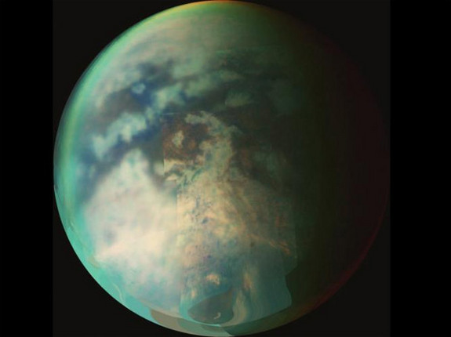

37. If we improve education and set higher standards, can we raise the median IQ of the general public?

No. Don’t get me wrong, we can make people more knowledgeable, better at critical thinking, better at problem solving, and altogether smarter, but you can’t raise the median IQ. By definition, in every sample, the median is designated as 100. No matter how well everybody does, the system takes the middle score and calls it “100”. The results of a set who have taken an IQ test are always plotted like this:

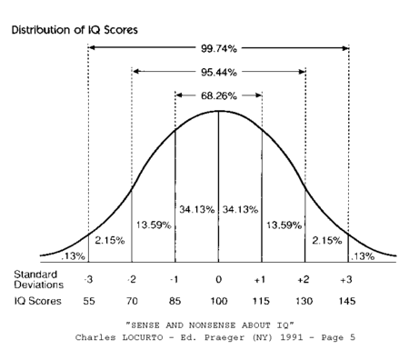
38. What is said to be almost literally eating the entire US South?

An imported Asian plant called Kudzu, which was initially prized as a decorative element in gardens and such. Kudzu is an aggressive climbing vine. It tries to turn every environment it inhabits into a monoculture, nothing but Kudzu. All Kudzu, all the time. Kudzu, Kudzu, and more Kudzu, with a side of Kudzu.

It’s spreading like wildfire across the South-Eastern US, annually gobbling up hundreds of thousands of acres, year after year, inexorably expanding its dominion, despite every effort to keep it under control. It’s become known as “the vine that ate the South”. Right now, Kudzu dominates about 7-8 million acres, taking residence along roadsides, up telephone poles, along the lengths of power lines, all over parking lots, even covering entire buildings. It climbs trees and chokes forested areas.

Slowly, its range is moving North. It’s up into New England, and it isn’t clear that it will be unable to adapt to colder conditions at higher latitudes. The stuff can grow a foot a day. It’s like The Day of the Triffids.

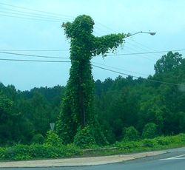




39. What do the letters in the famous equation “E=MC squared” stand for? Whose equation is it?

Einstein’s famous equation means energy = mass times the speed of light squared. This means that matter and energy are two sides of the same coin, and that even quite small amounts of matter contain gigantic stores of bottled-up energy.

I once heard a physicist say that he’d know when we’d developed the final equation that ties together all the remaining mysteries of the universe. You’ll be able to fit on a tee-shirt.


40. Who is usually credited with inventing the Radio? Who really invented it?

We all know Marconi invented the radio, except he didn’t. Tesla beat him to it, and was listening to distant lightning and sounds from space before Marconi quite had it all worked out. Tesla was capable of radio transmission by 1895, and demonstrated a remote controlled toy boat at Madison Square Garden in 1898. Nobody understood what magic permitted this, but it was simply radio. Marconi was just a bit behind him.

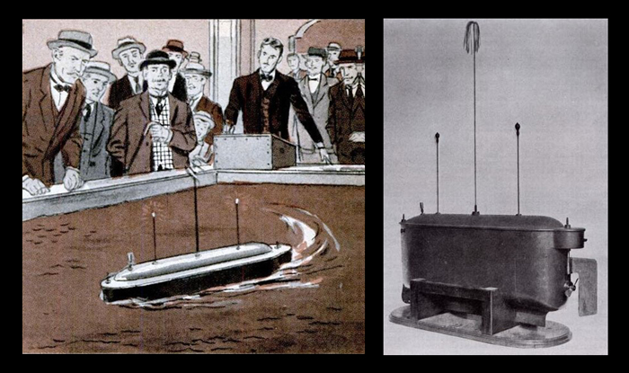
41. Is it true that people only use 10% of their brains?

NO. It isn’t. I don’t know where this crap started, but no, nature didn’t endow you with a huge brain just so 90% of it could sit idle. Actually most of your brain is in use constantly.

A similar load of hooey contends that people are 98% water. We are indeed water-based life forms, but the percentage is around 60%, maybe 65. Jellyfish are 98% water.


42. What is “herd immunity”?

A very live topic these days. “Herd immunity” is the immunity to disease likely to be enjoyed by the entire population once a certain percentage of them are vaccinated against it. That percentage is always high, between 80 and 95%, depending upon the contagiousness of the disease. Not everyone can get vaccinated, infants can’t, those with certain medical conditions that involve badly suppressed immune systems can’t, but that’s OK so long as we get to the level required. At that point the odds of catching the bug are reckoned to be practically 0. If you’re not vaccinated, but almost everyone else is, the chain of contagious infection is nearly impossible for a bug to establish.


43. What was Piltdown Man?

Piltdown Man was a fossil hominid discovered in Piltdown, England, early in the 20th century. It was very exciting to paleontologists, because it was previously unknown, and had features that suggested the species was an important transitional step between primitive hominids and modern humans. The jaw was quite ape-like, but the cranium was almost human. This made Piltdown Man a candidate for the “Missing Link” between ape-like creatures and humans.

Alas, it was a hoax. The cranium was from a modern human, the jaw from an orangutan. The forgery wasn’t exposed until mid-century, and it isn’t clear how many were in on it. The reconstructions of the purported fossils were probably innocent attempts by honest scientists to take the material provided, and put it together as best they could. They hadn’t excavated the fossils themselves, but that was OK, and no reason to suspect fraud. Paleontologists often worked on fossils that others had stumbled over in their line of work. It wasn’t strange for miners or construction workers to find weird bones, and send them off to the experts. The famous Archaeopteryx fossil, the one that was obviously as much reptile as bird, was discovered by German workers in a limestone quarry.

The instigator was a prankster named Dawson who worked in a gravel pit. I guess he thought it was great sport to bamboozle the propeller-heads.

There were relatively few hominid fossils known to science when the Piltdown skull was reconstructed. Subsequently, fossils found in Africa established a line of evolution that made Piltdown look like a strange and highly unlikely aberration. It didn’t fit within the evolving family tree – nothing with ape-like canines had a brain that big.

Piltdown Man has been called the greatest hoax in the history of science. It succeeded because it was just what scientists had been looking for, the coveted Missing Link.

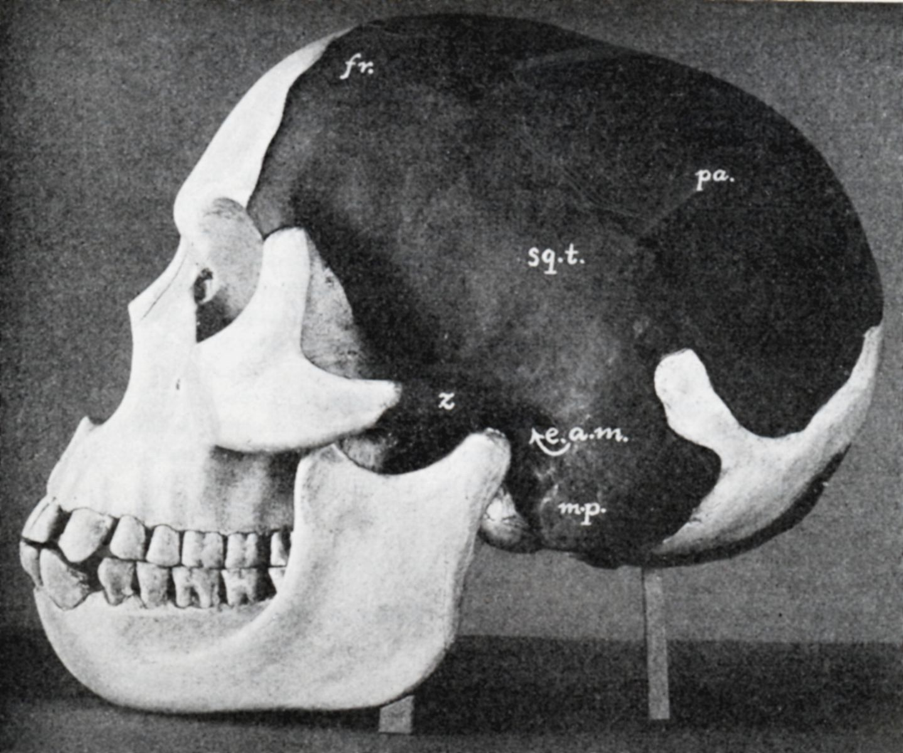
44. Approximately how many battleships serve today in the US Navy?

Trick question! Not a one. There are none in any other navy, either. Sloppy journalists often mix up the term “warship” with “battleship” – war, battle, same thing right? – but a battleship is a very special type of warship. The last American battleships, beautiful things of the Iowa class, serve as floating museums in places like Pearl Harbour.

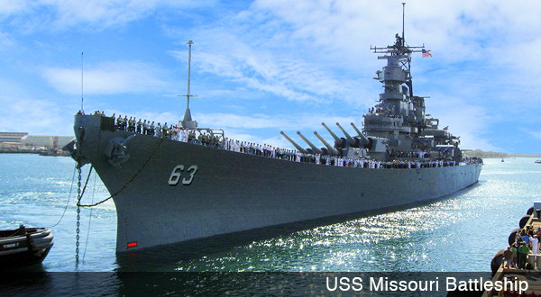

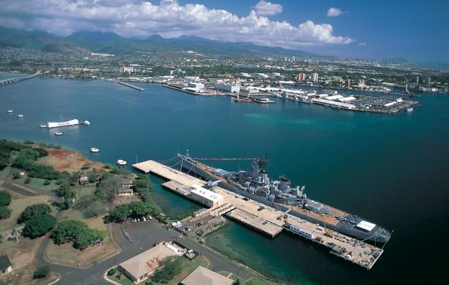
45. Where is the Strait of Hormuz, and what’s important about it?

The Strait of Hormuz is a narrow sea exit from the Persian Gulf, and perhaps the most strategic waterway on the earth. All the oil from the Middle East exits through this bottleneck (a “chokepoint” to we naval types), an average of 12-15 huge tankers a day, every day, amounting to maybe 40% of the oil traded on the global market.

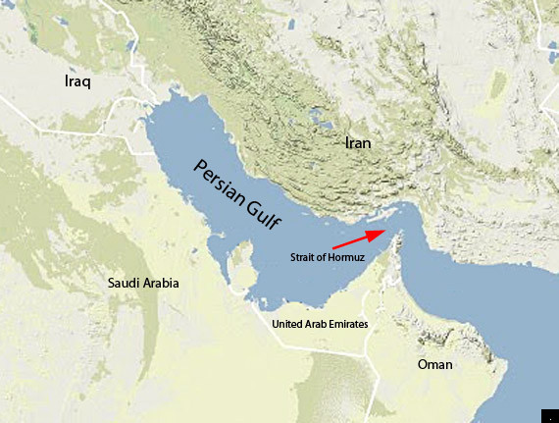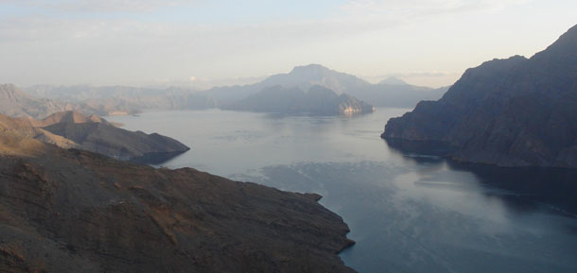
46. What animal can run the fastest, and about how fast?

The Cheetah is still usually regarded as the fastest, and is usually said to be able to sprint at 70 MPH or so. A number of unique adaptations permit this, including greyhound like bodies built to reduce air resistance, the only feline claws that don’t retract, but rather act as cleats, and a flexible spine that bends upwards into a u shape, allowing them to take longer strides.

Cheetahs have explosive acceleration, 0-65 in about three seconds, which is better than most any sports car, but they lack stamina. After a few hundred yards, if they haven’t caught their target, they give up.

http://www.core77.com/posts/28117/Designed-for-Speed-Cheetahs-Do-0-60-Faster-Than-a-Freaking-Ferrari

There are varieties of antelope in North America, like the Pronghorn, that are almost as fast, faster than they need to be to escape any of the predators they may encounter. This speed may be an evolutionary holdover from having adapted to escape much faster, but recently extinct predators like Dire Wolves (yup, it’s not a Game of Thrones invention, there really were big Pleistocene lupines called Dire Wolves). Gazelles are wicked fast too, but no mystery there. They share range with Cheetahs.

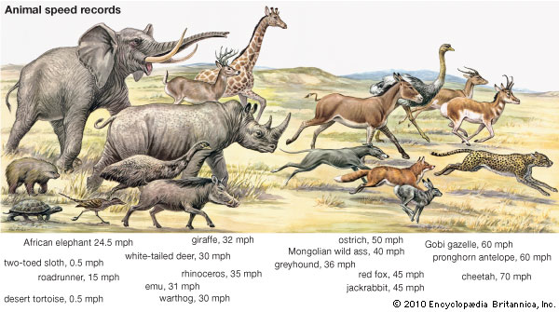
47. What’s a “swim bladder”, and what is it good for?

A swim bladder is an internal pouch in which fish store air. It’s like having a balloon inside, and it’s how fish maintain “neutral buoyancy”, and are able to float without sinking or rising. They hover in water, really, and don’t require forward motion to keep them at a chosen depth. By changing the size of the bladder through muscular contraction and expansion, they can change the volume of water they displace, and become either lighter, heavier, or exactly the same weight as the liquid they live in.

More primitive fish, like sharks, don’t have them. If a shark stops moving, it sinks to the bottom.

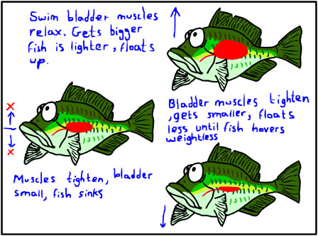

48. Are there air-breathing animals that don’t have lungs?

Yeah, insects, for example, don’t have lungs. They draw air into their tissues through tiny holes in the exoskeletons called “spiracles”.


49. Is “median” the same thing as “average”?

You often here terms like “median income” or “median score” used as if the term is interchangeable with “average”. The median is actually the number that holds the middle ground in a set, whereas average (or “mean”) is the addition product of the whole set divided by the number of values in the set.

I know, I know, math. But it’s simple. Suppose I have this set of numbers:

3

4

6

7

12

60

100

The median in this set is 7. Half the numbers are lower than 7, half are higher. It’s smack in the middle. But notice how much bigger the numbers that come after 7 are. The average of this set is a whopping 27.4.

Each figure can be misleading. If you hear the median income is 50,000 bucks, you could take that to mean that most people fall close to that figure. Same thing with average. You’d figure that was what most people earned. Used together, though, the two stats can be revealing. If the median income is, say, $40,000, but the average is $500,000, you know that the top half is doing far, far better than the bottom half. With half the population earning 40K or less, there must be some pretty big incomes out there to skew the average to such a high figure.

There are other concepts that statisticians play with, of course. The “mode” in a number set is the number that occurs most often. The “range” is the difference between top and bottom. In a given set all of those figures can be different


50. What star is the closest to our Sun in the whole Universe?

It’s called Alpha Centauri, and it’s about 4.5 light years from here. It’s actually a binary star, with two suns, one orbiting the other.



My father contended that “uh-oh” were the most frightening words in the English Language.

