1. What were the plates on the back of a stegosaurus for?

When I was a kid, it was obvious that they were there for protection, but more recently, palaeontologists have suggested that they might have been used for temperature control. The plates are not very tough, and full of blood vessels, which is not the sort of thing you find in structures meant to serve as armour. It’s figured they could turn them toward the sun to absorb heat, and turn them away to dissipate heat. A very handy adaptation for a cold-blooded animal. However, not everyone buys this; an alternative theory is that they were really for display.

As you look around the world today, you see plenty of animals with strange and rather flashy structures that appear to serve little purpose. The big branching antlers of moose, the elaborate tails of peacocks, the bony horns of rams, the showy frills of lizards, all do very little in day-to-day life. Come mating season, though, they all serve as vivid advertisements of their owners’ genetic bona fides – hey look at me, I’m clearly a good specimen to mate with, I mean, get a load of these antlers! – and often, male animals use things like antlers and horns to fight with each other over access to the females.

Thankfully, we human-type primates have evolved beyond all that preening and posing to get the girls nonsense.

Dinosaurs had all sorts of elaborate frills, horns, spikes, plates and so on, and maybe most of it was just for show, or intra-species competition for mates. Add some colour, and maybe in some cases feathers, and you can imagine many dinosaurs making quite the spectacle of themselves.
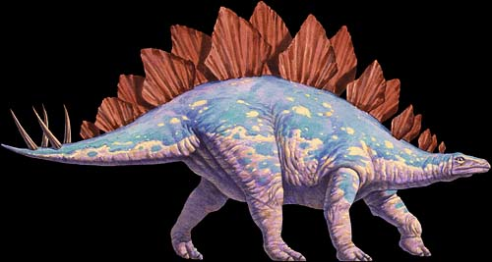

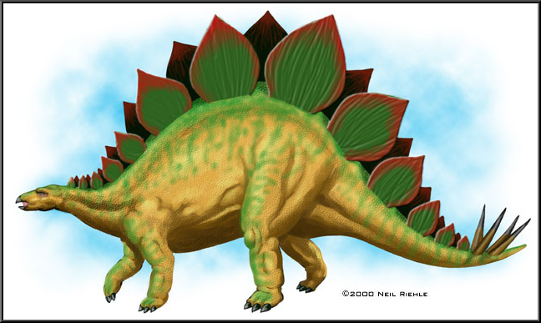
2. Bob Dylan had a vision that something was soon going to fall – what?

A hard rain. Written in 1962 and released on the 1963 album Freewheelin’, A Hard Rain’s A-Gonna Fall is full of bleak imagery and post-apocalyptic sentiments that seemed, in the immediate aftermath of the Cuban Missile Crisis, evocative of nuclear war and the deadly fallout that comes after. Dylan has said that’s too literal an interpretation. One thing’s for sure: it isn’t about bunnies hopping about in green flowery fields. From the first time I heard it, certain lines were indelibly burned into memory:

Oh, where have you been, my blue eyed son?
And what did you see, my darling young one?

I saw a newborn baby with wild wolves all around it
I saw a highway of diamonds with nobody on it
I saw a black branch with blood that kept drippin'
I saw a room full of men with their hammers a-bleedin'

I saw a white ladder all covered with water
I saw ten thousand talkers whose tongues were all broken
I saw guns and sharp swords in the hands of young children

And it's a hard, it's a hard, it's a hard, and it's a hard
It's a hard rain a-gonna fall

http://www.dailymotion.com/video/xq1q9k_bob-dylan-a-hard-rain-s-a-gonna-fall-1964_music

In 1963 the top song, according to Billboard, was Sugar Shack, by Jimmy Gilmer and the Fireballs. As Bobby D. told us, the times they were a-changin’. Popular music was suddenly a medium for serious artistic expression; and just around the corner, four kids from Liverpool were coming to blow the doors off the whole scene.




3. Bees build hives, and ants dig their hills, but who are the greatest insect architects of them all (arguably)?

Termites, especially the African variety (and in Australia and South America too), build mounds that amount to nothing less than insect apartment buildings. They’re served by vast networks of ventilation shafts and full of tunnels and chambers, including gardens where they grow fungus as food, all of it maintained by workers, and defended by soldiers. They can get huge, 20-30 feet tall, and house as many as a million of the little guys. They’re like castles, or little city-states.

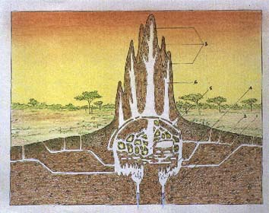

4. How is the Cunard Line’s Queen Mary II so very different from, say, Royal Caribbean’s Oasis of the Seas?

The Oasis of the Seas is a cruise ship. The Queen Mary II is an ocean liner. Cruise ships are frivolous thin-skinned pleasure palaces with low freeboards, marginal stability, and limited capacity to handle the weather. They’re meant to ply placid waters and scoot into port if things get choppy, and there’s always a port nearby on the routes they travel.

An ocean liner like the QM II is just what it says it is: it’s designed to cross whole oceans, including potentially nasty waters like the North Atlantic, and take everything that nature can throw at it. No scurrying into mama’s arms if it gets rough. Sailing where angels fear to tread requires a strong hull with a high freeboard, and QM-II has far more structural steel than any of those water-borne casinos that traipse between Caribbean islands, maybe half again as much. True ocean liners are descendants of the great vessels that were once the only way to cross oceans, and however luxurious they may be, they serve a purpose. They’re meant to get you from A to B in one piece. The journey may be pleasant, but the point isn’t to serve as a floating Disneyland. They’ve got places to go, and they’d better be there spot on time. At present, QM II is the only working example of her noble breed.

YAY:

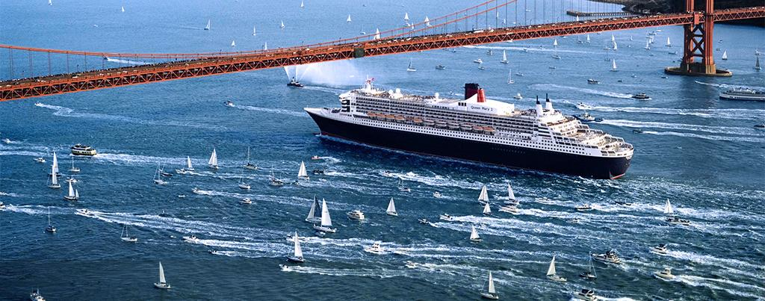

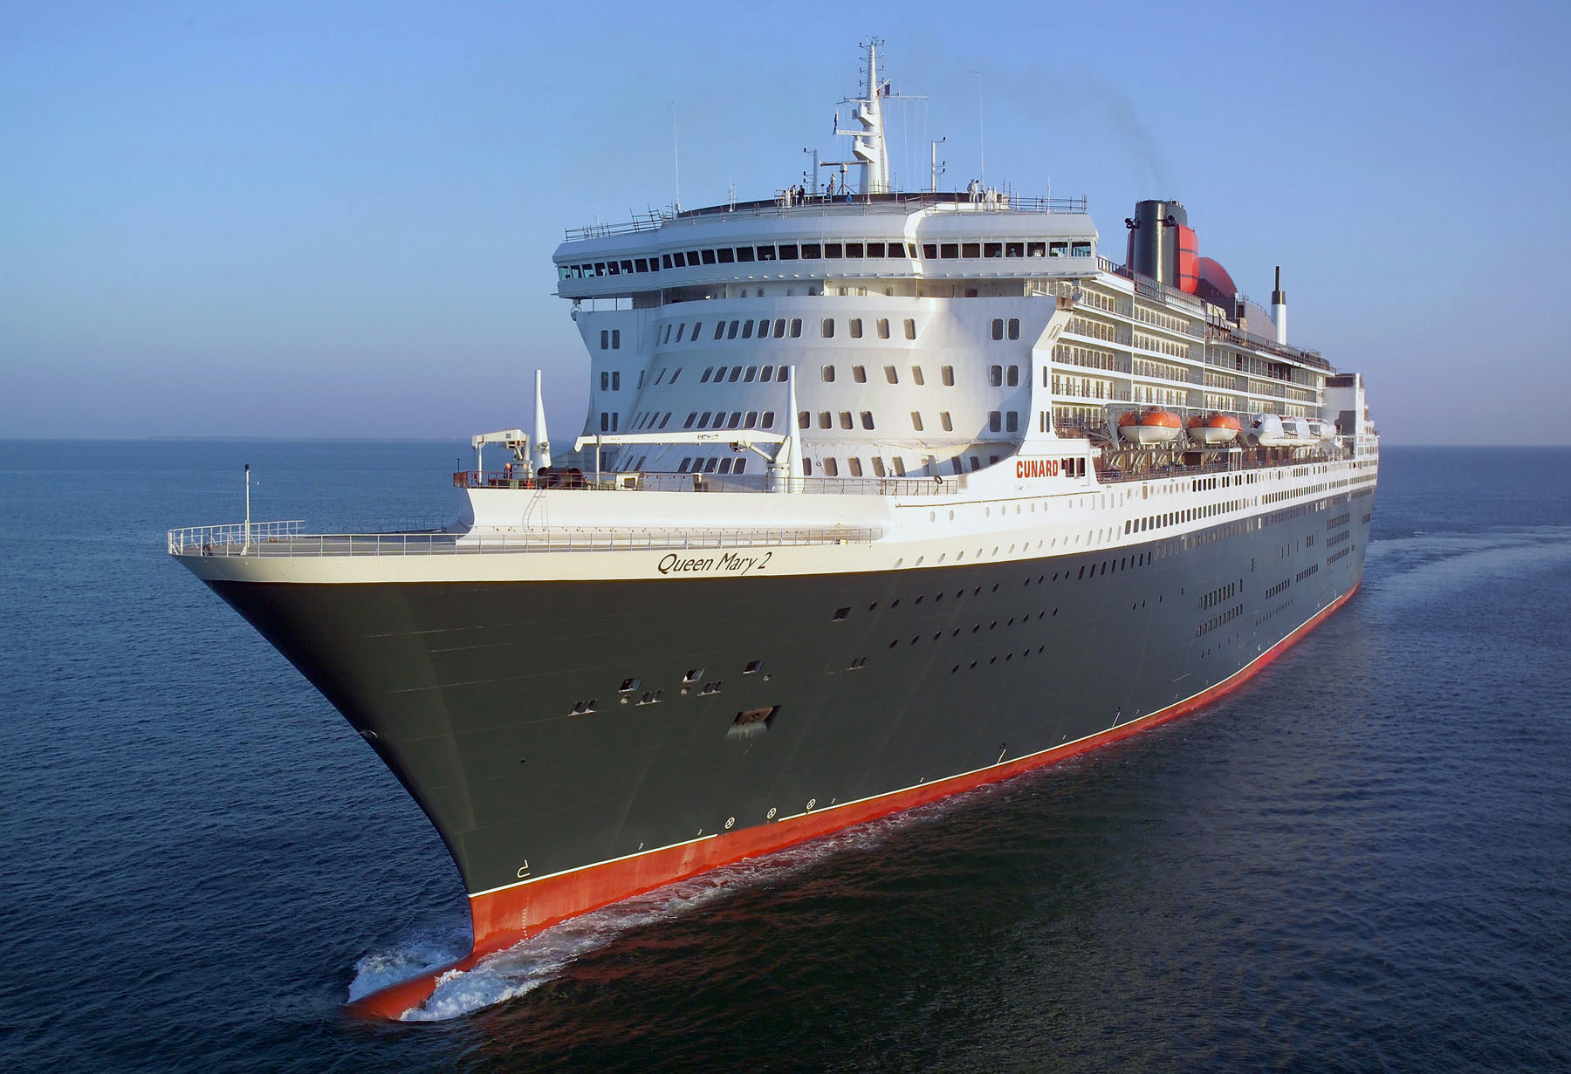

BOO:

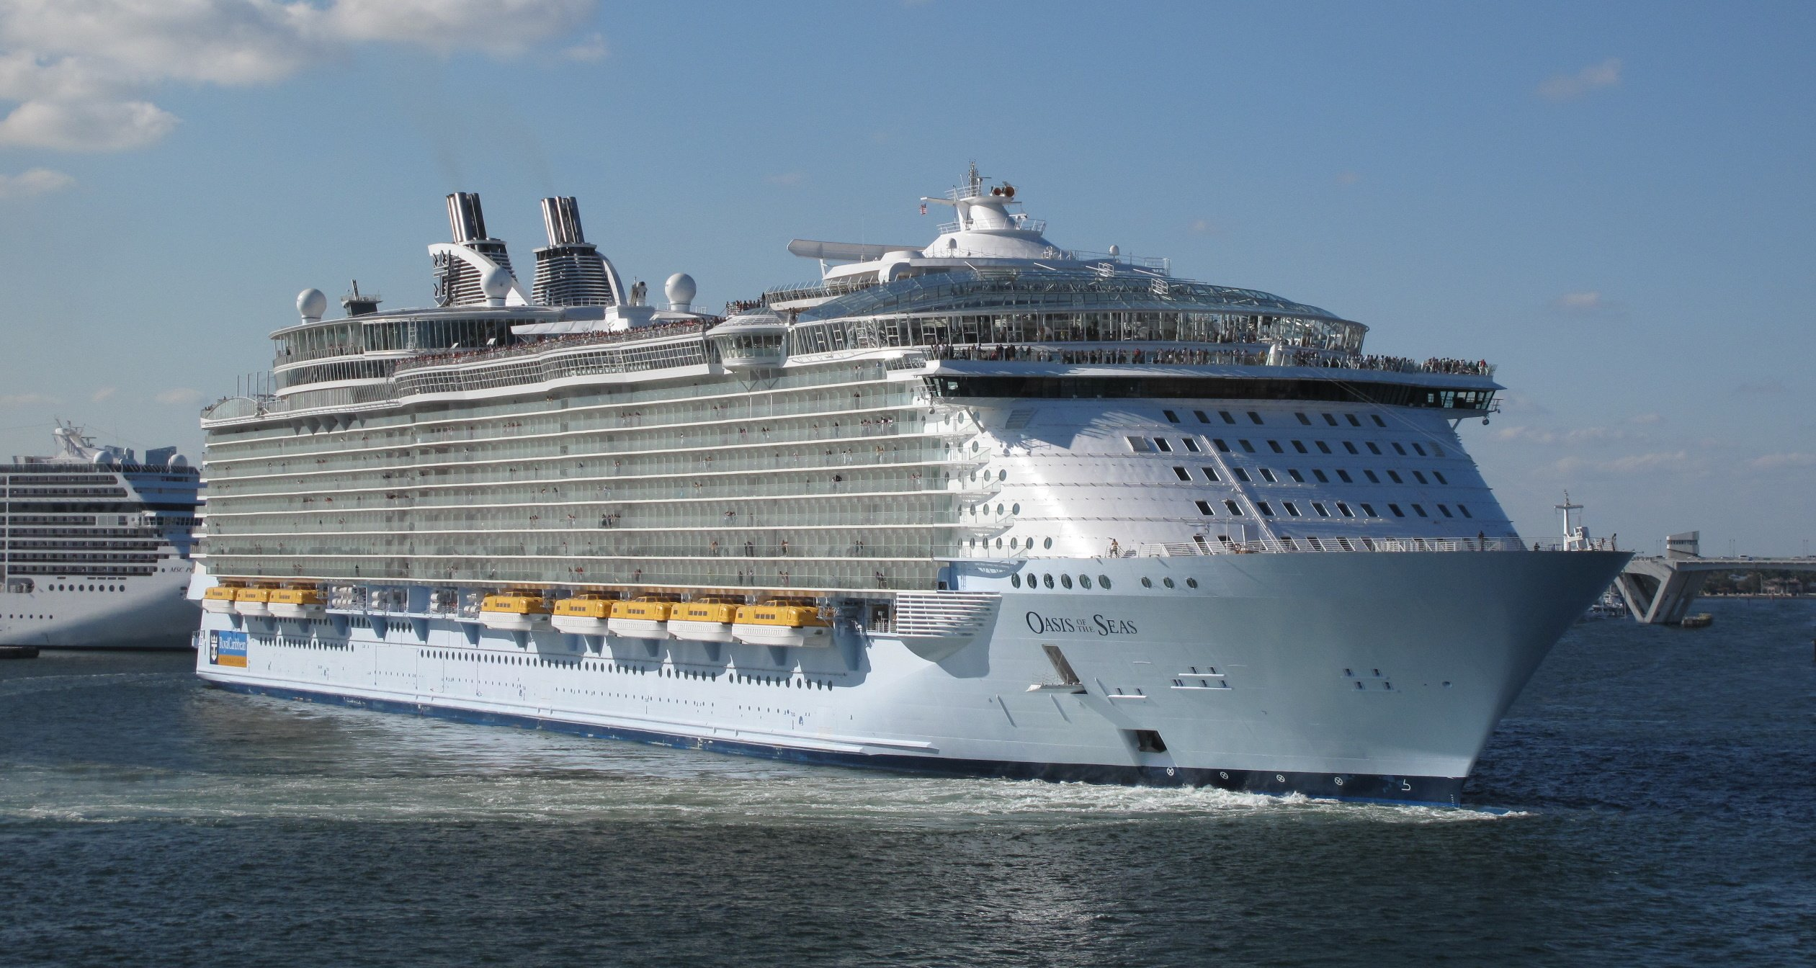

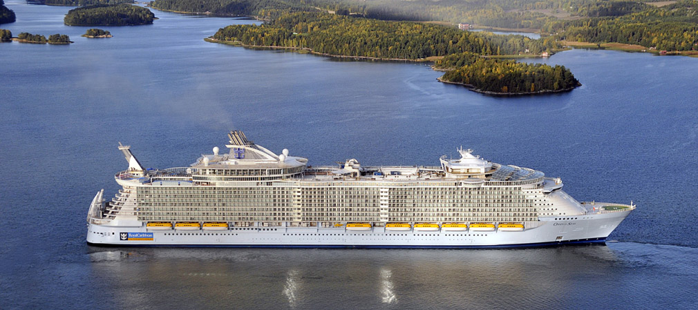
5. Who are the Cajuns, and where did they come from?

They form a dominant portion of the culture of Louisiana. “Cajun” is a shortened variant of the word “Acadian”; the folk of Louisiana are descendants of the French settlers who once occupied the nicest parts of Nova Scotia (and other regions in the Maritimes), and were expelled by the British for refusing to swear full allegiance to the King, including the duty to fight against their fellow French. The Acadians had lived peacefully under British rule for decades, after their conquest in the early 1700s, but come the Seven Year’s War in mid-century they seemed a bit of a nuisance, and actually did offer support to nearby territories that were still under French control.

Very well then. Those who please may belt out a lusty rendition of God Save the King right this minute. The rest who please may be stripped of their lands and sent packing.

The Expulsion of the Acadians is a legendary tragedy where I come from, and even those of us descended from the English find it saddening and brutally unfair. The Acadians had set up a good life for themselves in the green and fertile Annapolis Valley, and other desirable locales around the province, and in many ways enjoyed about the best lifestyle in the European world. They built it with their own hands, and it was taken from them without compensation or pity. Scattered to the four winds, those who survived – and thousands didn’t - settled all over the place. Eventually many wound up in Louisiana, including a sizeable contingent who had first settled back home in France.

They taught us all about it in school, and we all read Evangeline, Longfellow’s famous poem about the suffering of the Acadians. There’s a statue of the fictional Evangeline in Grand Pre, the setting of the poem. The lovely girl looks longingly over her shoulder at the home from which she must soon be exiled.

Over time, many were allowed to return, and the Acadian flag can be seen flying over many locations along the South Shore, and up in Cape Breton. It’s a pretty thing, a French Tri-Colour with a gold star in the corner.

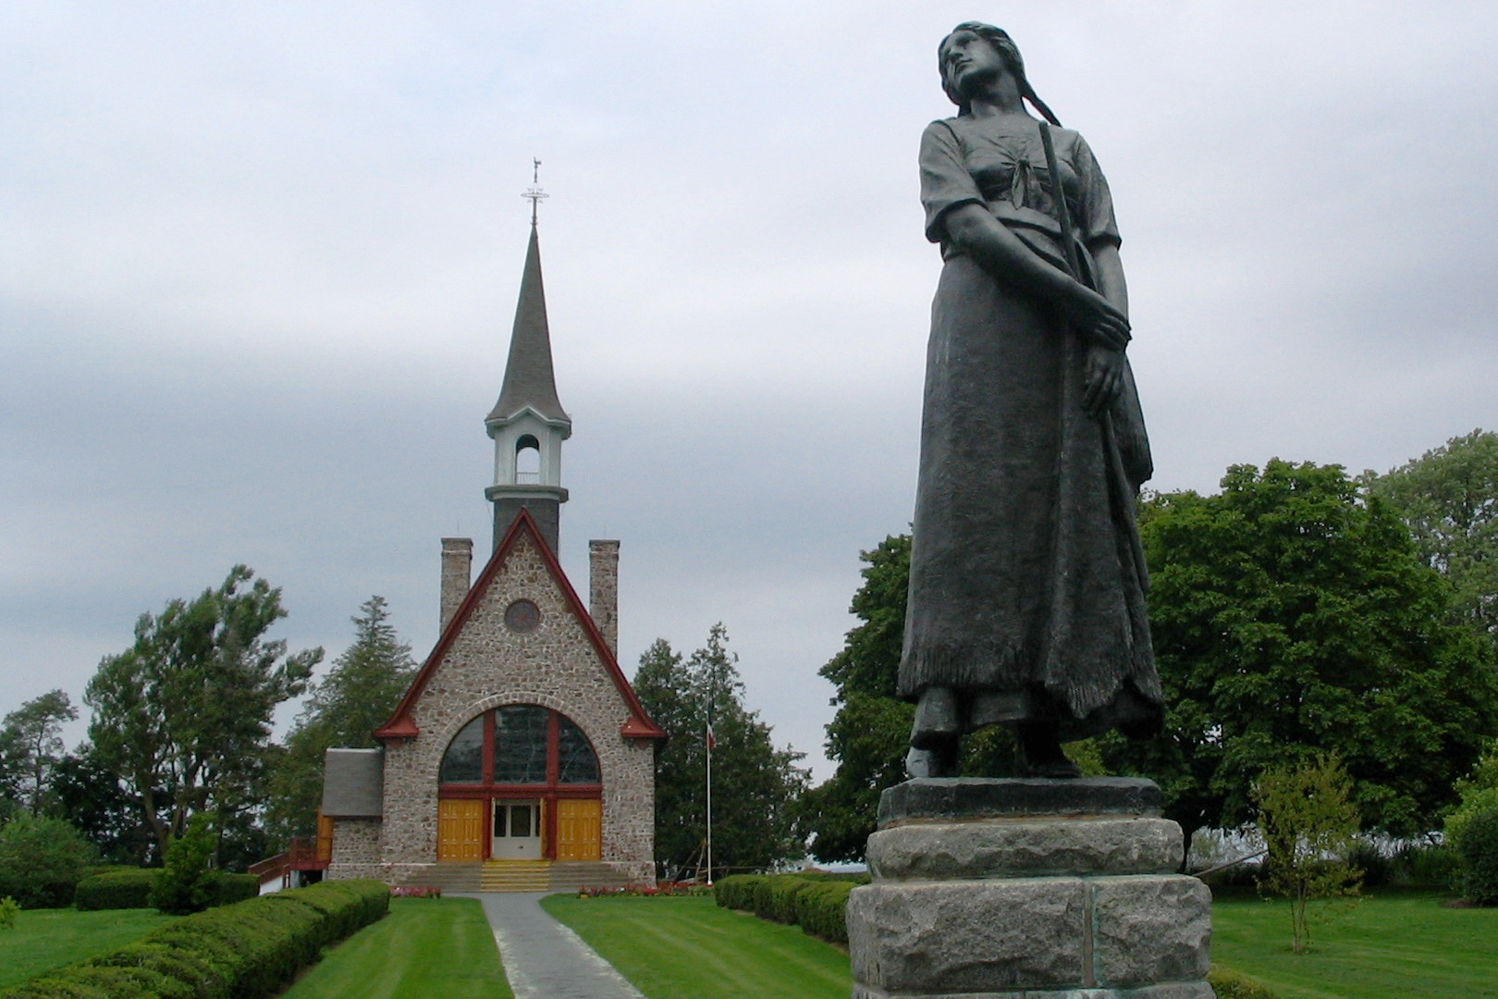




6. In the late 1800’s, who did American army officers respect as the “finest light cavalry on Earth”?

The phrase is sometimes attributed to General George Custer, and refers to the warriors of the Plains Indians, and in particular the Lakota Sioux under Sitting Bull, though the Cheyenne were just as good, as were the Apache. If Custer didn’t say it, he probably thought something similar as they wiped out his 7th Cavalry at Little Big Horn.

Horses were once unknown in North America, but having evolved here, they quickly began to thrive in their former habitats in the Great Plains once the Spanish reintroduced them in the 1600s. In the 1870s, when Custer met his fate, the tribes of the plains were riding the descendants of the original Spanish Mustangs.

To the Sioux, horses were more than prized, more than valuable. They were sacred. Their word for horse, sunkawakan (pronounced shoon-cah-wah-kawn, it says here on the web page I’m visiting) translates roughly as “God Dog” or “Holy Dog”. Some plains tribes had a word that translated less reverently to “Big Dog”. Before the arrival of horses, dogs were the only animals the tribes had domesticated, and to them, I guess, the horse was a sort of Super Dog. It certainly revolutionized their way of life. By the time white men encountered them, the Plains Indians were supremely skilled and confident mounted warriors. They could ride at full gallop without the benefit of saddles and stirrups, and it was said they could aim and fire their bows effectively while doing it.

They would not go quietly.

Sioux horses were considered superior, as a breed, to the horses of the US Cavalry, and a program to slaughter them in huge numbers was part of the strategy for wresting control of the plains away from its natives. Those who know and love horses must weep at the thought. They were never wiped out, though, and most of the current breeds of mixed-colour horses, like Paints and Palominos, are their descendants.



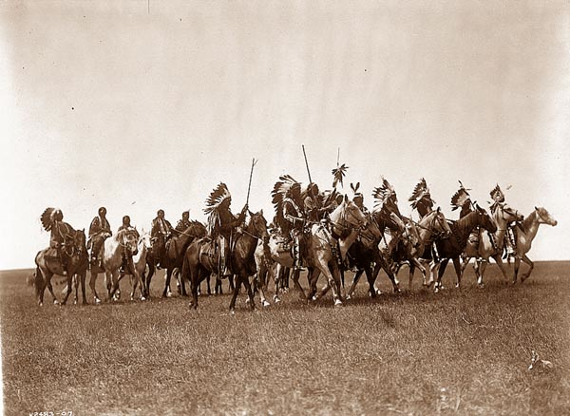
7. What was an “ornithopter”?

Or I guess I should say what is an ornithopter, since the idea is still around today. An ornithopter is any aircraft that moves by flapping its wings, and when I posed the question I was thinking particularly of the designs sketched out by Leonardo da Vinci. Leonardo’s contraption could never have worked, relying, as it did, on human muscles to supply the flapping motion. He didn’t have the light modern materials available that could have made the wings big enough, but not too heavy, for mere muscles to flap with a sufficient amount of lift. Even today, it’s a very tough trick to pull off – a human-powered machine named Snowbird designed at U of T had a 100 foot wingspan, and was constructed out of lightweight carbon fibre, foam, and plastic, and still they could only manage to flap it aloft for 30 seconds or so, and they had to tow it behind a car to get it airborne. I remember seeing it on the news.

Today, ornithopters are usually small machines powered by electric motors, and there’s talk of military applications – they can be made to resemble birds, or dragonflies, and who knows what mischief they could get up to. They might make terrific reconnaissance platforms, equipped with little cameras. Or uglier things.

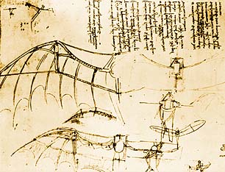




8. Who proved without a doubt that there was no such thing as “spontaneous generation”, and what has that got to do with chocolate milk?

Louis Pasteur, working in the mid-1800s, is the scientist who originated the germ theory of disease, and for that we have much for which to thank him. Very, very much. It was he who proved that microbial life was what made food and drink spoil, and that microbes caused diseases in plants, and by extension, people.

It was widely thought at the time, believe it or not, that these microbes of his were something that could spontaneously generate out of nothing. A simple experiment of devastating persuasiveness put an end to that nonsense; Pasteur used heat to sterilize samples of things like soup, and had the samples sealed up against outside air. Nothing grew. Microbes could only be the result of contamination.

What this led to was the method for preserving food that we use to this day, “pasteurization”.

Pasteur also conducted experiments that led the way to vaccination, one of the greatest gifts ever delivered by science to the ordinary person. It was Pasteur who came up with the Rabies vaccine. Widespread vaccination has lengthened untold millions of lives since it began, and we owe it all to Louis.

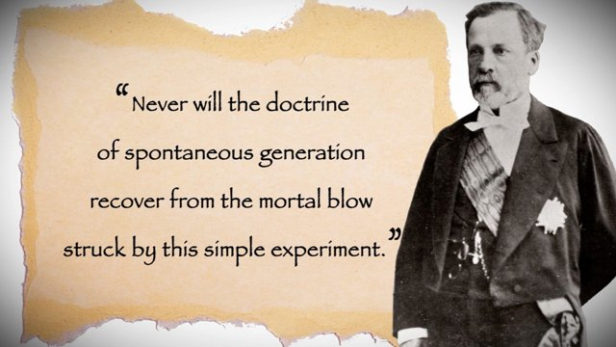

9. Life expectancy has risen dramatically over the past 150 years or so. Why?

Yes, we have better nutrition, better housing, better surgical procedures, better treatments for all sorts of diseases, better hospitals, but all that is trivial next to two simple things that have made all the difference: clean water, and vaccination. People all around the developing world continue to die in unconscionable numbers from the lack of safe water to drink, and the absence of immunization to common but deadly diseases like Measles.

The next time you turn on a tap, fully confident that unlimited quantities of safe, clean, drinkable water will pour out, spare a thought for what a miracle that is, and for the multitudes who suffer to this day because they can’t do the same. Whenever you hear anybody say vaccination is unhealthy, or “not for their children”, remember how recently it was that losing children and loved ones to Polio, Tuberculosis, Diphtheria, Tetanus, Pertussis, Measles, and a host of other pathogens was simply a fact of life.


10. Who was Bobby Fischer?

Fischer was an odd, reclusive American chess genius, who might just have been the greatest grand master who ever lived. In 1972, his defeat of Russian Boris Spassky in a set of matches played in Reykjavik, Iceland, was the stuff of legend. For the first and only time, ordinary people were as gripped by chess matches as they were by prize fights and football games.

Having won the world title, he refused to defend it in 1975, and bounced around ever after, living in all sorts of countries and becoming ever more eccentric, mad even. He started saying anti-Semitic things, and he even did some prison time, I forget for what, and at the end of his life became a citizen of Iceland. He’s dead now, and the sad and tatty anti-climax of his later days has done nothing to dent his mystique.



11. What was the Gossamer Condor, and what made it special?

A few questions back we were discussing the ongoing effort to develop an aircraft that a human being could power by flapping. There’s a much better way to get aloft on human muscle power – get a trained cyclist to peddle a bicycle-like mechanism geared to a propeller.

Designers Paul MacCready and Peter Lissman came up with the first successful human-powered airplane, and in 1977 won a large cash prize that had been put up by an industrialist for the first who could pilot the machine through a fixed course. Their creation was named Gossamer Condor. It had a hundred-foot wingspan, and weighed only about 70 or 80 pounds – the heaviest component was the cyclist inside, and he was as lean as a whippet.

Later, they built one that crossed the English Channel, named Gossamer Albatross, skimming the waves all the way – but it made it.

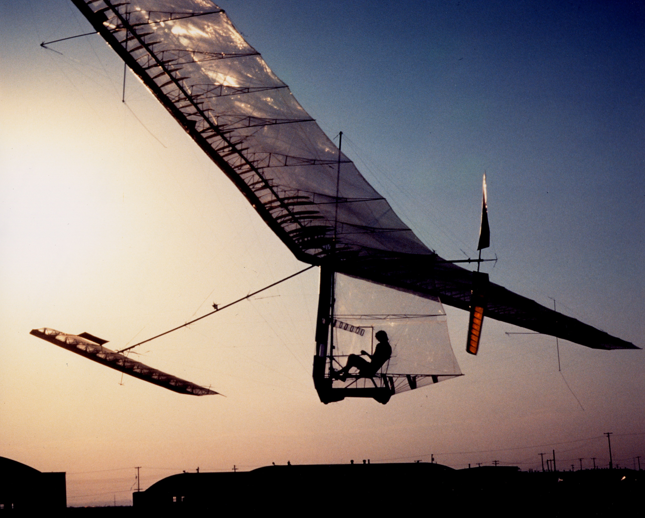

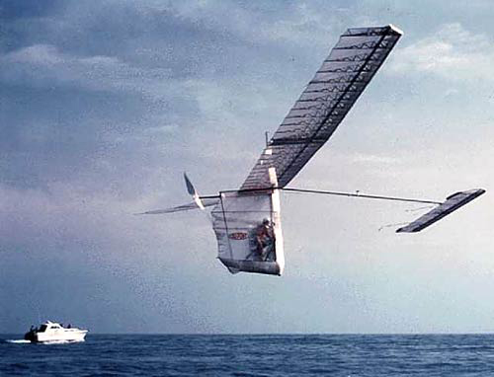
12. There’s a big mast on top of the Empire State Building that is now topped by a large antenna complex. What was the original ambition for the mast?

The Empire State went up in the era when huge rigid airships like the German Zeppelins plied the world’s skies, and its mast was meant to be a mooring mast for the great vessels. The idea was that passengers could disembark right into the building, on a ramp extended from the nose of the moored airship – a scary prospect, but worth it, maybe, for the convenience of arriving by air in the heart of Manhattan.

Airflow around supertall buildings was not well understood at the time. Those of us who have stood during the Winter in the windows of our Bay Street towers, and watched the snow falling upward, know that powerful air currents swirl around tall buildings, and create updrafts that would make any attempt to dock what amounts to a huge balloon rather difficult. This was the dream:

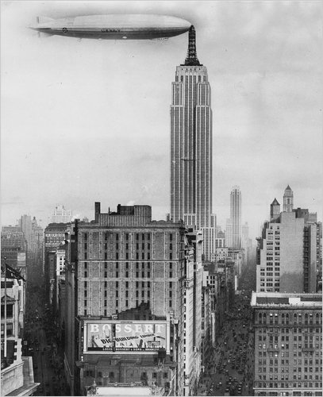
After several trial runs, the idea was abandoned. It was simply too hard to manoeuvre, and there was a good chance you might end up like this:

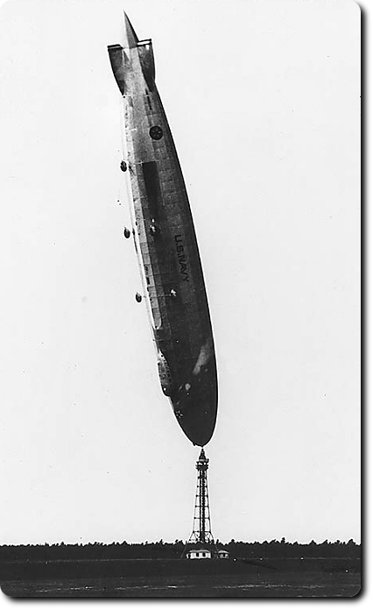
13. What amazing structure can you find in Akron Ohio, of all places?

There's a huge hangar, the Goodyear Airdock, constructed around 1930 for the manufacture and storage of huge rigid airships comparable to the German Zeppelins. The customer for these airships was the US Navy, who experimented throughout the 1930s with their use in ocean surveillance, reconnaissance, and even as flying aircraft carriers, with a small number of fighters that could be launched, and would return to base by hooking on to a sort of trapeze hung below to pull them inside. The system worked, but it was tricky.

The hangar is close to 1,200 feet long, over 300 feet wide, and over 200 feet high. The interior space is so cavernous that it has a sort of climate – changes in temperature between floor and ceiling can cause mist to condense and fall like a gentle rain. It's now owned by Lockheed, and I have no idea what they do in there.

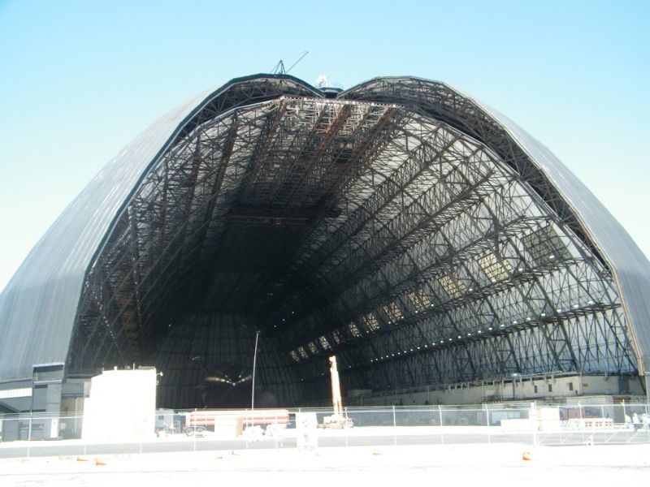
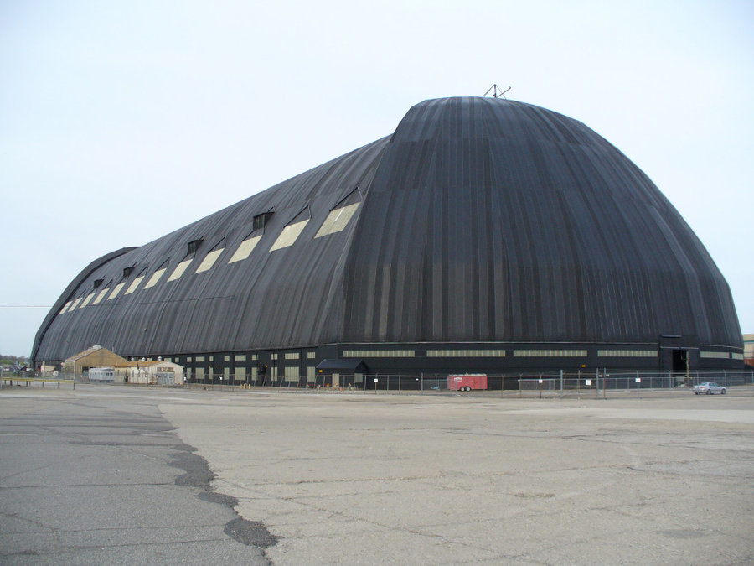

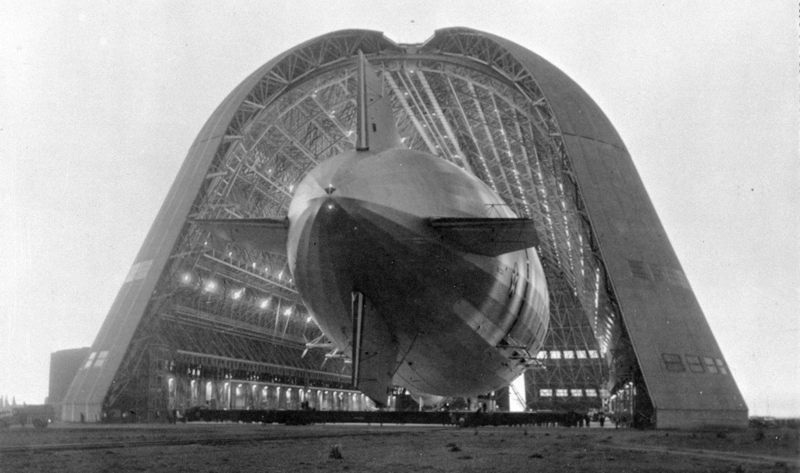

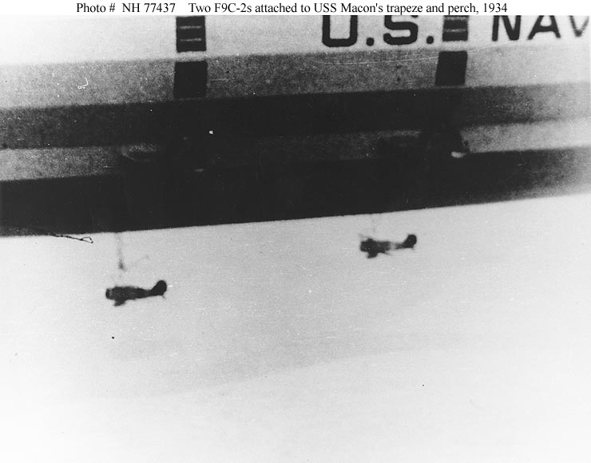

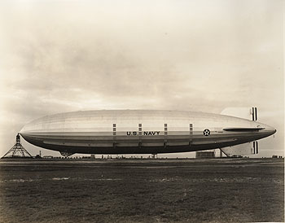
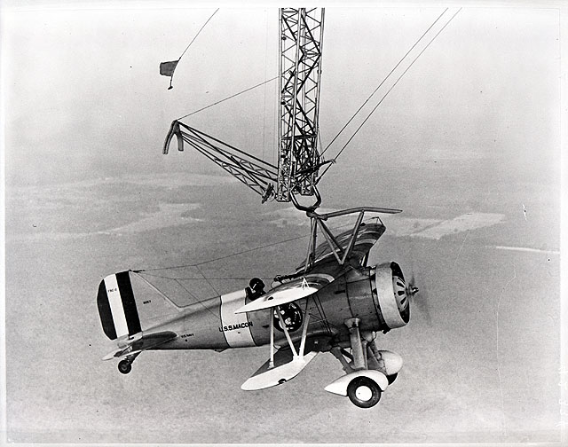
14. What strange properties make ordinary water so interesting?

We discussed in another set of questions how water can't be compressed. Water is also one of the very few substances that expands when heated, and also when frozen. You could blow the door off any safe if you could fill it with water and somehow freeze it in there.

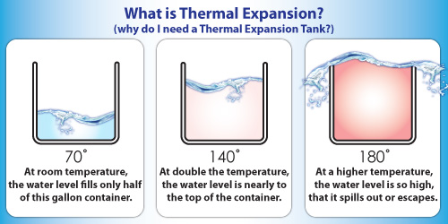


15. What happened to the Mayan civilization?

A great mystery. The Maya flourished for almost two millennia until around 900 AD on our calendar, after which some sort of rapid collapse overtook them. When the great structures they left behind were first explored by Westerners, they were derelict and overgrown in the jungles of Central America. It looked for all the world as if whole populations had just picked up and left. Some of their cities, like Tikal in Guatemala, may have had upwards of 100,000 inhabitants, and by all the evidence their civilization was vast, vibrant, and advanced, with a particularly sophisticated system of math, an amazingly elaborate calendar, and an evolved science of astronomy. Then, over a brief period, they all seem simply to have walked away. Parts of their civilization carried on in places like the Yucatan Peninsula, rather like parts of the Roman Empire survived in the East after the collapse in the West. Still, something laid a great culture low.

All sorts of theories have been proposed. Disease, war, famine, drought, exhaustion of cropland making farming untenable, everything but alien invasion, but so far we have no definitive answers.

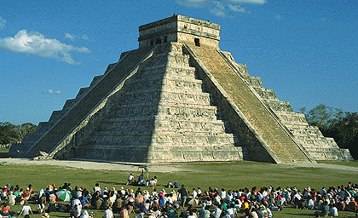
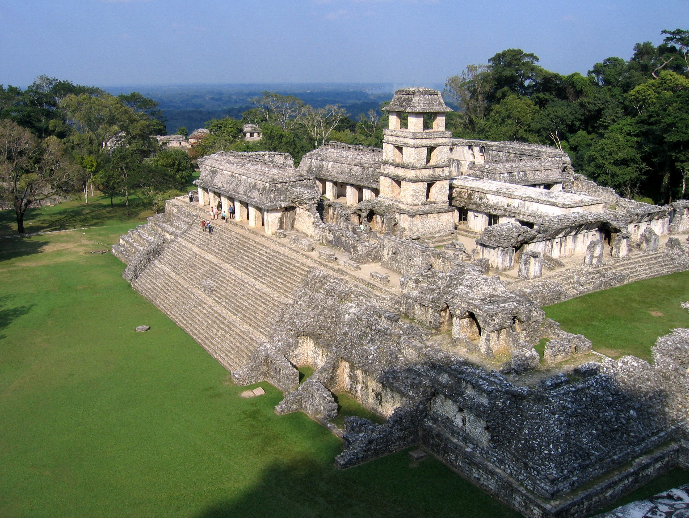

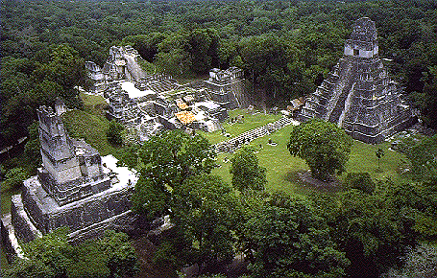
16. What is meant by “the tragedy of the commons”?

It's a term from economics to describe how a common resource can be plundered and destroyed forever if everybody behaves according to rational self-interest, and there isn’t anyone policing the common good and restraining individual behaviour. If a resource is made available to all, with no limit on what anyone can extract, everyone's best move in the short run is to grab as much of it as possible before somebody else does, and there's nothing left. Until, before long, there is indeed nothing left.

Though the "commons" in this phrase refers to the common grazing areas that used to be made available to inhabitants of English towns, the phenomenon can be seen in operation whenever a common resource is freely available to all. The tragedy of the commons is now being played out on the world's oceans, in which the plunder by fishing nations all but wiped out the Atlantic Cod, is just about to wipe out the Blue Fin Tuna, and bids fair to eradicate just about anything edible that swims.

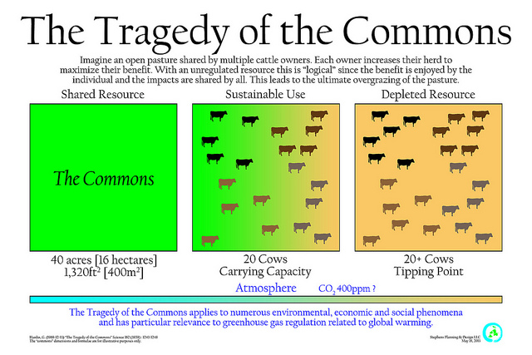

17. Who was Samuel Pepys, and why do we remember him?

Samuel Pepys (pronounced “peeps”) was a bureaucrat and member of Parliament in 17th century London, who eventually attained significant rank within the Admiralty, but we need never have heard of him save for his wonderful diaries, which detail day-to-day life and events in England at that time.

He began keeping his diary around 1660, and thus he provides eyewitness accounts of what went on with the Great Plague and the Great Fire of London, as well as some acute observations of the politics and major personalities of the day.

He seems to have been interested in everything around him, and the diary is as prized for its description of the ordinary details of life in those days as it is for its chronicling of major events. It’s a treasure trove to historians.

You can buy his diary on Amazon. I doubt he could have imagined that anyone in the year 2017 would possibly know he existed, let alone read his thoughts, and, through his vivid writing, be transported back to a different time and place.

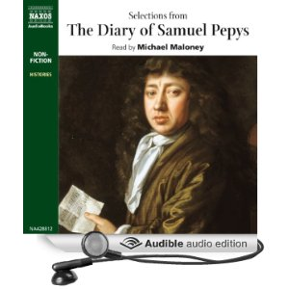
18. What classic work of American literature was inspired by a real event that involved a ship named Essex?

Essex was a whale ship operating out of Nantucket, Massachusetts, where my family first took root in the New World. Whaling in sailing ships was an arduous business. The most prized catches were large Sperm Whales, whose bodies contained reservoirs of valuable oil that were almost literally worth their weight in gold, and the hunt for them would take the ships around Cape Horn and into the Pacific. A whale ship might leave port and not return for two years.

Essex set out around 1820. Long story short, in one of her hunts an enraged Sperm Whale rammed the ship and stove in her bow, and Essex was destroyed. Survivors had to take to small whale boats to survive, and God help them, they were thousands of miles West of South America.

Conditions grew predictably desperate as they tried to navigate back to land, and eventually, in one of the boats, the time came to draw lots to see which of those aboard would be killed and eaten. Drawing the short straw was Owen Coffin, a teenager, who by all accounts accepted his lot with what could only be called stoic nobility – he assured his mates that it was all right, that if it had been different, he’d surely have been content to let one of them go to the same fate. Fair’s fair. Coffin was shot, and his remains devoured.

Eventually, the survivors of Essex were rescued by another ship from home, still in the Pacific but close to landfall in South America.

Thirty odd years later, Herman Melville heard their story and was inspired to write Moby Dick.

I know all this because I read the book pictured below, and also because my father, researching our family tree, discovered this story and told me about it over 40 years ago, now. He also told me that our family name was still among the most prominent in Nantucket, and that if ever I went there, as a direct descendant of the original inhabitants, I might well be welcomed as a wayward son. I’ve never gone. Don’t you think I should, though?

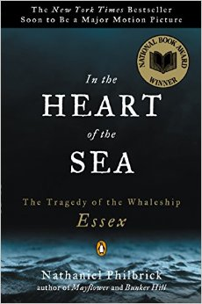


19. What movie took the “car chase” scene to a whole new level?

A favourite!! I love this movie!! Love love love it!!

In 1968, Warner Brothers released Bullitt, the progenitor of every cop movie that followed it, and it starred Steve McQueen – the coolest dude who ever lived – as a San Francisco cop in the middle of a criminal and political sh*t storm involving mafia drug kingpins and ambitious candidates for office. In many ways, particularly in its dry depictions of meticulous police procedure, its authentic scenes in hospital emergency wards, and its matter-of-fact dissection of the politics that infect every bureaucracy, it remains unsurpassed.

All anyone remembers, though, is the 120 MPH car chase as McQueen, doing his own driving for much of it, pursues a honking great Dodge Charger in his fastback Mustang, all over the hills of San Francisco. Much of it was filmed at normal speed, with no video tricks to make it look like the cars are going faster than they really are, and you can tell by the way these muscle cars bounce on their shocks, leave the ground as they go over humps, and shed hubcaps as they heel over in tight turns. The jaded modern viewer may say he’s seen it all before, but nobody in 1968 had ever seen such stuff, and I don’t know, there’s something about it.
.

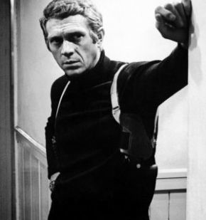
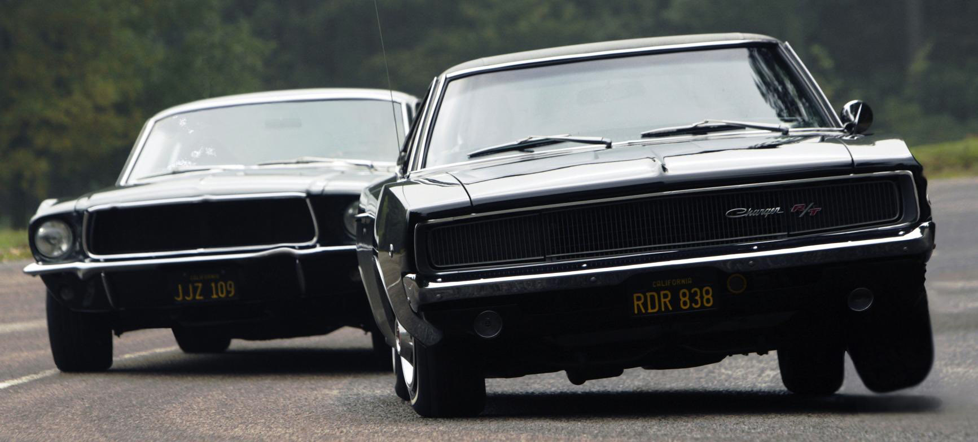

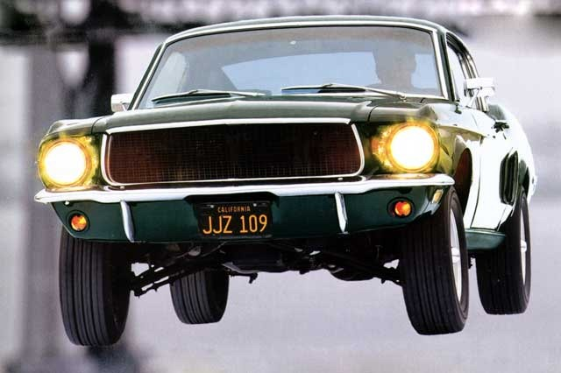

https://www.youtube.com/watch?v=31JgMAHVeg0

20. Where did buildings called “skyscrapers” first appear? What new building technique allowed them to reach unprecedented heights?

It’s not certain that the term originated in Chicago, but that’s my story.

As urban land became more scarce and precious, the urge to create extra real estate by building upwards took hold, and efforts in this direction were well under way by the 1880s. The problem with height is that there is only so much you can do with load bearing masonry walls, until, to support themselves, they take up so much of the structure’s volume that the building is self-defeating. Chicago’s Monadnock Building is usually cited as the ultimate stretch for structures with load bearing walls, and its walls had to be mighty thick to support the 16 storey tower, the largest office building in the world upon its completion in 1890 or so.



The solution was steel frame buildings. A modern skyscraper has an interior frame from which walls, dubbed “curtain walls”, are suspended. Curtain walls are not load bearing and can, in fact, be made entirely of glass.



Another technique is the “tube” building, with the steel structure forming a sort of exo-skeleton around a hollow core.

In any case, it’s the switch from load bearing masonry to structural steel – abetted by the modern elevator invented by Elisha Otis – that makes really tall buildings possible. The first such steel frame building was the Home Insurance Building in Chicago, constructed in the mid-1880s.

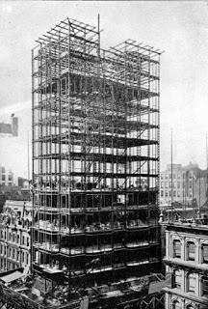
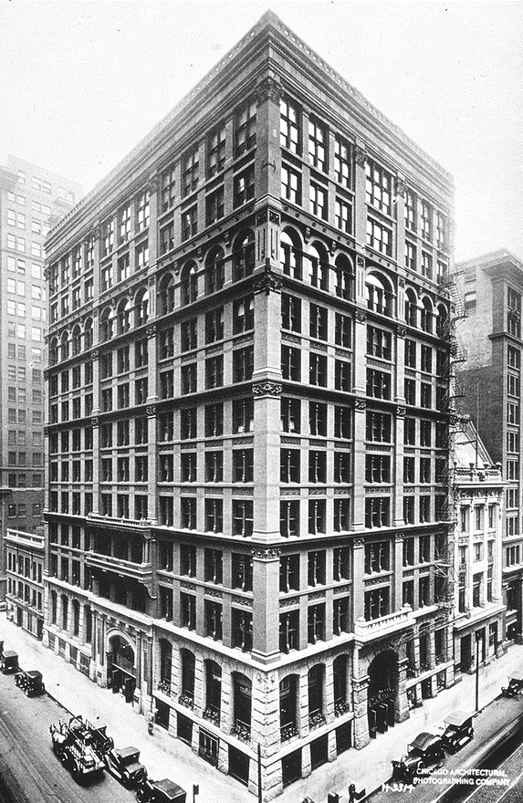
21. Which American politician of the 1930s could fairly be described as a tyrant, thief, populist boob, threat to democracy, and utter genius who was absolutely right, all at the same time?

That was Governor Huey P. Long of Louisiana. He was as corrupt a politician as ever lived, raking off public revenues for his own use and storing the cash in what he called the "dee-duct box". He was constantly exceeding his authority, concentrating power in his own hands, even doing unconstitutional things like getting elected to the U.S. Senate yet staying on as Governor. Even the good things he did were done in corrupt fashion, unlawfully, usually, and there was always a little something in it for Huey. He revelled in the nickname "Kingfish", while pretending to be an ordinary bumpkin, the better to pander to his base. And nobody, but nobody, pandered like Huey. All attacks on him failed, impeachment attempts came to nought, enemies were crushed. Political cartoons portrayed him as “Hooey the 14th”. All intelligent commentary opposed him, all elites loathed him, and it was said that you couldn't get three people in a room in Louisiana without somebody mentioning that Huey ought to be shot.

The crude bumpkin pose was pure theatre. Huey was a brilliant striver, at first a travelling salesman, who then, having passed the bar on the first try without any schooling in the law, became a lawyer who eventually fought and won cases before the Supreme Court. Huey was a sham, and a clown. Maybe the most intelligent and gifted sham of a clown to ever live.

It was easy to hate him. And yet...the base to whom he pandered comprised the mass of impoverished and downtrodden rural inhabitants of dirt-poor Louisiana. Coming to power in the depths of the Great Depression, Huey gave fiery speeches in which he spoke up for the poor, and against America's outrageous concentration of wealth in the hands of a small class of plutocrats. Pure demagoguery? You’d think so, except he built schools, and gave poor kids free textbooks. He built desperately needed roads and bridges, and charity hospitals to tend to the indigent. With an apparently genuine white-hot hatred of the greed of the upper classes, he railed against government incompetence, and advocated sweeping legal changes to redistribute wealth - indeed he started a political movement called Share Our Wealth. He proposed a guaranteed minimum income for all, limits on hours of work, old age pensions, and upper limits on the amount of filthy lucre any one person could accumulate.

And oh, what speeches he gave:

And it is here, under this oak where Evangeline waited for her lover Gabriel, who never came. This oak is an immortal spot, made so by Longfellow's poem, but Evangeline is not the only one who has waited here in disappointment.

Where are the schools that you have waited for your children to have, that have never come? Where are the roads and highways that you send your money to build, that are no nearer now than ever before? Where are the institutions to care for the sick and disabled? Your tears in this country have lasted for generations. Give me the chance to dry the eyes of those who still weep here.

And:

So, we have in America today, my friends, a condition by which about 10 men dominate the means of activity in at least 85 percent of the things you do to earn a living. They either own directly everything or they have got some kind of mortgage on it, with a very small percentage to be excepted. They own the banks, they own the steel mills, they own the railroads, they own the bonds, they own the mortgages, they own the stores, and they have chained the country from one end to the other, until there is not any kind of business that a small, independent man could go into today and make a living; and they have finally and gradually and steadily eliminated everybody from the fields in which there is a living to be made, and still they have got little enough sense to think they ought to be able to get more business out of it anyway.

And:

The wealth of this land is tied up in a few hands. It makes no difference how many years the labourer has worked, nor does it make any difference how many dreary rows the farmer has ploughed, the wealth he has created is in the hands of manipulators who have not worked any more than many other people who have nothing. Now, we do not propose to hurt these very rich persons. We simply say that when they reach the place of millionaires they have everything they can use, and they ought to let somebody else have something. As it is, 0.1 of 1 percent of the bank depositors own nearly half of the money in the banks, leaving 99.9 per cent of bank depositors owning the balance. Then two thirds of the people do not even have a bank account. The lowest estimate is that 4 percent of the people own 85 percent of our wealth. The people cannot ever come to light unless we share our wealth.

A favourite analogy of Huey’s was a church bar-be-que, at which meals had been set out for a hundred people, except one man came along and took the food for 90 away for himself. He couldn’t even eat all that food. Shouldn’t he be told to bring some of that back? What did these rich men want? After they had every mansion they could ever live in, every yacht they could sail, every car they could be driven around in, every silk suit they could ever wear, every steak they could ever eat, why did they still want more? Why did they insist on material wealth beyond anything they could ever even enjoy? Why did we let them?

Call it rabble rousing. When the plight of the ordinary worker was desperate and unconscionable, maybe the rabble needed a little rousing, right?

Was he wrong?

In 1935, he was fixing to run for President, when he was shot and killed by a relative of one of his political opponents. Among the most urgent questions posed by his cronies as they rushed him to the hospital: "Huey! Where's the dee-duct box?!" Meanwhile, it was said, everybody ran to the phone at once to call friends and family to make sure it wasn’t any of them that did it.



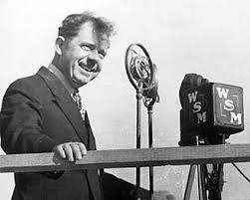

https://www.youtube.com/watch?v=hphgHi6FD8k
22. What Beatles album ends with a song titled, appropriately enough, The End?

Abbey Road, the last album they ever recorded, released in 1969.

The record ends with a 20-minute song suite (often called “the long medley”) that winds its way to a McCartney piece called Golden Slumbers/Carry That Weight, before climaxing with The End. In 1969, Paul was at the peak of his prowess, and here he produced an immaculate symphonic conclusion that every turgid Art Rocker since has tried, in one way or another, to emulate.

Once there was a way to get back home, sings Paul over his mournful piano. The inspiration came from an Elizabethan Era poem by Thomas Dekker:

Golden slumbers kiss your eyes,
Smiles awake you when you rise;
Sleep, pretty wantons, do not cry,
And I will sing a lullaby,
Rock them, rock them, lullaby.

The lyrics track the poem fairly closely, except, tellingly, the sentiments about losing the way home, and being left to carry that weight for a long time, were Paul’s own. Still just 27 years old, he was now scaling to dizzying musical heights; did he know he would never be back there again? It’s hard not to discern a sad awareness of all that was soon to be lost in this lovely, soaring song – but who wants to exit crying? The great, beautiful music machine that was the Beatles was just about to be sent to the breakers and turned into scrap, but why weep, when instead there was still time to take her out for one last glorious spin? So we end with a raucous guitar duel that vanishes in a flash to leave behind a single sweet note played on piano, over which is delivered a sort of benediction:

And in the end
the love you take
is equal to the love
you make.
The orchestra swells and lingers on a last note for just long enough, and no longer, and it’s all over.

I’ll let musicologist Walter Everett have the last word:

While not an unusual theme for the Beatles, and certainly one of central importance to John Lennon, as in “The Word”, and “All You Need is Love”, it seems rewarding to hear this uplifting message as a very personal final gift from Paul to his mates, as well as from the Beatles to the world. ‘Tis true that a good play needs no epilogue, but McCartney’s ear for structural balance graces a fine medley with a better coda.


23. What is perhaps the biggest problem to overcome if we ever want to send human astronauts to Mars?

You might well think that the biggest challenge is somehow preventing a half dozen people crammed into a small space from going stir crazy over their six to seven-month sojourn to the Red Planet, what with them travelling with little to do except stare at each other, and grow irritated at each other's little idiosyncrasies. You might well think that. And that is a huge concern, so much so, that after experiments in similar isolation conditions conducted by the Russians, the feeling is that the only answer may be to put everybody into a sort of hibernation, using a technique developed for trauma cases called "therapeutic hypothermia". They cool you down until you enter a torpor. So far, it's been used on people for just a few hours at a time, maybe as much as a couple of days, so they'll have to see whether such prolonged hibernation is harmful.

Even this problem, bad as it is, pales next to the threat posed by space itself. Astronauts engaged in long space missions on something like the International Space Station can stay aloft for lengthy periods because they travel in low Earth orbit, within the protective embrace of the Earth's magnetic field (they also have a great view, lots of room to roam around, and plenty of things to do, thus sparing them from the creeping insanity we anticipate for our Mars explorers). This means they are protected from two very dangerous types of radiation: cosmic rays, and solar flare activity.

The last time astronauts left Earth orbit and exited the safe zone was during the Apollo program, on short flights lasting only a few days. You could monitor solar activity and time the missions so they'd fall between solar flare events. If, however, you're going to be up there unprotected for six or seven months, there's no way to avoid at least one flare event occurring while you're en route, and solar flares chuck enough high energy particle radiation into space to all but fry the unprotected human occupants of a space craft. They've talked about having an inner sanctum, maybe a lead-lined vault, into which the astronauts could retreat at such times, but can you imagine? Solar flares can last for days. You're already half crazed by being in close quarters for so long, and now you're all going to lock yourselves together in a glorified broom closet to ride out the storm?
You first.

Even supposing this is the answer for the Sun's periodic assaults, you've still got to come up with a solution for cosmic rays. Cosmic rays are extremely high energy particles that permeate the whole galaxy, flung at high velocity by the force of events such as supernova star explosions, and they're far too powerful to be stopped by any conceivable thickness of lead that we could build into a space craft. They're like little bullets travelling at close to the speed of light, and they’ll perforate the tissues of astronauts in very large numbers, with potentially disastrous long term consequences.

All things considered, it might be more than likely that any astronauts sent to Mars would die before they got there.

Unless there's another way to protect them. The Earth's magnetic field does the trick in low orbit. Might similar protection be provided by a field surrounding the space craft? This idea, which is getting you close to what they called "deflector shields" in Star Trek, is an intriguing one, to be sure, but it would have to be a powerful field. I'm not sure they could build something with sufficient generating power that would fit inside a space craft. Remember, keeping mass down is always the first order of business when flinging objects through space with chemical rockets.

Stay tuned. We’ll get there some day.

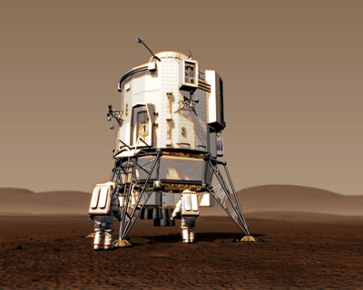
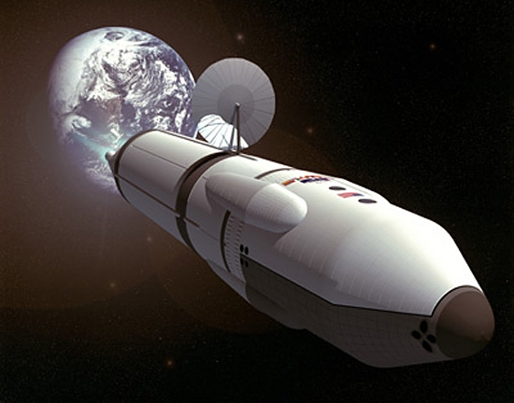

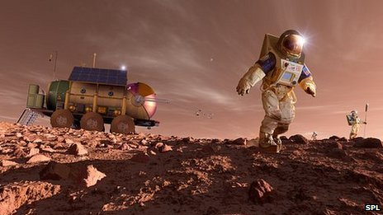
24. What absolutely freaky phenomenon was the Defence Intelligence Agency hoping to exploit in Project Stargate?

OK, this is absolutely true. In the 1980s, continuing through to 1995, the DIA recruited people who they hoped would have superior psychic abilities, and in particular the ability to engage in what is known as "remote viewing". Supposedly, certain gifted people can put themselves into a state in which they can transport their consciousness to any chosen spot on Earth, and look around when they get there. It's similar to the purported phenomenon known as "astral projection", or "out of body experience". The remote viewer, lying on a couch in some basement in Idaho or some such place, was thought to be able to visit, purely with his or her mind, places that were thousands of miles away.

The hope was that you could ask them to go have a peek at secret Soviet facilities, that sort of thing, and they investigated it for years. It was eventually deemed a failure, producing nothing more than vague and inconclusive information, but rumours persist that now and again the remote viewers really did provide accurate intelligence. Sceptics, of course, say this is nonsense. Those who have reviewed Stargate's protocols say it lacked proper controls, and didn't follow the scientific methodology needed to critically evaluate such a hypothetical phenomenon.

Still, isn't it wild that they even tried?




25. What is Kirlian photography?

Kirlian photography is a superficially spooky technique for detecting a sort of energy field – "electro-coronal discharges" - that surrounds objects both living and inanimate. It was developed by a fellow named Seyman Kirlian back around the time of the Second World War.

To get the effect, one has to place an object on a photographic plate and then run a charge through that plate, which causes the discharge that gets recorded. What's spooky about it, if you don't understand the technology, is that Kirlian photos seem to be recording evidence of an aura, or even a person's soul or life force, and this has lent itself to all sorts of pseudo-science and New Age mumbo jumbo. Since you can take a Kirlian photo of a hammer or a lug nut, it clearly can't be evidence of the immortal spirit of living things.

It's pretty, though.



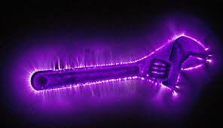


26. What, exactly, is “fascism”, and what’s the origin of that word?

Fascism is a sort of totalitarianism that glorifies the state above all individual concerns. It winds up in more or less the same place as Communism, but gets there under a different philosophy. It’s extreme right wing as opposed to extreme left wing, for those keeping track. To the individual, it means bleak servitude to a dictatorial government that permits no dissent, and demands utter obedience. I suppose the one big difference is that Fascism is thoroughly capitalist, and is quite happy to see corporations make vast fortunes, so long as they don’t get in the way of government, whereas Communism seeks to do away with private enterprise. I guess if your name is Krupp or Messerschmitt, that’s an important difference.

It’s an Italian term, based on a Latin word – the “fasces” was a Roman symbol, a bundle of sticks tied around the handle of an axe, that served as an emblem of Imperial authority. Benito Mussolini, who rose to power in Italy before World War II, was Fascism’s first great proponent, and had every ambition to recreate the Roman Empire. He ended up hanging from a lamp post, but it was a hell of a run while it lasted.

I suppose there might be a slightly different philosophical underpinning to National Socialism, which gave rise to the Nazis, but not so much as to matter to the ordinary schmuck who gets to bend every sinew in support of the ever-so-glorious state. The general idea is to promote war, the subjugation of other countries, and the attainment of a national destiny to rule the world. Ideas about racial purity and cultural superiority inevitably form part of the mix. It can’t be your destiny to rule all the peoples of the Earth and turn all others into slaves if you’re not actually better than everybody else - duh.

As Woody Allen once said, bricks and baseball bats are the only things they understand, and the only way to deal with them.




27. Where can you find the world’s tallest bridge?

In the south of France, near the town of Millau, a quirk of geography carved an extremely deep river valley that formed a significant impediment to transportation. You had to descend a long winding road on one side to reach the valley floor, and climb a similar road up the other side in order to get from A to B. A very large pain in the large muscle groups.

The solution is an extraordinary bridge that spans the valley, the Millau Viaduct, with towers that reach a height of 1,100 feet – taller than the Chrysler Building – from which is suspended a bridge deck that hangs about 900 feet above the valley floor below, and is close to a mile and a half in length. It isn’t just a monumental engineering achievement, it’s an aesthetic masterpiece, breath-taking in its beauty and symmetry.

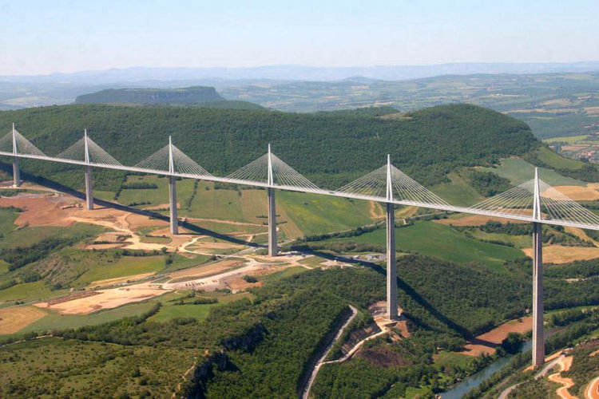

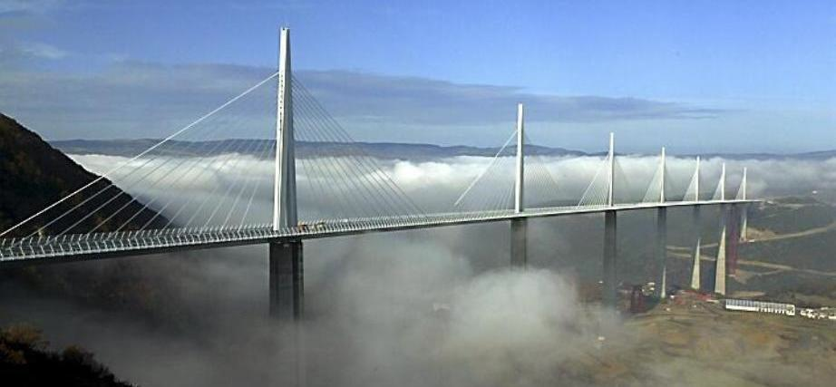

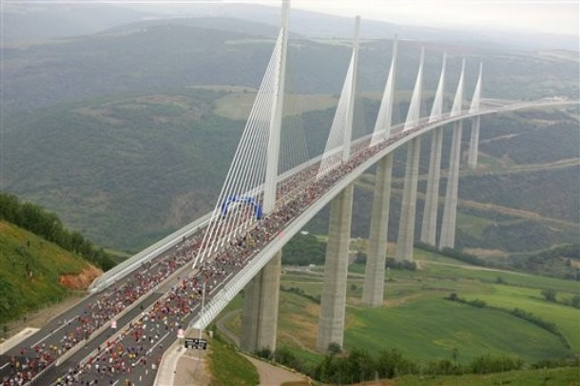
28. What was Cosmos 954, and why was it a problem?

Cosmos 954 was a Soviet military satellite – a “spy satellite” – designed for ocean surveillance, and the Russians decided to dispense with all that solar panel rigmarole and power it with a small nuclear reactor instead. More juice for the radar, yes?

Something went wrong when they launched it, and it never achieved a stable orbit at an altitude high enough for its radioactive material to decay before it fell back to Earth. That would have taken several hundred years. Instead, it tumbled back into the atmosphere and re-entered about a year after its launch, in 1978, and, not being designed to ever return safely to Earth, broke into thousands of little pieces, scattering about a hundred pounds of enriched uranium as it plummeted to destruction.

As luck had it, the satellite’s debris footprint included about a hundred thousand square kilometres of the Canadian Northwest Territories, necessitating a huge and expensive clean-up effort. I read at the time that if some passer-by had pocketed an interesting looking chunk of the thing as a souvenir, he’d have dropped dead in his tracks by dinner time. There was plenty of warning and tons of publicity, so when the thing crashed, everybody up North knew better than to pick-up any strange looking bits of metal.

The mission to gather up all the radioactive bits was a joint US-Canada effort dubbed “Operation Morning Light”.

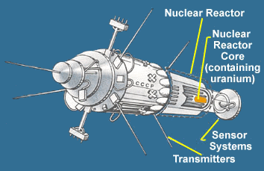
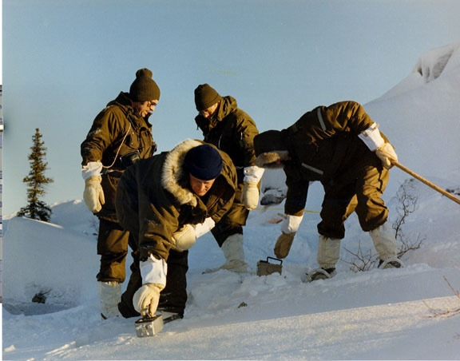


29. What is usually regarded as the first science fiction movie?

I bet you’ve seen a clip from the silent film adaptation of Jules Verne’s A Trip to the Moon, made in France way back in 1902. Intrepid explorers are fired from an enormous cannon right into the eye of the Man in the Moon, and encounter angry aliens before managing to return. Interestingly, the landing back on Earth is in the ocean, as it later was throughout the American space program prior to the Shuttle.

The movie was a sensation at the time. Special effects! Exploding aliens!

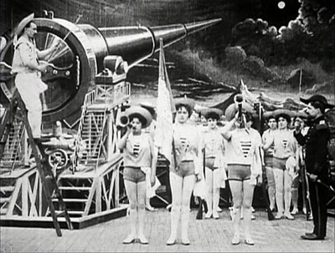

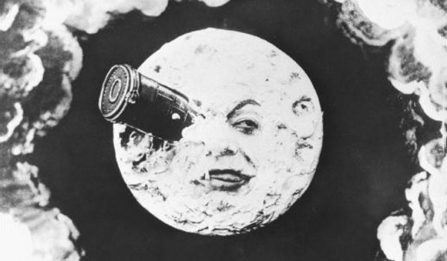

You can watch the whole thing on YouTube, it’s about 10 minutes long. It looks pretty goofy to modern eyes, lots of wild theatrical gesticulating and jumping about. The first two minutes seems to be a bunch of foppish astronomers standing around and yapping.

https://www.youtube.com/watch?v=7JDaOOw0MEE

30. What’s a “drumlin”?

It’s a knobby sort of hill left behind by glaciers, which scour the landscape as they advance, pushing along softer earth and such. When the glaciers retreat, smooth formations of the accumulated debris are left behind. They have a sort of streamlined, teardrop shape.

My home town of Halifax has drumlins all over the place. Citadel Hill, on which the great fortress was built, is one of them, as is George’s Island in the Harbour.

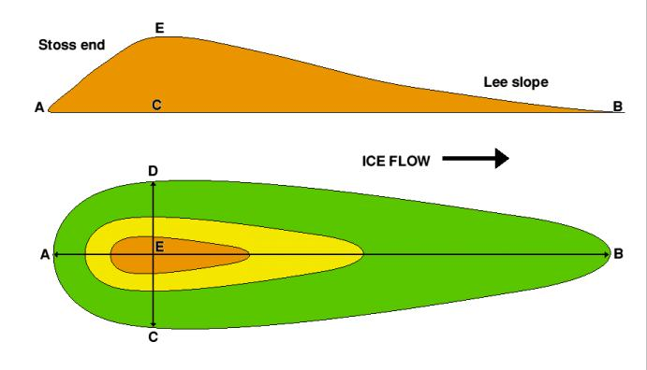

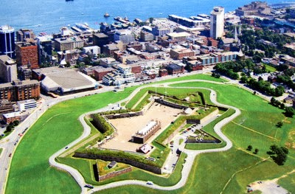

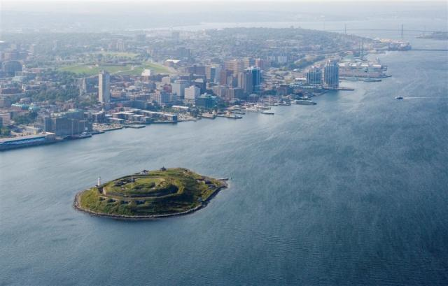
31. Some helicopters are classified as “NOTARS”. What the heck does that mean?

The rotors of a helicopter produce a lot of torque, and the machine would tend to spin in circles on its axis, except that the rotational motion is, typically, counter-acted by a vertical tail rotor that pushes against the momentum. Some big choppers, like the Chinook, have twin rotors that spin in opposite directions, cancelling each other out.

The tail rotor can be fragile, and its failure is catastrophic – just watch Black Hawk Down – so some helicopters employ a new method in which thrust is bled off the main engine and pushed out of slots in the tail, to provide the counter-acting force. “NOTAR” stands for “NO TAil Rotor”.



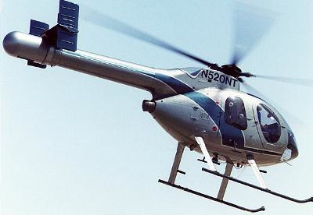


32. What’s so special about Pulse-Doppler radar?

Fighter aircraft began to be fitted with radars in World War II, initially for night-fighting. By the 1960s, most fighters carried some sort of radar in the nose, either to provide ranging and aiming data for guns, or, in big “all-weather” designs like the F-4 Phantom, to facilitate long range engagements, day or night, with radar-guided missiles. If everything went right, a Phantom could shoot you down about 15 miles away.

Well and good, but airborne radar suffered from a huge drawback. As you zipped along at high altitude, all you saw was clutter reflected from the ground if you pointed it at anything below you. Any enemy could get past you just by “flying in the weeds”, its small blip impossible to discern amidst the returns from the surface, and the highly reflective rocks, hills, and buildings that tended to be all over the place down there.

In other sets of questions we’ve discussed the Doppler Effect, the tendency of light waves to compress in the direction of movement, and stretch opposite the direction of movement. With visible light, an object moving towards you appears to be blue, which is a higher wave length, and one moving away tends to be red, a longer wavelength. This is a boon to astronomy.

Well, radar exploits radio waves, and radio waves are a form of light. They too are subject to the Doppler Effect when the object emitting them is moving. Moreover, emitting radio waves is no different, physically, from reflecting them. If I shine a radio wave at a moving object, I can tell from the Doppler shift of its reflection which way it is going.

I can also tell whether it’s moving at all, and this is how Pulse-Doppler radar cured the problem of ground clutter. Every object on the ground is moving relative to an aircraft, but another aircraft will have a relative motion, and thus a Doppler shift, that is different from rocks and trees. By analysing the Doppler shift of each pulse, the radar can filter out the stationary stuff, and show only what’s returning from something that is moving relative to the ground. Suddenly, the plane that was lost in the weeds is the only bright, shiny blip on the screen.

Doppler radar has useful civilian applications, such as in weather radars that track air masses, and detect wind shear at airports, but its main application is in fighter aircraft. All fighters have Doppler radars these days, and as they’ve become progressively more powerful and sophisticated, sneaking in at low level has become a very dicey proposition. High-flying interceptors can see you, and pick you off, with what they call “look down” radar.

Doppler radar is also used by the police to see how fast you’re going. The extent of the Doppler shift gives you away.

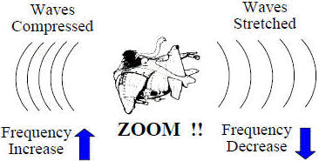



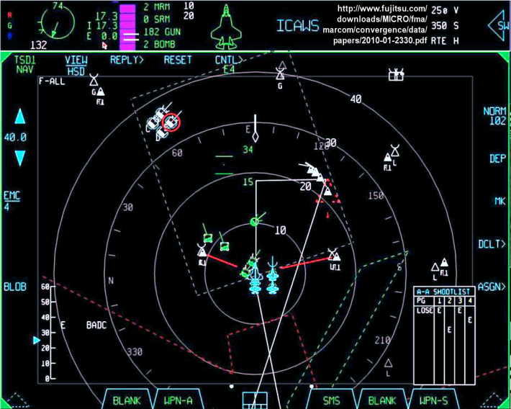

33. What’s so special about a Tuna?

The Tuna is a noble fish, an evolutionary masterpiece of hydrodynamics and propulsion. Some species, like the Bluefin, can swim at close to 50 MPH, and some sources claim even higher speeds for species like the Wahoo, rivalling our best torpedoes. More amazing, though, is that Tuna, unlike other fish, but just like you and me, are warm-blooded.

They don’t have the same sort of endothermy we do, but they can fairly be described as “endothermic” since they regulate their body heat internally through metabolic processes.

Tuna maintain a constant body temperature through the ceaseless use of their powerful muscles, which run hot, and they have a sophisticated set of veins and arteries to circulate hot blood from the core out to the skin and back, regulating temperature. Tuna thus maintain a body temperature that is warmer than the water they swim in, though not within the very narrow range typical of mammals.

No amount of engineering and computer-assisted design could arrive at a better swimming machine than the mighty Tuna. They’re perfect.

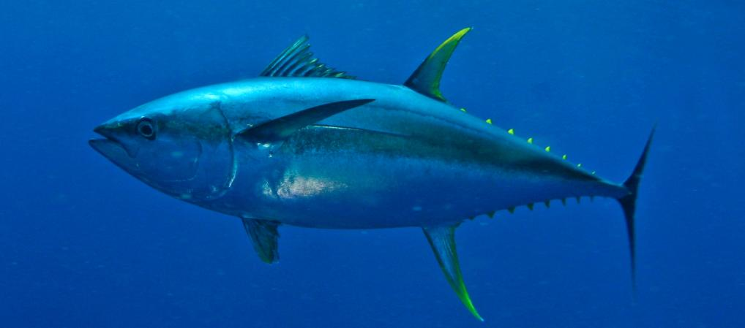

34. What are referred to as “the building blocks of life”?

Protein is assembled from a family of compounds known as Amino Acids, which means that a large portion of your body is, too. In a set of experiments in the 1950s, biochemists created an enclosed simulation of the atmospheric conditions thought to have existed on the primordial Earth, and found that large quantities of several organic compounds, including amino acids, were formed out of chemical reactions. More recently, astronomers have detected the signature of certain amino acids within interstellar dust clouds.

It would seem, then, that there is nothing unusual about the building blocks of life, and that essential organic compounds arise easily out of conditions such as those that prevailed early on our planet, and even exist in space. It may well be that organic compounds literally fell to Earth from the heavens when our planet was young.

But how do these building blocks get assembled to become something living? It takes a set of instructions – DNA or RNA – to pattern organic molecules into living things, and where did that come from? It’s one thing to have the necessary components lying around in abundance, but what causes it to assemble itself into something that can grow, reproduce, evolve, and, well, live?

They’re working on that:

http://news.sciencemag.org/biology/2015/03/researchers-may-have-solved-origin-life-conundrum



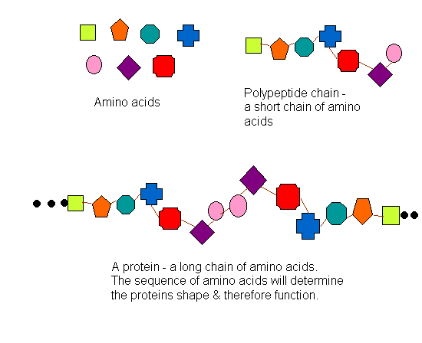
35. Do Flying Fish really fly?

No – like flying squirrels, flying fish have perfected the art of gliding. Still, what an amazing adaptation. It’s one thing for critters that live in trees to develop the knack for gliding a bit when they jump, but the idea of fish developing fins that will let them glide above the surface of the water when they leap powerfully out of their natural habitat, well, that’s kind of wild.

They can stay airborne for significant distances, 500-700 feet at a time. Some species do even better, by flapping their tails in the water below to supply forward thrust – which, come to think of it, really is flying.

It is supposed that they do this to evade predators. From the perspective of an attacking fish, it would be as if the flying variety has the ability to leap into another dimension to get away. It made the jump to hyperspace, captain!

If they didn’t exist, and instead George Lucas or somebody imagined one for a sci-fi movie, you’d probably laugh at how improbable and silly an idea it was. Nature is amazing.






36. “Dogies” aren’t dogs, so what are they?

A “dogie” was what cowboys used to call calves. Hence “Ride around little dogies”, a phrase you hear in the old cowboy song “I Ride an Old Paint”. A “Paint” is a multi-coloured horse, and the cowboy isn’t instructing the calves to ride around, he’s riding around them, singing, in order to keep them calm at night and prevent a stampede.

Ride around, little dogies
Ride around them slow
For the fiery and snuffy
are a-rarin' to go

Cowboys really did this.

Listen to Linda Ronstadt:

https://www.youtube.com/watch?v=tAHGbhmGttQ

My favourite composer, Aaron Copland, used this old song in his dance suite “Rodeo”, in a piece called “Saturday Night Waltz”.

https://www.youtube.com/watch?v=a9VcqwQIcOk

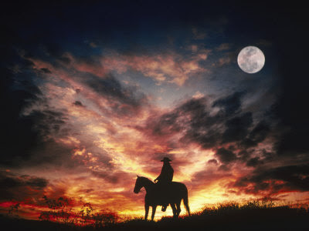
37. What’s the driest, most parched place on Earth?

The Sahara? The Gobi? Not even. According to most sources the driest place in the whole wide world is the Atacama Desert in South America, just West of the Andes, bordering Peru and Chile. It gets maybe 15 mm of rain a year – a year.

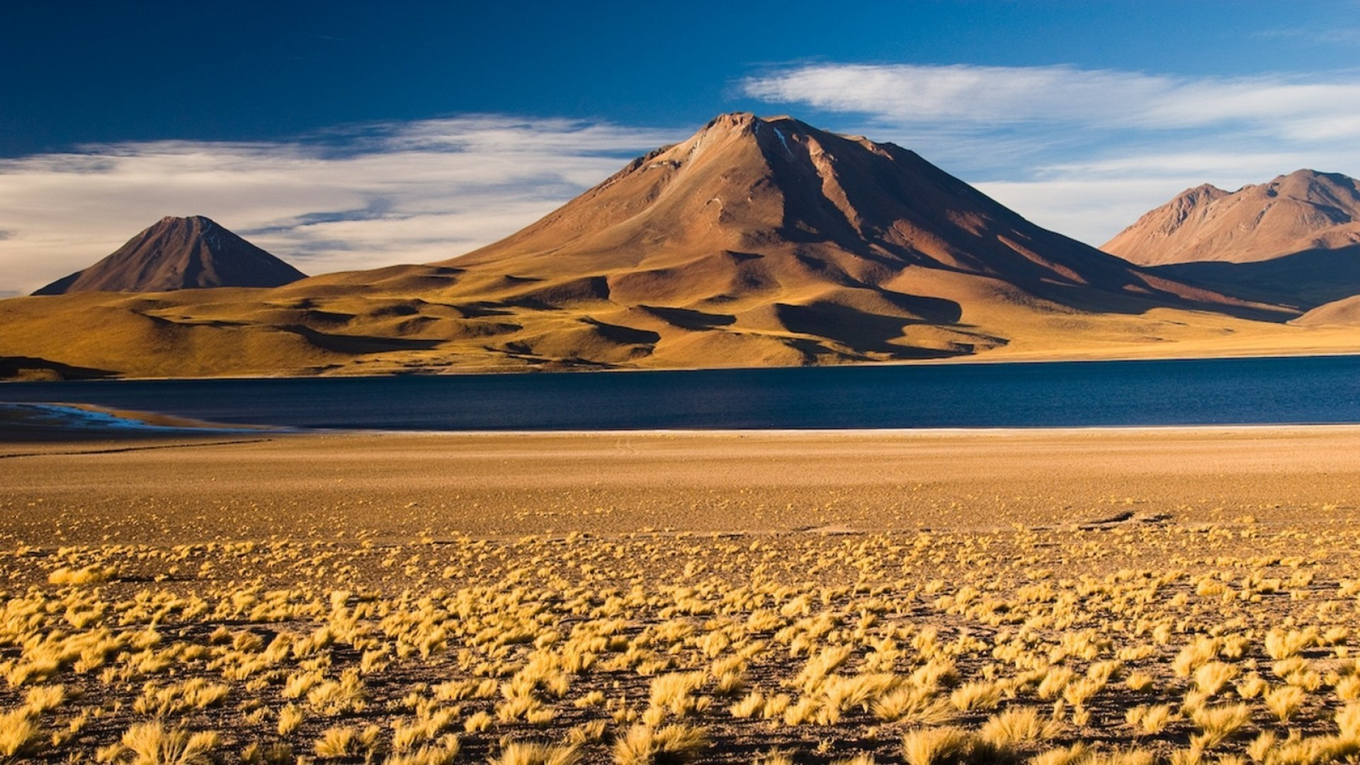


38. What’s Bakelite?

One of the first synthetic substances, a sort of plastic, it was the invention of one Leo Baekeland of Yonkers, New York, and was introduced in 1908 or so. It was a polymer, and could be moulded into just about any shape you wanted. Hard and heavy, it was good for making piano keys, billiard balls, the shells of appliances like radios, telephones, you name it. At one time it was ubiquitous. You probably couldn’t go a day without touching Bakelite in some form or other.

It’s still used today to make things like dominoes, dice, chess pieces, and so on, and its incredibly high resistance to electrical current makes it useful in some electronic applications.


39. What does a photovoltaic system do?

It converts sunlight into electricity – solar panels are photovoltaic. Actually, “solar panels” are technically panels that use the Sun to generate heat, whereas “photovoltaic panels” turn Sunlight directly into electric power. Some materials exhibit the “photovoltaic effect”, that is, they absorb photons and shed electrons, the stuff of electricity.


40. “SALT” had nothing to do with cooking, and “START” had nothing to do with getting going. What were they about (hint: they’re acronyms)?

Both were important strategic arms limitation treaties between the U.S. and the U.S.S.R. “SALT” stood for “Strategic Arms Limitations Talks”, which began in the early 1970s under the Nixon administration. SALT I and SALT II brokered significant reductions in the number of strategic nuclear warheads held by both sides. “START” stood for Strategic Arms Reduction Talks, and two START treaties were negotiated in the 1990s; Russia pulled out of START II in the early 2000s, but the US negotiated a new treaty with Russia - the Strategic Offensive Reductions Treaty (SORT), which was supposed to have reduced strategic arsenals to no more than 2,200 warheads apiece. SORT has in turn been superseded by a further treaty called New START, signed in 2010, which is meant to impose a 10-year process in which Russia and the US will limit the number of deployed strategic nuclear warheads to around 1500 each, though this does not limit the number of inactive warheads held in stockpiles.

This is a massive reduction from the arsenals deployed at the height of the Cold War, but as relations between East and West enter a new chilly era, one wonders if Putin’s Russia will withdraw from the treaty.


41. What was “the world’s first five-fingered satellite”?

The first American to exit his spacecraft and perform a tethered “space walk” was astronaut Ed White, during the Gemini program in 1965. White floated outside his capsule for about 20 minutes, and was clearly exhilarated. Houston was worried he was getting a little too exhilarated, actually. Here’s the transcript as fellow astronaut Jim McDivitt tries to talk White into coming back in to the capsule:

McDIVITT: They want you to get back in now.

WHITE (laughing): I’m not coming in… This is fun.

McDIVITT: Come on.

WHITE: Hate to come back to you but I’m coming

McDIVITT: Gosh, you still got three and a half more days to go, buddy

GEMINI CONTROL: You’re got about four minutes to Bermuda.

WHITE: I’m trying to…

McDIVITT: O.K. O.K. Don’t wear yourself out now. Just come in… How you doing there?

WHITE: … whenever a piece of dirt or something goes by, it always heads right for that door and goes on out.

McDIVITT: O.K., come in then.

WHITE: …aren’t you going to hold my hand?

McDIVITT: No, come on in the… Ed, come on in here!

WHITE: All right. I’ll open the door and come through there…

McDIVITT: Come on. Let’s get back in here before it gets dark.

WHITE: It’s the saddest moment of my life.

While White was floating around, having a ball, a spare glove drifted out of the Gemini capsule’s open door and went into orbit, becoming “the world’s first five-fingered satellite”. It was one of the first objects to be lost in a space walk, but by no means the last. Astronauts conducting EVAs (“Extra-Vehicular Activities”) on the International Space Station have lost something like 50 items, including a camera, and a whole bag of expensive tools worth about $100,000, which burned up upon re-entry in 2009.

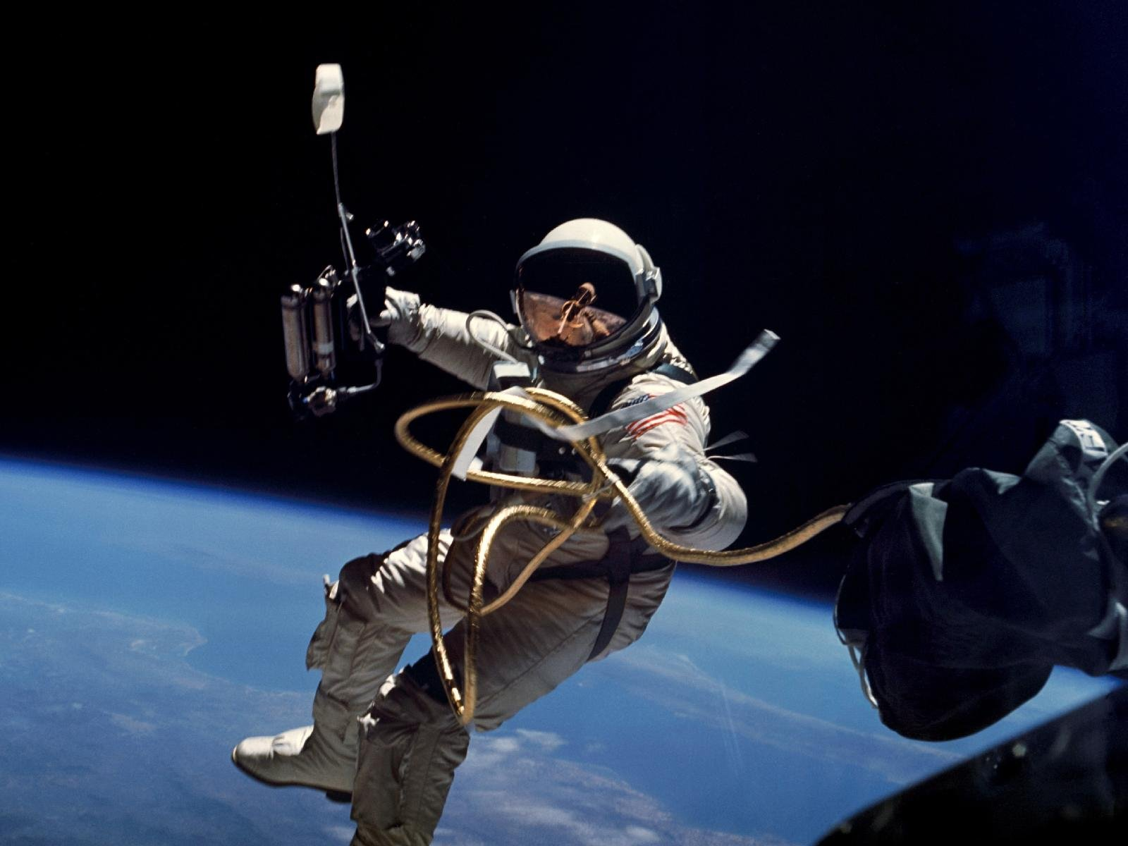
42. What makes it possible for iPods and the like to hold thousands upon thousands of songs, and why does that sadden audiophiles?

The problem of storing and transmitting the large quantities of data encoded into music and video files was tackled by the Motion Picture Experts Group, a sub-group of the International Organization for Standardization, in the 1990s. Their “MPEG” standards embody a clever solution to the problem of huge files: Data Compression.

“Compression” is just a polite word for “throwing out information”. The video standards, MPEG2 and MPEG 4, use sophisticated algorithms to analyze frames of a moving picture and detect information that isn’t changing from frame to frame. The redundant data is then tossed out – you don’t need to keep supplying information for something like, say, a framed picture hanging on a wall in the background of a scene. This allows you to vastly reduce the amount of data, such that you can fit a whole movie onto a DVD or BLU-Ray disc, or stream it from an on-line service like Netflix.

MPEG-1 Audio Layer 3 (which gives us the ubiquitous “.mp3” suffix) was developed for music. Again, the aim is to throw away as much information as possible without utterly destroying the music. To do this, the compression algorithms embody a technique called “perceptual encoding”, which is designed to eliminate data for sound that the human ear is not supposed to be able to hear. They can end up chucking out as much as 90% of the information in a sound file.

We audiophiles don’t agree that you can’t hear the difference. We think files produced by “lossy compression” methods like MP3 sound like crap.

There are forms of compression that purport to be “lossless”, like Apple’s iTunes ALAC system. It’s sort of like a zip file for music, and it’s claimed it can cut the size of an audio file in half with no loss of fidelity. Explanations on how this works are too technical, generally, for your faithful scribe to understand, that’s just not the degree I took, but one source put it into lay terms that make sense to we rubes who don’t talk computer:

Imagine you’re drafting written instructions for someone to use in order to recreate a picture that contains 200 red dots. You could write “red dot, red dot, red dot” etc. 200 times – or, you could write “200 red dots”. No information is lost, but we’ve used a lot less space to convey it.

We audiophiles aren’t so sure we believe that.

It was hard enough for us to give up analogue music on tapes and vinyl records in favour of CDs. An analogue recording captures all the music in a sort of continuous wave form. A CD uses digital information assembled by a system that measures 16 different parameters of a piece of music 44,100 times each second. Thus “16 bit 44.1 K” resolution. It’s the difference between looking at a bat flying around in a room lit by incandescent light, vs. one lit by a strobe light that flashes quickly. You can still follow the bat around with the strobe light, but the dark periods, however brief, change the viewing experience.

Early CDs sounded quite crappy, but this was due both to technical factors that were fixable, and sound engineers not knowing how to set up microphones and record levels in the studio in the optimal way for digital recording. I’m persuaded by the overwhelming weight of expert opinion that a modern CD fully captures the essence of music (though many of my audiophile brethren do not, hence the growing popularity of “high resolution” formats, and the survival of vinyl records).

But when you get into lossy vs. lossless compression, bit rates, perceptual encoding, and all that jazz, well, I just don’t know. To the extent possible I’m sticking with my CDs, as long as they exist.

And anyone who wants to take the Pepsi Challenge can come over to my place and hear what a CD sounds like when you’ve transferred it to high quality analogue tape and play it on a machine like a Nakamichi CR-7 cassette deck, properly tweaked and bias-adjusted. It’s far, far better, more crisp, more detailed, more rich. Doubt it? Those with ears, let them hear.
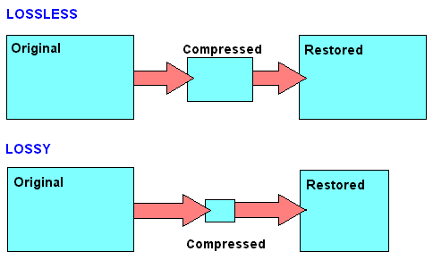


43. In 1979, people were so worried about something that they reminded me of Chicken Little crying that “the sky is falling!”. What had them all in a lather, and why was there nothing whatever to worry about, really?

In the mid 1970s, using components left over from the Apollo program, the Americans put a space station they named Skylab into low Earth orbit. It was a big roomy vehicle, and a great success. I remember neat experiments like seeing whether a spider could learn to build a web in Zero-G (it could), and long-duration flights of two months or more gave us insight into the effects of weightlessness on the human body (mostly bad).

Over time, its orbit began to decay, and by 1979 it was starting to skim the upper atmosphere as a prelude to re-entry. It had no heat shields, wasn’t designed to come back safely, and was therefore doomed to burn and break up. The general public, aware of the great size of the station, whipped itself into a state of near hysteria at the prospect that it wouldn’t fully incinerate before it hit. Why, jeepers, you could be walking down the street one day and then bang, you’d be taken out by searing hypersonic space junk plummeting from the sky! People started wearing hats with “Skylab targets” on their heads, and as re-entry loomed, people actually worried that their number could be up. Skylab would break up over your home town, and that’d be it, curtains. You wouldn’t even know what hit you. One second you’re sitting there watching Days of Our Lives, the next you’re a slimy goo of charred tomato paste and there’s a 30-foot hole in the roof. What could we do? Where could we hide?

Now, Skylab was indeed a big vehicle, and large parts of it, like the lead-lined film vault, were expected to make it to the ground before they could burn up completely, but what people tended to forget was that it’s actually a pretty big world. Not only is it two thirds ocean, but population centres formed only a fraction of the land mass that Skylab’s bits might hit. The odds of any part of it hitting any sort of town or city were very small, the odds of it being your town or city infinitesimally small, and the odds of it being your frigging house on top of that were vanishingly small. NASA figured it was 1 in 152 that anyone anywhere would get hurt, and your odds as an individual were 1 in 600 billion.

Needless to say, I was laughing myself stupid at all the terrified yahoos planning to hide in their basements and pray, especially since it was known, and NASA had announced, that it would be coming down in the Western Pacific.

Upon re-entry, Skylab broke up over the Indian Ocean, and a lot of the bits that didn’t burn up landed in Australia, and some did fall amid little towns in the outback, west of Perth, but nobody was hurt.

Hesitantly, people all over the world emerged, blinking, from their impromptu bomb shelters, grateful to be spared. Under the inevitable laws of statistics, some of them were probably run over and killed that very day, having failed to look both ways before stepping in front of a bus. Some threats are more probable than others.

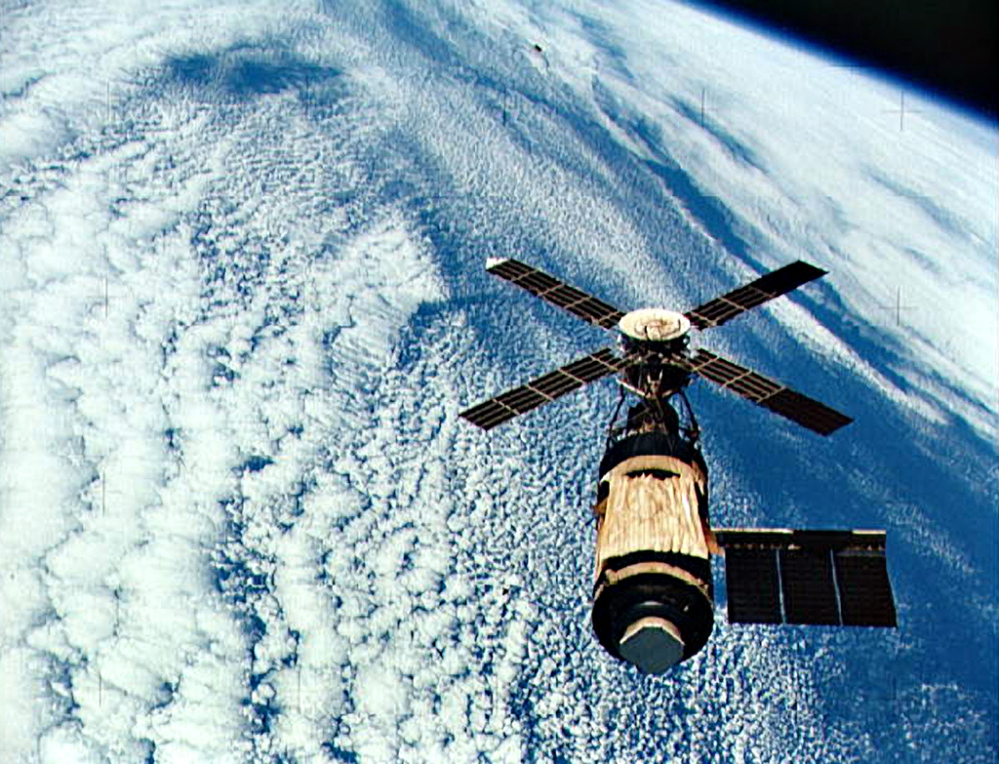

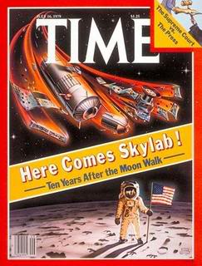

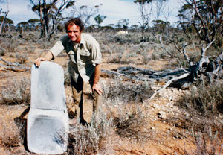
44. What’s so surprising about clouds?

Clouds are made of water vapour and untold billions of tiny droplets, spread so thin that they can hang there, suspended in the air, but nevertheless, water is heavy, and there’s a lot of it up there. A really big thunder cloud might hold as much as 275 million gallons of water, over a million tons – 10 times the amount displaced by an aircraft carrier. That’s about as much as goes over Niagara Falls in five minutes. Even a modest puffy cloud you see on a sunny day could be wafting along with 500 tons of water suspended over your head.


45. What does the acronym “PET” stand for, and how is it used?

“PET” stands for Positron Emission Tomography. A PET scanner tracks radioactive material – technically, positron emitting radionuclides – that is injected into patients attached to molecules used in the body’s metabolism, like water, or sugar. The position of the radioactive stuff is then tracked, and the machine builds up a three dimensional picture of metabolism at work. For example, by seeing where glucose is going, you can discern which parts of the brain are active in response to different stimuli.

It’s useful diagnostically, because it reveals how various organs are actually working, which is often more useful information than what you can glean from a simple image. It’s sort of like the difference between a regular photo of a person, and an infra-red scan. The photo may show me an athlete in a track suit. The IR scan will tell me whether that athlete has recently been running heats, or is just waiting for his event to start.

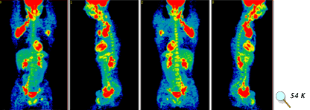

46. What about “MRI”?

A much different beast. “MRI” stands for Magnetic Resonance Imaging, and works like a sort of super x-ray to build up a three dimensional image of the internal structures of the body. Unlike X-rays, which are radiation that gets fired through you, MRIs induce the body itself to emit radiation.
Essentially, an MRI is a just a great big magnet. It’s harmless; a strong magnetic field is used to induce a person’s atoms, particularly hydrogen atoms, to line up in a certain direction, by attracting the protons, just like you might get iron filings to line up with one of those horseshoe magnets.

Short bursts of radio waves knock the protons about, and when those are turned off, they line up again under the influence of the magnet, and that process causes the atoms to emit their own radio waves. These emissions from your body’s atoms are analyzed and used to construct a picture in three dimensions.

In a way, it’s as if the MRI causes you to glow from the inside out.

It’s a far more gentle way of getting imagery than X-rays, which are deadly in large quantities, and dangerous in even small doses. MRIs are safe and non-invasive.

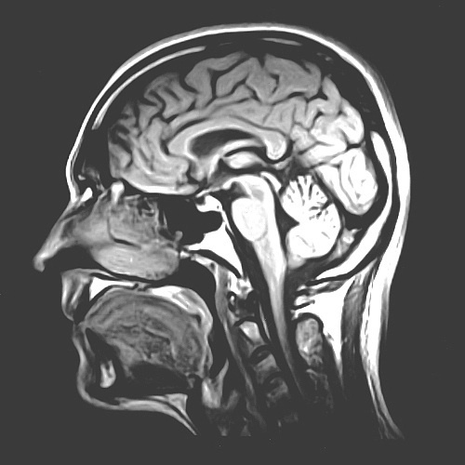

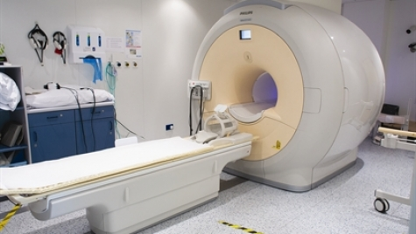
47. Many people were convinced the world was going to end on December 21, 2012. Why?

Blame it on the Maya, and their weird and wonderful calendar.

The Maya, like the Aztecs that followed them, were obsessed with cycles of time, and had what must be the most elaborate and accurate calendar system ever devised. They counted days in various increments that look strange to those of us who use the Roman calendar, and monitored the progress of different cycles in a system that seems needlessly complex.

A “Haab” cycle was 18 increments of 20 day units, to which they added a short “month” of 5 extra days to arrive at 365, a solar year. There were also overlapping “Tzolkin” cycles of 260 days, and the two cycles can be thought of as two interlocking wheels, one with 360 cogs, one with 260. As the two wheels turn, they set up different combinations of days, and no two cogs will repeat their combination for a full 52 years, which is called a “calendar round”.

The Maya also had a “long count” of days, with increments of 20, 360, 7,200, and 144,000 days being ticked off, until finally, 13 increments of 144,000 days, or 13 bactun, would equal an epoch known as a “Sun”, a Sun being 1,872,000 days long, or about 5100 years:

20 kin = 1 uinal
360 kin = 18 uinal = 1 tun
7200 kin = 360 uinal = 20 tun = 1 kactun
144000 kin = 8000 uinal = 400 tun = 20 kactun = 1 bactun
13 bactun = 1 Mayan epoch
1 epoch = 5125.26 Mayan years

Now, for reasons we still don’t understand, the Maya reckoned that the Sun, or epoch, they lived in began about 3100 BC – that’s when they calculated the “long count” started – and this meant that the end of the 13th bactun, the end of the current Sun, would fall on the Winter Solstice, December 21, in our year 2012.
The Mayan calendar has always fascinated occultists and New Age types, and there is something spooky about this relentless ticking-off of days, as if counting down to something big. Strained interpretations of Mayan beliefs and mythology led many to conclude that the end of the current Sun was, to the Maya, the end of their calendar, and therefore, the end of the world. The world was going to end in December 2012! The Maya had foreseen it!!

Actually, if the Maya had been around in 2012, they would have watched their long count tick over to “0”, and begun another one. It was the end of a cycle, not the end of the world.

More interesting is that the Maya believed that the current Sun was the Fifth Sun, so not only did they start their long count at a point far in the past, long before their civilization existed, they may have believed that a cycle of 5 such long counts had begun over 25,000 years ago. This intrigues me because 5 cycles of 1,872,000 days – 9,360,000 days in total – is 25,626 years, which is not a bad estimate – it is, in fact, an excellent estimate – for the time it takes for a full cycle of the precession of the equinoxes. That is, that in about that many years, all 12 constellations of the Zodiac will have taken a turn being the one behind the rising Sun on the morning of March 21 (a phenomenon that results from a wobble in the Earth’s rotation).

Maybe the Maya calculated a precession of the Solstices, not Equinoxes – any cardinal point of the year will do as the benchmark – in which case, the end of the Fifth Sun really would be a zero point, a time to start a new precessional cycle.

If so, then the Maya fit within a much larger global fascination with the precession, and the numbers that compose it, that you can discern across cultures and times all over the planet. There are spooky similarities between the increments of days that they counted and numbers that show up in other culture’s myths and religious stories, which are useful in calculating a different estimate for the precession. But that’s a story for a whole other day.

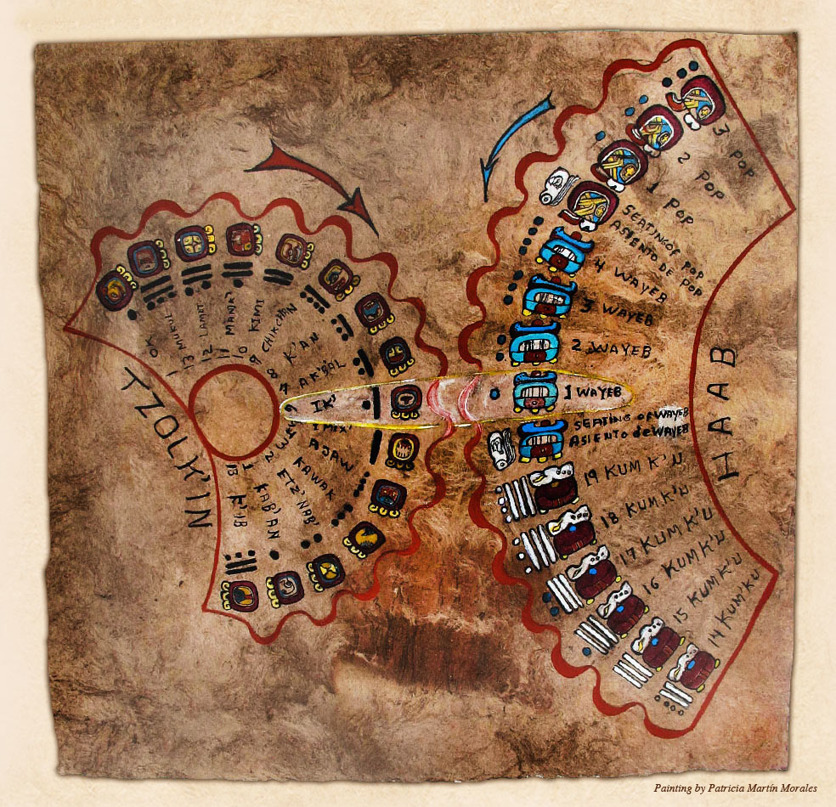
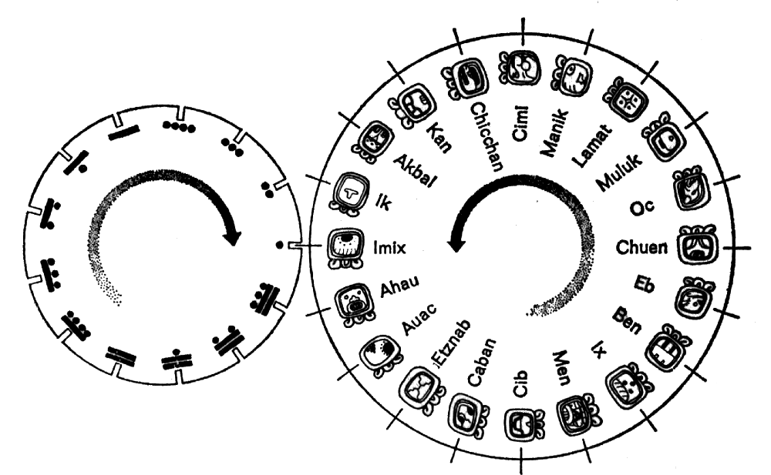
48. What was “mercantilism”?

It was an economic philosophy favoured by some European colonial empires, in particular Louis XIV’s France under the great finance minister Jean-Baptiste Colbert. It emphasized the acquisition of colonies with which the mother country could establish closed trading systems, promoting self-sufficiency, while pursuing a favourable trade balance with the outside world. Ideally, a mercantile power would become an exporter, rather than importer – goods would flow out, gold would flow in, national power and wealth would be consolidated.

The emphasis upon trade was a spur to the development of navies, which were needed to protect a nation’s merchant shipping, and protect overseas colonies.

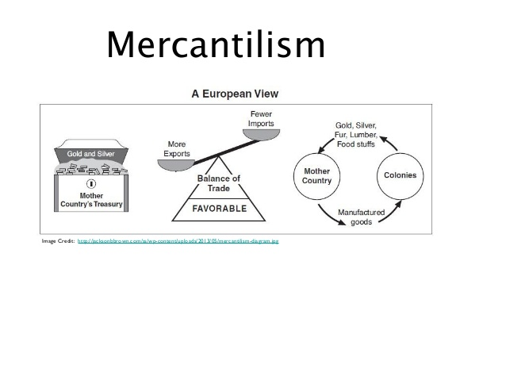
49. What construction project started costing so much that Louis XIV’s finance minister declared that he ought to have been able to see its spires rising above the distant horizon?

As European nations vied for national supremacy through the acquisition of colonies, military confrontation in far-flung corners of the world became inevitable. Everywhere the Europeans went, they built military facilities, and one such outpost was constructed in Louisbourg, Cape Breton, Nova Scotia, to support the French position in Canada, or “New France” to them. Cape Breton was then known as “Ile Royale”.

For various reasons, it cost a fortune. Colbert (see Question 48), going over the accounts back home, was flabbergasted – the finances were about as extravagant as you might expect today if you were building a fortress on the Moon.

The construction of heavy fortifications in Louisbourg was the impetus for the establishment of a rival English naval base in my home town, Halifax, which was founded in 1749.

For all the treasure expended on it, Louisbourg was not much of a military success. English forces captured it in 1745, gave it back under a treaty, and took it again in 1758, as part of the general campaign to conquer New France that formed part of the Seven Year’s War.

As Halifax thrived, Louisbourg was abandoned and fell into ruin, but in the 1960s a reconstruction and restoration effort was undertaken under the auspices of Parks Canada. Louisbourg is a tourist trap today, staffed by workers in period French apparel. It’s quite charming.



50. Who exceeded the speed of sound without using a plane, car, or any other type of conveyance?

In 2012, Felix Baumgartner, who holds several current records for skydiving, ascended under a balloon to almost 25 miles above the Earth before plunging into free fall, and exceeded the speed of sound on his way down.

According to Wikipedia, he reached a peak velocity of Mach 1.25, about 850 MPH at altitude.

https://www.youtube.com/watch?v=FHtvDA0W34I

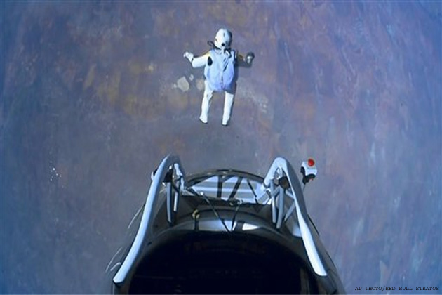

Naval architects insist that these vessels are perfectly stable. They just look top-heavy. Of course a ship can roll a lot and still be “stable”.
I’ve read that it was a term used for tall ships, with their high masts, before ever being applied to buildings.
“Monadnock” is a word for an isolated hill
Not everything went right a lot of the time, and apart from missile malfunction, a huge issue when you couldn’t eyeball what you were shooting at was the risk of shooting down a friendly plane, a problem meant to be addressed, with mixed success, by “Identification Friend or Foe” (IFF) systems. Long story for another day.
This may have something to do with tracking cycles of the Planet Venus
There’s a nice symmetry to this, given their overlapping 260 day and 360 day calendars; 9,360,000 is 26,000 x 360, or 36,000 x 260

