51. The F-111 was the first operational “variable geometry” aircraft, back in the mid-1960s. What was different about it?

“Variable geometry” is the fancy term for an aircraft that can change the shape or position of its wings, but we’re using it here to mean a “swing-wing aircraft”. The concept was first toyed with by the Germans during the war, and later by Bell Aircraft in an experimental X-Plane. The idea was that you’d sweep the wings forward for extra lift and manoeuvrability, and aft, into a highly-swept configuration, for speed. The best of both worlds! But of course the aerodynamics are tricky.

The first to be deployed in service was the General Dynamics F-111. In the mid-sixties, whiz-kid Secretary of Defence Robert McNamara commissioned the design as a “universal fighter” that would serve all tactical needs of both the Navy and the Air Force. They’re pursuing the same goal now with the F-35, and it’s as difficult and elusive now as it was then.

General Dynamics had no experience with naval fighters, so Grumman, which had plenty, was given the job of turning the F-111 into something that could land and take off from a carrier. Grumman shortened the nose so that pilots could see the deck as they approached at the high angles of attack typical of carrier landings, and lengthened the wings for more lift, but the F-111 was heavy, and with the engines then available, under-powered. The catapults could barely heave them off the front end, and the arresting cables could barely restrain them at the back, and after years of effort, Grumman cried “uncle”. It couldn’t be done. Anyway, the F-111 might have made a fine fleet defence interceptor, with its big radar and Mach 2.5 speed, but it was no dogfighter, and the Navy brass, watching Phantoms and Crusaders hassle with agile MiGs over downtown Hanoi, shuddered at the thought of the 45-ton F-111 wallowing around in close combat.

Grumman had a better idea. The guts of the naval F-111 included the mighty AWG-9 radar system, which controlled the rather amazing Phoenix missile, a weapon with its own radar in the nose that could be “ripple fired” six at a time, at ranges of up to 110 miles, and a speed of Mach 5, each finally slamming its target with a 100-pound warhead. That part of the F-111 worked. Grumman offered the Navy a new design built around this system that was also a pilot’s airplane and a dogfighter, and Grumman design 303E became the F-14 Tomcat. The day was thus saved by this last, and maybe greatest, Grumman cat, now sorely missed after its retirement a few years back. It wasn’t obsolete. No, far from it. But no new airframes had been built since the early 1990s, and the things were getting awfully expensive to maintain. The obvious answer was new and improved Tomcats. So of course Congress and the Navy opted for an enlarged F-18 instead.

The F-111 went on to be a superb long range all-weather strike bomber with the Air Force. In its wake, and following the unequivocal success of the Tomcat, many nations started building swing-wing designs, from the Panavia Tornado in Europe to the MiG-23 in the Soviet Union. Bombers like the B-1 and TU-160 had (and still have) swing wings. The idea has gone out of fashion, though, and no one expects any new designs to go into service. Swing wings are complicated, heavy, and difficult to make stealthy, what with the slots and seams that accommodate them. Still, people who know aircraft sure do miss the F-14.






52. How did an octopus named Paul obtain global fame back around 2010?

As a gag, the keepers of a sea life centre in Germany gave Paul the task of predicting the winners of World Cup soccer games. They’d offer him two identical boxes with an identical morsel inside, each with a flag of one of the competitors, and see which box, and therefore nation, Paul favoured in the match.

It was silly. It was hilarious. But Paul started getting the picks spookily correct. He had an 85% success rate, far better than random chance, and people started to believe that this frigging cephalopod, who easily outstripped the predictive efforts of football experts and commentators, really could pick winners. Somehow, it seemed, this octopus knew football, and knew a winning squad when he saw one. I bet people were making book on Paul’s advice. Don’t listen to that guy, go with the octopus! Sure enough, Paul picked Spain to beat the Netherlands in the final – right again, oh eight-legged seer. He had also predicted Germany’s third place finish.

He died of natural causes shortly after, and we’re still not sure what was going on, exactly. Dumb luck, I guess…

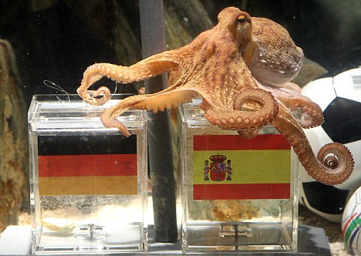
53. What’s your biggest problem if you want to tunnel out of a prison camp, as discovered by the Allied POWs who inspired “The Great Escape”?

Years ago, a writer named Barry Broadfoot collected the oral histories of hundreds of Canadian WW II veterans, and recorded them in a quite wonderful book called Six War Years. One of his interviewees was a fellow who’d been at Stalag Luft III when the “Great Escape”, later the subject of a big budget star-studded Hollywood extravaganza, was pulled off. In the movie, as in real life, the mass escape of POWs was at first a rip-roaring success, but in the end most were recaptured, and many, sadly, were shot for having made the attempt.

Anyway, this fellow had watched it all go down, and the first thing he said to Broadfoot was:

“Great big, hairy problem number one: what do you do with the dirt?”

The Great Escape was made possible by a long tunnel that went from the POW barracks to outside the wire. I mean, the one they used was long, about 300 feet or so, and a long escape tunnel leaves you with huge volumes of dirt, tons of the stuff, to somehow shift to the surface without anyone catching on. Impossible, really, but the solution was to hang it in little bags from rafters, spread it around the compound, use it in garden plots, and ultimately, since they were digging three tunnels, code named “Tom”, “Dick” and “Harry” - Imagine! - one of which hit the wrong kind of soil and had to be abandoned, they used the aborted tunnel to store the dirt from the others. One of the two remaining tunnels was then discovered, but the Germans never guessed that there could be still another one, just as the POWs had hoped. They used the survivor, “Harry”, to make their break for it.

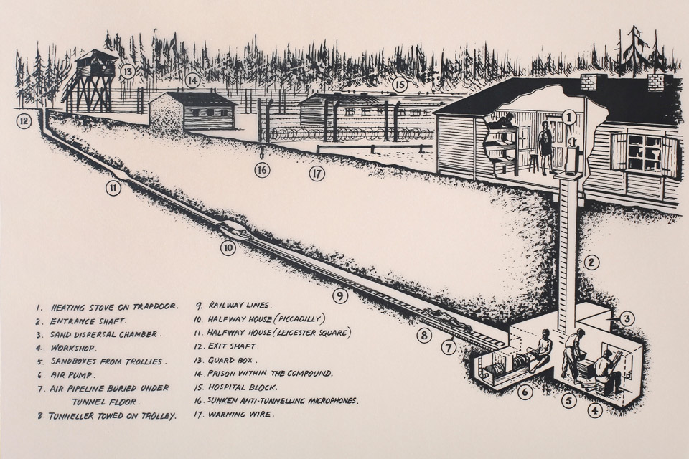

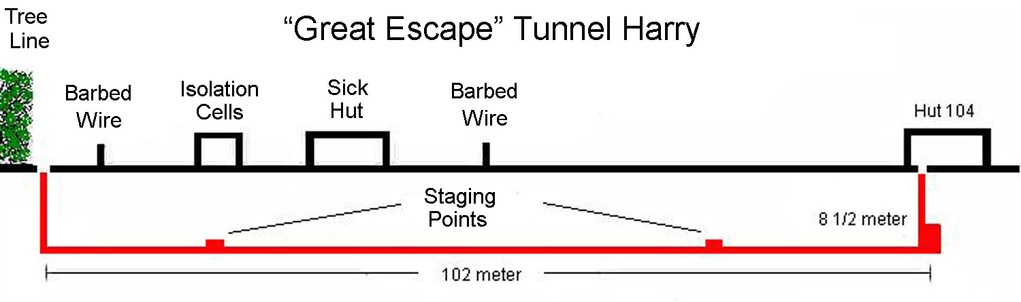
54. What device is often described as the most efficient machine ever made?

The plain old ordinary bicycle is often cited as the machine that does the most with the amount of energy it consumes. Think of it. Human muscle power is quite limited, yet on a bike, you can travel at 10-15 miles per hour, about 5 times walking speed, pretty much indefinitely. Who would relish the chore of walking, say, 20 miles? How about running it, then? Yet on a bike, that's just a nice ride. On the highway, you could probably do it in a couple of hours or so, and arrive refreshed.


55. Roughly how fast is the world spinning at its equator?

About 1,000 MPH. That means, then, that world is about 24,000 miles around. It spins faster at the equator than at higher or lower latitudes – see below.

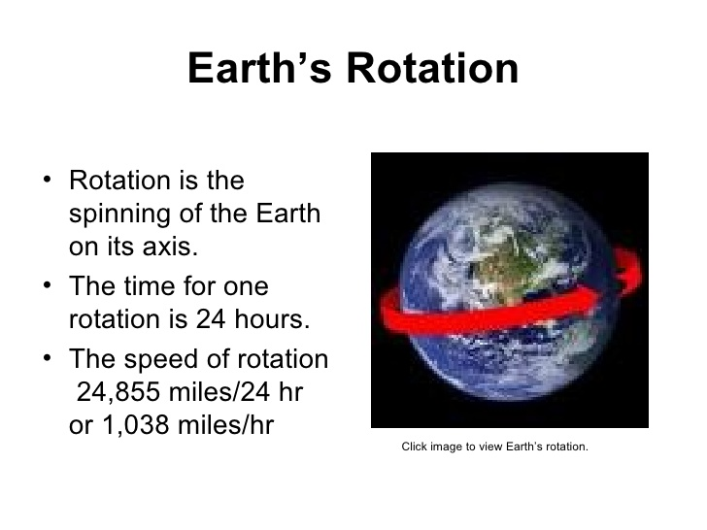
56. Speaking of the Equator, what can be proved by putting an atomic clock there, and another atomic clock at the Arctic Circle?

If you look at the world from the top or bottom, it looks pretty much like a spinning disc, or to date myself, a vinyl LP spinning on a turntable. The outer edge of the disc would be the equator, the centre the pole. Things fixed to a spinning disc spin faster and faster as they are placed closer to the edge – a full revolution happens in the same amount of time for any point on the disc, yet there is so much farther to go to make a circle when you're at the edge, compared with next to the centre, so if you do it in the same time you must be going faster, right?

Why is this useful? Well, Einstein predicted that time dilation is a product of speed – that is, the faster you go, the slower time passes for you. In the world as we perceive it, this is a pretty tough proposition to observe – you'd need to be travelling at a significant fraction of the speed of light before any difference was discernible to us, relying only on our senses, or crude instruments like watches. But atomic clocks can measure time in unbelievably tiny increments by monitoring the vibrations of atoms like Cesium – the latest measure time in ticks so short that there are 430 trillion each second.

Therefore, take two clocks that are that ridiculously accurate, put one at a high latitude (near the centre of the disk), one at the equator (the disk's rim), and see what time they each say it is after they've been spinning for just a little while. The experiment has been done, and yup, the slower moving clock near the centre measures more clicks than the faster moving one on the rim. These clocks are so accurate that placed side by side, they’d only be out of synch by a second or two after several billion years, so any divergence between them must be down to other factors. The difference is so miniscule that it’s hard to wrap your mind around, but the point is, the variance is measureable. The clock on the rim is measuring time at a slower rate than the one near the centre, and the only difference, after controlling for all other variables, is their relative speed. Einstein was right.

You can run the same experiment with stationary clocks compared to ones flown about in airplanes.
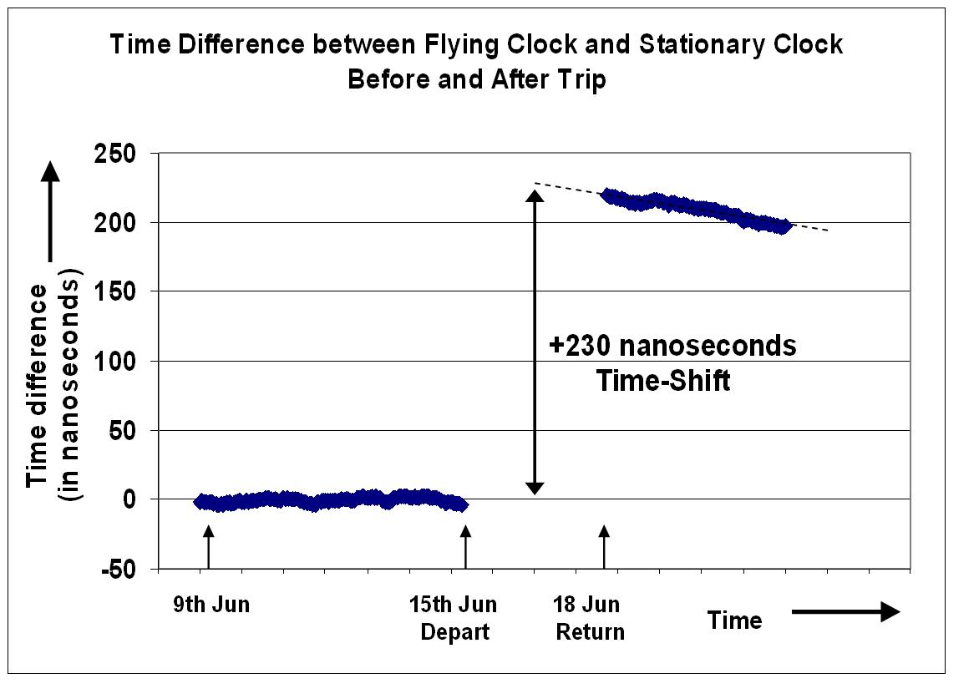


57. If we detected an asteroid heading for an impact with the Earth, could we do anything about it?

At present, no, no matter how much warning we have. Sadly, the Hollywood notion of knocking asteroids off track with nuclear weapons is just a fantasy; any asteroid dangerous enough to make us want to blow it up is far too large and solid to much care about an atomic blast in the vacuum of space.

However, scientists are conducting a survey of Near Earth Asteroids ("NEOs") and their orbits, and our observations and computers are accurate enough that we can plot their trajectories centuries into the future. Factors like the gravity of other large objects will change their orbits in slightly unpredictable ways, but we'll be able to tell, say, that the orbit that poses the greatest risk to us is 250 years from now.

With that kind of lead time, it would be possible to deflect the orbital path of a NEO just enough to make all the difference, without developing some sort of super weapon or mountain-moving warp drive. It could actually be quite simple.

Newtonian physics tells us that for every action there is an equal, opposite reaction. If you fire a gun there's recoil. The same is true with less energetic actions like throwing a baseball, and however small, the effect is still there. Thus, we could land a probe on a NEO that was designed to dig in, and throw chunks of the asteroid over its shoulder and into space. This would exert a minor recoil pressure on the asteroid. Each toss would make a miniscule difference, but over a couple of centuries, you could actually budge a large NEO, the kind that leads to extinction-level events, enough that it would miss us. You don't have to perturb the orbit very much at all, really. The tiniest overall percentage change in trajectory would cause it to miss its rendezvous with Earth.

Given the stakes, the fact that we know asteroid impacts have periodically wiped vast numbers of species off the face of the planet, and the risk that tomorrow, they may spot that fateful earth-crossing NEO, maybe we should get on this problem sooner rather than later?

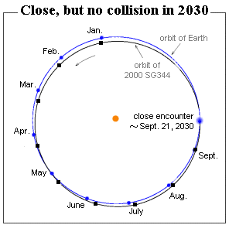

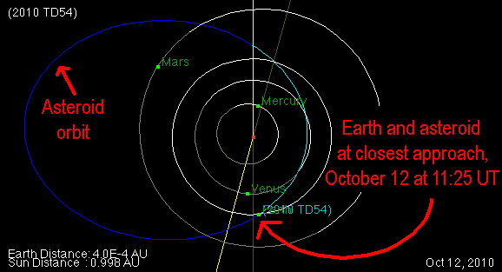
58. What was a Megalodon?

There are sharks today about as big as whales, like the Basking Shark, and the aptly named Whale Shark, but they share the lifestyle of whales, too, being placid filter feeders. The biggest toothy shark these days is the Great White. Megalodon (which means “Giant Tooth”) was essentially a Great White the size of a whale which terrorized the oceans until quite recently, geologically speaking, disappearing only about 2 - 3 million years ago. If you didn’t know it was true, you’d scoff at the idea of a shark this big:

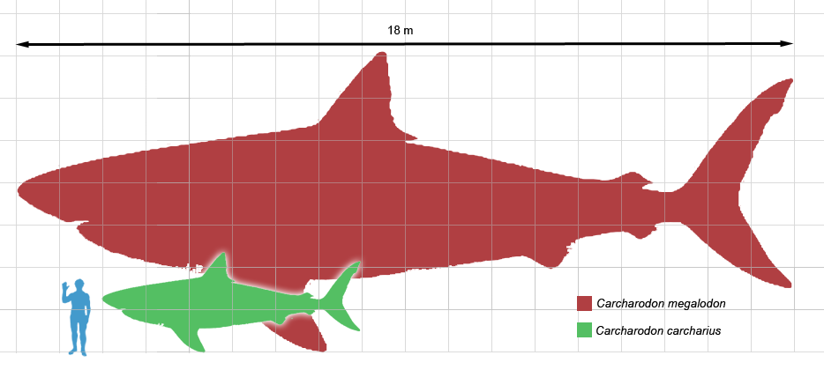



How on Earth, then, did the ancestors of modern whales cope with these things? Just about like you’d expect; a huge Great White deserves to be matched by an equally huge Killer Whale, a monster discovered quite recently called Livyatan Melvilli (“Melville’s Leviathan”, in honour of the author of Moby Dick). Hunting in pods, and perhaps blasting painful sonar pulses to deter rivals, Livyatan was a terrifying predator. Megalodon may have been inclined to give these whales a wide berth, just as modern sharks tend to book it when Killer Whales are around. It’s the kind of thing fan boys like to debate, but for my money, go with the animal with brains that hunts in packs.

Livyatan is actually an ancestor of the modern Sperm Whale, not the Killer Whale, but I doubt Megalodon cared much about that distinction.

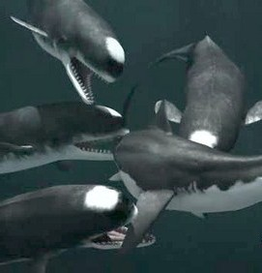

https://www.youtube.com/watch?v=Oknj0SzQX-k
59. How is it that Viking traders and other unscrupulous types were able to make a fortune selling Unicorn horns during the Middle Ages?

Sailing into Northern waters, Vikings came across Narwhals, whose long tusks - they’re not horns, but great long canine teeth – looked just like Unicorn’s horns were supposed to look. Bonus! If you didn’t know better, it would be easy to be fooled. I read somewhere that even Queen Elizabeth I paid a small fortune for one.

It is now thought that the Narwhal’s extravagant tooth, which lacks enamel and is full of nerve endings, may be a sensory device with which the animal tastes the surrounding water and evaluates its chemical content. Yet only males have them – is it another form of display, like antlers and such, too?

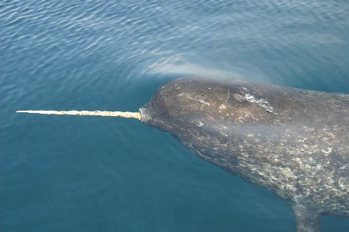
60. A 1994 book titled “The Hot Zone” raised public awareness of a devastating threat that few at the time even knew existed – what?

Back in ’94, I probably wasn’t the only guy around who’d never heard of Ebola. Richard Preston’s The Hot Zone laid it all out in gruesome detail, while describing a 1989 outbreak of an Ebola-like virus in a primate house in Reston, Virginia, just a few miles from Washington, D.C.

Scientists have roundly criticized the work, saying Preston over-sensationalized the effects and contagiousness of the disease, particularly in implying that Ebola can be airborne, like flu – which so far, it cannot. They’re right, of course, and The Hot Zone no doubt contributed to the general, and generally misplaced, hysteria that surrounded the contraction of Ebola by a handful of people in the U.S. last year; the book was back on bestseller lists at the time, as people sought to learn about the disease.

Still, nobody is saying that Ebola isn’t awful, and a certain amount of fear with respect to such things is not only justified, but useful in mobilizing resources to fight outbreaks in seemingly distant lands. In the age of jet travel, no place on Earth is really remote from any other, and I’d rather folks were jumpy than complacent – to a point, of course. The problem is, people seem to have only two settings, utter indifference or full-blown panic.


61. What was so frightening about a meeting of the American Legion held in Philadelphia in 1976?

Speaking of scary diseases, in 1976 numerous attendees at that year’s convention of Legionnaires (military veterans) came down with a deadly strain of pneumonia. Of 2,000 attendees, over 200 contracted the disease, of whom over 30 died, a very high and frightening mortality rate, particularly as it felled the young and healthy as well as the old and more infirm.

Investigators from the Centers for Disease Control were initially baffled as to its source; it was hard to communicate person-to-person, and seemed not to have originated outside the hotel venue of the convention – yet a couple of passers-by outside also caught the bug. It was eventually determined that the bacteria were breeding in damp places within the hotel’s air conditioning system, which then spread it through the hotel. The people who caught it while wandering by outside were struck by falling droplets of water condensing and dropping off the air conditioning system’s cooling tower. The bacteria that caused “Legionnaires Disease” was named “Legionella”, and it’s a constant threat whenever air conditioning systems are improperly maintained.


62. Who invented Chess?

Some historians think the game originated in China, while most say India. It seems to have appeared around 600 AD, and had spread to Persia, and from there to the Muslim world, within the next 200 years, eventually making its way to Europe. Truth is, nobody really knows who invented it, there’s no physical evidence old enough to mark its origin, or painted depictions of people playing it, or mention of it in any writings we know of, that date from any time prior to it becoming widespread and popular.

The game and its rules evolved over time, but in Persia, 1200 years ago, they were playing a version of chess that any modern observer would immediately recognize. This is a reproduction of an old Persian chess board:


63. What’s a “Gooney Bird”?

“Gooney Bird” was the name applied to Albatross by American servicemen who occupied Pacific islands during WW II, particularly Midway Atoll, which hosts a huge population. Albatross are extremely elegant flyers with long, graceful wings, and when aloft are nothing less than majestic, so it seems an odd nickname for them.

However, when they come in to land, they often make a botch of it, and they have a bit of a hard time getting back in the air, too, needing to run like scalded cats for several yards to get the required lift over those long slender wings. They can’t just leap into the sky like sparrows. They need a bit of runway. Picture Donald Duck in the hundred yard dash, his webbed feet going pitter-patter. While on the ground, they engage in elaborate and rather silly-looking mating dances, and generally look like avian goofballs – especially when they’re learning to fly.

Once they’re in their element, though, all the yuk-yuks stop. Nothing, natural or artificial, soars like an Albatross. If you’d only ever seen them aloft, hundreds of miles out to sea, a word like “gooney” would never occur to you, which is why, while we chortle here on the beach, awestruck sailors all but worship them.

https://www.youtube.com/watch?v=w8ZdtN69xF8

https://www.youtube.com/watch?v=vS7cK3JubWg

https://www.youtube.com/watch?v=2H9PQ6jt9us

https://www.youtube.com/watch?v=CZszfACuXjQ




64. What’s a “Cargo Cult”?

A fascinating phenomenon that illustrates what Arthur C. Clarke was saying in 2001: A Space Odyssey – any technology sufficiently advanced over your own will appear to you as magic.

During WW II, primitive cultures that inhabited islands like Melanesia had front row seats to high technology warfare on an unprecedented scale. They saw aircraft of various types, and when troops were landed they were exposed for the first time to vast amounts of manufactured goods that the foreigners brought with them. It seemed like gifts from the gods, and after the war a sort of religion developed, in which islanders believed that if they could entice the god-like outsiders back with the right kind of ritual ceremony, they could enjoy more of their marvellous bounty. On an island called Tanna, they even worship a deity called John Frum, who must have been an American serviceman, and pray for his return, when he’ll bring them more of the amazing things he gave them before, like Coca-Cola, and wristwatches.

So, to entice the gods, they build idols out of twigs that look like American aircraft of the period, and march about in ranks like soldiers, carrying wooden sticks to simulate rifles. They wave lovingly-preserved American flags. They even construct little imitation runways with imitation control towers, hoping to draw in planes with the beloved star symbols on their wings.





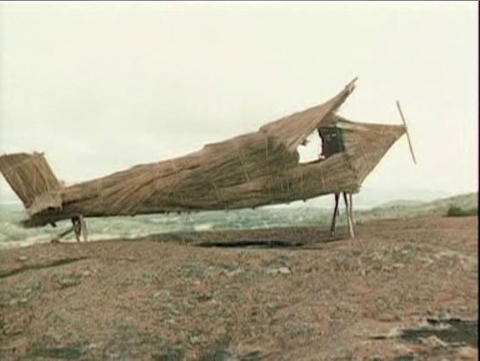


65. In 1968, most everyone was puzzled and confused by an image dubbed the “Star Child”. What was that about?

The Star Child is a strange, foetal entity that shows up floating in space at the conclusion of 2001: A Space Odyssey, and to many at the time it seemed like an especially inexplicable finale to a generally inexplicable movie. There’s not a lot of exposition in the film, and you have to pay attention, and strain to figure out what’s going on – I very much doubt that it would affect modern audiences the way it did in 1968. It’s too much work. They’d just be bored. Nothing blows up.

The premise is that some advanced and inscrutable alien race, evidenced throughout only by examples of its strange technological implement - a featureless, jet-black rectangular monolith - is guiding the course of human evolution. The aliens intervene with a rectangle when we’re still ape-like hominids, on the brink of extinction. The same aliens are apparently signalled when, millions of years later, astronauts unearth another such rectangle on the Moon. A third rectangle in orbit around Jupiter waits to encounter the space mission sent to find what the Moon device signalled, and it opens up a wormhole and transports an astronaut to some other dimension. There, a final rectangle proceeds to transform the astronaut from a physical animal into a being of pure energy. This, presumably, is the final step in our carefully managed evolution.

The Star Child is this ultimate entity, now viewing the Earth from space. It’s foetal because it conceives of itself that way, having just been “born”, but you get the feeling that it has almost infinite power, and can do anything, including turn all of us down here into fellow star children.

We’re not supposed to know, or even be able to understand, just how these mute and featureless rectangles are doing everything from planting bright ideas into the heads of primates to opening up star gates to other dimensions. We’re like Medieval farmers watching a guy playing a digital piano on his iPad, while he talks to unseen entities via this weird thing stuck in his ear.

So, you go to the theatre to see spaceships go whoosh and such, maybe hi-jinks with Robbie the Robot, ray guns, that kind of thing, and instead you get this:

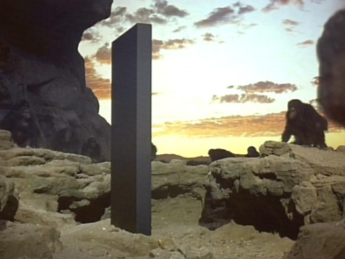


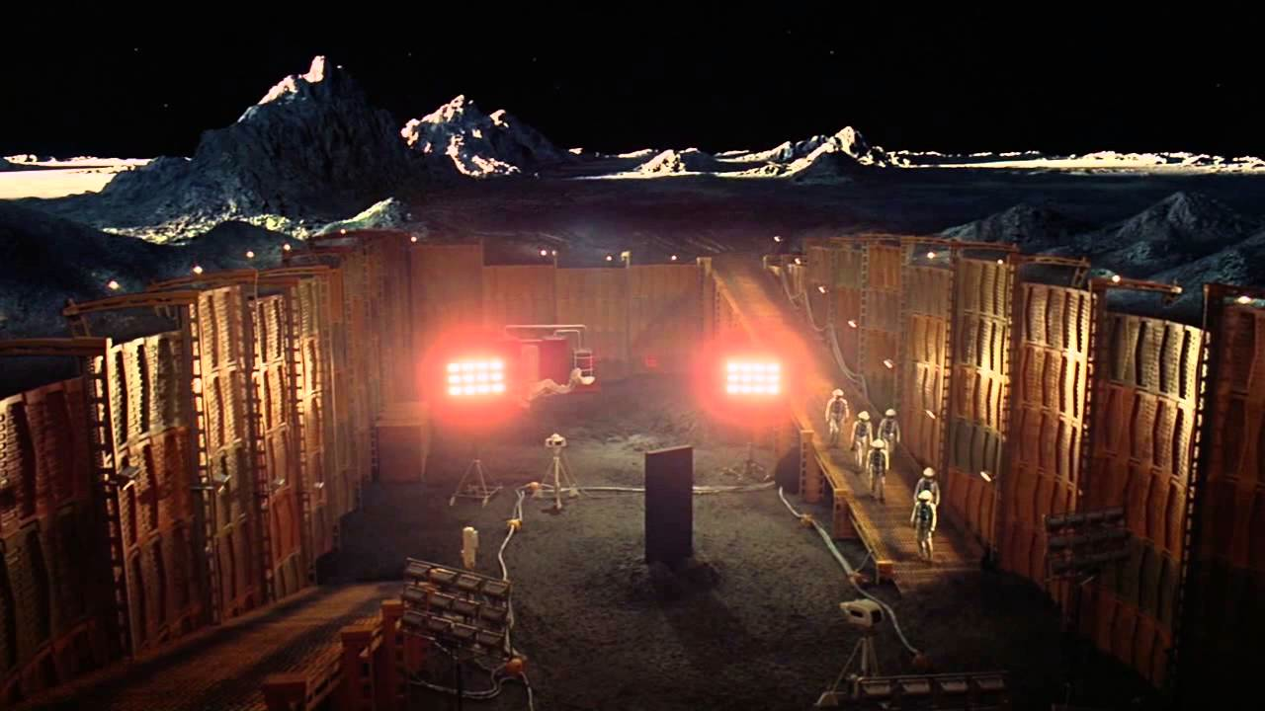



66. Ever since the 1960s, partly as a result of the popularity of a song from the musical Hair, we’ve been hearing that “this is the dawning of the Age of Aquarius”. How do we know what Age we’re in anyway?

The Age of Aquarius is one of 12 possible astrological ages. Which Age you live in is determined by which of the 12 constellations of the Zodiac forms the backdrop to the rising Sun on the morning of the Spring Equinox, on March 21 each year. Owing to the phenomenon of precession, explained elsewhere in one of these quizzes, the March 21 rising of the Sun will, over long periods, transition from one sign to the next one adjacent. Each constellation forms the backdrop for an average of roughly 2,160 years, and a full scroll through all 12 of them takes 25,920 years. Roughly. According to modern astrology, we’ve been in the Age of Pisces since the time of Christ, and should thus be on the cusp of transitioning to the next constellation, which will be Aquarius.

This is actually quite incorrect. It’s true in the abstract if you divide the sky into 12 equal slices, but the slices aren’t equal. Some constellations of the Zodiac are much bigger than other ones, and thus the actual time when each will form the backdrop for the equinoctial Sunrise varies considerably. Pisces is one of the bigger ones; my astronomy program informs me that the Sun will not have arrived in Aquarius until about 750 years from now.

It made for a heck of a pop tune, though. Huge hit when I was a kid.




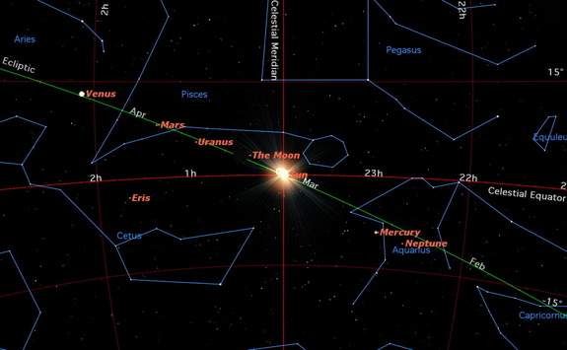
67. Related to that, we all have a “Sign” we were born under, depending on the time of year we came into the world. I, for example, am supposed to be a Pisces. Why does my March birthday have anything to do with any particular sign of the Zodiac?

The “Sign” that you are assigned by the horoscope in your morning paper is actually your “Sun Sign”. Horoscopes are, of course, a load of hooey, but your Sun Sign is quite real. On the morning you were born, one of the constellations of the Zodiac formed the backdrop for the rising Sun. That constellation is your Sign. Which one depends on the time of year you were born, and that’s why your birthday determines it.

Or it should. Because of the precession effect, the months of the year that correspond to given signs change gradually over time. If you don’t adjust for that, and the most familiar type of astrology doesn’t, then after about 2,160 years, depending, you’ll be off by a whole sign – that is, say, that the Sun used to rise in front of Aries in February, but now it’s actually March. As it happens, modern astrology bases its reckoning of where constellations appear in the sky on the circumstances that existed about 2,000 years ago. Thus, they’re off by a whole sign, and this means that while my March birthday gives me a Sun Sign of Pisces, in fact, on March 3, 1961, the Sun rose in front of Aquarius.

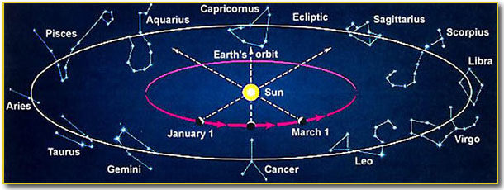
68. What’s the difference between morals and ethics?

It’s a subtle one, and many people use the terms interchangeably, which is not quite right, though the two often lead to the same conclusion.

Morals are supposed to be absolutes based on natural law. What’s right is right, what’s wrong is wrong, and not just because we say so. In theory, of course. What we deem to be moral changes over time, and varies by culture, but supposedly morality is something distinct from law, or rules. A law can be immoral. Breaking the law can be moral. If the rules say I can own a slave, that doesn’t make it right (though of course, as the slave owner, I will talk myself into thinking it is). I’m supposed to be able to evaluate the morality of cultural norms and rules according to universal and immutable principles, and philosophers have struggled since the time of the ancient Greeks to figure out what those principles are. This is why morality is often described as an individualized code of conduct – each individual has to gauge the morality of a situation according to what’s right as best he or she sees it, based on what he or she thinks are the universal principles. In this reckoning, it doesn’t matter what the official rules are.

Ethics, on the other hand, are just human-made systems of rules. They are usually designed to create safeguards against bad outcomes, but being mere rules, they are blunt instruments. The ethical outcome may not always be the moral one, and unethical behaviour may not always be immoral, but the rules are societal, and individuals aren’t supposed to second-guess them. Overall, it’s better that way – but this may pose a dilemma in a particular case.

A good example of the distinction is in the debate over abortion. It is both legal and perfectly ethical for a doctor to perform this procedure, but some doctors object on moral grounds, based on their perception of when human life begins. Just because it’s permitted doesn’t make it right, they would say. Others would disagree that there is any divergence in this case between ethics and morality.

Or take capital punishment. In the U.S. it is perfectly legal for doctors to assist the state in executing criminals by lethal injection, and the proponents of the death penalty will tell you it’s moral as well – eye for an eye, and all that. But is it ethical? Weren’t the ethics set out way back with the Hippocratic oath? “First, do no harm”, right?

Similarly, it is unethical for a doctor to treat a family member, a perfectly sensible rule that prevents the sort of mistakes that flow from judgment clouded by emotion, rather than dispassionate reason. Yet, under the circumstances it might not be immoral. If my kid needs a powerful pain killer like oxycodone, is it immoral to prescribe it? This time, maybe not. She might really need it, and any other doctor might agree. This time. Still, we prohibit the practice because in general, determining medical outcomes for loved ones can lead to very bad things.

It sure is tricky stuff. The interaction between ethics and morals puts us in the position of being obligated to second-guess the rules that we must never, under any circumstances, second-guess.

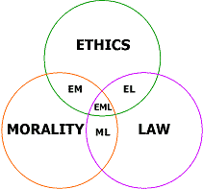

69. What Canadian city has been dubbed “The Warden of the North”?

We think of “wardens” as the people who run prisons, but the dictionary meaning is “a person responsible for the supervision of a particular place or thing or for ensuring that regulations associated with it are obeyed”.

My home town, Halifax, was the base from which the British Empire monitored the Northern approaches to British North America.

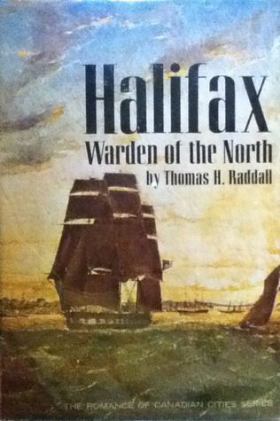
70. Why did philosopher John Rawls think a “Veil of Ignorance” was something to be striven for, not avoided?

The “Veil of Ignorance” was a thought experiment to assist in the creation of a just society. Imagine, says Rawls, that you were designing a society and its laws in complete ignorance of what your own circumstances would be. When you’re done, the veil will be lifted, and then you’ll find out; maybe you’re the King, maybe you’re a wealthy industrialist – or maybe you’re on trial, accused of a terrible crime, or already in prison, or dirt poor.

If you want to play it safe, you’ll design things so that no matter what you turn out to be, you’ll be treated with fairness and compassion, and granted justice. You might come out from behind the veil to find yourself homeless and alone – maybe, then, there should be places for the homeless to find shelter, and enjoy the kindness of others. You might be a renter, rather than a home owner – maybe, then, there should be laws that constrain the behaviour of landlords. Since you might well be a relative nobody, maybe everybody, not just the powerful and connected, should get a vote when it comes to appointing the leaders who will draft our laws.

If you could think about it that way when you advocated policy, you’d always do the right thing, as best you could figure it. I suppose it’s just a twist on the golden rule, but it’s a wonderfully lucid way to prompt a profoundly moral question– what if it was me that was getting the short end?

How different the world would be, if we could just make that our guiding principle. A lot of short ends would become a lot less short.

71. Some fuel tanks are “self-sealing” when punctured. How does that work?

It was an idea first developed for fighter aircraft, and American planes had self-sealing fuel tanks in WW II (British too, not sure about the Germans – something to look up, but I very much doubt we had a technological edge on the Germans!). The Japanese did not.

What you do is line the fuel tanks with layers of rubber, vulcanized on the outside and natural rubber beneath it (vulcanized rubber is treated with a process that makes it very hard – it’s what hockey pucks are made of). If a bullet pierces the tank, gas seeps in and hits the natural rubber, which expands on contact with the fuel, sealing the tank. This prevented many a fatal fire.

Japanese aircraft suffered greatly without this technology. American pilots knew that no Japanese plane ever caught fire short of blowing up.

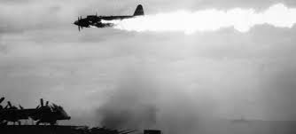

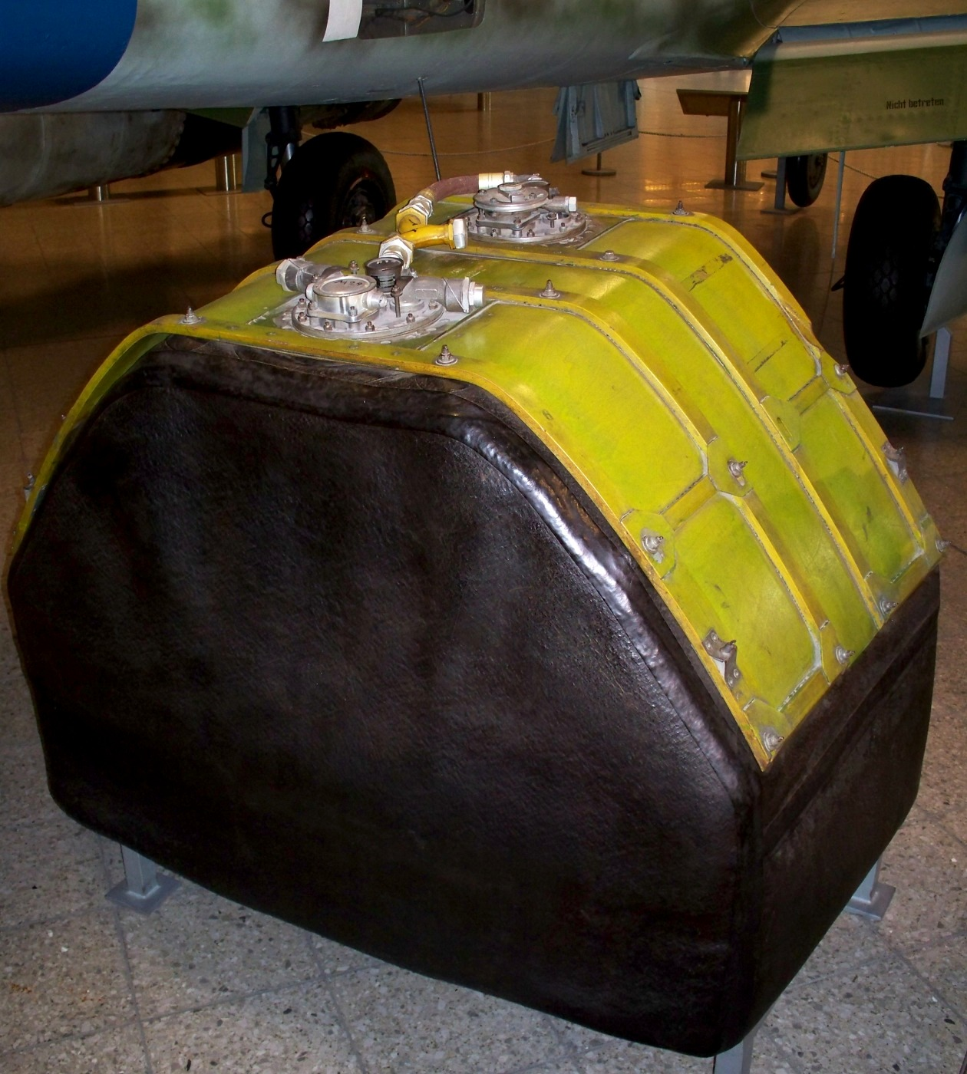
72. We tend to use the word “mirage” as a synonym for an illusion, but it’s actually something real – in a way. How so?

A mirage results from the refraction of light in the atmosphere; different layers of air at different temperatures have different optical properties. Light waves reflecting off a real object are bent, and the eye is fooled about the direction from which they originated, making it seem like you’re seeing something that isn’t there. It’s somewhere, all right, just not where it appears to be.




73. What vital system is particularly vulnerable to “cascade failure”?

Electrical grids, which tend to be interconnected in very large networks, are vulnerable to this phenomenon. An overload or other failure in one location causes power to be drawn in from others, and then those elements of the grid overload (or shut down in “safe mode”), and so on, until the whole thing goes out in a “cascade” of failures. We had a huge one here in 2003, during which a large swath of Eastern North America was without power, all because of an initial failure caused by a tree branch brushing a transmission wire in Ohio.

It’s possible to contain such failures before they start to cascade, but something went wrong in Ohio, and there we all went. I was on the 22nd floor of the Cadillac Fairview Tower at the time. I’ll always remember that strange sound of everything electrical going down at once, all the computers, printers, photocopiers, lights, it’s difficult to describe – sort of a “beeeeeuuwwwww” noise. As reports started coming in over a battery powered transistor radio that somebody happened to have, it was clear something big had happened, and as I looked out the window and saw stalled streetcars and gridlock at intersections deprived of traffic lights, my mind raced to the conclusion that it was al-Qaeda.

Nope. Just a tree.

It was initially an anxious feeling that evening. I wondered what would happen when night fell, pessimist that I am, but instead of riot, looting, and insurrection, something quite wonderful occurred. In our strangely quiet neighbourhood, and neighbourhoods all over, people mingled on the street, sharing perishable food (might as well eat it), barbequing all the meat they had, and passing around hamburgers and hotdogs. The sky, now jet-black in the absence of urban light pollution, displayed a glittering panoply of twinkling stars. All around was quiet, and serene. You could hear the gentle breeze as it rustled leaves.

I wasn’t sure I wanted the power to come back on, at that point. Not too soon, anyway.


74. People often say that a certain set of facts “begs the question”, and in my experience they’re always wrong about that. What does “begs the question” actually mean?

I guess I should say “what did it used to actually mean, before getting it wrong became so universal that in effect its meaning changed?”. People use “begs the question” to mean the same thing as “prompts the question”, as in “that guy’s sports car only gets 2 miles per gallon, which begs the question how he affords the gas”, or “the reservoir is running dry, which begs the question where we’re going to get our drinking water”.

Wrong. There’s a reason the phrase uses the word “begs” instead of “prompts”. To beg the question is to commit a logical fallacy in which the only support for an argument is the argument itself. Like, “he’s stupid because he lacks intelligence”, or “The soul is immortal because it never dies”. It’s also used sometimes for what lawyers call “assuming facts not in evidence”, like “Women pay higher insurance because they can’t drive very well” (who says women don’t drive very well?), but technically, “begs the question” applies to circular reasoning.

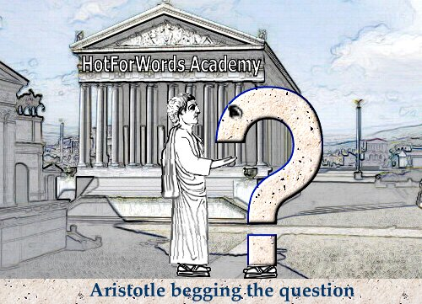

75. In the same vein, why do I pop an aneurysm every time I hear “hone in”, “have your cake and eat it too”, “chomping at the bit”, and “card shark”?

More examples of things that have been gotten wrong so widely, and for so long, that the dummy versions are now the correct ones, for all practical purposes. Still, I resist.

First, nothing “hones in” on anything else. The expression is “homes in”, as in homing pigeons, or homing weapons (i.e., guided weapons that home in on laser light, or radar reflections, and such). “Hone” means to sharpen. You can certainly sharpen something, but could you ever “sharpen in” on something? Makes no sense.

Second, if I now have a piece of cake, it is certainly open to me to eat it. This produces no logical conundrum, no conflicting whim. I have it, I want to eat it, so I eat it. Ah, but if I eat it I can’t then have it, you say? RIGHT. So the proper expression is “eat your cake and have it too”. I want to eat it, but I also want to keep it. Those are conflicting impulses.

Third, “chomping at the bit” is perhaps more forgivable, since that makes literal sense, but horses don’t “chomp”, they “champ”. The critter is “champing at the bit”.

Finally, there was never any such thing as a “card shark”. There were players who were particularly sharp at cards, and were thus “card sharps”.

They can corrupt my beloved language all they like, but I’m not going down without a fight.


76. Who coined the term “invisible hand”, and what has that got to do with the price of oranges?

Adam Smith coined the term in his seminal book The Wealth of Nations. It’s in a brief and tangential passage, and is really just Smith musing that myriad economic actors, pursuing their own interests, can often unwittingly promote broad social good, as if their behaviour is governed by some sort of invisible hand.

Since then, the Invisible Hand has come to be used as a symbol of rampant capitalism, and the assertion that free markets need no regulation, but will always manage themselves appropriately – an idea which, after 2008, has surely been proved patently wrong.

If I was to write a book about the recent financial crisis I think I’d call it “Bitch-Slapped by the Invisible Hand”. Or maybe “The Invisible Hand Picked My Pocket”.

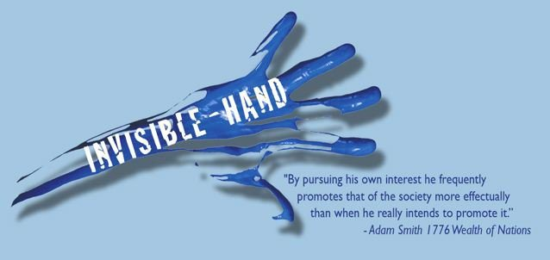
77. Futurists like Ray Kurzweil are predicting that within the next 20-30 years, humankind will have arrived at a point called the “Singularity”. What do they mean?

The prediction is that we are fast approaching the point at which our computers become not just artificially intelligent, but far more intelligent than we are. This will change our role in the world, but Kurzweil sees us merging with the computers, not being driven extinct. We might even upload our consciousness into the web, attaining immortality – or at least, creating an immortal copy of one’s consciousness that is so exact it believes it’s you. One way or another, argues Kurzweil, our descendents will be a combination of machine and human intelligence, essentially a new species, and probably immortal. I bet I kick the bucket two weeks before it happens.



78. What was/is the Flying Dutchman?

It is supposed to be a sort of ghost ship, doomed to sail the seas forever. The myth may well have emerged from sightings of those mirages we were discussing a while back – refraction can make it seem like objects, including ships, are floating in the air. These are called “superior” or “looming” mirages. If you didn’t know the science, what would you make of it if you saw the ship pictured below? No trickery or manipulation here – this is actually a frame from TV coverage of the Scottish Open golf tournament:

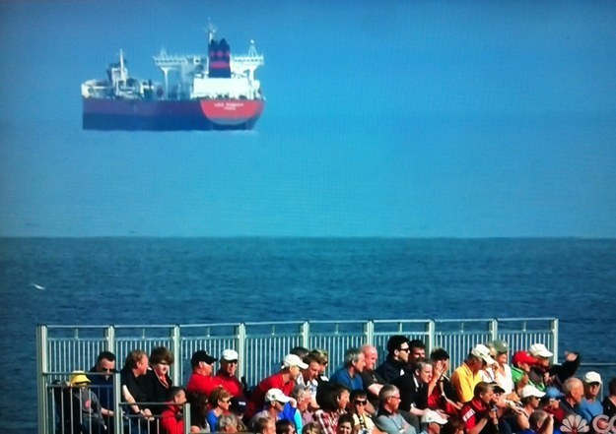

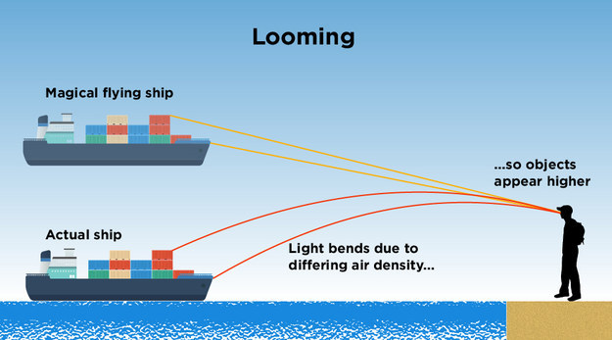


79. How did a Cro-Magnon hunter have it all over an Olympic javelin thrower?

It’s simple physics that the longer your arm, the farther (and harder) you can throw something. It’s kind of like the principle of the spinning disc that came up in another quiz: the closer you are to the outer edge, the faster you’re going. Push that edge out somehow, and you’re going faster still. Same thing with the arm of a catapult – or a human arm. Extra speed at the end, be it hand or bucket, translates into higher velocity for the thrown object, and therefore greater range.

Cro-Magnons had worked this out, and developed a tool called a throwing stick that effectively increased the length of their arms. It’s called an “atlatl” for some reason – it sounds like an Aztec word, and Aztecs certainly used them. Watch one demonstrated in this video:

https://www.youtube.com/watch?v=hjV7lYP6hRw

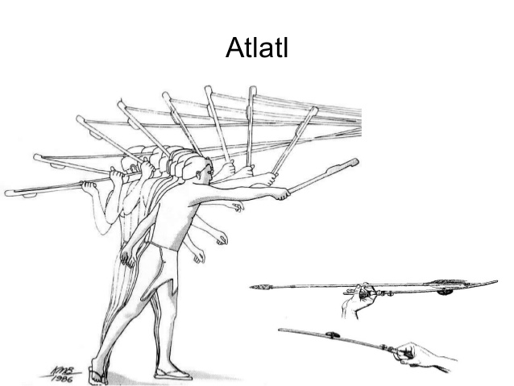
80. Yellowstone Park in the US is a lovely place, and a perennial favourite of visitors from all over the world. Why would anybody find the place terrifying, with good reason?

Oh, you know, because one day it might just kill us all. It will certainly cause a mammoth disaster at some point. The geysers at the park, like the famous “Old Faithful”, evidence a rather troubling geology at work; there is a mammoth lava dome beneath the Yellowstone, which must, sooner or later, erupt in what scientists call a “supervolcano”. It might be a hundred times the size of regular volcanoes, and spew enough ash into the high atmosphere to blot out the Sun, either disrupting or ending altogether the growing season. We believe supervolcano eruptions in the past have been behind mass extinction events, perhaps even the great dying at the end of the Permian period, about 250 million years ago, when 90% of all species then living were wiped out. That’s the worst mass extinction in the history of our planet. It likely won’t be that bad, but it will certainly cause catastrophe here in North America.

Yellowstone, they figure, last erupted about 600,000 years ago. They monitor it closely, and assure us that it isn’t going to blow any time soon, but it has to erupt at some point.


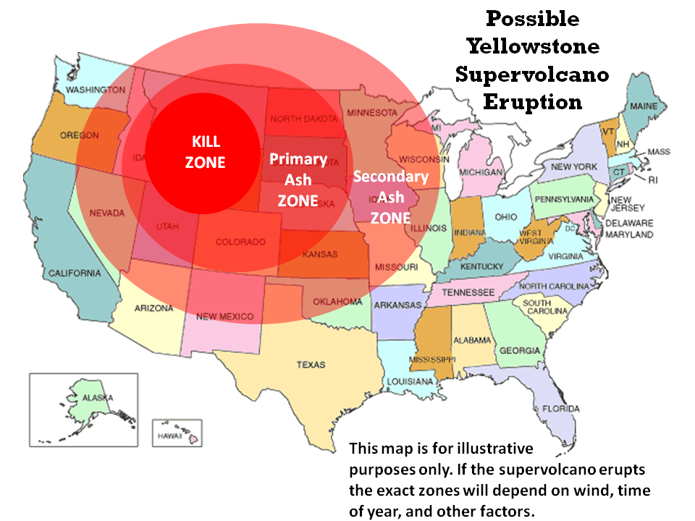
81. It’s hard to be sure with new projects being announced all the time, but which city will probably have the most supertall buildings (buildings taller than a thousand feet) by the end of this decade?

You might guess an Asian city like Shanghai, but it might well be New York City. There are at least 12 towers going up right now in the supertall category, and doubtless more will come. By the time the boom is over, Manhattan will probably boast close to 20 buildings in the 1,000 foot plus range. The tallest being built at the moment, the Nordstrom tower, a condo, will have a roof line just short of the pinnacle height of the new World Trade Center, a building with a roof line about 1,370 feet high – its tall spire takes it to a symbolic 1,776 feet. Word is that the Nordstrom will top out, diplomatically, at 1,775. Manhattan is going to look wild. This is an artist’s conception of the Big Apple in 2018:



82. Where and what was the “Diefenbunker”?

The “Diefenbunker” was a Cold War bomb shelter outside of Ottawa, created by P.M. Diefenbaker, one of several here and throughout the Western world designed to ensure continuity of government in case of nuclear war. It was finished in 1961, and according to the website – it’s now a museum! – it was quite elaborate:

The Diefenbunker is a four-story, 300 room, 100,000 square foot underground bunker, and was meant to house 535 Canadian government officials and military officers in the event of a nuclear war. Shrouded in mystery, the Diefenbunker, nicknamed after then Prime Minister John Diefenbaker, was designed and built in secrecy during the crest of Cold War fear, between 1959 and 1961. The name of the facility was given by a Toronto Star journalist who exposed a story of its development.

http://diefenbunker.ca






83. Why do conspiracy nuts think the US Government had a massive underground facility, built in case of nuclear war, hidden (get this) beneath a luxury hotel in West Virginia?

BECAUSE THEY DID.

The reason it’s sometimes so difficult to persuade conspiracy nuts that they are indeed nutty is that sometimes the craziest rumours turn out to be true. The facility was constructed in secret at the Greenbrier luxury resort in West Virginia, under the cover of the construction of a new wing to the hotel, and it was massive – right out of a James Bond movie.

When its existence and location were leaked by the Press in 1992, it became useless, and is now open for tours, just like the Diefenbunker.

Today, people believe there’s something similar hidden under the Denver international airport, which is a crazy idea…really nutty…

http://www.npr.org/2011/03/26/134379296/the-secret-bunker-congress-never-used







http://rationalwiki.org/wiki/Denver_Airport_conspiracy_theory

84. Is it true that if you were in a falling elevator, you could save yourself by jumping vertically just before it hit bottom?

Sadly, no. First, you might well be in freefall, and thus floating inside the box, with no way to jump up. Second, even if you still had purchase on the floor, you could only accelerate upwards at a few feet a second, not enough to counteract the fact that you are already falling at many times that rate. You’d slam into the floor just after the elevator hits. If you could jump upwards at a rate fast enough to counteract the speed at which you’re plummeting inside the box, you would stop in mid air as the elevator continued to fall – and thus the elevator ceiling would, in short order, clobber your poor hovering brains out, as it sped towards the bottom of the shaft.

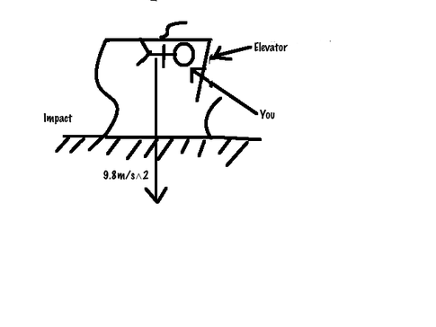
85. What did members of the Calvinist faith say you should do in order to ensure entry into Heaven?

Nothing. Your status as one of the “elect” was predetermined in the Calvinist faith, and nothing you could do would get you into heaven if you weren’t already selected, and nothing could get you booted off the list, either. You were going or you weren’t. Why behave here on Earth then? I’m not sure, the reasoning gets rather murky – I’ve read, for example, that people behaved in a righteous way because that would serve as evidence that they were, after all, among the elect. It sounds crazy, but if you take the idea of a God that knows everything, including everything that will ever happen in the future, to its logical extension, it actually makes sense. God already knows how you’re going to behave all your life, and knowing that, of course He knows whether you will make the grade and get through the Pearly Gates. He knew it from the start.


86. What organization had the slogan “Peace is Our Profession”, which struck some people as rather, well, misleading?

This was the slogan of United States Strategic Air Command, the branch of the air force whose ICBMs and bombers would destroy the Soviet Union (and everything else) if the Russkies ever dared attack the West. Within deterrence theory, the threat of massive retaliation would actually create peace, by instilling in the enemy the fear to attack. You know, so long as nobody panics, miscalculates, or acts on the basis of bogus data from broken systems warning of non-existent incoming warheads.

The SAC symbol was a mailed fist holding lightning bolts (the threat) and an olive branch (the desired outcome).

Peace may indeed have been their goal, but their profession, well, that was being good and ready to kill every living thing on earth, and manifestly capable of doing so despite any attack. That was their profession.




87. Who gave the “Checkers Speech”, and what was it about?

Our old pal Richard Nixon, in 1952, when running for election as Veep under Eisenhower, gave the “Checkers” speech in response to allegations of political corruption. He claimed the only gift ever given him was his faithful little doggie, Checkers. He certainly wasn’t on the take. There certainly wasn’t anything untoward going on with any sort of slush funds set up by cronies seeking favour. No, no. Nixon insisted, too, that he was keeping the dog, no matter what anybody said. It led to a huge outpouring of approval and support, and Tricky Dick learned the lesson that would one day bring him down. Lie, always lie. They’ll eat it up.

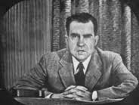
88. What’s a solenoid?

Technically, it’s a coiled electromagnet that generates a uniform magnetic field, but solenoids are used to electro-mechanically actuate valves or switches inside machines. Car engines are started by solenoid switches, for example – when electrified, they create magnetic fields which pull upon plungers that in turn cause levers to move, starting the motor.


89. What’s a klystron?

It’s a vacuum tube that energizes and amplifies the power of radio signals using electron beams, through properties of electromagnetism which, let’s be honest, are beyond me. Klystrons were crucial in the development of radar systems, and are also useful in communications applications.

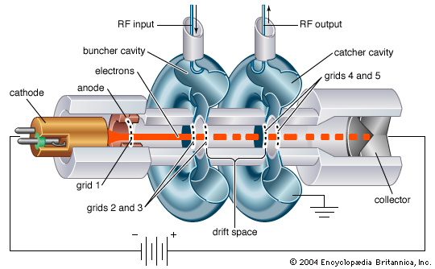

90. What’s a cyclotron?

A cyclotron is one of the earliest particle accelerators, designed to accelerate electrons or other particles with magnetic forces. They’re used to create isotopes – you smash the particles into other atoms at a velocity sufficient to make them lose neutrons from their nuclei, making them unstable, and thus radioactive. Radioactive isotopes are used in many medical applications, particularly in diagnostic imaging – the isotopes are attached to something like sugar, and injected into the body, and machines can track their progress as the sugar is used in the person’s metabolism. Cancers use more sugar than surrounding tissues, so follow the isotopes, and you’ll find the cancer.

They can also be used as part of the “atom-smashing” process used by particle physicists in the investigation of the constituents of matter.

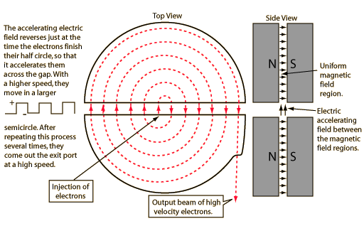

91. Why do we care about how many centrifuges a country might be purchasing?

It’s an indication of whether that country is pursuing nuclear power – or atomic weapons. Uranium is always radioactive, but the best, most unstable uranium, perfect for setting up chain reactions, is U-235. Less than 1% of any given Uranium sample is likely to be of the 235 variety, but because it is lighter than the more stable U-238, you can use a centrifuge, spinning on its axis, to separate the two varieties. The heavier U-238 clings to the outside, and the lighter U-235 stays at the centre. A gas is then introduced, and The 238 sinks to the bottom, while the 235 rises to the top to be harvested. This is a gross over-simplification, of course, but you get the idea. To get a meaningful amount of U-235 you need a great many of the devices. When a country like Iran buys thousands of centrifuges on the sly, it wants to build a bomb.

U-235 is called “enriched”, or “weapon grade” Uranium.


92. What goes on in an autoclave?

It’s a device used to sterilize surgical instruments using high heat. It’s a sort of pressure cooker for scalpels, retractors, endoscopes and such.


93. What is so strange about a place called Coral Castle?

Coral Castle is a strange structure in Florida built entirely by a fellow named Edward Leedskalnin, over a 30 year period ending around 1950. For building material he used monolithic blocks of coral, each weighing tons, and no one is quite sure how he did it. He had no machinery, only home made tools, and nobody ever saw him at work, except a couple of teenagers who swore he was making the great blocks float like hydrogen balloons. Leedskalnin himself claimed he had “discovered the secrets of the pyramids”, and who knows, maybe he did develop some sort of technique that eludes the rest of us – for example, the front gate, which swivels on a pivot, weighs nine tons. When it fell off its bearing in the 1980s it took a team of six men, with the help of a very large crane, to move it.

Nevertheless, there are various techniques that can be used to move very heavy stones, using tripods, wedges, block and tackle, levers, and so on. Leedskalnin was a clever man, and we don’t need to invoke magic or the supernatural to explain Coral Castle, though when you see pictures of it, and realize it was built by one small man without any modern equipment, you can see why people are awestruck.










94. What did palaeontologists dub “Quetzalcoatlus”, and why?

“Quetzalcoatl”, the reader will no doubt remember from another quiz, was the winged lizard god of the Aztecs. A few years back, palaeontologists unearthed the fossils of a huge flying reptile, a “pterosaur”, which had the wingspan of an F-15, and was obviously particularly well adapted to soaring flight – it was mostly flight surfaces. The Aztec god seemed a natural namesake.

Its full name is “Quetzalcoatlas Northropi”, the “Northropi” being a nod to the great Jack Northrop, an aircraft designer who pioneered, among other things, “flying wing” designs for large aircraft. The modern B-2 Stealth Bomber is a flying wing, built by the Northrop company, that resembles in many ways the YB-49 that Northrop designed back in the late 1940s. Back then, he didn’t have access to the computerized “fly-by-wire” control technology that is needed to make such designs stable in all flight regimes. By the 1980s, a pure, and purely stealthy, flying wing became possible. By then, Jack Northrop had long since retired, and was hobbled in a wheelchair, and knew nothing of the project that was inspired by his own work – it was too highly classified. The USAF decided to grant him security clearance so he could see what his ideas had wrought, and very near the end of his life, he was wheeled in to see the B-2. It had exactly the same wingspan as his YB-49, to the inch, precisely 172 feet, a deliberate homage to Jack and his design.

Qutzalcoatlus Northropi had a wingspan of between 35 and 40 feet. What a sight it must have been.

Northrop’s YB-49, second picture below, still appears like something from the future, even though the photo is over 60 years old.

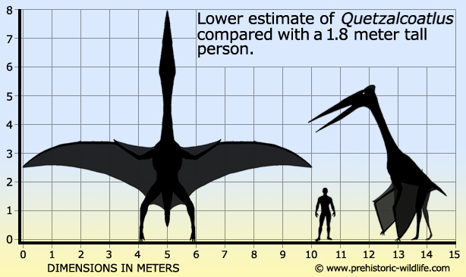




95. What is “additive manufacturing”?

The popular term is “3-D Printing”. It’s “additive” because the process involves the spraying of successive layers of material by a moving nozzle, slowly building the final object, one pass at a time. We’re just beginning to explore the potential of this technology – in a few short years it’s gone from making plastic busts of Elvis to metal alloy parts for turbofan engines. There’s talk of using them in medical applications, including, eventually, the creation of replacement organs – already, they’ve managed to 3-D print a prosthetic earlobe. In the not too distant future, 3-D printers may be as common as microwave ovens, placing the means of industrial production within everybody’s home, with incalculable effects on manufacturing and retail. Not only will bricks and mortar establishments be obsolete, you won’t even have to order goods on-line. Instead, you’ll download the pattern and print yourself a pair of sneakers. Or a gun, sadly. It’s all very close to what they used to call “replicators” on Star Trek; now all we need is a holodeck, and I’m outtie!

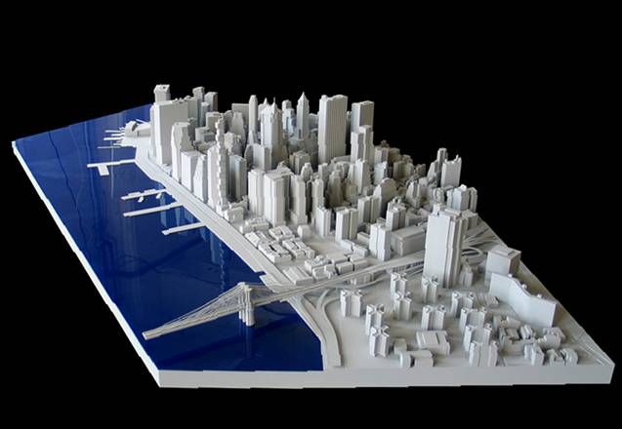




96. You’ve never heard of Malcolm McLean, but just about everybody has seen, and been affected by the influence of, his invention – what did he come up with?

McLean invented the standard shipping container, the ubiquitous boxes within which nearly all goods are transported by sea, rail and truck. It seems such an obvious idea, which is the hallmark of many a stroke of genius; you know it’s something brilliant when you can’t help but say “Why didn’t I think of that?”. McLean was the owner of a trucking outfit, and his vision, fully realized, was of a means to transfer goods seamlessly between ships and trucks. He founded the first container shipping line, Sea-Land, and revolutionized the global market for manufacturing – containerization made shipping cheap, and this made overseas manufacturing economical. You could build it there and ship it here.

Globalization, as we know and love it today, would be impossible without economical, containerized shipping. McLean changed the world.






97. What sort of Gin was Cotton Gin?

No sort, if by “gin” we mean the alcoholic variety. “Gin” in this case was short for “Engine”, and the “Cotton Gin” was Eli Whitney’s machine for automating the separation of cotton fibre from the seeds of the cotton plant, previously an extremely time consuming and arduous process.

Another example of the Law of Unintended Consequences, the Gins led to increased demand for workers to pick the cotton that got fed into them, spurring the growth of slavery in the United states. It was a simple device that you cranked by hand, and to look at one, you’d never guess that it had a momentous impact on the economy and politics of the United States.




98. What’s “G-LOC”? Is it serious?

Oh boy is it serious. “G-LOC” stands for “G-induced Loss of Consciousness”, a phenomenon that afflicts fighter pilots engaged in hard manoeuvring. It first became a really serious issue with the advent of the F-16, a “fly-by-wire” jet that could whip into a 9G turn in the blink of an eye. At nine times the force of gravity, even pilots equipped with “G-Suits” were apt to quickly lose consciousness as the blood flowed out of their heads toward their torsos and legs. There were a number of unexplained crashes early on, until the Air force caught on, and all fighter pilots today are trained in centrifuges and drilled in exercises to fight the physical effects of high G, and stave off G-LOC as long as possible. It’s all pretty and graceful from our vantage point, but flying fast jets is exhausting and difficult, which is why future generations of warplane may dispense with human pilots. The key limiter on aerodynamic performance is becoming the ability of the human pilot to stay conscious and alert.

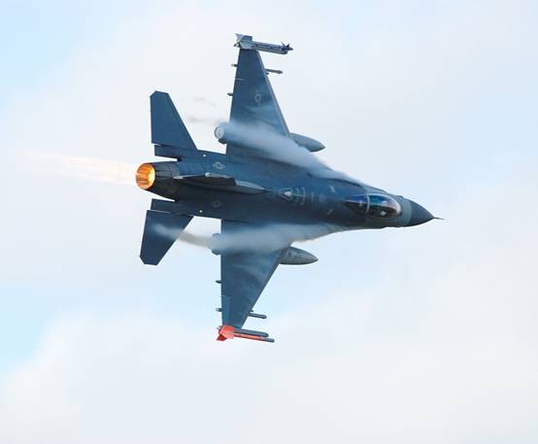
99. What sort of beast is a Kraken?

The Kraken was a mythical sea monster in sailor lore, but maybe not so mythical as was once believed. It is now thought that stories of the Kraken were just slightly hyperbolic tales of encounters with that real monster of the deep, the Giant Squid.

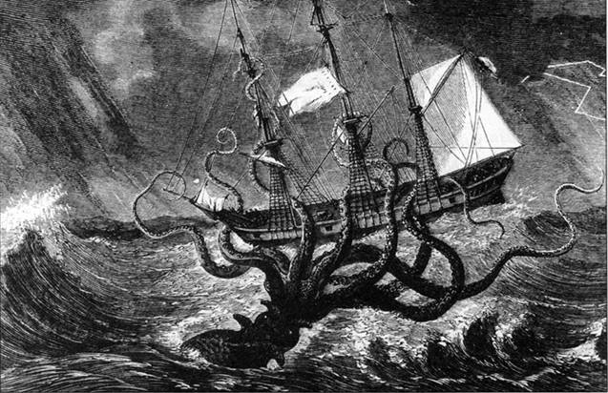
100. A Mantis Shrimp is a rather exotic and beautiful crustacean, brightly coloured and fascinating to look at. What would the guy at the pet store tell me about its care and feeding in an aquarium environment?

The pet store owner, if he knew anything at all about this exotic creature, which he likely wouldn’t given that it isn’t safe to keep them in aquariums, would tell me to give my head a shake. Mantis Shrimp are not shrimp at all, but strange armoured crustaceans with a lineage going back to the Cambrian period, 500 million years ago. They give us some idea of just how frightening the sea floor was at that time, with its weird, multi-legged predators sporting terrible claws and other chitinous weaponry. The Mantis Shrimp has two club-like appendages that it can wield with amazing speed and power, literally beating the brains out if its prey in the wink of an eye. They strike so hard that they can break out of a glass aquarium, which they might do after becoming bored at the absence of any further things inside to kill.

There’s a fabulous piece on the Oatmeal about them:

http://theoatmeal.com/comics/mantis_shrimp



A gross understatement. Grumman designed the Wildcat, Hellcat, Bearcat, Avenger, Tigercat, the Intruder bomber, the Prowler ECM platform, the Hawkeye AWACS platform, and so on. No aviation firm on the planet knew how to design naval aircraft better than Grumman.
Which, sadly, was just a few feet short of the tree line – they miscalculated by a little, so had to emerge in the open, not behind the forest cover.
The different effect of gravity at relatively higher altitude will also cause one to go faster than the other, for example.
(or so-called “speed jeans”, leggings that have inflatable bladders that expand at high G levels, squeezing blood out of the lower body and up towards the brain)

