1. What's the difference between a fruit and a vegetable?

Technically, a fruit is the ripened ovary of a flowering plant, and is part of the reproductive cycle. Fruits therefore always have seeds, at least until we start to mess around with their genetics to produce seedless oranges and grapes and such. A vegetable is any other edible part of a plant. So, if it has seeds in it, it’s actually a fruit, even though we might think of tomatoes and cucumbers, and squash and pumpkins and the like, as veggies.


2. Who won a Nobel prize for originating the idea of military peacekeeping?

Our own great Prime Minister (but at the time External Affairs Minister) Lester Pearson floated the idea as a way to separate the belligerents in the Suez Crisis in the late 1950s, a strange last-gasp colonial adventure in which France and Britain, in collusion with Israel, tried to manufacture the pretext for war with Egypt and seize the Suez Canal. The canal had been (more or less) a colonial possession of Britain’s, and had recently been nationalized by Egyptian President Nasser. Can’t have the bloody colonials owning their own country, not when it’s strategic!

US President Eisenhower went ape over it, and more or less ordered the European powers to back off. US strategy at the time was to curtail the influence of the Soviet Union in the Middle East by wooing important Arab states like Egypt, and the European action couldn’t have been better conceived to drive Egypt into the loving arms of Mother Russia (and so it proved). Pearson brokered the peace talks and won his Nobel prize for it, but historians aren’t sure he “invented” UN Peacekeeping, as we Canadians like to think. British P.M. Anthony Eden also floated the idea at the time. No matter. The laurels went to Pearson.

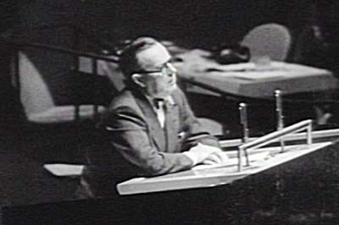
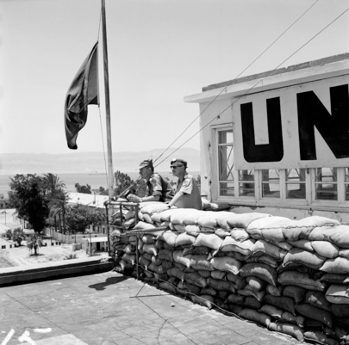
3. Who first conceptualized what turned out to be the correct model for the atom?

Danish physicist Niels Bohr, along with English physicist Ernest Rutherford, both figured out atoms had a nucleus, with the electrons going around it, but there was a crucial difference between Bohr’s and Rutherford’s concepts. Rutherford proposed a solar system model, with the electrons literally in orbit. That won’t work, said Bohr, because over time orbits decay, and the electrons would spiral into the nucleus, yet they don’t – they must be in fixed “shells” around the atom. And this is the starting point for quantum physics, because for fixed shells to exist, it had to be that electrons could occupy one shell, or another, but nothing in between. The energy state of the electron will determine which shell, and thus energy must have an indivisible unit – a “quantum” – which forced electrons to jump between shells in fixed gradations. The mental model we all have of the atom is often called the “Bohr-Rutherford” model, since they look the same in an image, but really, the atom was first fully understood by Bohr.

Another alternative, proposed by an English physicist named Thompson, was that atoms had protons, electrons and neutrons all mixed together in a sort of “plum pudding”. That model would not have started the quantum ball rolling.

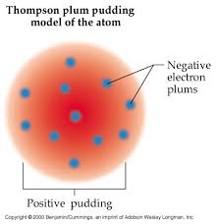


Then along comes Heisenberg to tell us that those little “orbiting” electrons only exist like tiny planets when we measure them. Otherwise, they’re just a tendency to exist somewhere within the entire shell they occupy. And, we’re off!!
4. What is the world’s biggest insect?

It depends on whether you go for length, or weight, but in either case some sort of beetle. Get a load of the Titan Beetle:



Or the Hercules Beetle:



Or the Goliath Beetle:



The biggest bug ever to exist was an ancient dragonfly that went extinct long before the Dinosaurs entered the scene, a true monster with a 30 inch (2.5 feet!) wingspan.


5. What famous insult did Churchill fling at Clement Atlee?

Clement Atlee was a rival politician. Churchill called him “A sheep in sheep’s clothing”. Or, he may have said it about another politician, Ramsay MacDonald. Or both. That Winston! Always the wag!

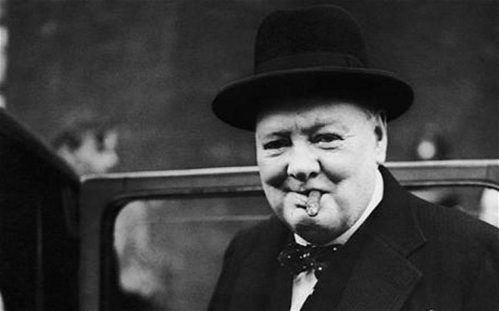
6. What iconic vehicle was manufactured by the Willys company?

Willys was the original manufacturer of the Jeep, so called because it was a “GP” or “general purpose” vehicle. The brand name has changed hands a few times since then, and now belongs to Fiat-Chrysler. They’ve been careful over the decades to preserve the general look of the iconic grille.




7. How many neurons compose the average human brain?

Most sources quote 100 billion, though recent findings suggest maybe closer to 90 billion, but whatever, that’s a lot of brain cells, able to form almost infinite networks of interconnection. See next.


8. What's a synapse?

A synapse is a tiny gap between neurons, the structures of which include numerous “dendrites”, almost like the branches of a tree. Nerve cells align their dendrites to within a minuscule distance measured in microns, so must communicate electrochemically across those gaps, but the wonder of them is that since nothing is “hard wired”, neurons are able to form almost infinite connections and reconnections, creating new networks. This is how, we believe, memories are stored and retrieved, how new knowledge is filed away, how, indeed, we experience consciousness. It is reckoned that each neuron can form as many as 10,000 dendritic connections with other neurons at any given time, and the total number of interconnections must be enormous – perhaps 100 trillion, and, according to some sources, perhaps 10 times that.

Our old friends at DARPA are funding a project to replicate this architecture in a new generation of supercomputers. One day, perhaps sooner than we think, they may have computers that are, essentially, artificial people, with us unable to tell whether they’re really conscious.

Will they admire us, their creators? Or will they find us mystifying and disgusting?

http://www.kurzweilai.net/ibm-simulates-530-billon-neurons-100-trillion-synapses-on-worlds-fastest-supercomputer

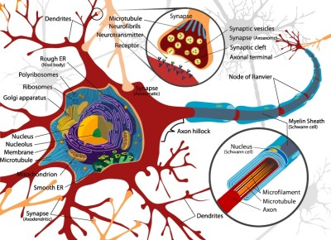
9. What's a Gar?

A Gar is a big, bony, primitive fresh water fish. We’ve got various species in the Great Lakes. They go back at least a hundred million years, and the meanest, which lives in Southern waters, is the Alligator Gar, which typically grows to six feet in length and weighs well over 100 pounds. There have been bigger ones caught though, and it’s thought that the outside limit is closer to 10 feet, and more than 300 pounds. Mean fishy!


10. What's so interesting about the Chicago River?

The Chicago River, as would be expected, once drained into Lake Michigan, but in the late 19th century, by dint of some amazing civic engineering, its flow was reversed. Water now flows into it from the lake through a system of locks. Why’d they do that? It was a way to dump sewage in a happier direction, mainly. A huge clean-up and revitalization effort improved the state of the river greatly in the 1990s. It’s now quite nice. And it winds its way through a cornucopia of wonderful architecture.

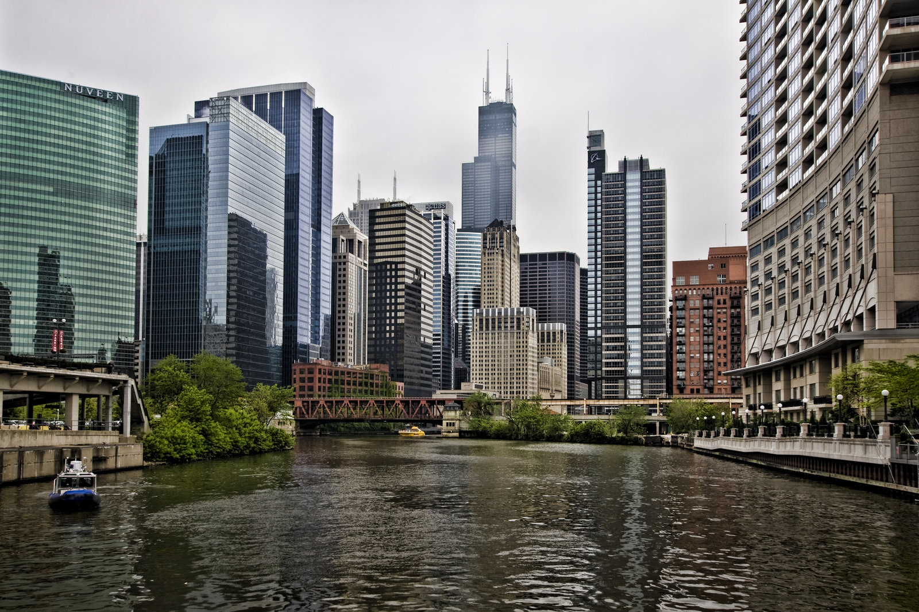
11. What is the world’s longest suspension bridge?

There are much longer bridges, some stretching dozens of miles, that might more properly be called “viaducts” (see Question 25!) but the longest suspension bridge is the Akashi Kaikyo in Japan, which has a total length of close to two and a half miles.

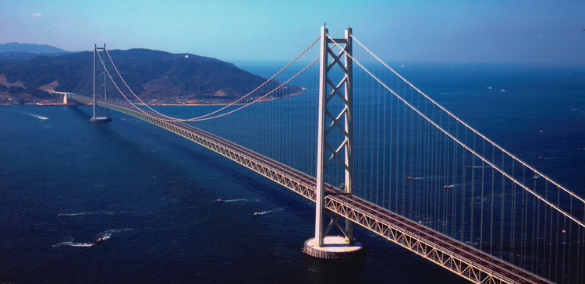

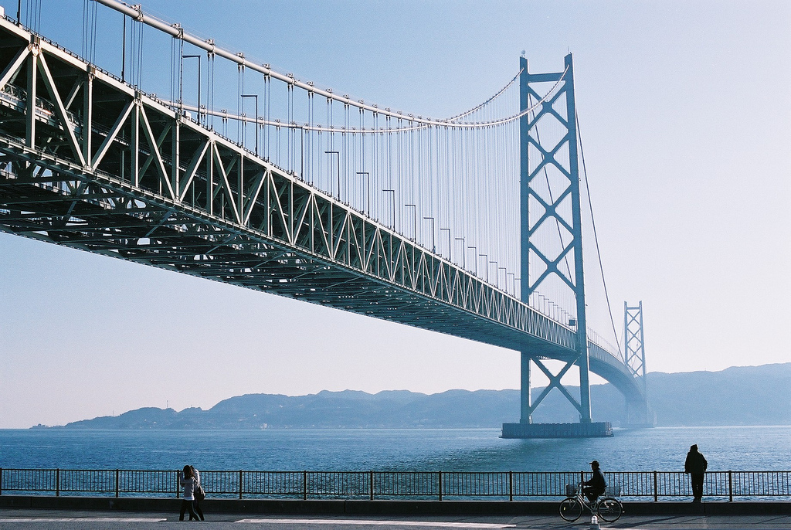
12. Who first heard what might fairly be called the "sound of creation"?

In 1964, engineers at Bell Labs were testing a type of radio receiver, that looked kind of like a giant ear trumpet, called a horn antenna. I looked up the names of the fellows involved, and it was Arno Penzias and Robert Wilson. Annoyingly, they kept getting this persistent hissing sound, surely some type of ordinary interference, but they couldn’t pinpoint its source. No matter where they pointed the horn, they got the same background hiss. It was inexplicable. They even cleared some pigeon droppings out of the horn, wondering if that, somehow, was the problem. No change. There didn’t seem to be anything wrong with the antenna, and any human source would have to be directional – an earthly radio signal, or indeed any flying or orbiting signal, has to come from somewhere, it couldn’t come at you from everywhere at once. So what the…?

What they were hearing is now referred to as Cosmic Background Radiation. It is the residual radio hiss of the Big Bang, 14 billion years ago, still not fully dissipated in the vacuum of space.

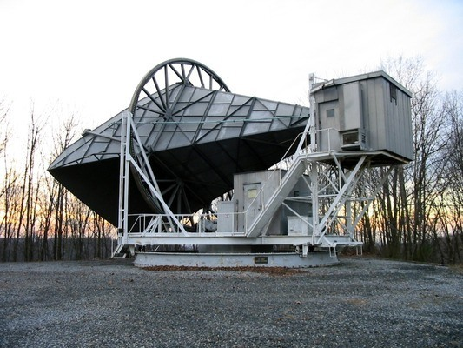
13. Who was Chuck Jones?

The great cartoonist and director of all the funniest Warner Brothers cartoons, which, in unedited form, truly are hilarious. If all he’d done was Duck Amuck, starring an increasingly enraged and hysterical Daffy suffering torments inflicted by the cartoonist himself, his place in history would be assured. Of course, he did much, much more. Chuck used to say that Bugs Bunny was American as Americans like to see themselves: shrewd, practical, funny, eager to make friends out of strangers, slow to anger, but holy hell and apt to destroy you if you insisted on picking a fight (“of course you know, this means war”). Daffy, on the other hand, was American as Americans really are, greedy, almost insanely self-centred, impatient, panicky, quick to anger, and oh-so-willing to screw over the other guy to get ahead (“It’s mine! It’s all mine!! And what’s mine is mine!!”)

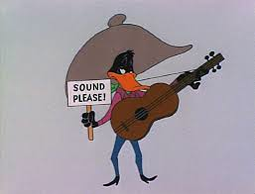
14. What fish is a grave threat to the waterways of North America?

Asian Carp, which might as well be called the Cane Toads of the Inland Waters (see subsequent question), are an invasive and voracious species that tends to overwhelm and push out all indigenous fish. They were first brought over to clean ponds maintained by fish farmers (they eat algae and help maintain water quality), and nobody really knows how they got out – in floods maybe, or maybe some idiot thought it a good idea to set some free.

They’re on the march, taking over lakes and rivers, and we’re trying like all get-out to keep them out of the Great Lakes. They just crowd out everything else, and would ruin the lucrative sport fishery, plus they’re ugly, and sometimes dangerous - the silver variety tend to leap out of the water when startled by boats or water-skiers, and several people have been injured by the damnable things. I mean, these Hellish fish really leap, they can clear your head when you’re standing at the helm. You can find yourself in a chaotic jumping swarm of the critters, flying every which way like scaly projectiles. They can weigh anything from 10-90 pounds, too, and that’s a substantial load of fish to get right in the puss at high velocity.

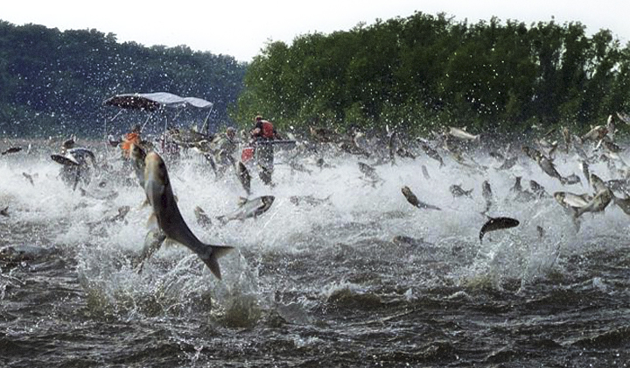




15. Where did the great director John Ford like to film his classic Westerns?

Monument Valley, which straddles the Arizona/Utah border. If you’ve ever watched a Road Runner cartoon, you’re familiar with the iconic geography of the place, which for many people is the image called to mind when they think “old West”. Really, the West is mainly rolling plains crossed by long rivers, good for grazing and homesteading. It would be hard to eke out a living in dry, dusty Monument Valley. The “monuments” are huge sandstone formations known as “buttes”, created by erosion as water and wind take their toll over time. Their fate, in due course, will be to wear away almost entirely, and they tend to be girded by piles of debris that has worn off their tops; but this isn’t a rapid process. They’ll be with us a while yet.

It’s just an awesome place.

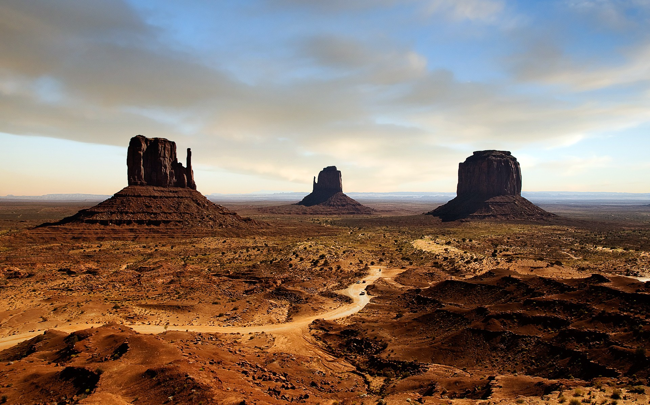
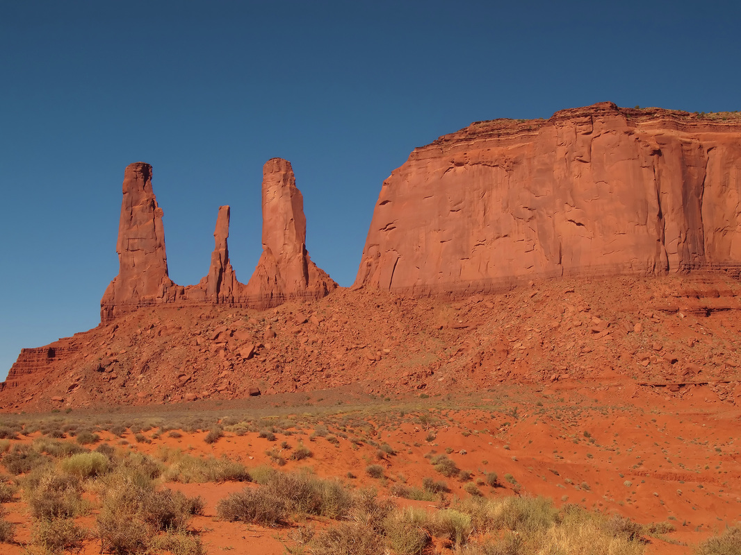

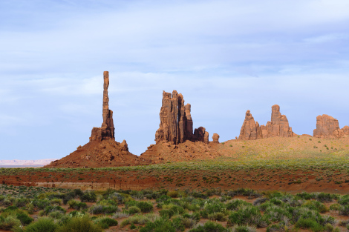
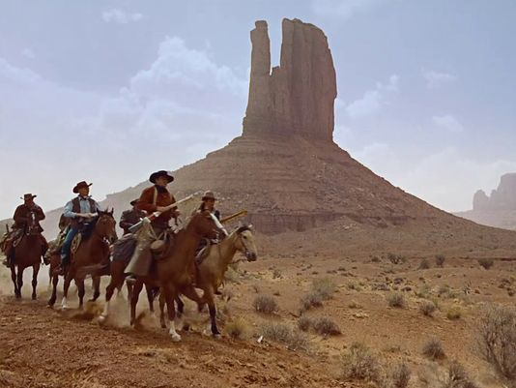

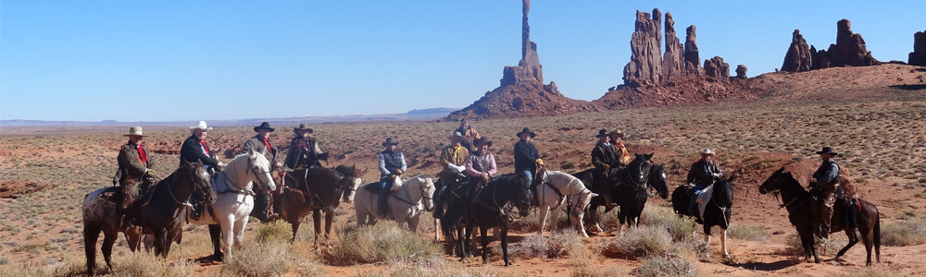

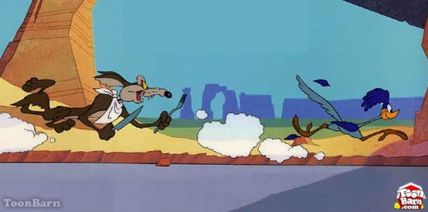
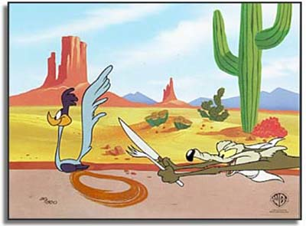
16. What lives solely on eucalyptus leaves?

Koalas, poor, harmless, endangered things. Who doesn’t love a Koala? A big nasty grump, that’s who.

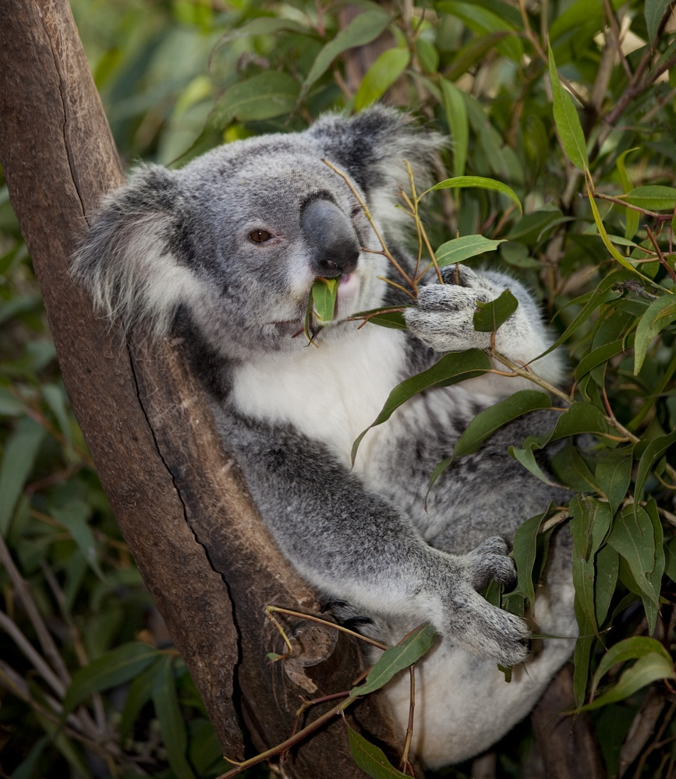

17. What are the four states of matter?

No special prizes for getting solid, liquid and gas, but most people are unaware of the fourth state – plasma. A plasma is a mass of excited particles, a state in which so much energy has been added that electrons are stripped away from the nuclei of atoms, leaving behind ions (atoms with a positive or negative charge). The ions and electrons mix chaotically in the plasma, which is a bit like a superheated gas, but is not a gas, technically.

The coronas of stars are a plasma, and so is fire (flames, more specifically) here on Earth.

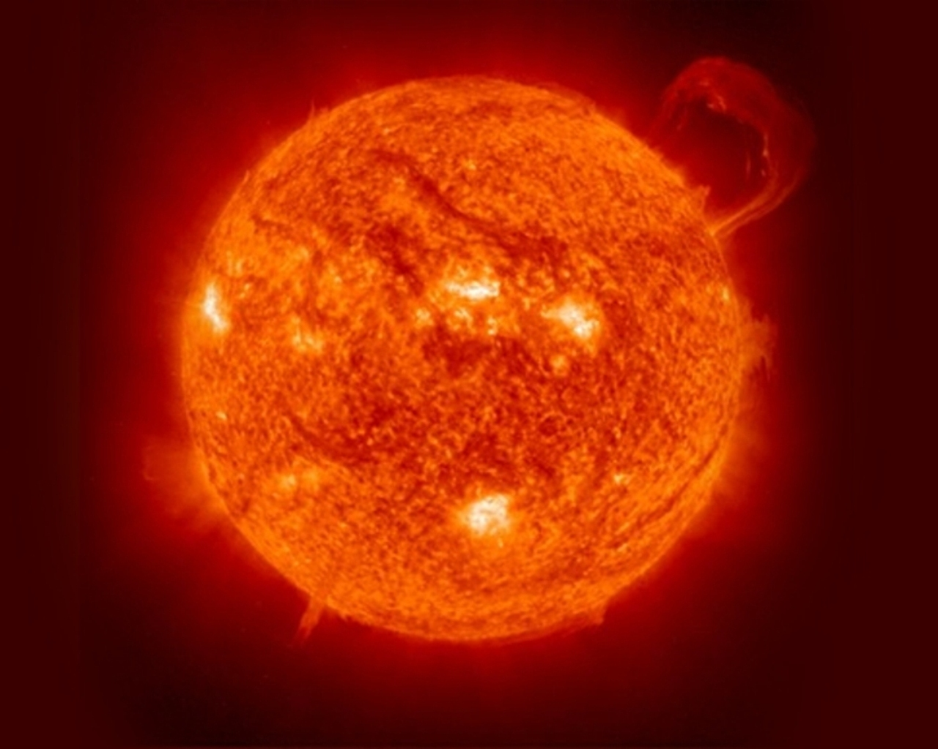
18. Who famously painted saggy, limp pocket watches?

Our favourite surrealist, Salvador Dali! The title of the famous painting is The Persistence of Memory.

https://www.youtube.com/watch?v=xF1BYMMipP0

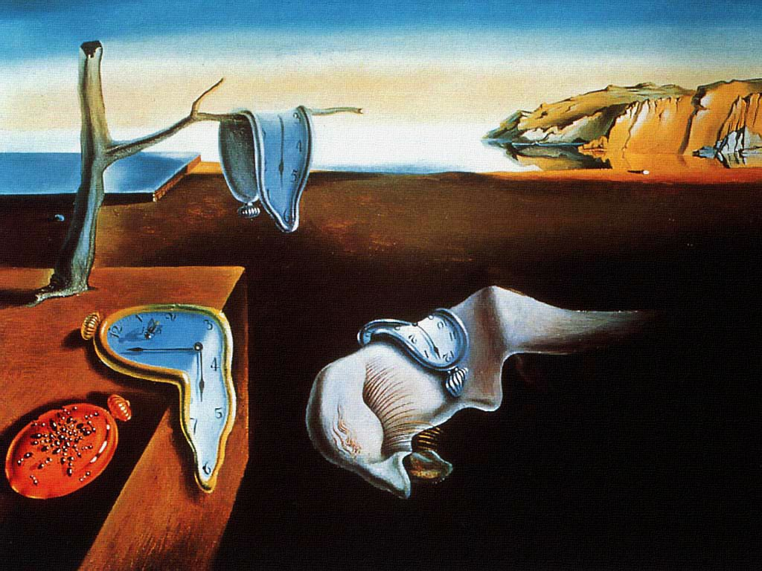

19. Who was the artist who painted a work called Guernica? Where does it hang? What's it about?

Pablo Picasso, recording the horrors of the Spanish Civil War, and the aerial bombardment of the town of Guernica by Franco’s Italian and German allies – one big happy fascist family, in those days. The Spanish Civil War was, for the Germans, and the Luftwaffe in particular, a sort of practice round for the World War to come. Wholesale bombing of civilian populations still shocked the conscience, then.

It’s a large mural, and while the original hangs in Spain, a tapestry copy is displayed at UN Headquarters in New York. Perhaps intending to evoke the photos and newsreels of the day, Picasso painted it purely in shades of black, white, and grey. Even when photographed in colour, it produces what looks like a black and white image.

The light bulb glaring above the horse’s head reminds me of Churchill’s ringing phrase, how a world run by the Nazis would plunge us into “the abyss of a new Dark Age, made more sinister, and perhaps more protracted, by the lights of perverted science”. Was Winston inspired by Guernica, which was completed about three years before he said that? Scholars believe that the bulb represents the Sun, but does it actually symbolize the same thought Winston articulated? Perhaps the special horror of Guernica is in its depiction of terrible destruction abetted by advancing science, the relentless progress of which is symbolized by the kerosene lamp held next to the horse’s mane, now rendered obsolete by electric light.


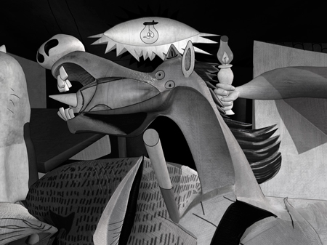


20. Windmills are emblematic of the Dutch - what were they for?

You might well ask, as they sit there spinning in the breeze, what the picturesque structures are all about. Well, the Netherlands is always fighting to keep out sea water, as we all know form various kids’ stories featuring dykes and little Dutch boys, and the classic Dutch windmill was part of that effort. Through various gears, cogs and wheels they turned the rotational force of their sails into a pumping action using waterwheels, or Archimedes Screws, which helped them keep the wetlands drained.

Windmills can be used for all sorts of things, like rotating large stones to grind grain into flour, or, as in Antigua, powering a mechanism that squeezes the sweet juices out of sugar cane, like a wringer washer. These days we use windmills to make electricity. Turns out you can do a lot with a steady rotational motion.


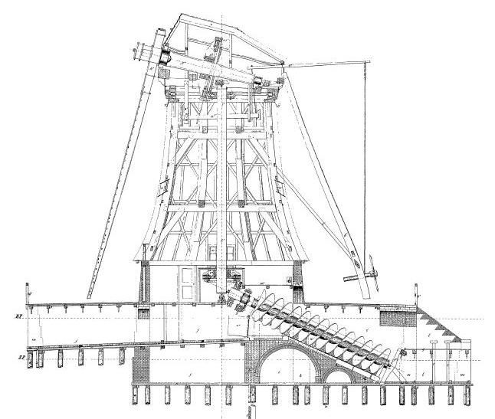

https://www.youtube.com/watch?v=TGiVX-uQYGA

21. Where is London Bridge?

If you’re a clever-boots, you just asked, mentally, “which one”? Good for you, you clever-boots, you.

First off, no matter how many people get this wrong, this is NOT London Bridge:

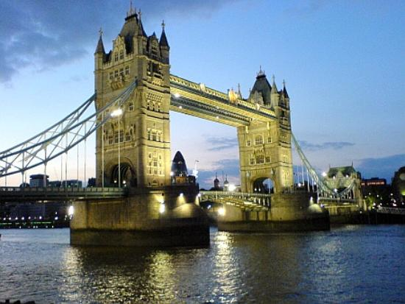

That’s Tower Bridge.

The real London Bridge as it exists today is a much more ordinary affair:

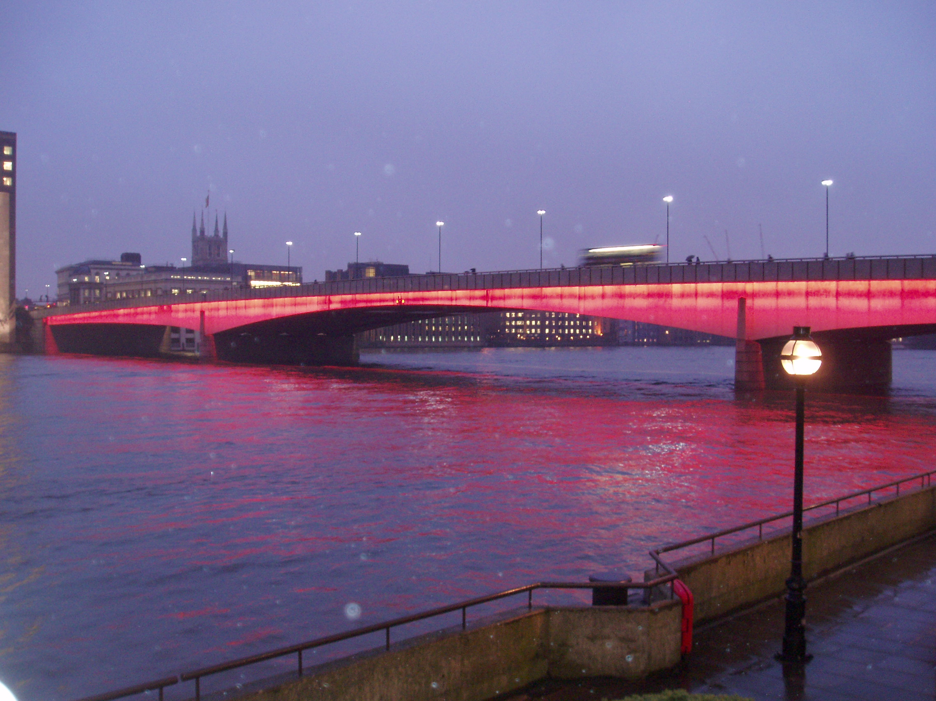

But this is merely the most recent incarnation of the storied bridge across the Thames. The one that was the basis of the children’s rhyme “London Bridge is Falling Down” really was falling down, in the 1700s, after about six centuries of use, and it was replaced by a newer London Bridge, which preceded the current London Bridge, and now resides in – drum roll – ARIZONA, at a place called Lake Havasu. It really is the bridge that stood in London from about 1830 to 1920. A rich American named McCulloch bought the thing and had the stones shipped over, all carefully numbered, to be reassembled as an ornament for Lake Havasu City.

And there it sits:

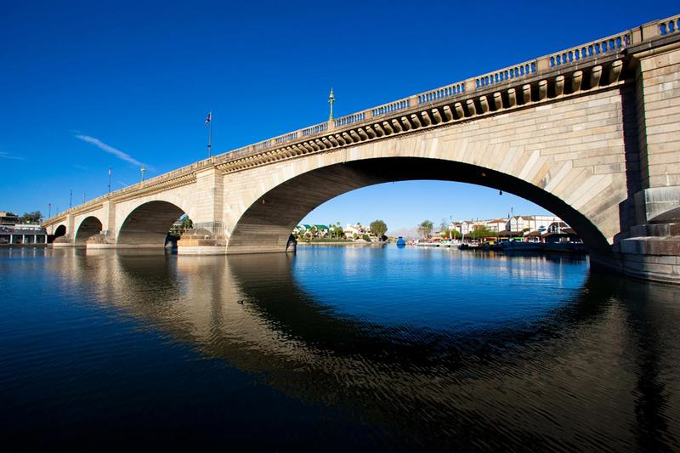
22. What invasive species plagues Australia more than any other?

The invincible Cane Toad, a catastrophic answer to a problem it didn’t even solve. The Cane Toad is a large and ugly amphibian native to Central and South America, and was imported to Australia in the 1930s in the belief that it would attack Cane Grubs, beetles which were then a huge problem for the Australian sugar cane industry.

Now, importing a species into an eco-system that has never had to deal with it is always a dicey proposition, as those monitoring the proliferation of giant constricting snakes in the Florida Everglades can attest. Just as pythons and boas are wiping out wildlife in Florida, the Cane Toads, with no natural predators, began to overwhelm the fragile species of Australia, and have relentlessly expanded their territory. They’re voracious predators, and it turns out they will eat just about anything they can fit in their mouths, with one crucial exception – Cane Grubs. Nope. Don’t like ‘em.

They’re rather foul creatures, and have glands that produce poison that tends to kill anything that tries to prey on them. Ecologically, they’re a case study in the dangers of messing around with Mother Nature.

A great, quirky documentary, truly hilarious, was made in 1988 about the problem. You can find it on YouTube, broken up into parts:

https://www.youtube.com/watch?v=4mvV8OT-mmE&list=PL96840EDD836CF164

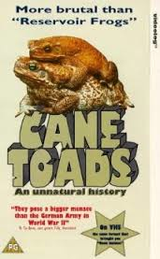
23. What great event was the backdrop for the drama in Hugh MacLennan's novel Barometer Rising?

Barometer Rising is set in Halifax in 1917, a drama of war, family strife, betrayal, high level incompetence, and the struggle of a young woman to make it in a man’s world, all of it coming to a head just when the Halifax Explosion violently shifts all the pieces on the board. I’ve always thought the novel was a prototype for the “disaster movie” genre of the 1970s (Earthquake, Towering Inferno, Poseidon Adventure, the various Airport sequels etc.), all of which follow a very similar arc – interpersonal dramas beginning to tie knots so dense and thick that only a cataclysm can cut through it all.

Barometer Rising is a great read, and a great depiction of the Canadian experience in 1917, as our exploits in WW I called into question both our status within the British Empire, and the moral fibre of those who led it.

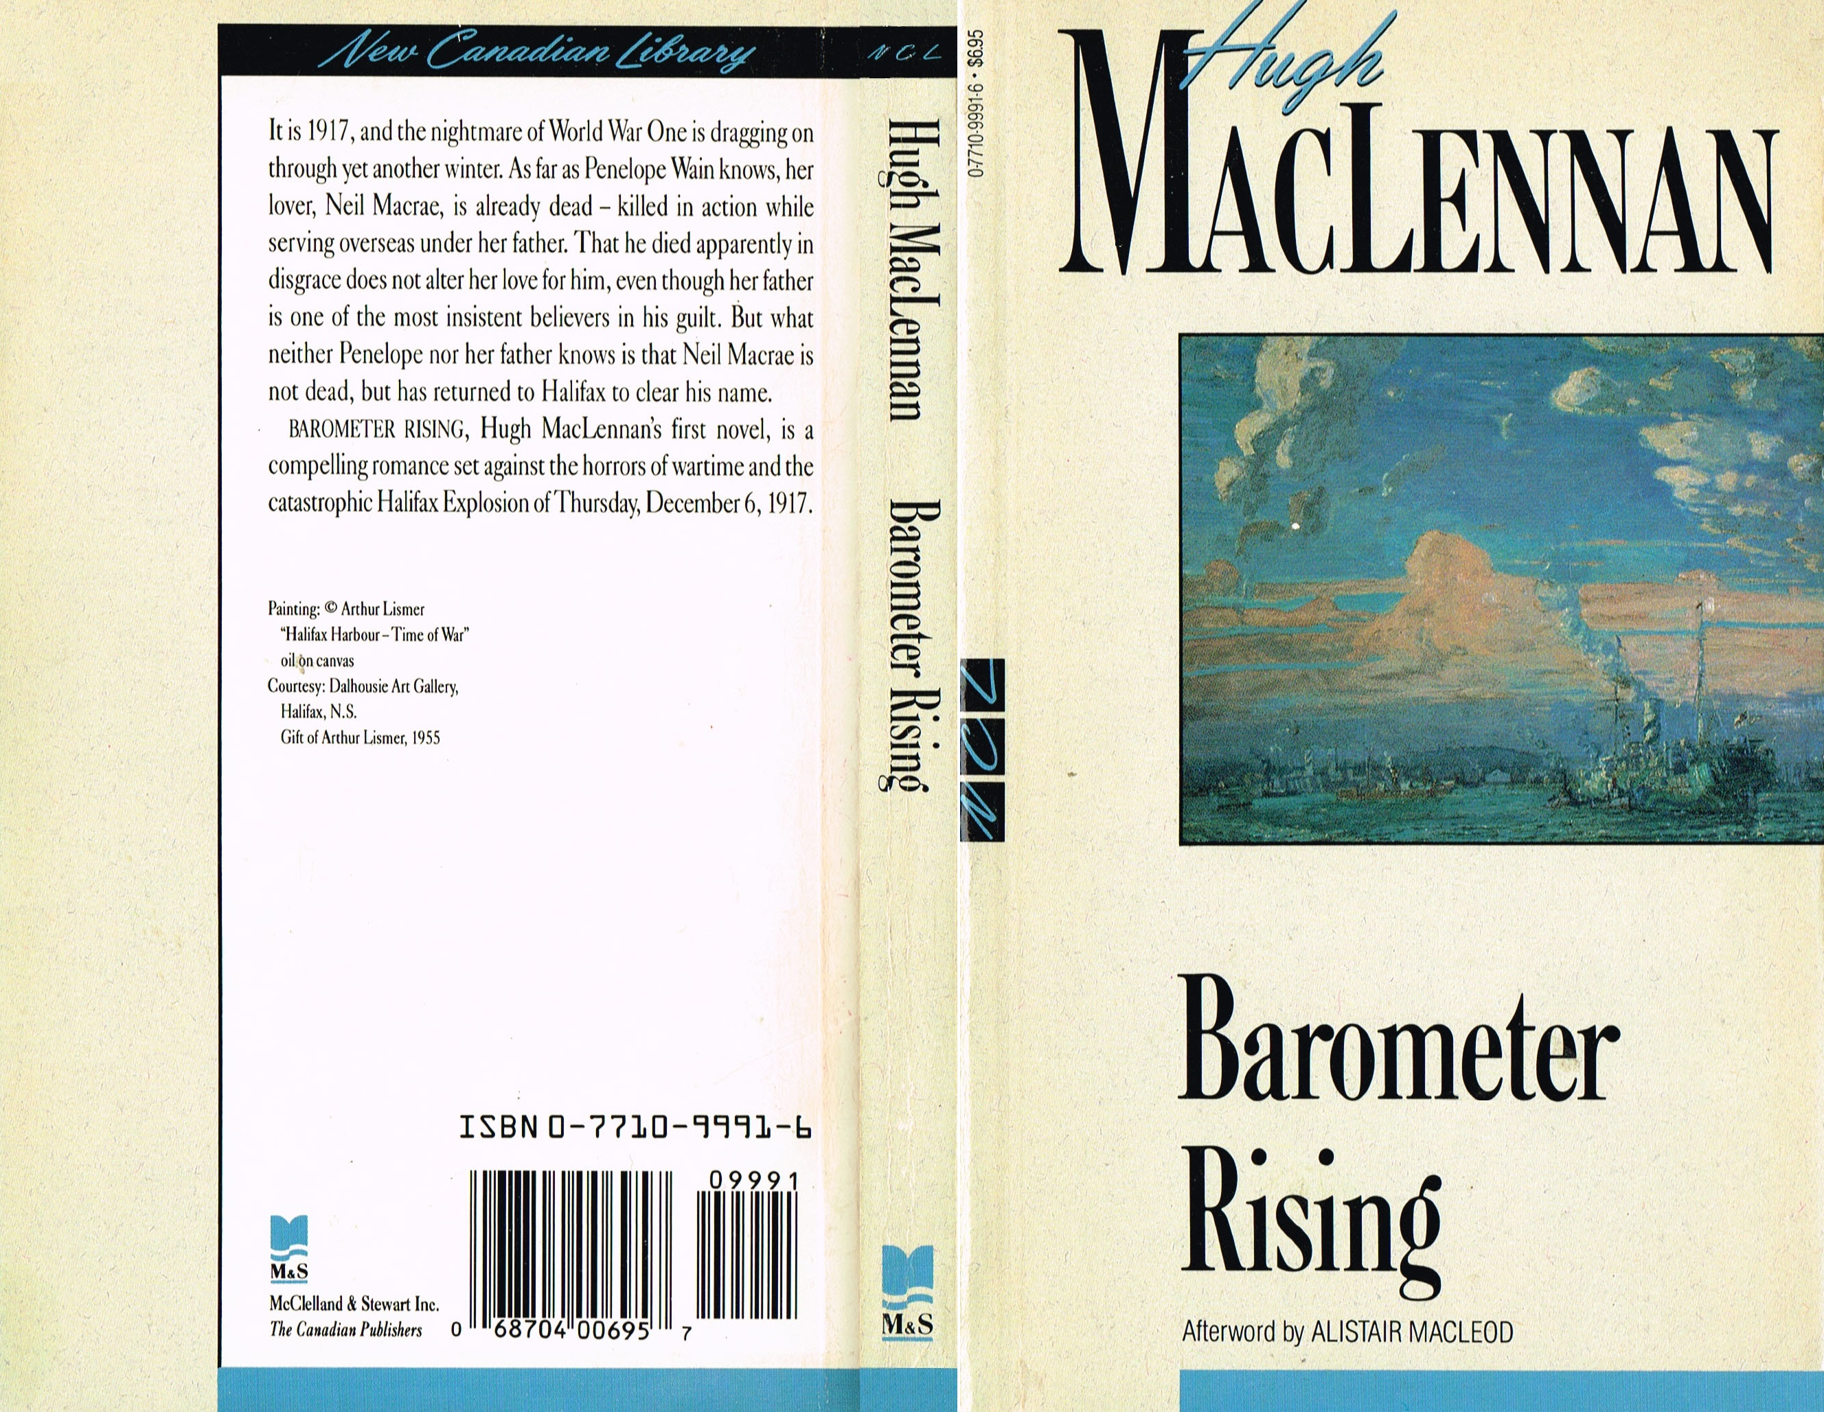

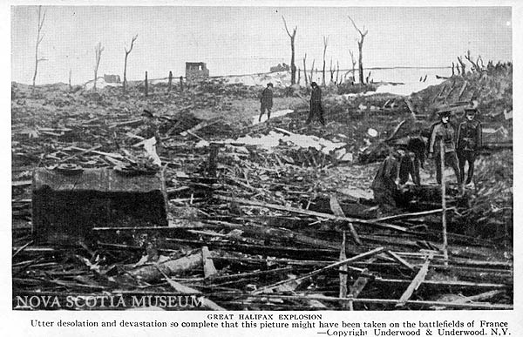
24. Why is salt water salty, when water itself is not?

Fresh rain water has properties that dissolve minerals in rock, being slightly acidic, and rivers and other runoff take these minerals out to sea, including the sodium and chloride that make up common table salt – NaCl. What this ought to mean is that the oceans are getting saltier all the time, and should therefore be much more salty than the seas in which plesiosaurs and ichthyosaurs frolicked. Yet in looking this up, one finds that nothing is ever so simple. Ocean salinity varies for lots of reasons, including depth, and the configuration of the continents, and back a hundred million years ago, continental drift had yet to take the landmasses as far afield as they are today. Recent work indicates that the confined and relatively shallow waters off the coast of North America had twice the salinity level of today’s Atlantic.

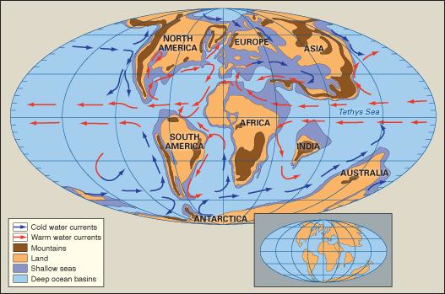
25. What's the difference between a bridge and a viaduct?

I’m not even sure there is any difference. Some sources state they are synonyms, some say they’re different without being very helpful as to why, and some focus on what might seem to be unimportant differences, such as that a viaduct is distinguished by more intermediate supports than a bridge.

The best answer seems to be that a viaduct is a type of bridge, characterized by numerous short spans. So this is a viaduct:



And this is a bridge:

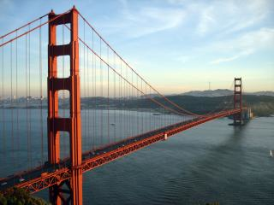

26. What’s the M’Naghten Rule, and why is it obsolete, but irreplaceable?

The M’Naghten Rule gets its name from a mid 19th century case involving a deranged man who took a shot at a government official – from the description of his symptoms, modern psychiatrists have no trouble determining he was a paranoid schizophrenic. The court articulated a rule which has little changed over the years – here’s the version in our current Criminal Code:

Defence of mental disorder

16. (1) No person is criminally responsible for an act committed or an omission made while suffering from a mental disorder that rendered the person incapable of appreciating the nature and quality of the act or omission or of knowing that it was wrong.

The problem with this is that it focuses solely upon delusion or utter senselessness. There are so many types of mental illness that can make rational decision-making difficult or impossible, even though the actor knows perfectly well he is doing something criminal. Indeed, M’Naghten himself, while found legally insane, really should not have been, under the test as articulated. He thought people were out to get him, sure, but he knew exactly what he was doing, and the law doesn’t recognize a defence of “I had to get him before he got me”; his beliefs, had they been true, would not have got him off the hook.

Yet try as we might, and some jurisdictions have tried mightily, we can’t come up with a better test without risking a defence that comes close to defining the propensity to commit crime as legal insanity. I tried it once for a project at law school. My draft rule made sense, on paper; apart from delusions, it granted the jury the power to excuse, fully or partially, a defendant whose mental illness impeded rational decision making and made lawful behaviour difficult or impossible. I imagine a canny defence lawyer could do a lot with that test – would sociopathy fit the bill? Depression? Explosive personality disorder?

So we stick with the same old obsolete M’Naghton Rule.

My brother paraphrased the current defence of mental disorder thusly:

If the cops raid your house and there’s a head in a pot on the stove, you’re as crazy as a mad cow on rollerblades.

If, however, the head is wrapped up carefully in aluminium foil and stored in the freezer, with a nice little label that says “Head”, you’re as sane as the next guy.

That about sums it up.

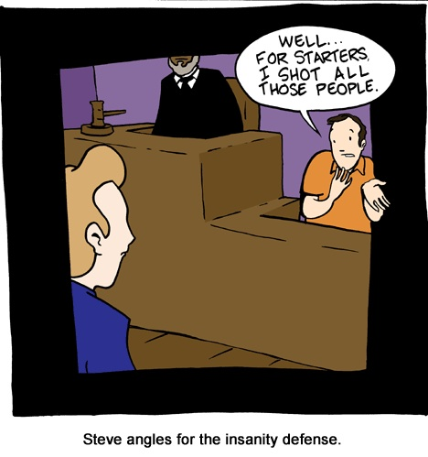
27. Who calmed his nation’s nerves with regular “fireside chats”?

Franklin Roosevelt gave regular radio talks which he called fireside chats, just trying to reassure people, at the height of the Great Depression, that something was being done to address the situation. He made these radio addresses straight through the Depression and WW II, and is considered the first president to have mastered the use of mass media.

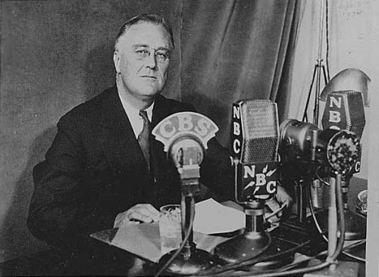
28. How is a house like a rowboat?

A house is nothing at all like a rowboat if its foundation is planted on bedrock. Most houses, though, have their foundations in soil, and thus remain where they are by the same physics that rowboats stay on top of water: they displace as much supporting matter as they weigh. An ordinary house built on soil floats, literally, according to the Archimedes principle. Just like a ship in water.

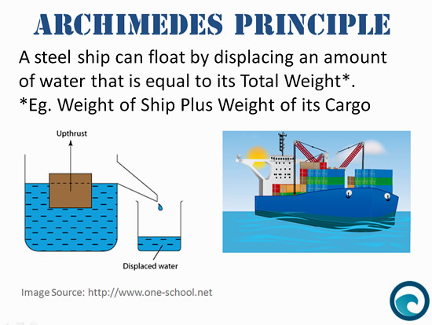
29. What’s an angstrom?

An almost inconceivably small distance. An Angstrom, named after scientist Anders Jonas Ångström, is a metric unit of length equal to about one ten-billionth of a metre. It’s a measurement unit that only makes sense when describing the size of atoms and molecules, the actual wavelength of light/radio waves, and other miniscule phenomena.

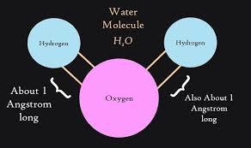

30. What’s an angiosperm?

That’s just the scientific name for a flowering plant!


31. The North American car-buying public was once obsessed with huge “land cruisers”, and top-end models were enormous. Just how big were they?

BIG. Today there are some high end designs, like the Mercedes S Class, that come close, and I imagine that a Rolls Royce is even heavier, but those are rare – back in the day, one form or another of Detroit’s monstrous land yachts was within reach of just about any middle or upper middle class family. The roads were clogged with them. Beasts like the 1959 Cadillac, with its ludicrous fins, or later apparent pituitary cases like the Oldsmobile 98, Buick Electra, or Mercury Grand Marquis, were just shy of 20 feet long, almost seven feet wide, and could weigh from 4,500 to 5,000 pounds – that’s curb weight, not loaded. Loaded with four big Americans and some stuff in the trunk, they could be three tons. Even the largest modern SUVs, like say the Cadillac Escalade, have no bigger footprint, and are only a bit heavier. They needed enormous V-8 engines to haul themselves around, and had terrible fuel economy. My Dad used to joke that it took two gallons of gas just to start our big Mercury Rideau 500, which weighed about 5,000 lbs., loaded, with family aboard. Can you imagine parallel parking one of these things?

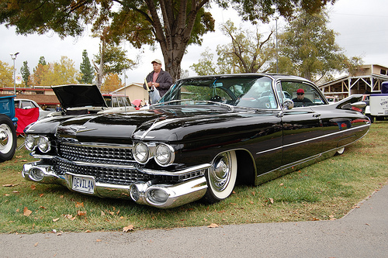

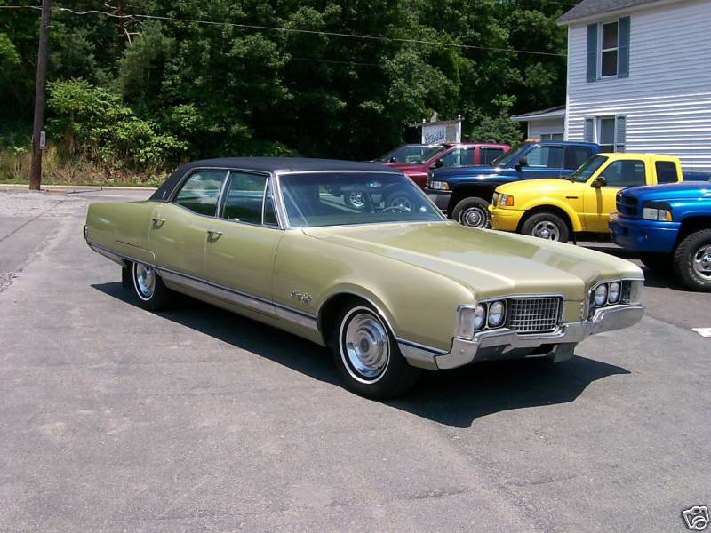

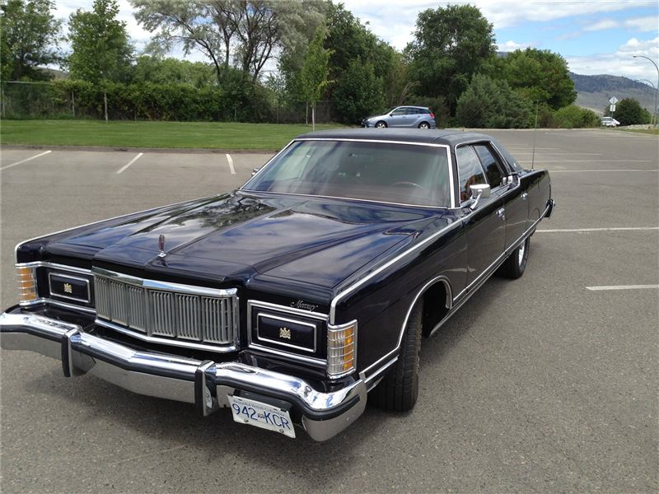

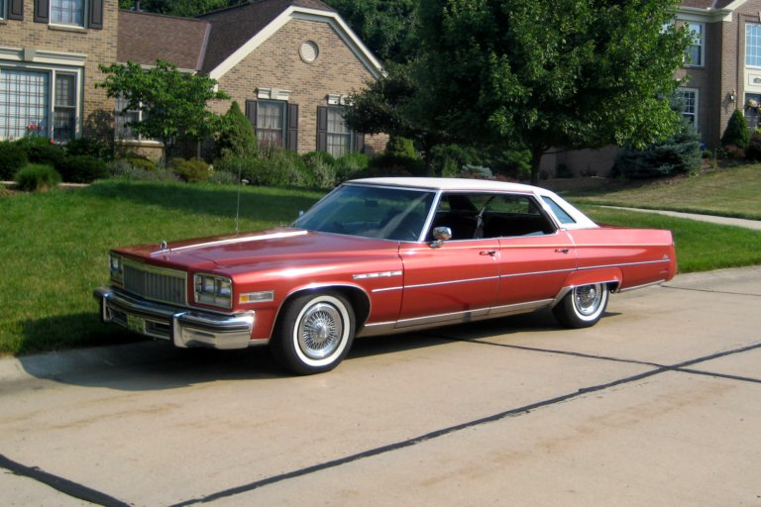

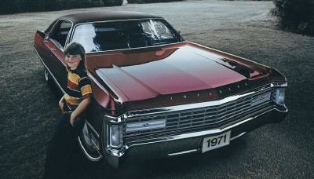

https://www.youtube.com/watch?v=pjzpx_jUUA0

32. What is generally reckoned to be the most commercially successful film ever released?

Officially, Avatar is the highest grossing film in history, having raked in over 3 billion dollars, but really, it’s Gone With the Wind. If you adjust ticket prices for inflation, there’s still nothing that beats it.

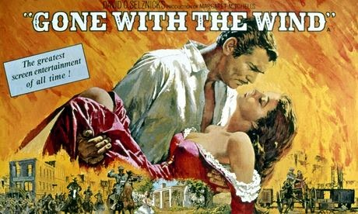
33. We’ve generally avoided precise dates in these questions, but some years, at least, should be worth remembering. We’ve been over a few; 54 B.C., 1066, 1215, 1968, and I think several others.

Just a few more to round out your liberal education: What happened in 1588 (lots of things, I’m sure, but what really big thing)?

That was the year that English naval forces (and some terrible weather) defeated the Spanish Armada, saving the British peoples from subjugation by the stridently Catholic superpower. It’s odd, looking at Spain today, to imagine it as the World’s pre-eminent nation, and master of the seas. The gold of the New World had brought Spain wealth, and wealth, then as now, is power.

The defeat of the Armada changed the course of history. Imagine all the ways the world would be different today if England never prevailed to spread the Rule of Law and Constitutional Monarchy across the globe, never colonized North America, never settled Australia and New Zealand, never ascended to supremacy on the world’s oceans. It almost doesn’t bear thinking about.

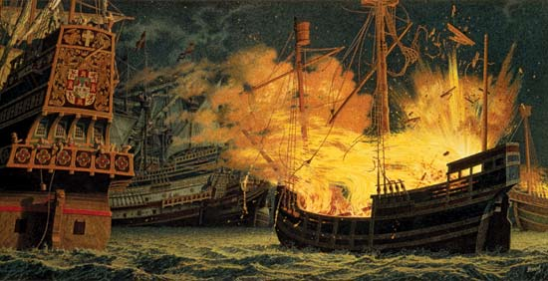
34. 1805?

I know you remember this one – the Battle of Trafalgar!! Described ad nauseam elsewhere among all these Q&As.

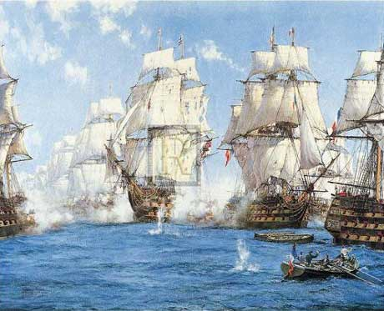
35. 1861?

The year the American Civil War started, also described elsewhere. The first shots were fired at Fort Sumter, an island stronghold in Charleston harbour, South Carolina.

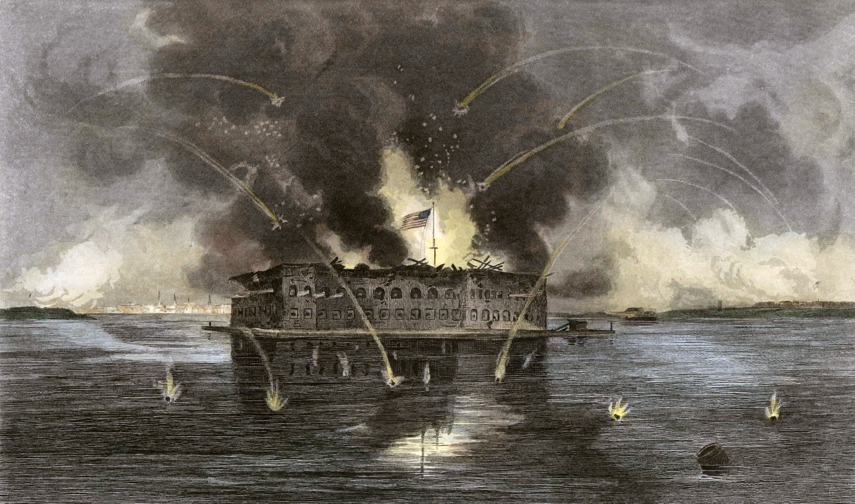

36. 1903?

The year that at place called Kitty Hawk, in North Carolina, the Wright Brothers made the first powered flight. Recall from previous entries how the first flight was actually shorter than the 1960s vintage aircraft carrier named after the event! The Wright Flyer was interesting in that it was a “tail first” or “canard” design, and it manoeuvred by warping its flight surfaces, not by actuating flaps and such. Both are ideas still pursued in cutting edge designs today.

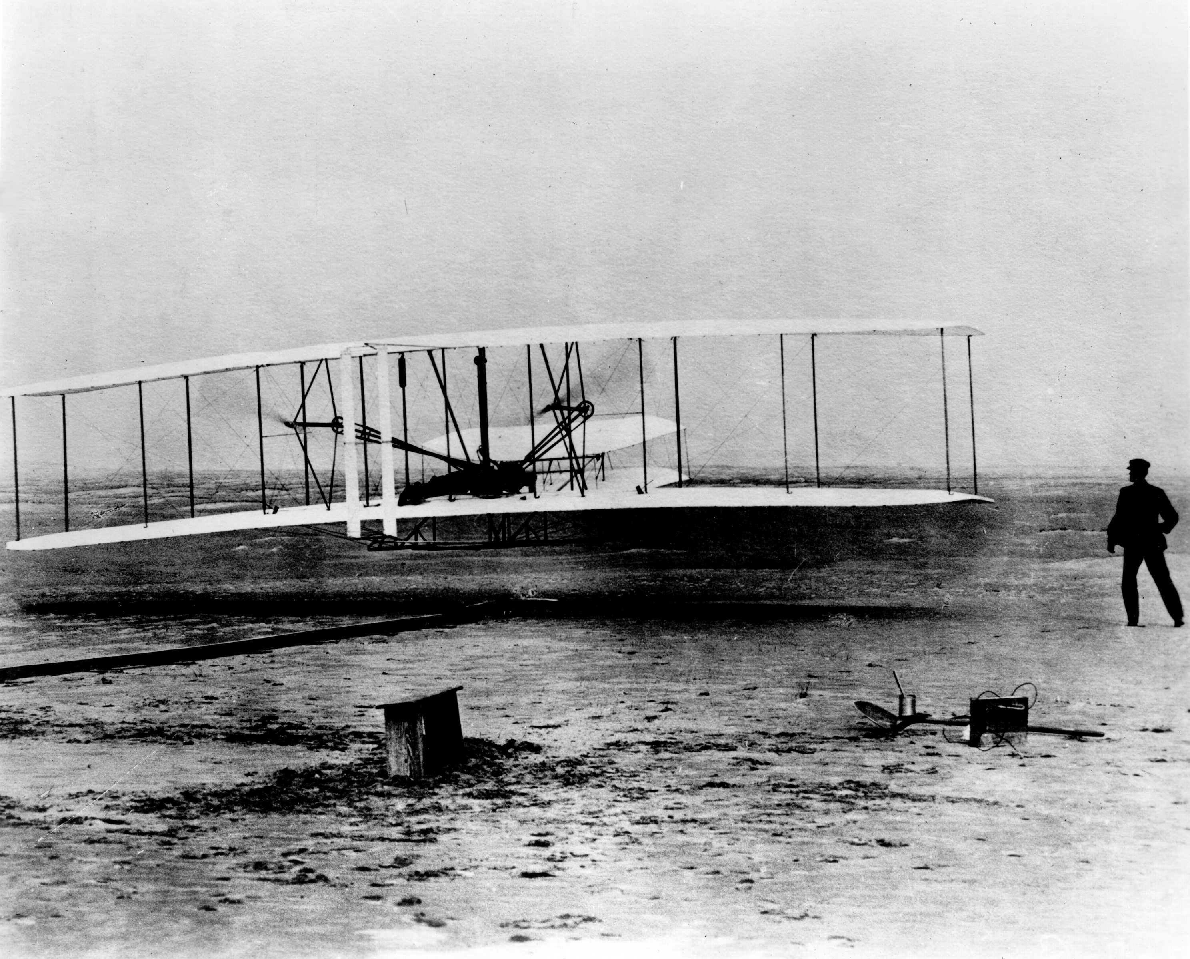
37. 1914?

Surely you remember the year that World War I started?

It was thought they were all going to be home by Christmas.

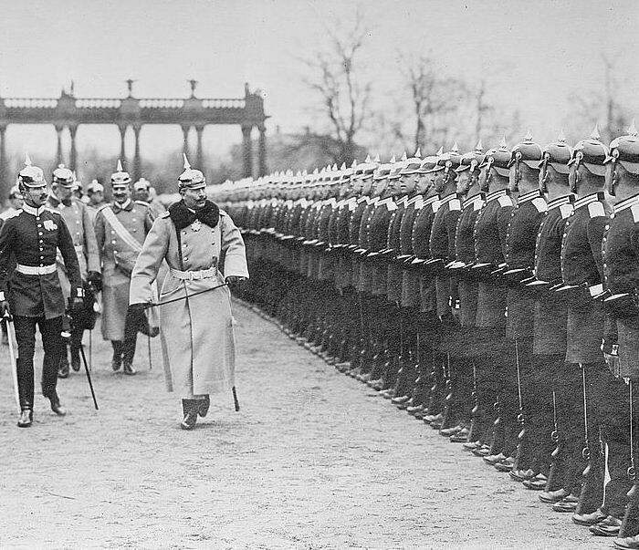
38. 1929?

Stock Market crash, Great Depression.

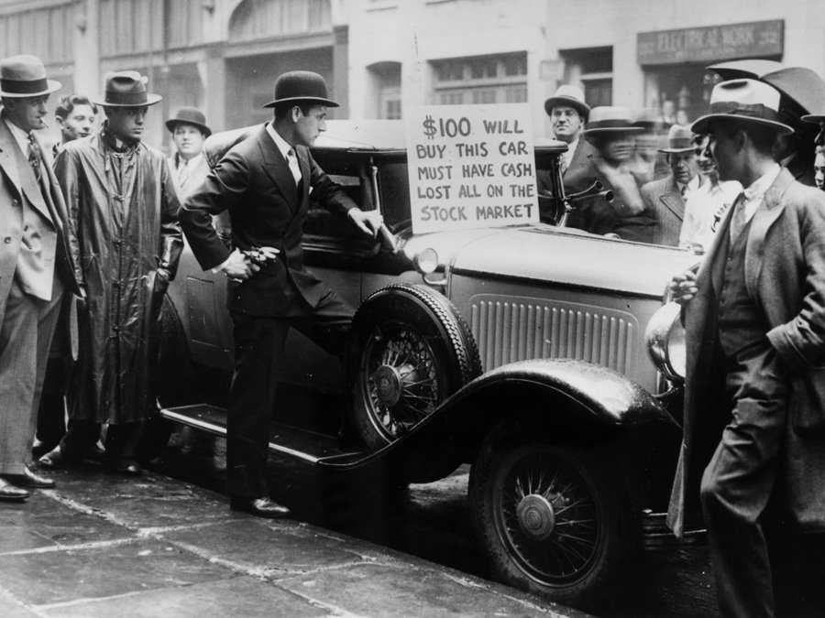
40. 1939?

The beginning of World war II. NOT 1941, as Americans tend to believe (we’d been at it for a couple of years before Pearl Harbour brought in the Yanks). The Panzers swept all before them, and a new form of war – “Blitzkrieg”, “lightning war” in English, was born. We call it “manoeuvre warfare” today.



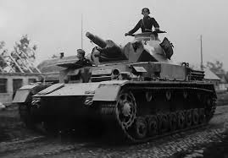
41. 1962?

The Cuban Missile Crisis.

I don’t think we’ve done this one at any length yet, but we should, since not only were we close to Armageddon, just like we thought at the time, it is now known that we were a lot closer than we realized.

The placing of ballistic missiles in Cuba was a rash gamble by Soviet Premier Nikita Khrushchev. He probably figured that if the Americans could have missiles in Turkey, why couldn’t he have them in Cuba, and protect the little Communist state from Imperialist aggression? Hadn’t the Americans sponsored an invasion of Cuba in an attempt to squelch their Revolution in the disastrous Bay of Pigs operation? Wasn’t deterring another invasion legitimate?

Anyway, he wanted to rub their noses in it, and it would be great propaganda, except, of course, the United States wouldn’t stand for it. Might have seen that coming, in retrospect.

President Kennedy’s options seemed limited. The Joint Chiefs urged massive air strikes followed by amphibious invasion, just what the Soviet missiles were there to deter. It seemed plausible; US reconnaissance by U2 overflight had caught the Russians with their pants down, only, it seemed, halfway through the necessary work of installing the weapons. Khruschev had probably hoped to finish the work in secret, then announce his fait accompli to the world. Now, having caught them in the act, the pressure to hit the missiles before they became operational was intense.

Yet Kennedy resisted. He put it to the hawks in Cabinet and the Joint Chiefs: were they sure no missiles were operational? Were they sure they would get them all? What would the Soviets do then? Nothing? Really? So JFK ordered Secretary of Defense McNamara and his brother Bobby, then Attorney General, to come up with another option. They formed the “Executive Committee of the National Security Council”, and ExCom, in a stroke of genius, came up with a naval blockade. Blockade is an act of war, so they called it a “quarantine”, and now the ball was back in Nikita’s court.

As Soviet ships approached, carrying more missiles and protected by submarines, nobody knew what would happen. The ships halted. Yet work continued furiously on the Island to complete the existing launch sites. The Joint Chiefs fumed. A tortured cable arrived from Khruschev, obviously composed by the man himself, speaking of their awful predicament, how they were pulling on two ends of a rope drawing the knot of war ever tighter. You could just see him there at his desk, in the middle of the night, vodka in hand, sweating through a crisis of the soul. Between the lines, he was terrified, and grasping for a way out. The way seemed open, now, to some sort of compromise.

But the next morning a second cable arrived, harsh and belligerent, which clearly was not in Khruschev’s own words. It looked bad. Maybe there’d been a coup. Maybe hard-liners had seized power. A second stroke of genius: Bobby advised the President to simply ignore the second cable, and respond as if the first was the only one they received.

Khrushchev had not been deposed, though he would be, before too long. A back channel was opened up, and a deal was struck – the Soviets would withdraw the missiles from Cuba, America would promise publicly not to invade, and a few months later, the US would remove its missiles from Turkey, quietly, with no fanfare. Khruschev could save face in the inner circles of the Politburo.

So it ended.

Ever since, every student of strategic studies has pored over the decision-making in the Missile Crisis, hour by hour, like chess aficionados examining the moves of Fisher vs. Spassky. There were some clear lessons. Always leave room above you on the “escalation ladder”. Leave your adversary with the painful decision whether to take it to the next level, while also leaving him a way to back down without losing face. If you’re in charge, and your gut is howling at you to slow down and think before you leap, that’s probably a good idea. Be sceptical of advice that raw force can be a “silver bullet” – it almost never is.

This last point was driven home by revelations that followed the collapse of the Soviet Union, and the brief period of warmth that existed between the old Cold War foes. Historians from the West were given access to Soviet archives, and allowed to interview former Soviet officers who were there in 1962, and what they learned sent horrified shivers down their backs.

A few of the missiles were already operational when the Joint Chiefs urged they be struck pre-emptively. Local officers had independent launch authority. Their orders were to “launch on warning” – at the first hint of attack, they were to nuke American cities, and not wait for any authorization from Moscow.

Had Kennedy listened to the Chiefs, instead of his gut, I likely would have died in my crib.

Worse, I nearly did anyway. We also learned that a Soviet submarine commander, believing war had begun, ordered a nuclear torpedo be fired at US warships. One officer, Vasili Archipov, thwarted the attack; as second in command, he had to concur. He did not. We were that close.

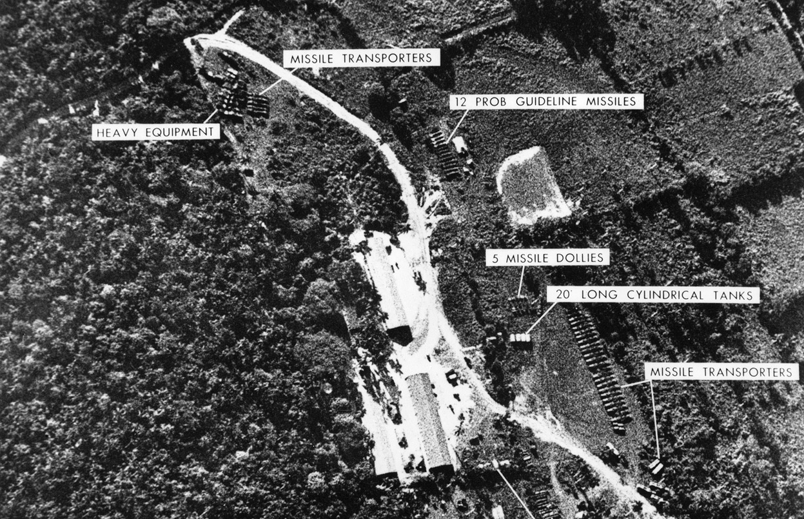

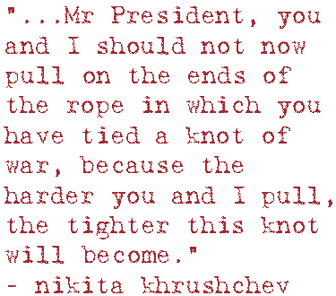

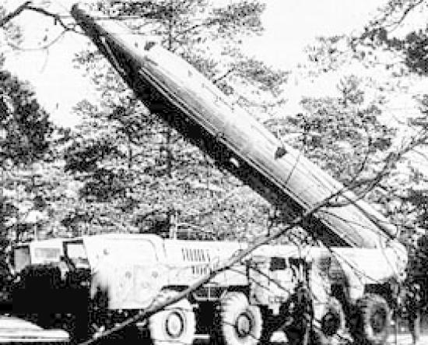


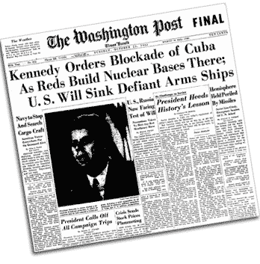
42. 1964?

The world almost faded to black in October, 1962. It was dour and grey after Kennedy was murdered in November 1963. Now, in February, 1964, it exploded into brilliant technicolour. It was as if the whole world had been hoping for a party to start, and boy, did it.

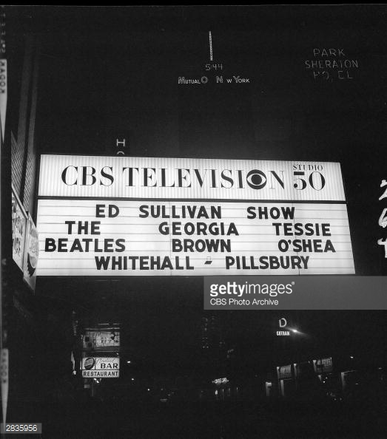

Ace guitarist George Thorogood explains:

https://www.youtube.com/watch?v=xxbFDElIQb8
43. 1969?

The Moon landing!!

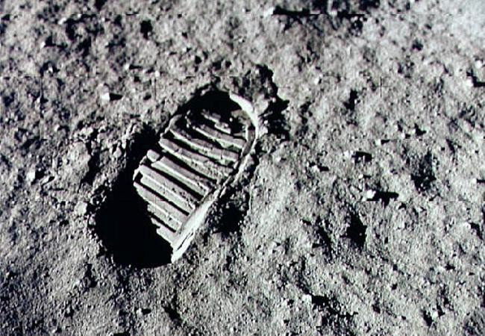
44. 1989?

A wall came down.


45. 1991?

The first Gulf War – Operation Desert Storm.

Actually it was the second Gulf War, if you count the eight years of inconclusive combat that had just finished between Iraq and Iran. Attacking Iran had been a stupid move by Saddam Hussein, and now he did something even dumber and invaded Kuwait, a crucial Gulf ally of the United States. His army was then in position to go one better and conquer HUGELY important US ally and oil supplier Saudi Arabia. There was little to stop him, and he would have then commanded about half the World’s oil reserves.

He had, perhaps, received mixed diplomatic signals about America’s potential reaction to all this, but c’mon, really? What did he think was going to happen?

What he got was the result of a superbly skilled diplomatic effort by George Bush the Elder, who built a huge coalition under the auspices of a UN resolution, including many Arab nations, with the mandate to force Iraq out of Kuwait. Beginning January, 1991, that’s just what they did. It was the first “smart bomb” war, the first use of cruise missiles and stealth aircraft, the first implementation of an air power doctrine that saw an almost inconceivably huge air assault on Saddam’s armies and strategic assets. A subsequent invasion needed just 100 hours to mop the floor with what was left of the Iraqi military.

Bush the Elder had the sense to call it quits when the quitting was good, and didn’t invade Iraq to try to topple the Hussein regime – a decision in which his senior military advisors heartily concurred. If only Bush Junior had anticipated what theatre commander General Norman Schwarzkopf foresaw as the outcome of an invasion of Iraq proper: “we’d have been like an elephant in a tar pit”.

Viet Nam may have been the first “television war”, but never had a conflict been splattered across our home theatres like this; CNN actually broadcast live from a hotel amid the first wave of air attacks in Baghdad, as F-117s came in the dead of night and took out command, control and communications targets in a surgical “decapitation” strike. Those of us then glued to our screens will never forget the night vision shots of huge bursts of Iraqi anti-aircraft fire streaming from a thousand points into the sky in a futile attempt to hit the elusive stealth fighters. It was great drama, high theatre, and if you thought about it, more than a little disconcerting. You couldn’t quite keep down the shameful exhilaration of watching all that amazing technology do its thing.

Eerily, just prior to the strike aircraft arriving on target, the CNN crew caught the sound of dogs barking all over Baghdad. Radar couldn’t find the F-117s, but the dogs could hear them coming.

Then BANG!! Big explosions! It was like an action movie!!

And then you thought, maybe, what if that was happening to me, right now? The Americans were exceptionally careful to hit only military targets, but if you were in Baghdad, your walls were rattling, your windows shattering, and you could feel the concussion in your ears as the power, water, lights, TV, radio, phones, everything, all failed immediately and at the same time. Bridges were being dropped. Key transportation arteries were being cratered. Explosion after explosion rocked you in your seat as guided bombs and cruise missiles extinguished target after target, bang, bang, bang, bang, relentless. It would have seemed at that point that your life would never be the same, and in the weird chain reaction of events that followed Desert Storm and continues to this day, it never has.

Not for them, and not for us. But especially not for them.

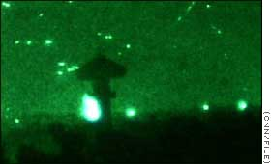


A very good BBC documentary here, if you ever have an hour to kill:

https://www.youtube.com/watch?v=HMV_0iTk1qs

AND NOW:

THE LAST FIVE QUESTIONS
46. Centipedes have 100 legs, this we know, so how many legs must millipedes have?

A thousand, right? <RUDE BUZZER NOISE>. No species of millipede, despite its name, has 1,000 legs, though some have over 800. Actually, centipedes don’t have a hundred legs either, and vary from fewer than that to up as high as 300.

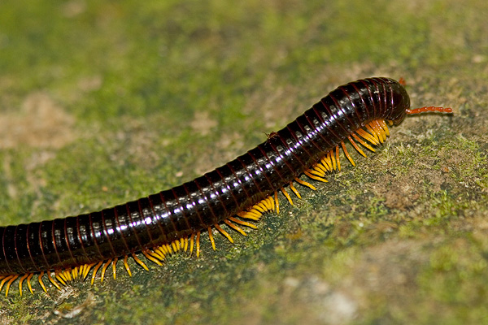
47. What’s going to happen some time in 2061?

That’s when Halley’s Comet will be swinging by again. In July, it says here in Wikipedia. It was last here in 1986, when I was hoping to see it, but the ’86 flyby was kind of a bust, it wasn’t prominent in the sky. Bummer. Maybe it will be better in 2061, just like it was in 1910, though predictions are that it will again be almost invisible to the naked eye.

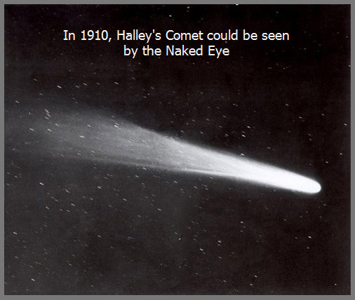
48. What is the most amazing of many amazing things about the construction of the “Chunnel” (OK, it’s subjective, but I find it amazing)?

The Channel Tunnel between England and France is carved through the sea floor at a depth of over 200 feet, and is 31 miles long. That’s a long way, and the engineers wanted to dig it as fast as possible, so rather than start at one end and tunnel all the way to the other, they started at both ends at once and met in the middle. Each side had over 15 miles to dig, and the slightest deviation could have made them miss each other by a wide margin, but they met, precisely as planned, in perfect alignment, both vertically and horizontally. Below is a picture of workers from both sides raising a hat to their achievement; behind is the disc of the French boring machine, having broken through to the English side. Before that happened, the workers on the French side took a couple of jack hammers and punched a small hole, through which appeared the beaming mug of an English worker. Amazing. Video at bottom below.

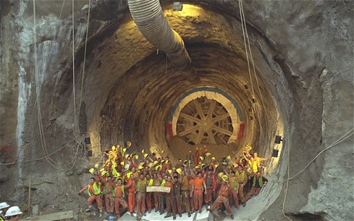

https://www.youtube.com/watch?v=Q5V-Hks0oDM

49. Neil Armstrong was the first man to set foot on the Moon, sure, but who was the last?

The last astronauts to touch down on the Moon were Apollo 17’s Harrison Schmitt and Eugene Cernan. Schmitt was the last, and 12th, person to exit an LM and set foot on the Moon. However, at the end of the mission, Cernan was the last to get back on board, making him the last human being, so far, to ever plant his boots in Moon dust. Since December, 1972, no one has travelled farther into space than low Earth orbit.

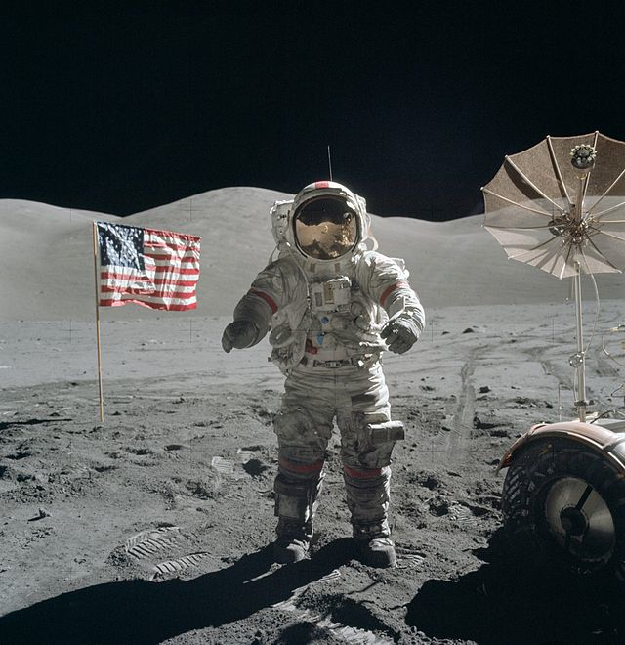
50. Who turned a dead bird into one of the funniest things in all of comedy?

The Monty Python troupe, and specifically, Michael Palin playing a pet shop owner, and John Cleese in the role of an increasingly frustrated pet buyer rooked into buying a parrot that was, unfortunately, quite dead.

The two did another riff on the theme in the setting of a cheese shop which, it becomes evident, has no cheese whatever.

https://www.youtube.com/watch?v=npjOSLCR2hE

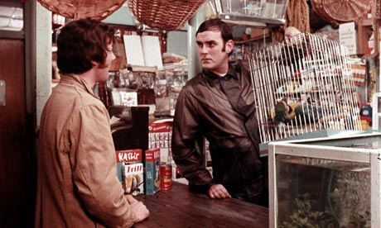
51. SURPRISE!! Bonus question: In what cartoon do we hear an unlikely singer belt out a tune called “Michigan Rag”?

The cartoon is One Froggy Evening, another Chuck Jones masterpiece and arguably the greatest short cartoon ever made. It isn’t just that it’s uproariously funny, it’s that it’s so very funny while amounting to little less than a Greek tragedy, as a humble construction worker, blinded by visions of fabulous wealth, is humiliated, left penniless, and ultimately destroyed.

The action begins with our unlucky protagonist working demolition, and prying apart the stones of an old building. Within the hollow cornerstone, dated 1892, he finds an old metal box, a sort of time capsule. Inside that is some sort of formal document, and a frog, somehow still alive, who crawls out, sits listlessly on the open lid, croaks, and looks balefully at the worker. Our friend with the pry-bar is at a loss. Then, inexplicably, unbelievably, the frog reaches back into the box, pulls out a little cane and top hat, stands up, and starts high-kicking as he just belts out old Vaudeville tunes, and other popular songs that would have been current at the time he was buried inside the building.

From there, the whole story plays out without a single word of dialogue, while only the frog opens his mouth. He sings in a wonderful baritone voice, clear as a bell, and he has a great entertainer’s chops. He performs ragtime, classics from the American Songbook, old Irish tunes, and even Opera, as he hoofs away, wide eyed and exuberant, back and forth in front of the box. Among the tunes is Michigan Rag, which sounds just like a genuine period piece, as are the other numbers in the frog’s repertoire, but was actually written for the cartoon. Once you’ve heard it, you’ll never forget it:
Everybody does the Michigan Rag!
Everybody loves the Michigan Rag!
Every Mame and Jane and Ruth
From Hoboken to Duluth
Romp, bomp, stomp the Michigan
Ride, glide, slide the Michigan
Jump, hump, pump the Michigan Rag!
That lovin’ raaaaaaaaaaag!
Yup, the frog is a dynamo. A sensation. But there’s a catch…

http://filmschoolrejects.com/features/short-fil-watch-one-froggy-evening-the-citizen-kane-of-animated-film.php

The singing and dancing amphibian, given no name in the cartoon, somehow acquired the handle Michigan J. Frog.

The Library of Congress has deemed this little cartoon to be of such cultural significance that it has preserved a print in the National Film Registry.



Or civic workers in the US South trying to halt the spread of Kudzu, or forest managers trying to stop the Asian Longhorn Beetle, or the stewards of the Great Lakes as they try to keep out the Asian Carp, and do something about the Zebra Mussels.

