1. What does “Arbeit macht frei” mean, and what is its horrifying significance?

“Work shall set you free”. This was the sign over the gate at Auschwitz.



2. What was “the gun that won the West”?

The Winchester Repeating Rifle, Model 1873.

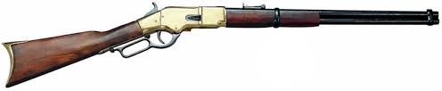

3. Which shoots farther, a crossbow or a longbow?

Crossbows, generally. Their strings could be pulled to a greater tension because they used a mechanical ratchet system to draw them back - a longbow has to be drawn by muscle power. The longbow’s key advantage was rate of fire. Incidentally, note that a crossbow projectile is called not an “arrow”, but a “bolt”, hence the expression “having shot your bolt”, meaning you gave it your best shot, and are now out of action.

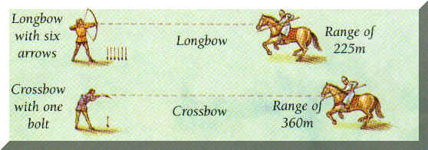

4. About how many cubic centimetres is the volume of an average human brain (ball park)?

1300-1400. Except for Homer Simpson.

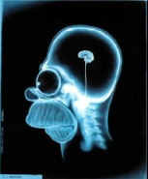

5. What lurked in the Labyrinth?

The Minotaur.

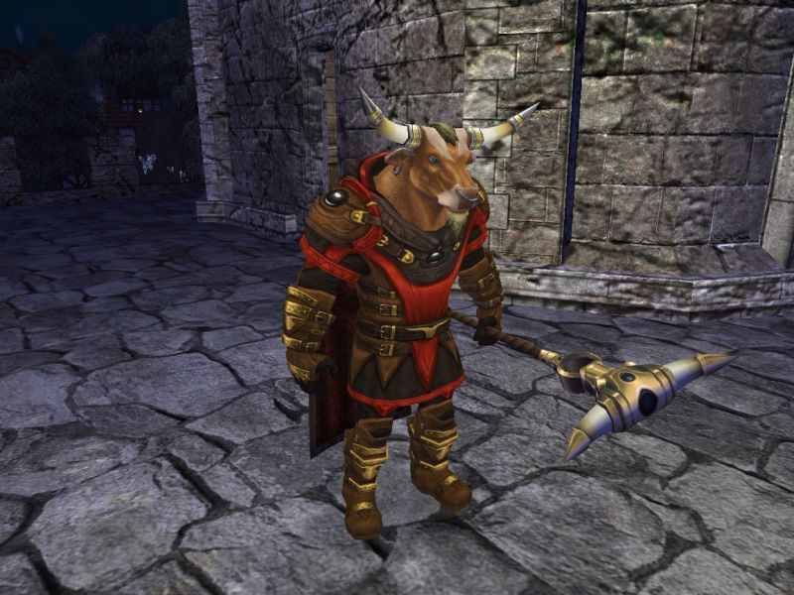

6. What movie took place on the commercial towing vehicle Nostromo?

Alien. Ridley Scott’s masterpiece was really a haunted house movie set in space, and the set for the Nostromo broke all science fiction precedent. It was a big, noisy, dark and dirty freighter, a working vessel, not a fancy star ship with glossy surfaces and bright shiny buttons everywhere. Its crew was civilian, and unarmed; when the monster appears they have to improvise weapons and sensors – why would they have ray guns and tricorders on a freighter? They’re hauling metallic ore and processing it, not looking for Klingons, and they’re wholly unprepared for the events about to overtake them.

They’re not even supposed to be awake. Their plodding vessel takes months and months to travel the vast distances between planets, and in a wonderful opening shot, the camera wanders all over the ship, finding signs of habitation, but nobody on duty, not a soul anywhere. The crew is hibernating while the massive vessel cruises on autopilot.



7. Where is McMurdo Sound?

Antarctica.



8. What country owns Antarctica?

None, by international treaty. For once we decided not to fight over something - good thing nobody struck oil.

http://www.discoverfrance.net/Colonies/Antarctic_Treaty.shtml



9. Why is the boreal forest “boreal”?

“Boreal” means Northern, and so our forest here in the Northern hemisphere is the “boreal forest”. See also “Aurora Borealis”. “Austral” means Southern, hence “Australia”. There is also an “Aurora Australis”, the same phenomenon occurring at each of the poles.



10. What’s the key advantage of binocular vision, and what is its key drawback?

Superb depth perception; but the more “binocular” the more limited the field of view. We have binocular vision because we descend from a long line of arboreal primates.

Being able to judge with precision just how far away is that next branch, as you grasp for it, is a trait that would have been naturally selected straight away, while those with less acute depth perception were no doubt heard crashing through the foliage to the distant ground below.

A life in the trees is also what bequeathed us our opposable thumbs, so crucial to our evolution as tool-makers, the better to grab cylindrical branches. Thus all primates have binocular vision and opposable thumbs - both are essential pieces of kit. Those that have stayed in the trees tend to have prehensile tails, too, almost as useful as another hand (a crucial exception are gibbons - the most supernaturally gifted tree dwellers of them all, swinging from limb to limb at unbelievable speed with almost unfathomable precision). It’s not the easiest way to live, but the fruit is nice, and few predators, even those that can climb, can go as high and fast as you, though there are species of eagle that can hunt monkeys. Can’t win ‘em all.

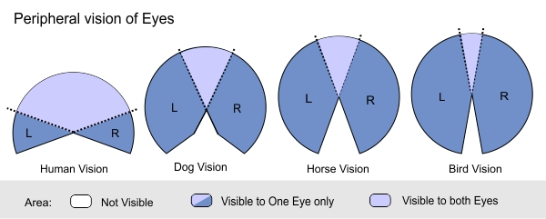

11. What did Christiaan Barnard do?

The doctor who performed the first human heart transplant.

Christiaan Neethling Barnard (8 November 1922 – 2 September 2001) was a South African cardiac surgeon who performed the world's first successful human-to-human heart transplant.

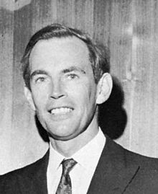

12. Who was Barney Clark?

The first human recipient of an artificial heart. It kept him alive for about 4 months, as its workings tended to cause coagulation that would get chucked off as deadly blood clots. The heart is no simple pump, and a really good artificial one eludes us still, though there are several devices that can, if absolutely necessary, serve as permanent replacements. I’m not sure what the life expectancy is with these things, but perhaps a clue is that artificial hearts are often used as an interim solution while awaiting a suitable organ transplant.

http://www.wired.com/2009/12/dayintech_1202jarvikheart/

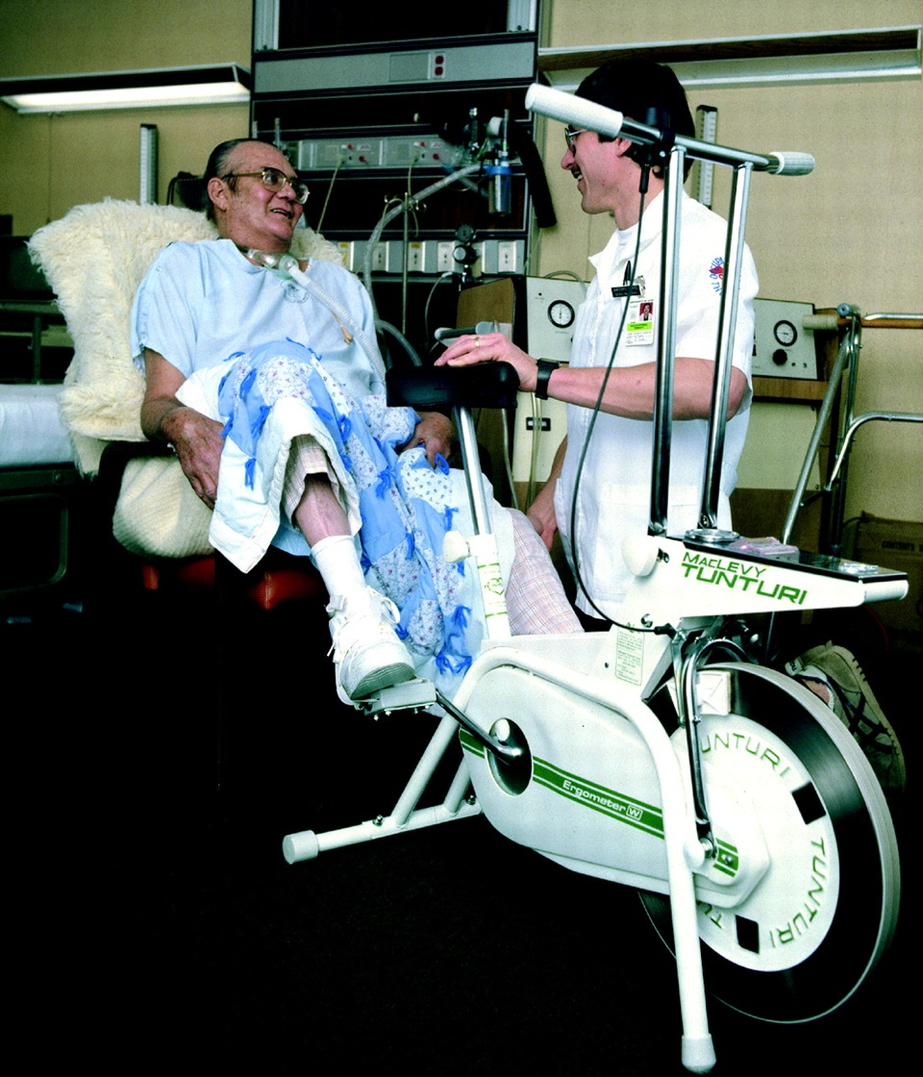
13. What do you call an object with 12 sides?

A dodecahedron.

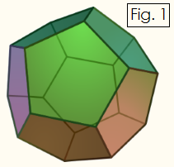

14. What is distinctive about a topographic map?

It shows elevation. Also called a “contour map”

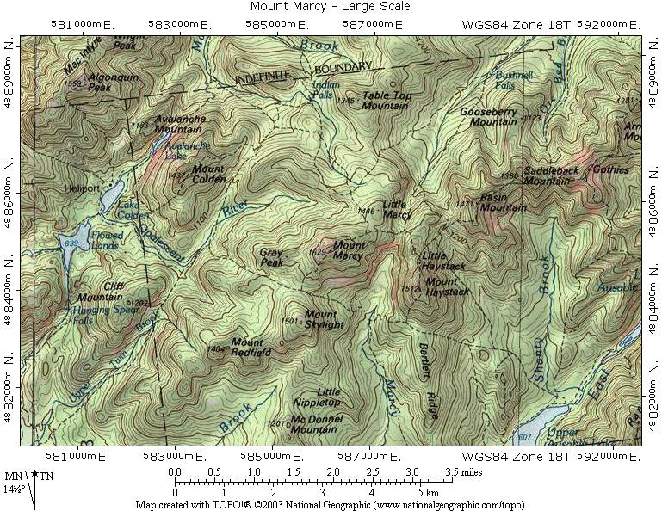

15. What inaccurate impressions are created by a Mercator Projection?

The size of landmasses is distorted to look larger as you move toward the poles, because the lines of longitude don’t converge, as they actually do on our spherical world. It also tends to make you think that Europe and Russia are way over there on the right, and not very close to us on the other side of the globe.



16. What was “caisson disease”, and who got it? Who gets it today, under a different name?

Workers in underwater compartments (called “caissons”) working on the footings of the Brooklyn Bridge. We call it the “bends” today, technically “decompression sickness”, and it’s a risk for scuba divers.

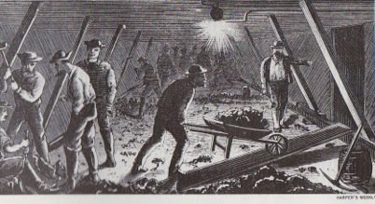

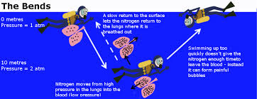

17. What, to biologists, was so significant about the discovery of albino tube worms living around volcanic vents in the deep ocean?

The First ecosystem ever discovered in which no component draws energy from the Sun.



18. What is an “astrobleme”? Where would you find a reputed astrobleme in Canada?

Literally, a “star wound” - an impact crater. It is suspected that Lake Manicougan in Quebec is one, it being circular.


19. Who said “L’etat c’est moi”? What does it mean?

Louis the XIV; I assume you can do the translation.

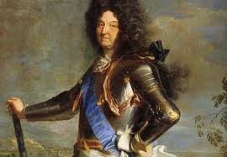

20. Who so fascinated Alexis de Toqueville?

American society and culture. Democracy fascinated him, risking, as he put it, the “tyranny of the majority”.

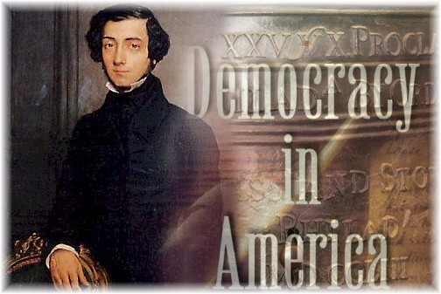

21. Who originated the idea of the “collective unconscience”?

Carl Jung. Jung believed that every human mind was endowed with certain “archetypes”, ideas and drives common to us all, innate psychic traits that drove us at a fundamental level. Mothers and children, fathers and sons, overlords and underlings, all behaved according to a sort of universal playbook built right into our DNA, leading to behaviours that could neither be taught nor undone. He believed we carried around a set of universal images and symbols that expressed themselves in dreams and visions, relating to love, death, fear, power and so on. Anyone who looks to analyze dreams through the interpretation of common symbols and motifs is walking in Jung’s footsteps.

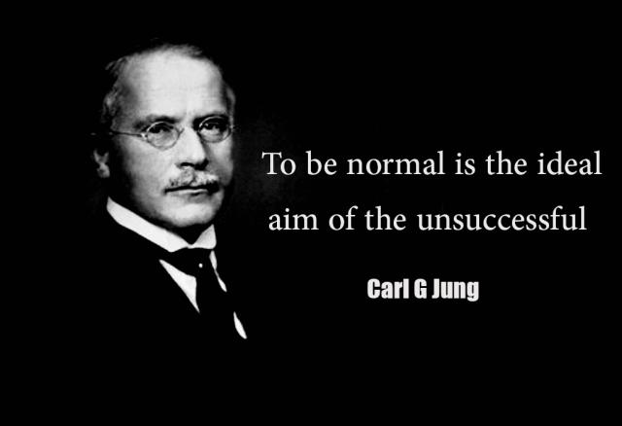

22. Who was Satchel Paige? What’s so disappointing about his life story?

Perhaps the greatest pitcher who ever lived, he was black and sequestered in the Negro league in his prime, mowing down the likes of the NY Yankees in exhibition games, and only got to play in the majors late in his career. Who knows what records this man would have set. He remained effective into what is usually thought of as old age in athletics.

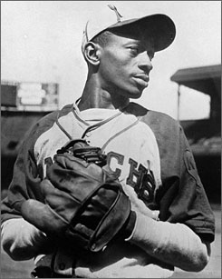

A poem I always liked, written by Samuel Washington Allen:

To Satch

Sometimes I feel like I will never stop
Just go on forever
Till one fine mornin
I'm gonna reach up and grab me a handfulla stars
Swing out my long lean leg
And whip three hot strikes burnin down the heavens
And look over at God and say
How about that!!!!
21. What was an “arquebus”?

An early firearm.

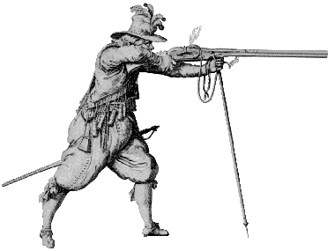

22. What was supposedly stored within the Ark of the Covenant?

The original stone tablets upon which were inscribed the Ten Commandments. And the Wrath of Almighty God, that was in there too.


23. What are flying squirrels doing when they fly, technically?

Gliding. The only mammals that truly fly are bats.

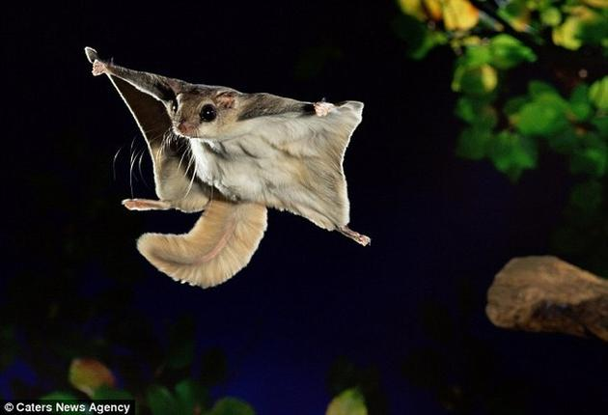

24. What group of islands were fought over by the UK and Argentina?

The Falklands (“Malvinas” to the Argentinians}.

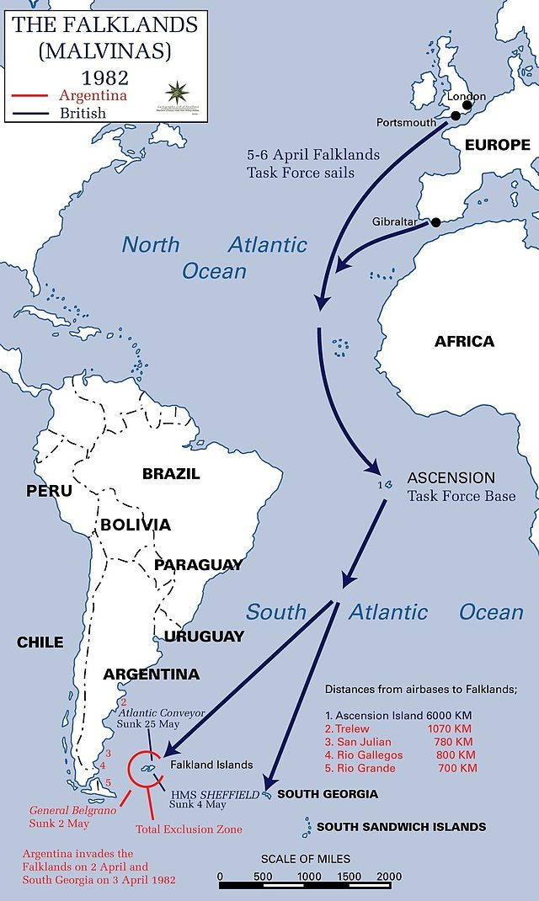
25. How is a turbofan different from a turbojet?

It has an extra fan stage at the front that is much bigger than the engine core behind it, and by-passes air around the core and out the back. For various reasons this makes them more efficient, and less noisy as well. The amount of air that flows around the engine core as opposed to that which gets compressed and ignited within the combustion chamber is known as the “bypass ratio”. High by-pass ratios make for the most efficient engines, so you see them on airliners, but low by-pass engines allow for higher thrust-weight ratios, greater exit velocity, and the use of afterburners, so you see those on military aircraft. Pure turbojets are rare these days.

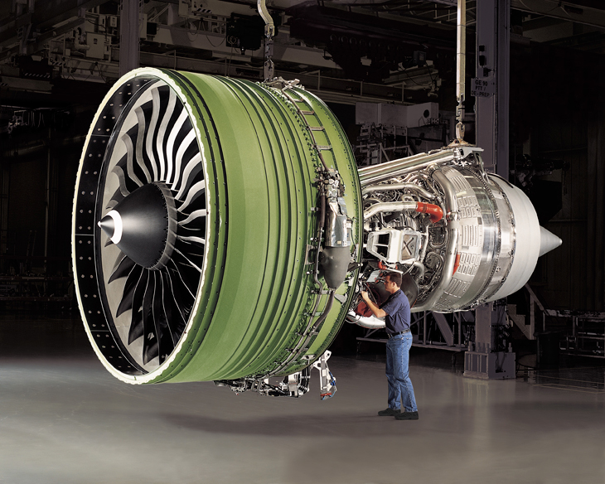

26. How is a Diesel engine distinct from a standard internal combustion engine?

Diesel engines don’t use spark plugs - they compress the air (which generates heat) in the cylinders to produce the interior explosions that drive the pistons.

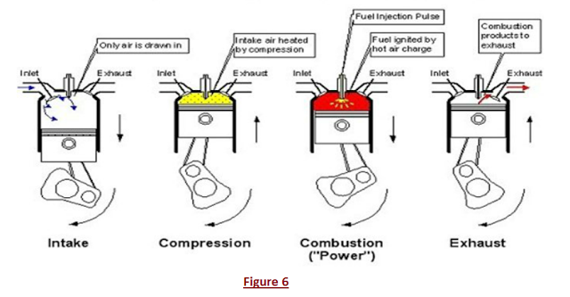

27. Who lived by the Code of Bushido?

The Samurai.

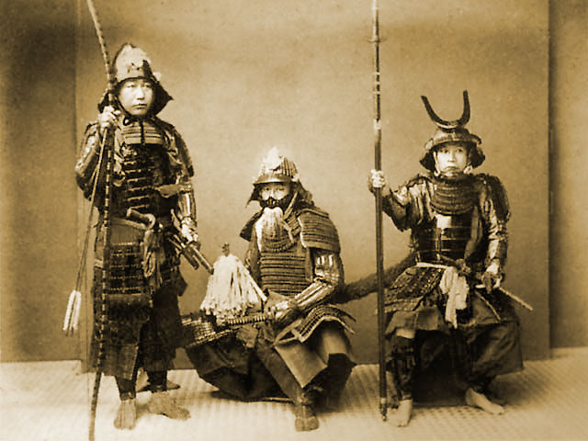

28. What was the Bessemer Process, and what did it make possible?

It was the first process that allowed the mass manufacture of steel. Before it came along, in the mid 1800s, you would see certain implements out of steel, like swords, but you couldn’t scrape enough together to build bridges and the like.



29. What does a sewing machine have in common with the ship that laid the Trans-Atlantic Cable?

Both work on the principle of a spool and bobbin. To lay the first intercontinental telegraph line, they crossed the Atlantic around 1865 or so, in a specially modified ship, spooling out one long cable (over 2000 miles!) as they went. The ship was named Great Eastern, and was designed by the greatest engineer you never heard of, Isambard K. Brunel. It was constructed of iron, was 700 feet long, and displaced over 30,000 tons, a marvel of the age and easily the biggest ship ever built at the time of its launch. Great Eastern was later used to lay huge lengths of cable on other parts of the sea floor, tens of thousands of miles, I forget how much.

Brunel also designed revolutionary bridges, and tunnels, and then died young. Everything he did was amazing, even his failures.

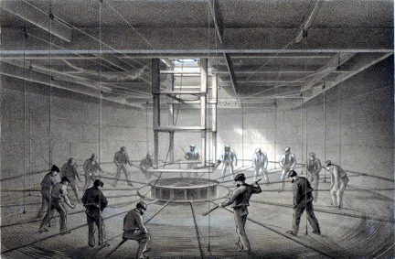

30. What was said to lie “Beyond the Pillars of Heracles”, and what did that mean?

Atlantis; beyond the mouth of the Mediterranean.

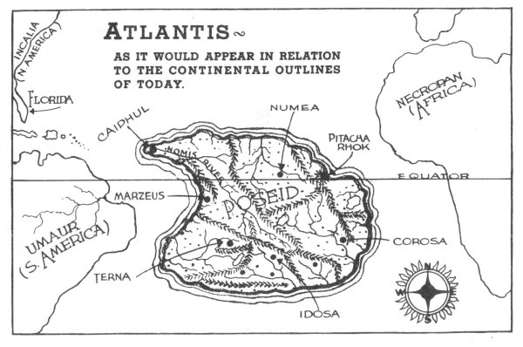
31. What is so wonderful about spinning a magnet around a copper coil?

Or spinning a copper coil around a magnet, if you prefer - that’s how you manufacture electricity.

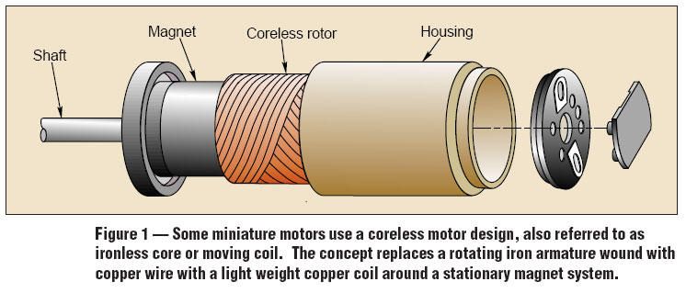
32. What is the First Law of thermodynamics called for short?

Conservation of energy. This holds that energy can neither be created nor destroyed, just transformed from one form into another, or transferred from one object to another.

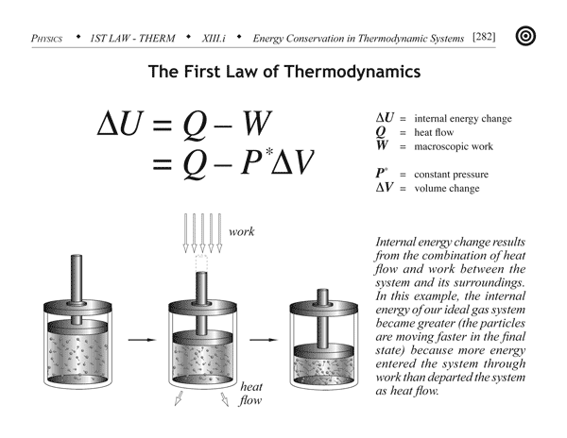
33. Why were mad hatters as mad as hatters?

Their process used mercury, which is a potent neurotoxin.

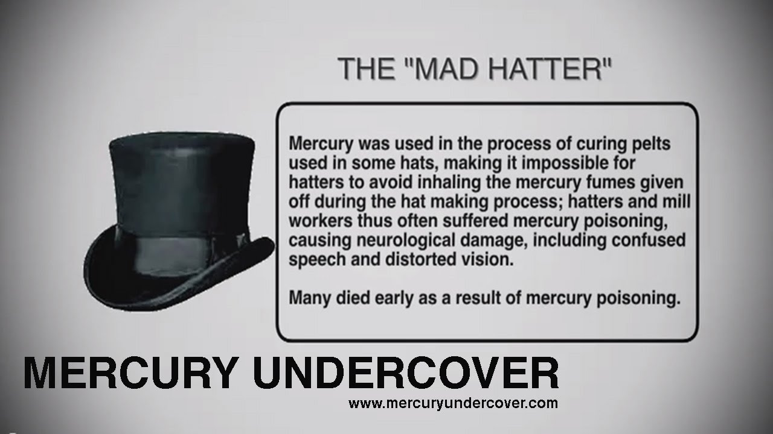

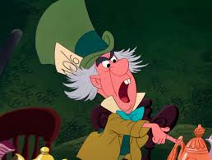
34. What is a cuttlefish?

A sort of squid-like critter.



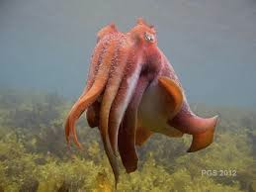
35. What besides birds have beaks?

Squid and octopus. Kind of nasty, no?

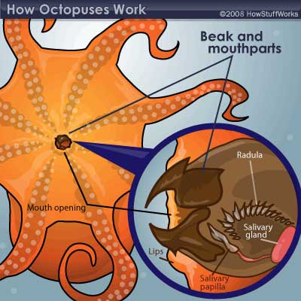

36. What supposedly happened during the Philadelphia Experiment?

In an experiment said to have been conducted during WW II, a US Navy destroyer was supposedly induced to briefly leave our reality and travel through a sort of hole in space-time before snapping back. The genesis of the myth appears to be in experiments conducted at the Philadelphia Naval Yard during the war, attempting to demagnetize the hulls of steel ships, in order to thwart magnetic mines and homing torpedoes. Nobody left the universe.

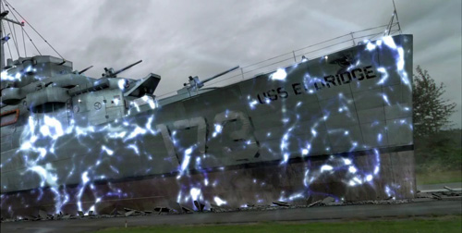

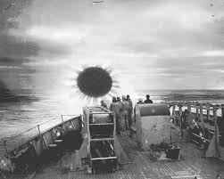
37. What was so special about the Tuskegee Airmen?

The first squadron of black fighter pilots in the USAAF in WW II, they flew red-tailed Mustangs, and after initial derision and skepticism, proved themselves so good that their presence as escorts was considered essential to the morale of bomber crews. There was nothing so comforting to those vulnerable occupants of the lumbering B-17s and B-24s as the sight of red tails. It would take years after the war, but their example made the demise of segregation all but inevitable - Truman de-segregated the military around 1947, I think. Those with brains in their heads were ever after of the view that if the black race really was inferior, it could not have produced such damn fine fighter pilots.


38. What happened on Iwo Jima?

One of the most vicious island fights of the Pacific war, and the site of one of the most iconic images in history - raising the flag on Mt. Suribachi.

Iwo Jima was a rock midway between the Marianas island chain and Japan, a volcano cone atop a flat plateau, and of no Earthly good to anyone, except when you’re fighting a war and want to put an airstrip within striking range of the Japanese home islands. The Americans suffered 7,000 dead and about 20,000 wounded to take 8 miserable square miles of volcanic rock, and the Japanese garrison of 22,000 was killed practically to a man.

Cynical stories that this picture was staged are entirely false.

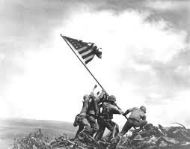

39. In what season do lemmings tend to run off of cliffs to their death?

It’s a myth - they don’t actually do that at all, of course. A tendency towards mass suicide wouldn’t be the sort of trait that could persist in the process of natural selection, would it? Sometimes they drown in large numbers when fording rivers during migration.

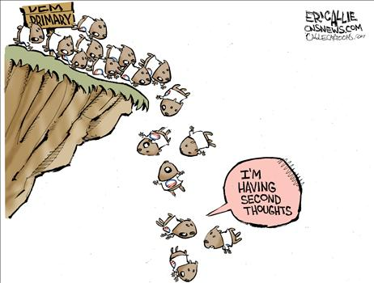

40. What’s a Prairie Schooner?

A covered wagon.

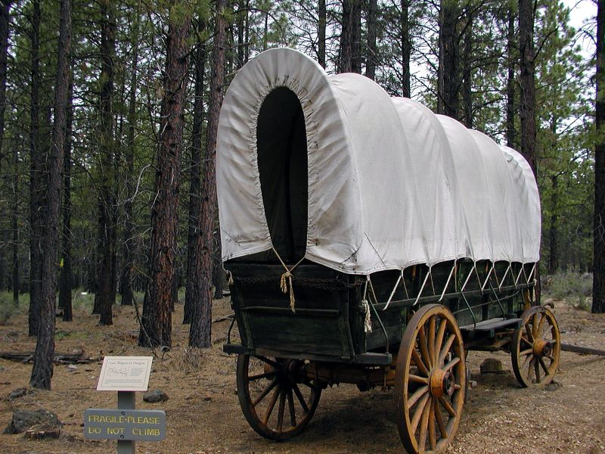

41. Who was Robert E Lee’s favourite subordinate and right arm?

General Stonewall Jackson - like Lee, a genius. The Confederate Army had no business doing so well in the Civil War, except that it was commanded by the best officers on earth.

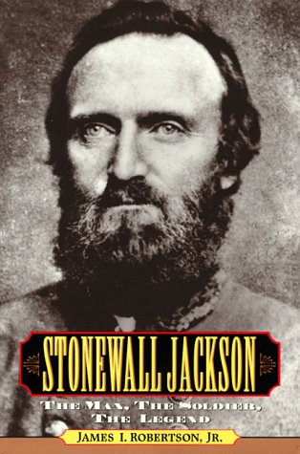
42. You’re an “endotherm”. What’s the big advantage of that? What’s the big disadvantage?

That means you’re warm-blooded. By maintaining constant temperature, you can have more sophisticated internal organs, and colonize areas too cold for, say, reptiles. Disadvantage: you need 10 times the calories, pound for pound, of a lizard or alligator to do it. But you won’t see any crocodile do this:

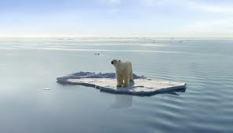


43. Eagles and other birds of prey are said to have “telescopic vision”. What’s different about their eyes?

They don’t actually have zoom lenses, but they are much more densely packed with rods and cones than our eyes, in effect giving them more pixels and much higher resolution. You could say our vision is grainy compared to their high-def.

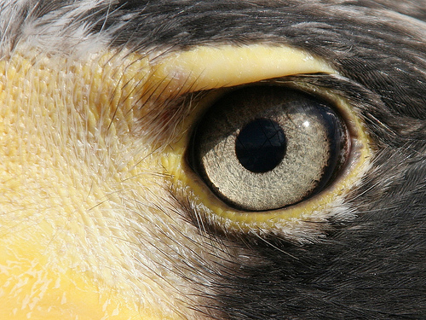

44. What is the “persistence of vision”, and what wouldn’t be possible without it?

When the rods and cones fire in your eyes and send signals to your brain, they need a brief instant to “recharge” before firing again, and in the mean time your brain simply maintains the last image sent.
Movies and cartoons rely on this - the gaps between frames literally go by unseen while you aren’t looking. You gotta watch this:

https://www.youtube.com/watch?v=W-yLfm5HsHc

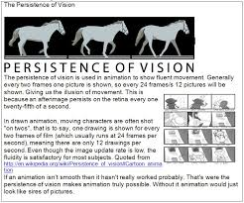

45. Who is usually credited with inventing the electric guitar (though of course nothing is ever that simple)?

Les Paul.

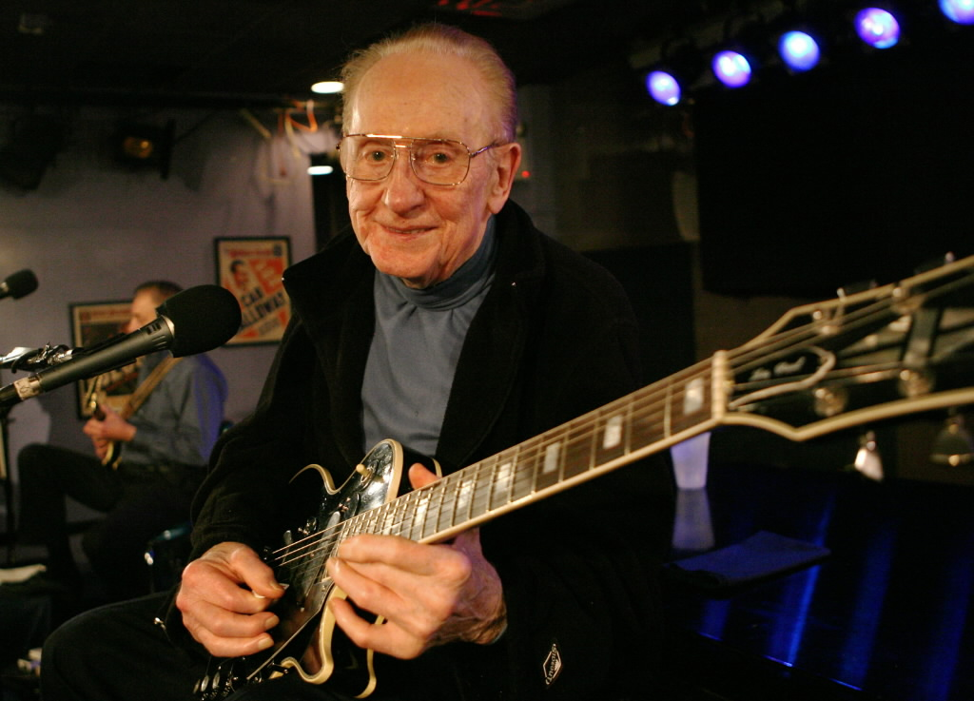

46. How is a harpsichord different from a piano?

Pianos work by striking the chords with little hammers. Harpsichords, in effect, pluck the strings.

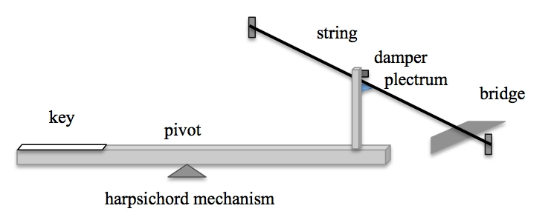

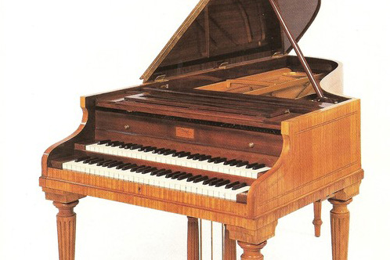

47. Who wrote the 1812 Overture, and what was it about?

Tchaikovsky; Napoleon’s defeat and retreat before Moscow.

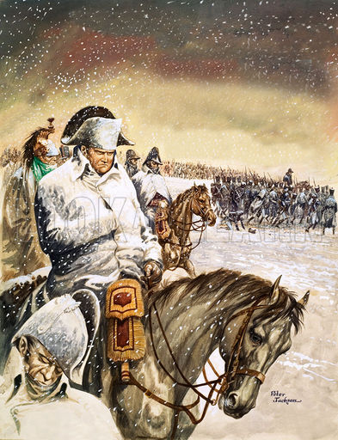
48. What conflict might properly be called the First World War (though it isn’t)?

The Seven Years' War, known as the French and Indian War over here (the one that featured the conquest of Quebec, Plains of Abraham and all that) was fought all over the globe.

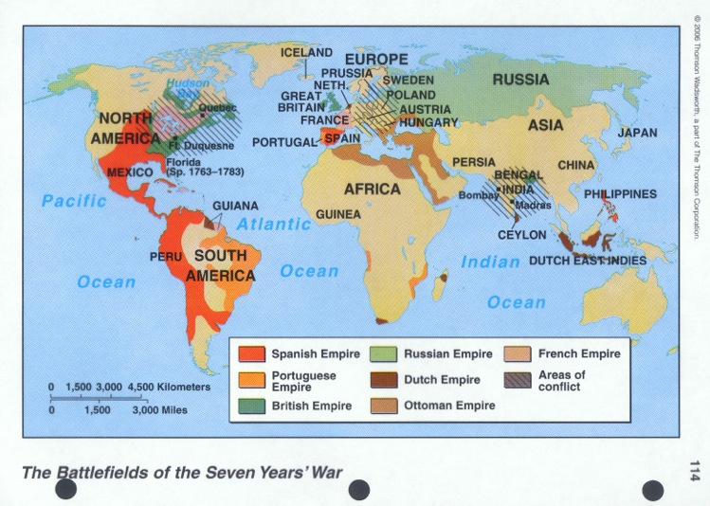

49. What science of moving objects has to be completely mysterious to people who call a certain projectile the “magic bullet”?

Ballistics. Dumbass conspiracy nuts don’t know anything about how bullets actually travel. The “magic bullet” is the single round that made such a mess of both Kennedy and Governor Connelly in the assassination in Dallas. Conspiracy nuts say the bullet would have had to change direction in mid-air in order to strike both men the way it did, as depicted first below, so there must have been a second shooter, likely on the famous “grassy knoll”.

That theory only begins to make the teeniest bit of sense if you imagine both Kennedy and Connelly sitting bolt upright in their seats, like mannequins, perfectly aligned. When you look at the actual posture of both men as recorded on film at that awful moment, Kennedy is hunched over, Connelly is bending around in the front seat, and all the wounds line up perfectly, given that the bullet, like all bullets that strike bone and soft tissue, changed trajectory (in this case downward) within Kennedy’s body and started to tumble. In a recent experiment, the exact same wounds, and even the location of the spent bullet on the floor of the car, were duplicated precisely, using dummies made of “ballistic gel” in the correct postures, and the same make of gun used by Oswald, from exactly the same distance, elevation and angle. One bullet. One shooter. No magic.

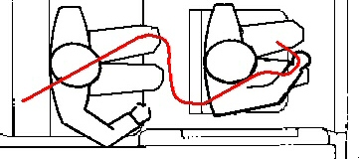

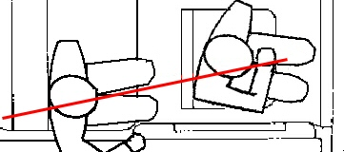

50. Why would you know that a clothing maker named Abraham Zapruder ever existed?

He’s the one who filmed the Kennedy assassination, giving us the info we need to reconstruct events. You’ve seen it, almost certainly - the “Zapruder Film” is perhaps the most famous movie ever shot.

Seen in its entirety, it’s graphic and horrifying. In the frame below, Jackie isn’t trying to flee the car, she’s desperately trying to retrieve pieces of her husband’s brains and shattered skull off the lid of the trunk, not yet having processed that this was pointless.

How horrible the power and accuracy of even the cheap sort of rifle that Oswald used, ordered through the mail. People just don’t want to believe how easy it was for a single shooter to have pulled this off, but in truth it wasn’t even a difficult shot, and Oswald only missed on one out of three rounds because the limo passed under a suspended traffic light at the moment he fired, and it ricocheted off the metal housing. You don’t need hidden shooters on grassy knolls to wreak this kind of havoc. You just need a mediocre rifle and a scope.

