1. In the 1960s Grumman Aircraft Corporation was asked to design something called a LEM. What was it?

“LEM” stands for Lunar Excursion Module, a name which was later shortened just to “Lunar Module” or “LM” – it was the spider-like machine that the Apollo astronauts used to descend to the Lunar surface, and then ascend back to the orbiting Command Module. Designing a single vehicle that could serve both as transport between the Earth and the Moon and Lunar lander posed all sorts of design challenges which were neatly sidestepped by the LM concept; the Command Module would release the single-purpose LM in much the same way as a yacht might deploy a dinghy to transport people to and from the beach. Genius, really.

The key challenge was to keep weight down (a perennial issue with things launched on top of rockets), and Grumman employed several ingenious techniques to achieve this. For example, the vehicle would be lighter if the astronauts stood at the windows rather than sat in heavy padded chairs – their legs could handle the relatively mild jolt of landing in 1/6th gravity. So, ditch the chairs. Standing at the windows rather than sitting down inside also meant the windows could be much smaller and still afford a sufficient view outside – glass specified for space flight is heavy. Thus, so long, big windows. The craft’s skin was extremely thin and light, and the astronauts were protected from solar radiation by a layer of Mylar coated with gold, almost as flimsy as the aluminum foil in your kitchen drawer. There’s a spare LM, left over from a cancelled Apollo mission, on display in the Smithsonian Air and Space Museum, and I swear it looks like an 8 year old girl could put a mean beating onto it.
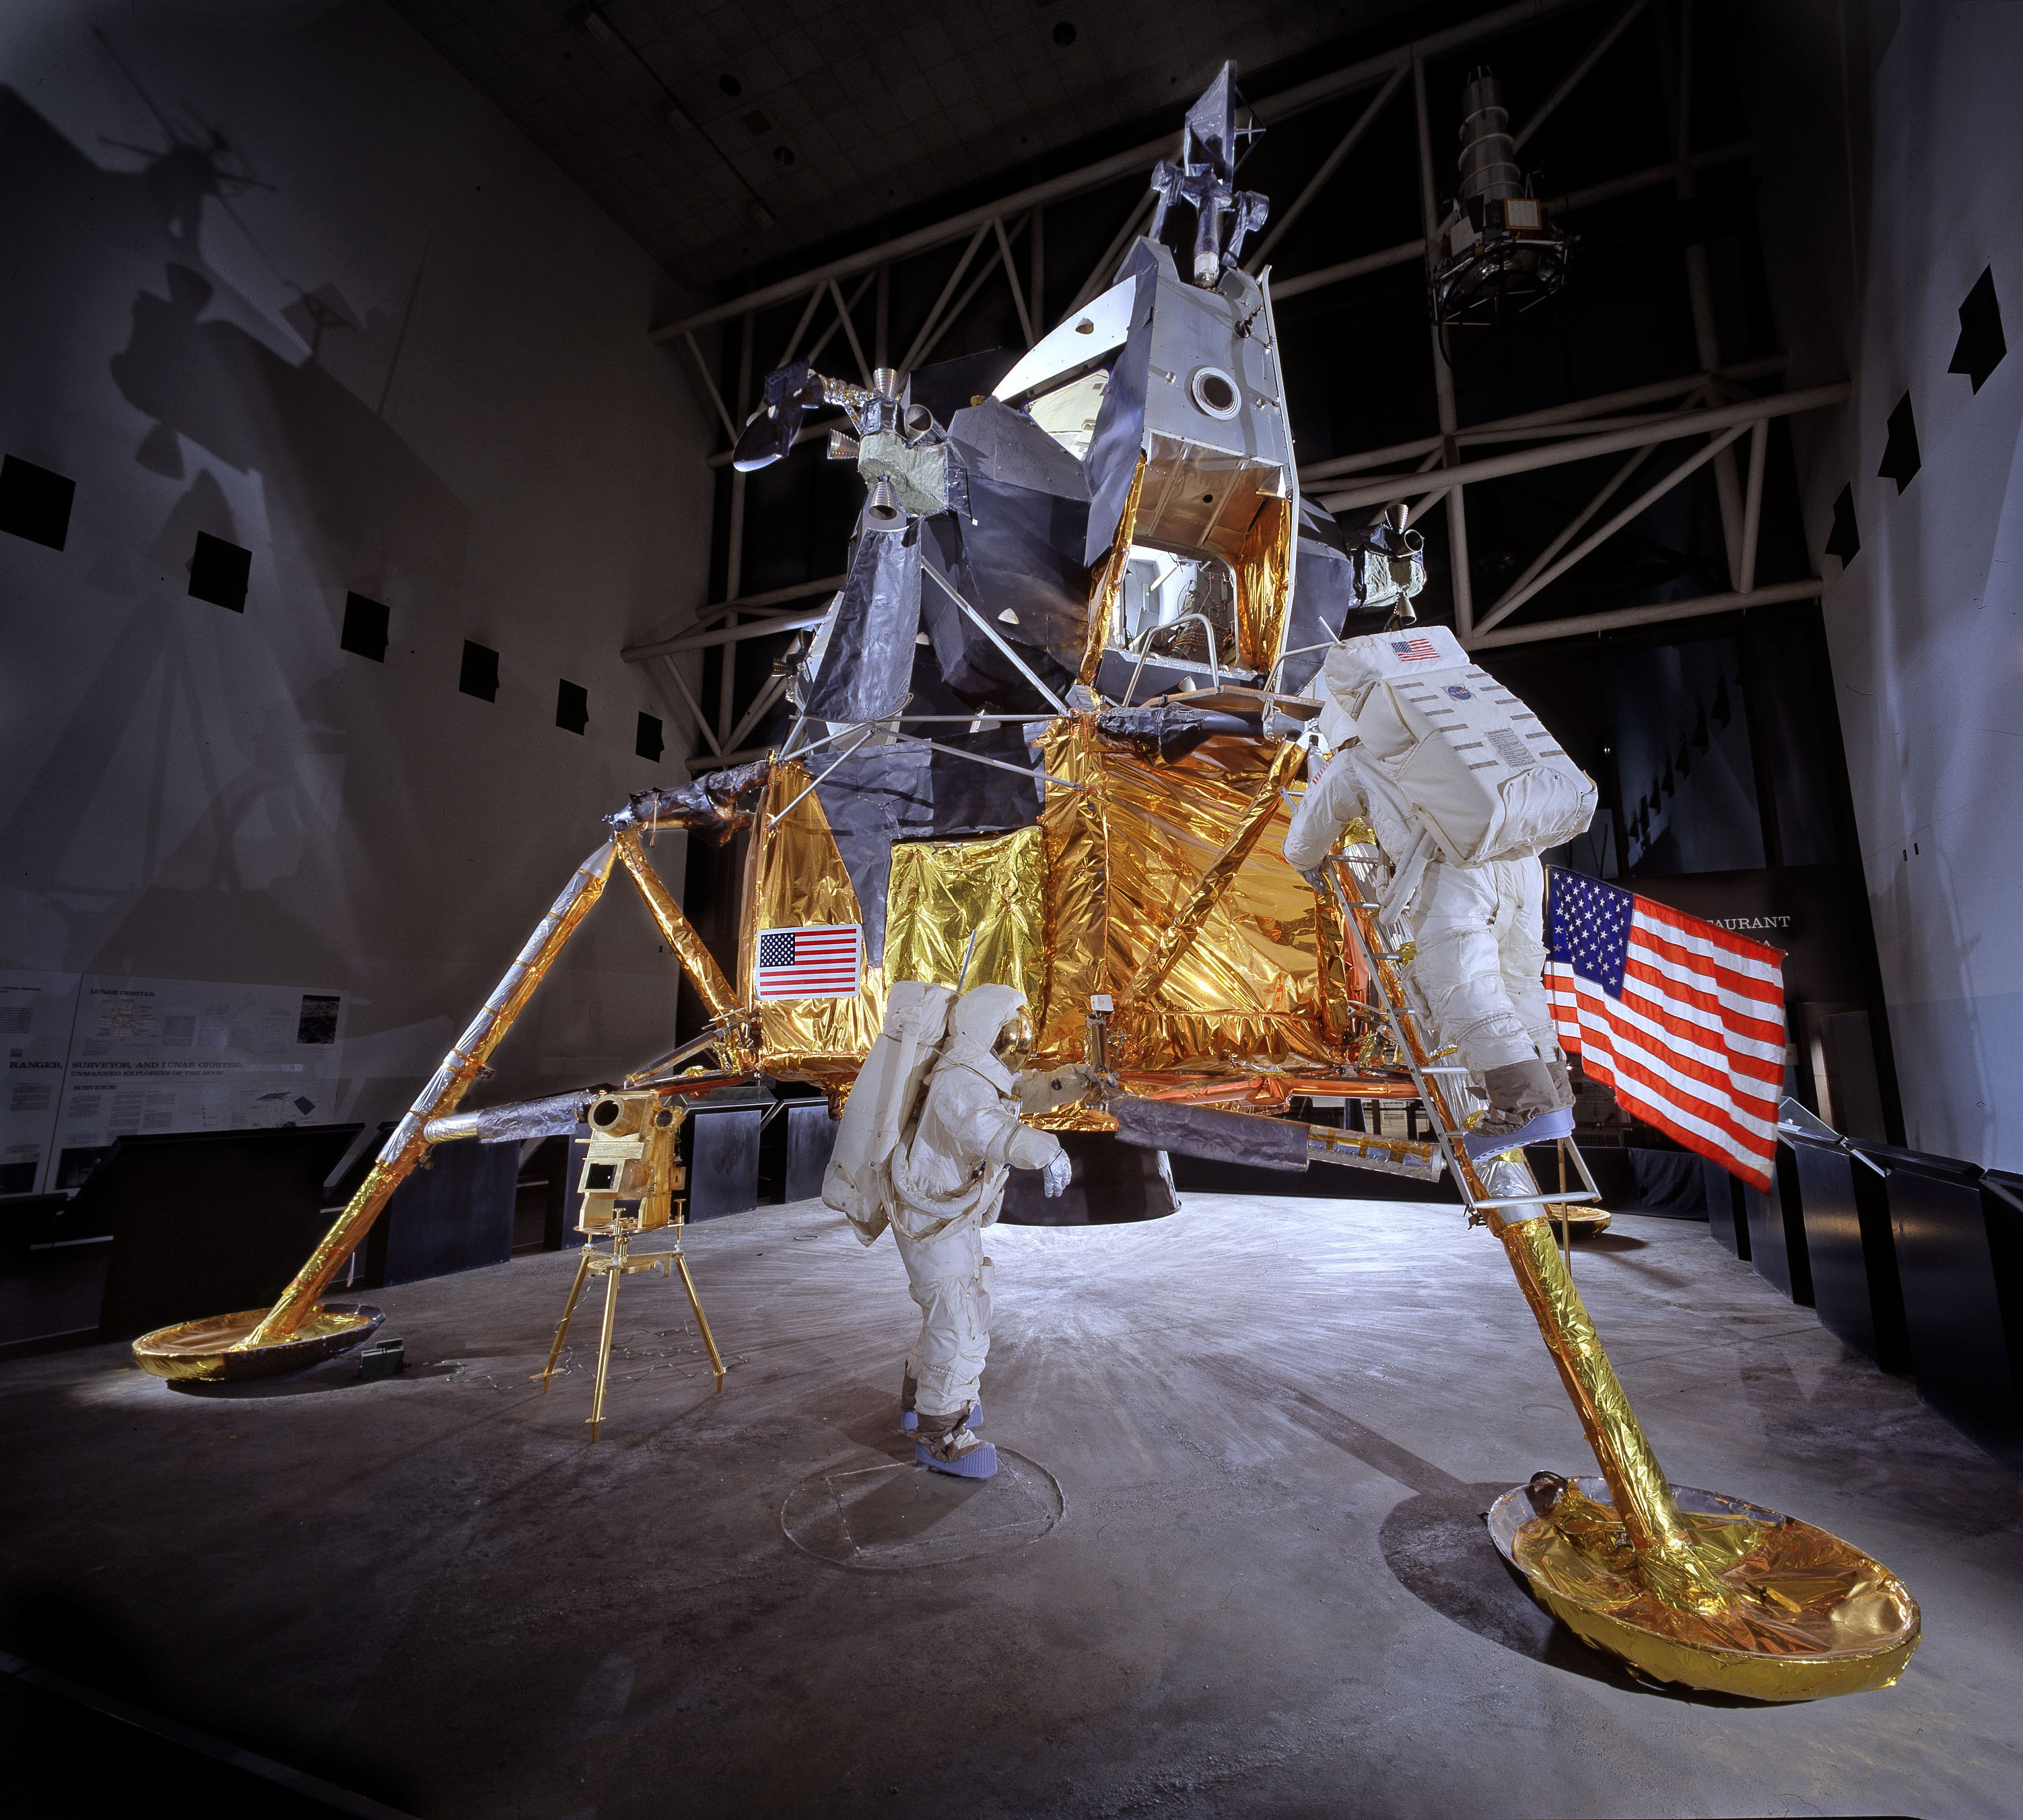

2. How is information encoded on a CD or DVD?

Compact discs and DVDs have patterns of pits and smooth portions (called “lands”) engraved at microscopic scale into an aluminum substrate, each of varying lengths. As a laser is reflected off the disc, it senses the difference between the pits and lands, which stand in for the 1s and 0s of binary code. Pits and lands of different lengths represent longer and shorter strings of binary numbers, and this creates the digital information. So a short land and a longer pit might be “110000”. The length of each section corresponds to a different dwell time for the laser, and the computer inside the machine measures the time with tremendous precision – say 5 one-millionths of a second on a pit equals six 1s (I can’t recall if it’s the pits that are 1s or the lands – doesn’t really matter). Extremely accurate clocks thus become necessary to make sure it’s always counting the right number of 1s and 0s, and this necessitates clocks that can measure time in increments of trillionths of a second – “picoseconds”. The binary numbers assembled from the laser’s dwell times are then converted into electrical impulses that your stereo can use, in what is known as a Digital-to-analog Converter, or “DAC”. The more accurate all of this is, the better the sound, and the more the CD player costs. Extremely stable internal power supplies are also a necessity so that there are no minor interruptions that might screw up the measurements.

This is why my Mark Levinson CD player cost $12,000.

The pits and lands are much smaller on a DVD than a CD, meaning it can encode the greater bulk of information needed to assemble video images. Smaller pits and lands require a higher frequency of laser light to accurately measure them. Thus CD players have red lasers (low frequency) and DVD players use blue lasers (higher frequency).

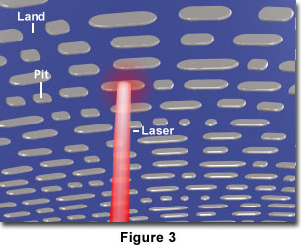
3. How did a player piano (a piano that played itself) work, and how is that similar to how a computer works?

Player pianos used a mechanical mechanism which was actuated when a rotating drum with little spring-mounted pins was fed a roll of perforated paper. When the pins encountered smooth paper nothing happened, but when a pin poked up through a hole, it triggered a pneumatic device that was attached to one of the piano keys. Which keys were triggered, and in what combinations – i.e., what piece of music was played – depended on where the perforations in the paper were located, so different rolls encoded different songs.

The perforations are directly analogous to the pits on a CD, the un-punctured paper just like the lands. In each case the presence or absence of an interruption to the smoothness of the medium conveys information – yes there’s a perforation, no there isn’t - just as binary numbers, 1s and 0s, are said to work on the “yes/no” principle.

Indeed, the computers I used in university used cards of paper with holes in them – “punch cards” – to encode binary information. A hole meant a “1”, no hole meant “0”, and great stacks of these cards, fed through an optical reader kind of like the machines that count cash, amounted to a computer program.

Here’s a player piano at work, playing a piano roll that encodes “Boogie Woogie”, one of my favourite Swing Era songs.

https://www.youtube.com/watch?v=ydcRAMZl0l0

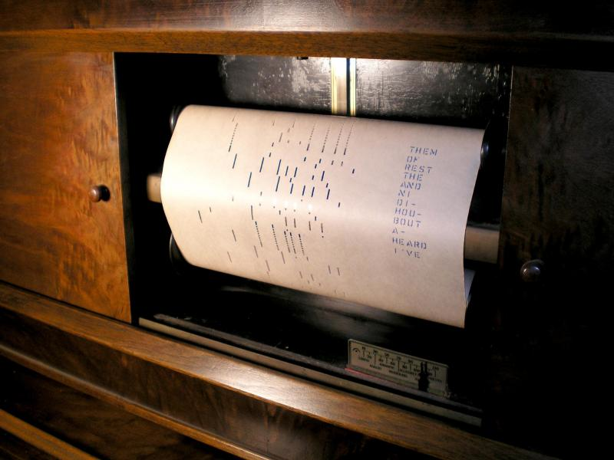
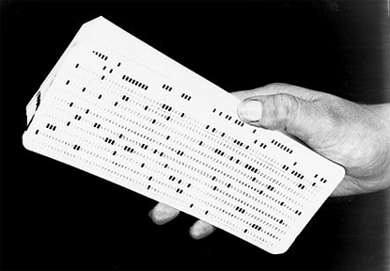
4. Explain the Doppler effect.

When a moving object emits waves – either sound waves or light – it tends to catch up a little with the waves it emits from the front end, and run away from the waves it emits from the back end. Say I have a car going down the road, and it rings a bell once a second. In the second between rings, the car will have moved forward a bit, so the next wave it emits will be closer to the last previous one up front, and farther away from the last previous one at the back. In other words, the frequency of the waves at the front will be scrunched tighter, creating higher frequency, than the one coming off the back. This is why a race car going by makes that “EEEEEEEEE-OWWWWWW” sound as it whips past you. It is also why celestial objects that move away from us are seen to be emitting light that is closer to red, red being the lower, not so tightly scrunched together, frequency of light.

The Doppler “red shift” effect is how astronomers (in particular Edwin Hubble) figured out the Universe is expanding. The light from just about every object in the universe is shifted red, lower frequency, meaning that each object is moving away from us.

Doppler was the name of the scientist who first explained this.

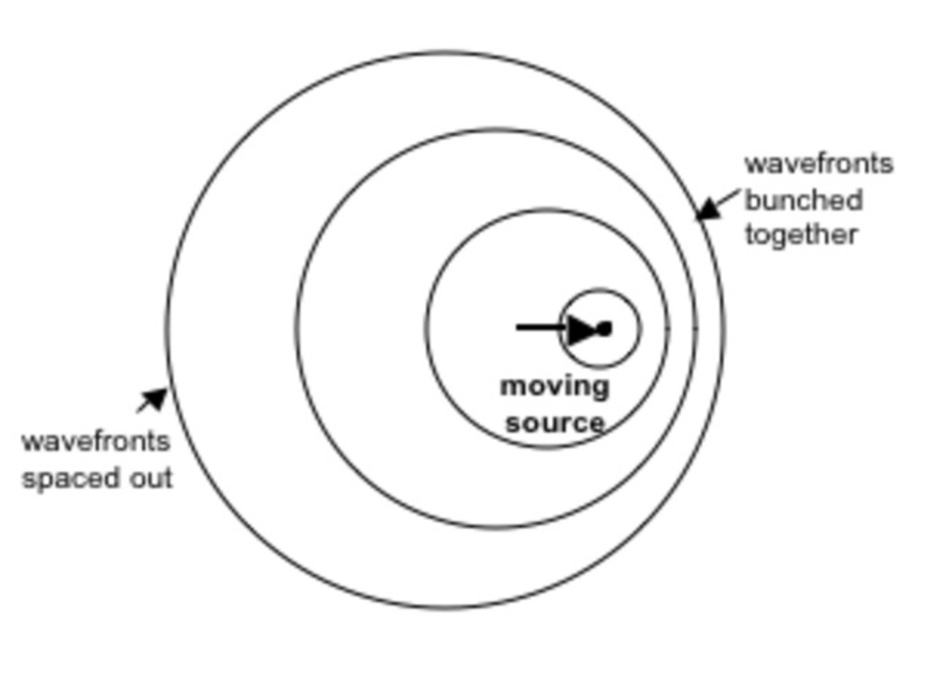
5. What was a Pullman Porter?

A Pullman Porter was a very special person.

Before air travel became feasible for the masses, the best, fastest way to travel any distance cross-country was by rail, and by the 1930s hugely powerful streamlined trains running on smooth rails were capable of sustained speeds in the 90-100 MPH range. Express trains with romantic names like the 20th Century Limited were the technological marvels of their time.

Then as now, transportation companies provided different levels of luxury accommodation to those who could pay, and the equivalent of first class on a Cathay Pacific 777 was found in special cars built by the Pullman Company. These Pullman cars were often “sleepers”, configured like regular coach cars during the day (but far nicer) and convertible to sleeping quarters at night. They were the height of luxury, and came with a sort of concierge service, porters who would see to your every need. Pullman Porters were legendary. If you needed to have two bottles of 24 year-old scotch delivered at the next station, they would arrange it. If you needed tickets to the Yankees Game, a new suit tailored, a Cuban cigar, a signed first edition of The Great Gatsby, an exotic tropical bird, or perhaps other things gentlemen wouldn’t discuss in polite company, you name it, a Pullman Porter would arrange it.

The porters tended to be African American, and in a racist America, Pullman Porter was about the best job a black man could get. They were expected to exercise the utmost discretion, and their clientele trusted them more than family.

Pullman Porters formed the first all-black union, and their example was important in the advancement of civil rights. A Pullman Porter was a somebody. A picked man.

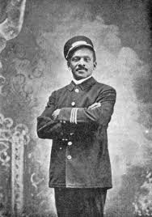

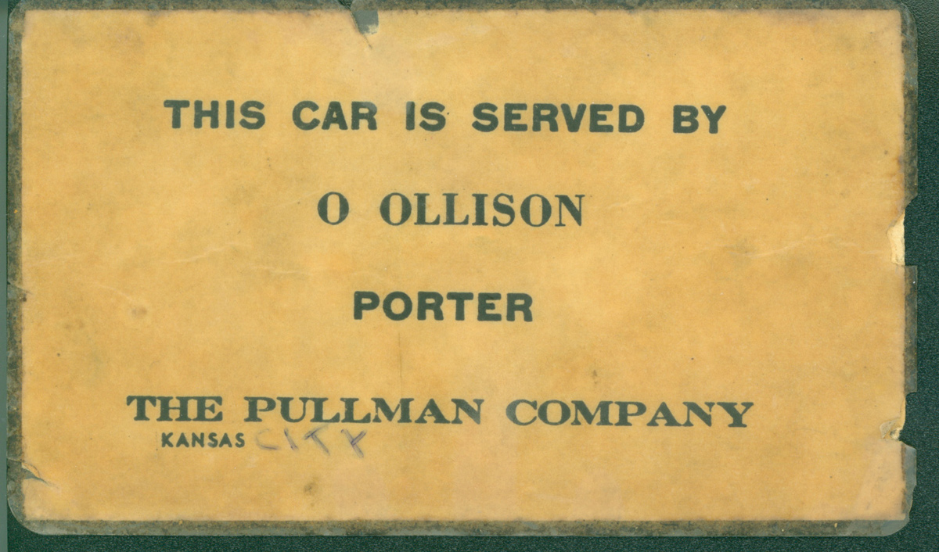

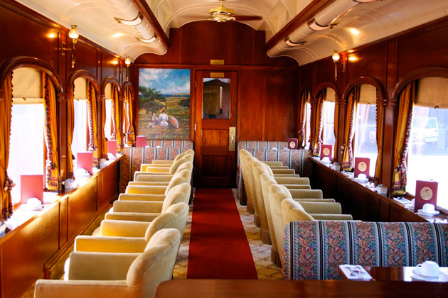



6. What happens if the temperature drops to 0 degrees Kelvin?

Nothing. Literally nothing. Zero on the Kelvin scale is “absolute zero”, the temperature at which molecular motion ceases and no device in the universe can function. Even interstellar space is a couple of degrees warmer than absolute zero (we think owing to residual heat from the Big Bang) – zero on the Kelvin scale is COLD. Indeed, it was long thought that it was impossible for anything to be colder, but maybe not:

http://www.livescience.com/25959-atoms-colder-than-absolute-zero.html

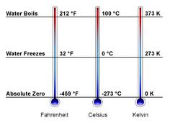

7. Which is bigger - a ship that displaces 100,000 tons, or a ship that encloses 150,000 gross tons?

A pet peeve. Cruise ship companies always advertise their ships as being X number of “gross tons”, and it makes them sound like the biggest ships on Earth, but a “gross ton” is not an actual unit of measurement; it’s just a figure that imprecisely describes the enclosed volume of the whole ship. If you want to know how big a ship really is, the figure is “displacement”, that is, how many tons of water must be shunted aside, as per the principle discovered by Archimedes, in order for the ship to float. By that measure, the largest cruise ship built to date, the Oasis of the Seas, advertised as coming in at over 200,000 gross tons, is actually smaller than a Nimitz class aircraft carrier that displaces 100,000 tons of water.

Bigger still are the super-tankers that ship as much as 2 million barrels of oil. They displace as much as 700,000 tons.

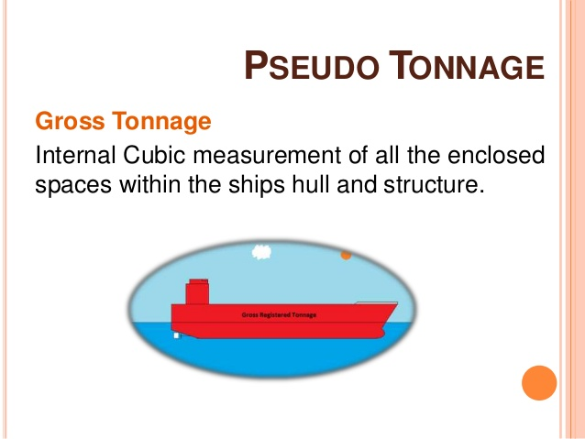

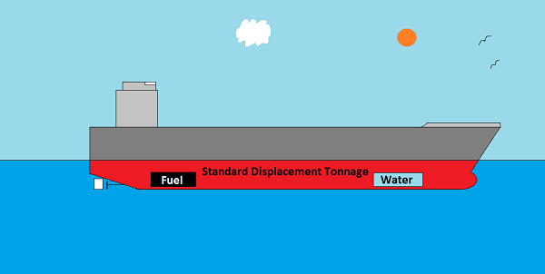
8. What is often referred to as "4.5 acres of sovereign US territory"?

The above-mentioned Nimitz class carrier. Its flight deck measures 4.5 acres, being about 1100 feet long, and 250 feet wide.

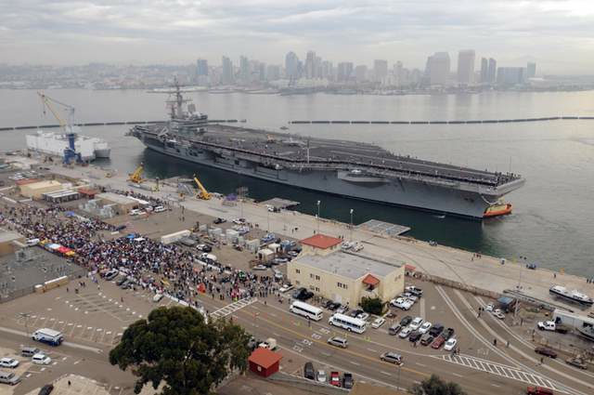
9. What were "the wooden walls of England"?

In the era of sail, the wooden ships of the Royal Navy were known as the “wooden walls of England”. They defended the island kingdom against all challengers.

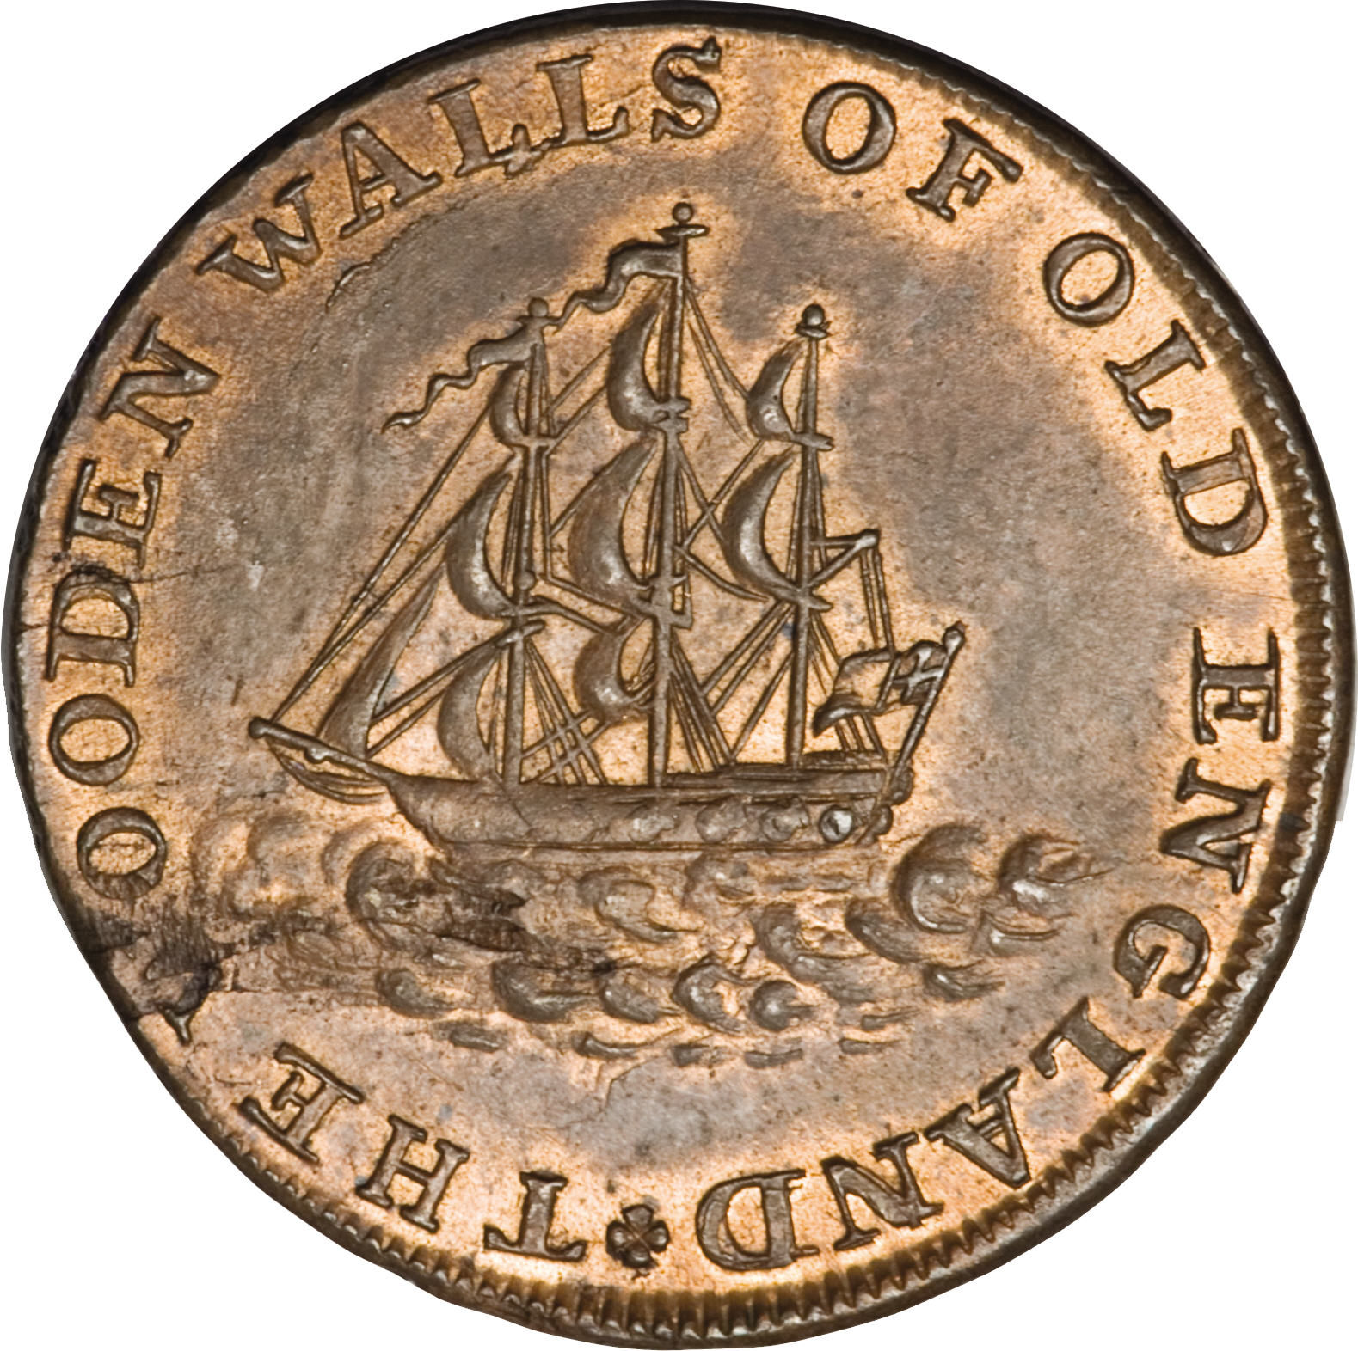
10. What was an Edsel?

A classic case study in how clever marketing can induce consumers to buy anything - unless they don’t want it. The Edsel was named after Edsel Ford, son of Henry, and was meant to be a flagship product of the Ford Motor Company. It was hyped to the nth degree, but the thing was, it was butt-ugly. It had a front grille that was described as looking like an Oldsmobile sucking a lemon, and it just didn’t look right. The whole thing cratered, and “Edsel” became a generic term for a crappy product that nobody will buy.

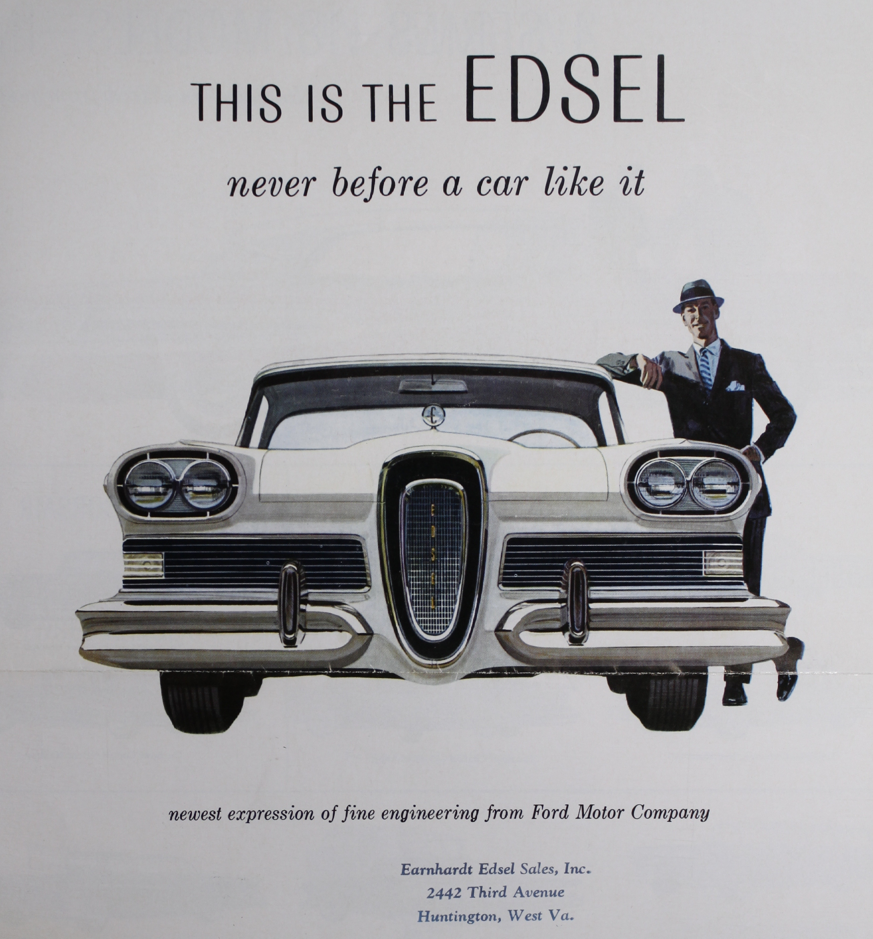
11. What is a picosecond?

See above – it’s a trillionth of a second. A picosecond is to one second what one second is to over 31,000 years.


12. At what speed does the International Space Station orbit the earth?

The ISS is in a low orbit only about 250 miles up, and whips around the globe at about 17,000 MPH, going around the whole Earth once every 90 minutes.

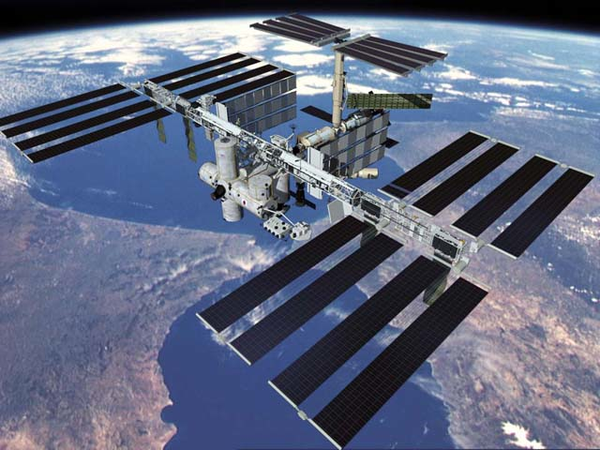
13. Why is it more dangerous to hit a moose than a cow with your car?

Moose stand on tall spindly legs, with their tremendous bulk suspended high up – you clip one, you tend to take out the legs while a ton of moose meat crashes right through the windshield, and often crushes the whole passenger compartment. Better to hit something with short legs like a cow, and let the engine block take the hit.

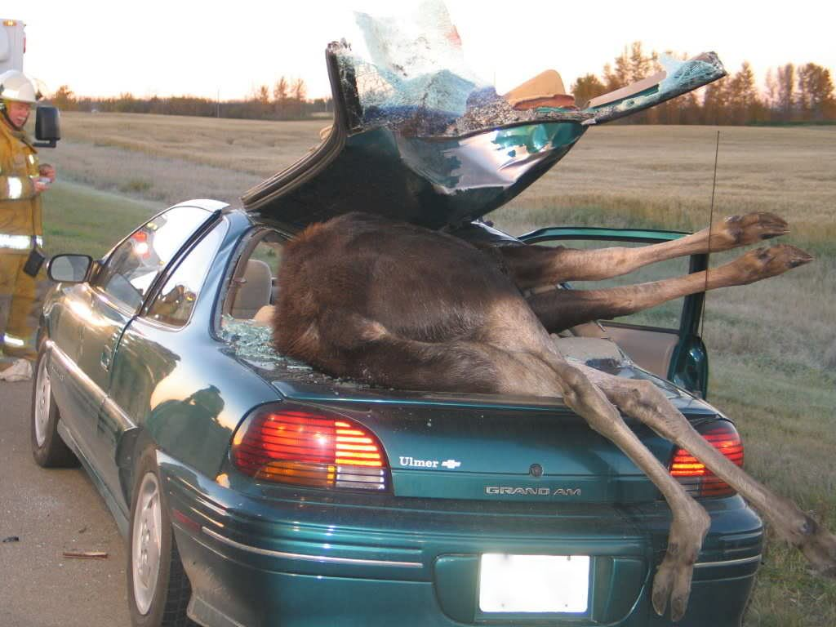
14. What did Edwin Hubble figure out?

See above again! Hubble studied the spectra of light being emitted by stars, incredibly painstaking at the time (back around 1930), and realized that just about everything we could see with our telescopes had its spectrum shifted toward lower frequencies – being “red-shifted”. This meant they were all moving away from us. In fact, the objects are not themselves moving, the space in which they reside is expanding, and thus we all grow apart like dots painted on the surface of an expanding balloon. This was conclusive observational evidence of the Big Bang.

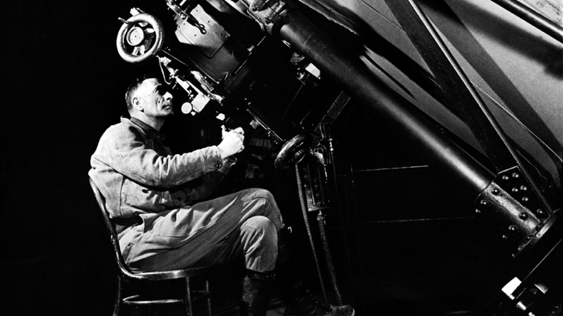
15. Give me an example of a Pleistocene megafauna.

“Pleistocene megafauna” just means “huge Stone Age animal”. Can’t think of a better example than the wooly mammoth, but there were all sorts of huge animals back about 20,000 years ago, all now extinct.

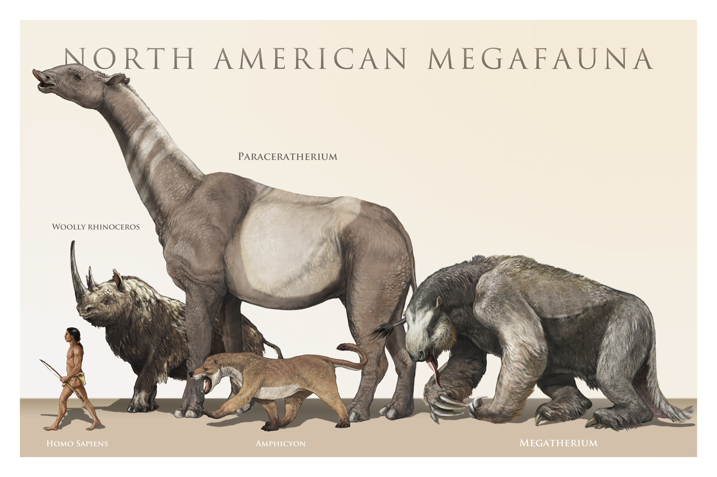
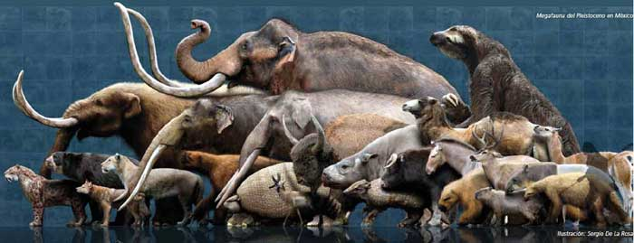
16. Why did plants evolve flowers?

As we discussed in some other quiz about how we know bees see in colour, the flower is an evolutionary development designed to attract pollinating insects. The garish colours attract critters like bees much as roadside neon signs might entice truck drivers. The plant then dispenses a treat – sweet nectar – via the flower, and in gobbling that up the insect gets covered in pollen, which it then carries to other plants of the same kind. Bees and their like are thus symbiotic with flowering plants, a key part of the way plants reproduce.


17. What's the deepest point of any ocean, and how deep?

It’s called the Mariana trench, and is located in the Western pacific. It is about 36,000 feet deep, thus far deeper than Mt. Everest is high.

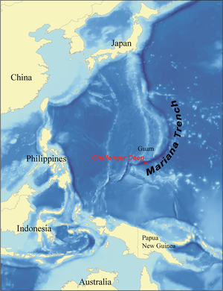
18. What goes on at DARPA?

DARPA stands for Defense Advanced Research Projects Agency, the branch of the Pentagon that funds cutting edge science for the US military. DARPA has pioneered many advances that have changed our lives – for example, the first prototype internet was “DARPANET”. Drones, cars that drive themselves, advanced composite materials, you name it, and somewhere back there, years before you ever heard of it, DARPA was funding its development. The projects they’re working on now boggle the mind – science fiction stuff like invisibility cloaks (using nano-tubes embedded in fabric to bend light around objects, like little fibre-optic pipelines for photons), wearable reactive liquid armour that turns solid as steel when struck by a bullet, mechanical four-legged “mules” for carrying supplies, and exoskeletons (virtual Iron Man suits) to increase the strength of individual soldiers. And God knows what else.

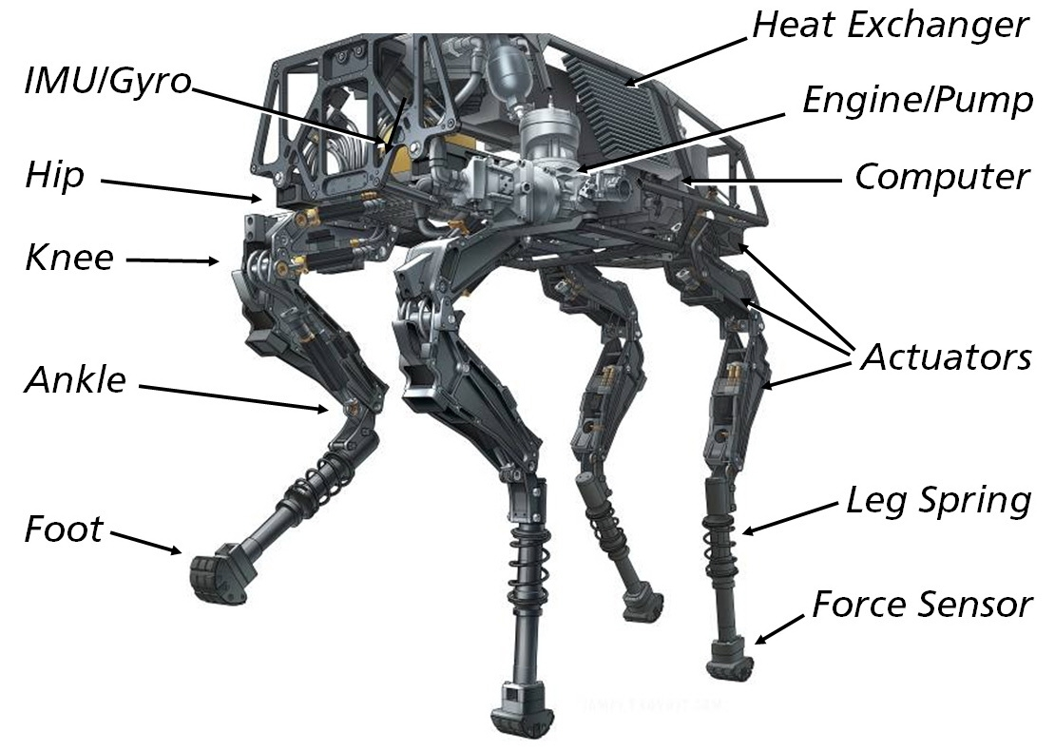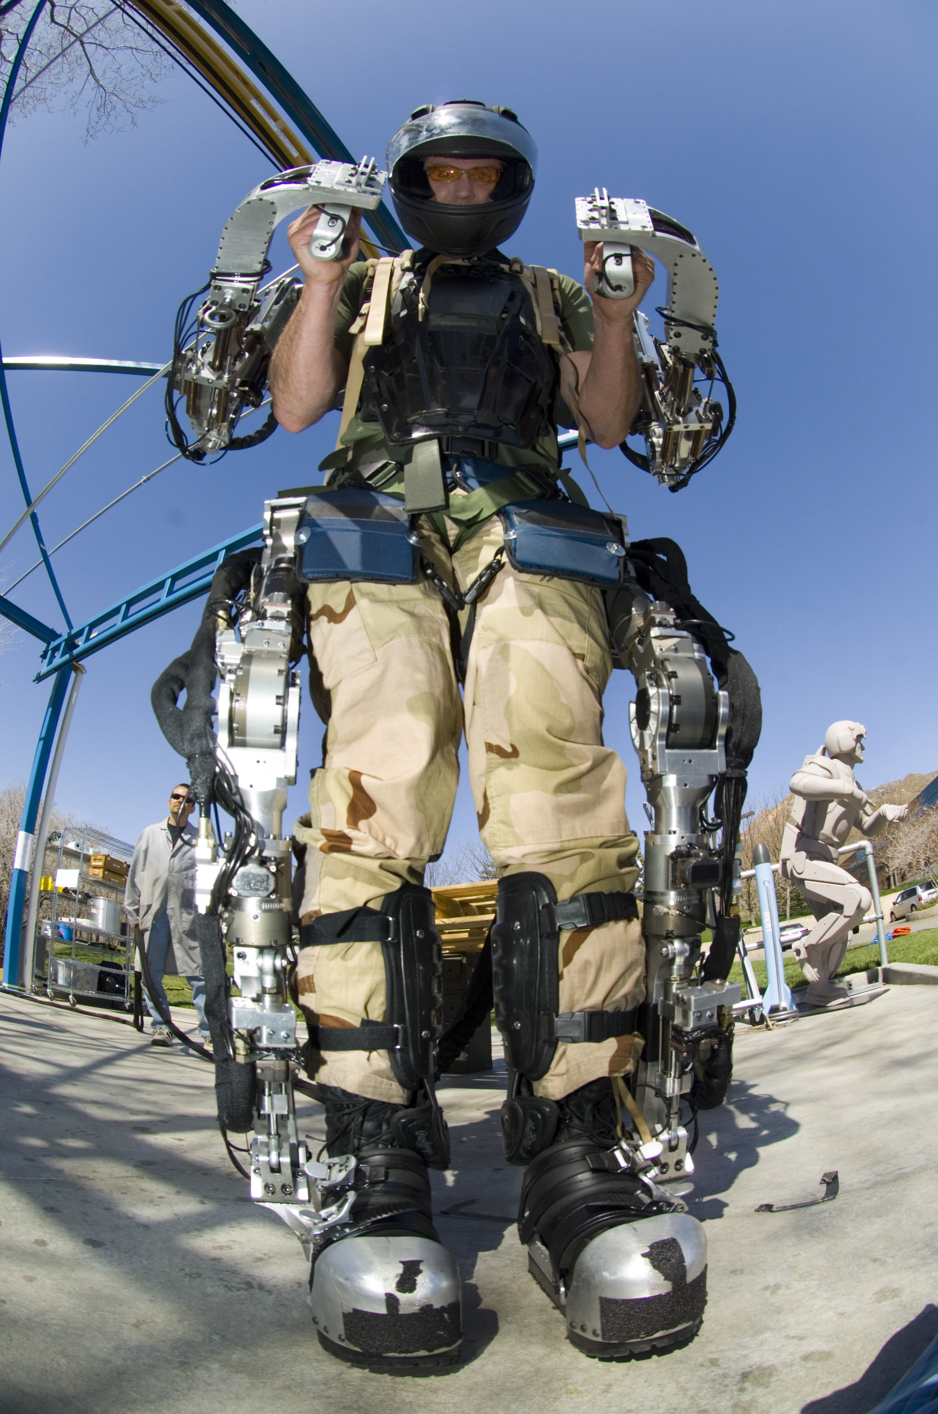

19. Who are the "Van Doos"?

The Royal Canadian 22nd Regiment, based in Quebec and thus the “Vingt-deux”, “Van Doos” to everybody in the military. They are elite troops of legendary toughness, with a storied history extending back before WW I. You do not mess with them.


20. How many people, roughly, live in greater Tokyo?

Incredibly, about the same number as live in all of Canada, approximately 33 million.


21. What could Renaissance artists depict that Medieval artists could not?

Renaissance masters developed techniques to depict lines of perspective, accurately representing the way that distant objects appeared to be smaller and farther away than near ones, and parallel lines appeared to converge. Medieval artists didn’t have the knack – an object supposed to be more distant was apt to appear higher on the canvass, but identical in size.

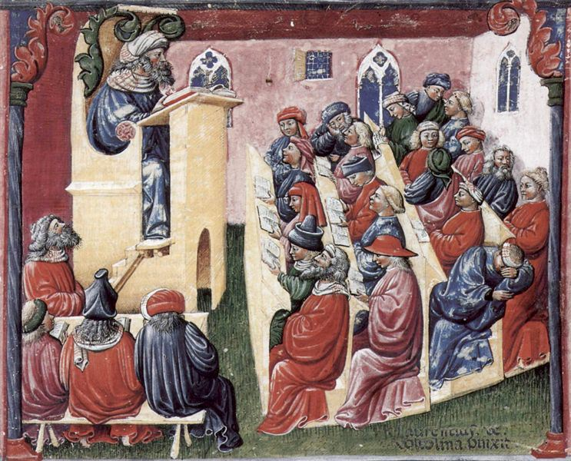

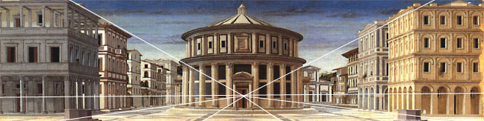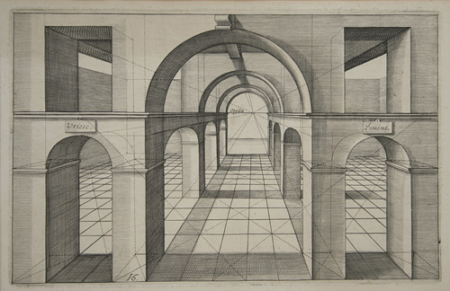
22. Speaking of the Renaissance, what does "Renaissance" mean?

It means “rebirth”, and is used with respect to the re-emergence of sophisticated science, art and learning following the Middle Ages. Modern scholars question whether the Middle Ages really deserve the nickname “Dark Ages”, pointing to things like the superb engineering and architecture of Gothic cathedrals, but there is no doubt that the centuries between the fall of Rome and the rise of the Italian City States, where it all began, were nasty times, full of plagues, religious struggles and interminable wars.

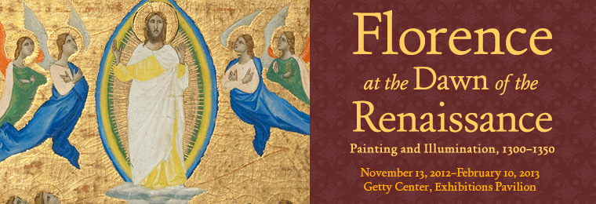

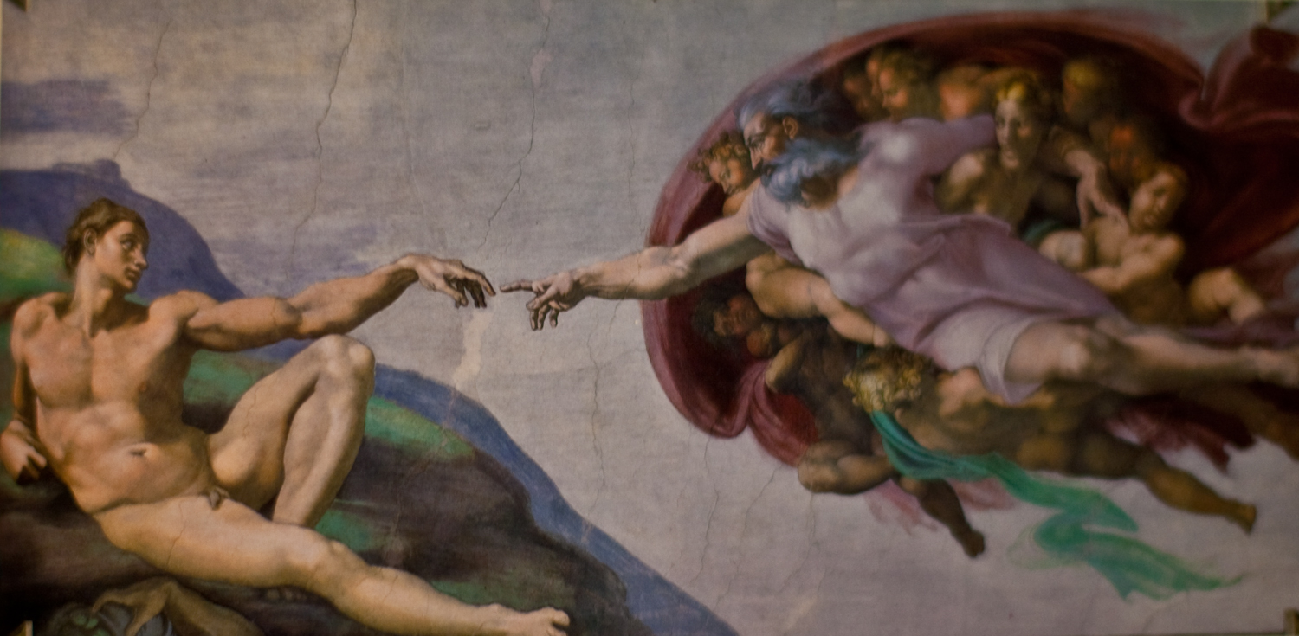
23. Who wrote "The Prince"?

Related topic – Renaissance author Niccolo Machiavelli wrote this treatise on the qualities required of any man who wished to seize and hold on to power. “Machiavellian” is an adjective used today to describe cynical strategizing and underhanded dealing, but Machiavelli’s work did not encourage evil – it just told people the hard-boiled facts. Like, for a Prince, better to be feared than loved, if you cannot be both. That may not be pleasant, but the truth is not always a pretty thing.

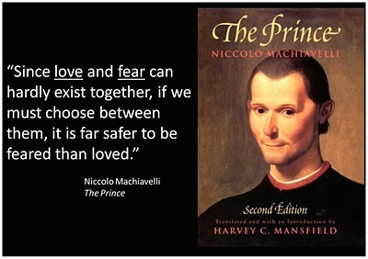
24. What did Jonathan Swift propose in "A Modest Proposal"?

Swift was a great satirist, intent on lampooning the stupidities, and condemning the institutionalized cruelties, of the society and government that, to his mind, were an affliction upon the just and rational soul. His book Gulliver’s Travels told the story of fictional civilizations that warred because one of them thinks you should open a hard-boiled egg at the fatter end, the other preferring you start at the smaller end – the sort of useless quarrel that characterized squabbles between Catholics and Protestants in his day, and Sunnis and Shiites today.

A Modest Proposal, a 1729 essay, was a comment on the horrific heartlessness with which the Irish people were governed. It proposed, in all apparent seriousness, that one good solution to the plight of poor families and their starving children would be to sell the youngsters to rich folk to be skinned and eaten. Two birds with one stone, money comes in, mouths to feed get eliminated, and you could make lovely gloves from the soft youthful hides.

Three centuries later, you still can’t get more cutting than that. It hurt because it rang almost true as a policy response, and still does.

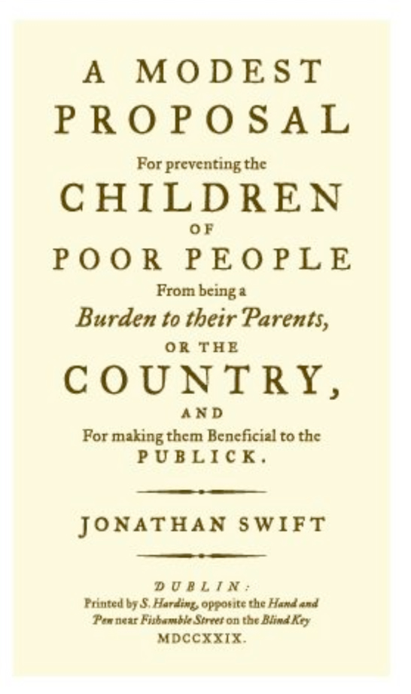
25. Who wrote "The Rights of Man" and in what context?

Thomas Paine wrote The Rights of Man as a manifesto on political liberty in the aftermath of the American Revolution. It proposed that the French, spurred on by the American example, had every right to rise up in revolution against their monarchy, and argued that revolution to overthrow established authority was permissible whenever government failed to defend the essential “natural rights” of its people. Ideas about inherent rights and a “natural justice” which flowed not from the laws of men, but rather from immutable truths that no human law could trump, were very much of a piece with the spirit of the earlier Declaration of Independence:

We hold these truths to be self-evident, that all men are created equal, that they are endowed by their Creator with certain unalienable Rights, that among these are Life, Liberty and the pursuit of Happiness.--That to secure these rights, Governments are instituted among Men, deriving their just powers from the consent of the governed, --That whenever any Form of Government becomes destructive of these ends, it is the Right of the People to alter or to abolish it, and to institute new Government

In this, they were spitting in the face of prior political philosophies that promoted the “Divine Right of Kings”, and held that we, the governed, are to keep to our place and accept our lot, owing to the conferral upon our betters by God Himself of the right to rule us. No. The right to rule is a privilege that must be earned with our consent, and can rightly be taken away. With such statements, the American founding fathers, children of the Age of Reason, were merely expressing the philosophy pioneered by English writers such as John Locke, who promoted the revolutionary idea that a common person, not the King, rightly owns the products of his own labour. “Life, Liberty and Private Property”, said Locke. Jefferson changed “property” to “the pursuit of happiness”, which sounded more noble.

It can often seem that the United States has repeatedly failed to live up to its professed ideals and fulfill its promise, right from the start (seeing as the US Constitution acknowledged and condoned slavery). We can argue about that, but surely no one could argue with the pure truth and beauty of its founding premise, or claim that any other nation ever dared to aim so high.


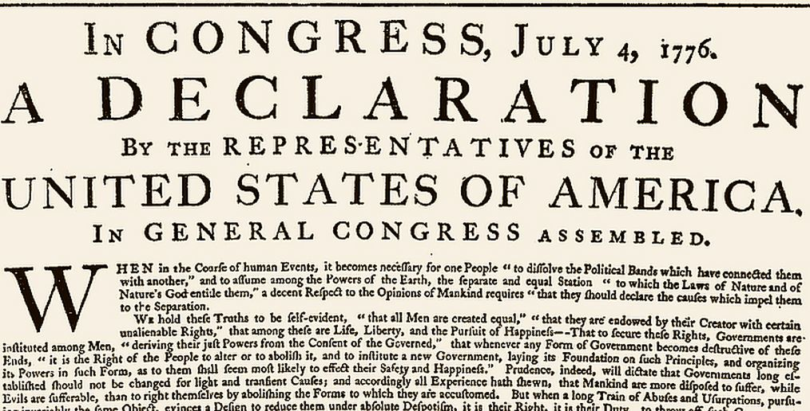

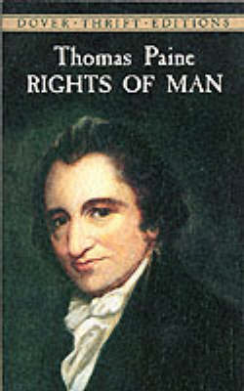
26. Who coined the phrase "the iron curtain"?

Historians insist that he didn’t originate the phrase, but it was made famous by Churchill, in a speech he gave at Westminster College in Fulton, Missouri, after WW II, decrying the creation by Stalin of a Soviet empire that oppressed the countries of Eastern Europe, in violation of treaties signed by the great powers before war’s end.

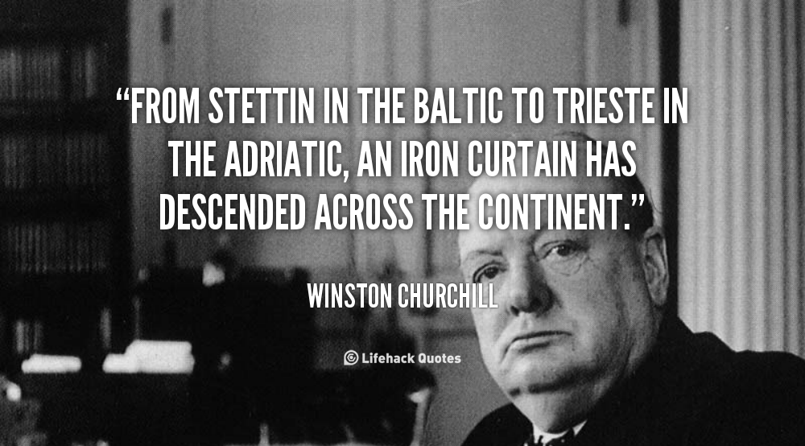

27. What does a Deist believe?

Deism was a religious philosophy that grew out of the scientific revolution of the 17th century. Isaac Newton had proved mathematically that the workings of the Universe were governed by immutable mechanical laws, not the variable whims of some Supreme Being. Deists believed that God could therefore be understood as the sum-total of these universal laws, not some bearded fellow on a throne up there who messed about in our daily lives. To the extent God was a being, he did not interfere in human affairs, and let the Universe run like a vast clockwork that obeyed only the laws He created at the outset.

Thomas Jefferson was a Deist. The idea of universal laws instituted by God and part of the fabric of the Universe is articulated in the Declaration of Independence in the context of human politics. Jefferson and his ilk believed that God gave us brains so we could reason for ourselves, not accept what we’re told by our supposed superiors. Reason and God were, in fact, synonymous, and no reasonable question, even if deemed to be heresy, was out of bounds.

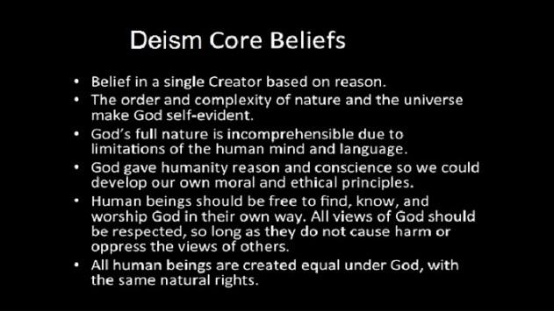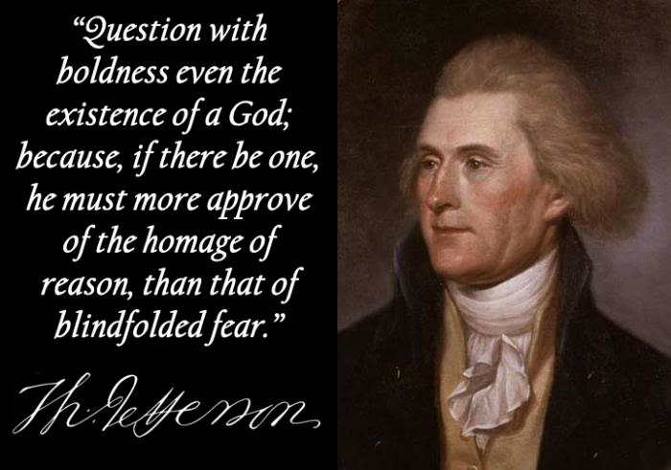
28. What sort of plant is bamboo?

Bamboo is just an enormous variety of grass.




29. What is a Portuguese Man of War?

Somewhere else in these quizzes we saw that a Portuguese Man of War is a huge and dangerous jellyfish.


30. What is a dugong?

We did this elsewhere too. A dugong is a relative of the manatee, and surely among the most harmless creatures ever to grace this awful ball of cruelty.


31. Where do you find a caldera?

The Caldera is a circular depression in the terrain that results from the collapse of volcanic cones - its name is derived from the word “cauldron”. They occur throughout the world – a dandy one, pictured below, is at Mt. Pinatubo in the Philippines.


32. Why are fossil fuels called "fossil fuels"?

Fossil fuels like oil are thought to be the organic residue of billions upon billions of ancient deceased sea creatures and plants. Like real fossils, they are the altered remains of things that used to be animate matter.

As sediments pile up, heat and pressure breaks down organic matter into smaller molecules, and living things, being essentially carbon-based, with plenty of water thrown in, are reduced in large part to molecules composed of carbon and hydrogen. The chemical reaction of burning the stuff creates carbon dioxide, hence the greenhouse effect.

Given its origin, it’s no wonder you can find oil under the sea bed – and also in the former sea beds of long evaporated shallow seas, as exist in the Middle East, and the prairies of our own western provinces.

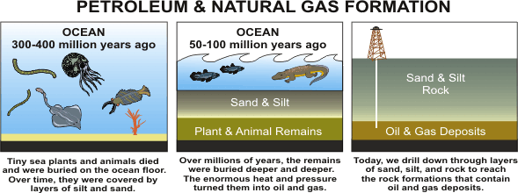
33. About how much does a 747 weigh?

A LOT. The biggest variants top out, when fully fueled, at more than 450 tons, that is, over 900,000 pounds. That’s much more than, for example, the Statue of Liberty, which weighs about half as much. Aerodynamic lift is a powerful thing!


34. What was referred to as "a third rate burglary"?

The break-in at Democratic National Headquarters at the Watergate Hotel was a really botched affair. Nixon’s dirty tricks brigade was first detected when a security guard noticed some duct tape sloppily applied to a door latch to prevent it from locking, a dead giveaway that skullduggery was afoot.

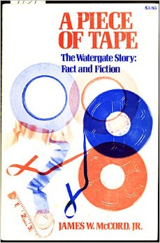
35. What goes on at Foggy Bottom?

Much of Washington DC is reclaimed swamp land, and Foggy Bottom is the once swampy, misty riverside neighborhood in which the State Department buildings are located. Foggy Bottom, everyone’s nickname for the State Department itself, is where US foreign policy is formulated.


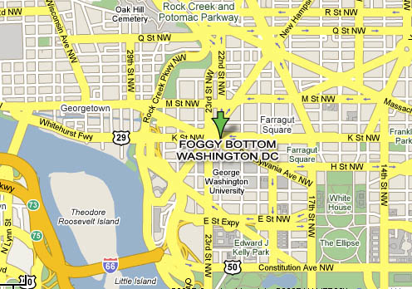
36. What is a Mandarin?

“Mandarin” is a word used today for a bureaucrat, or senior civil servant. The term originated in a Portuguese word for functionaries in Imperial China back in the 1500s, and is related to the Latin word “mandare”, “to command”, also the root of words in our language like “mandatory”.


37. Who was the world's first billionaire?

John D. Rockefeller, owner of the almighty Standard Oil Corporation, had a billion dollars back when the average worker lived on about 35 bucks a week. Adjusted for inflation, he had over 250 billion when he died in 1937, or about 1.5 billion in 1937 dollars, and was easily the richest person in history, with command of a 1.5% share of the entire US Economy. The richest man alive today has about 75 billion.

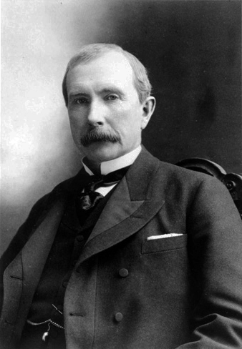
38. Who famously claimed to have said "fuddle duddle"?

In 1971 Canadian PM Pierre Trudeau was heard to mutter something like “oh fuck off” or “fucking idiot” during a debate in Parliament, and claimed all he said was something akin to what a person says when he’s thinking “fuddle duddle”, without actually asserting what, exactly, he really did say. It became a sort of Trudeau trade-mark.

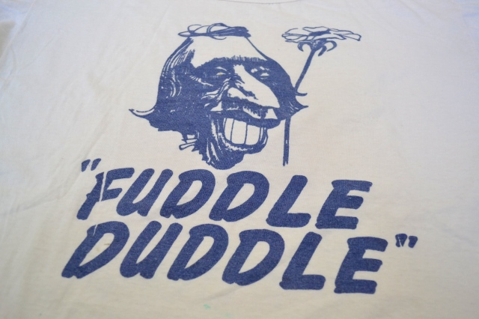
39. What name is given to the official record of Parliament's proceedings?

It’s called “Hansard”, not just here, but in England and other Commonwealth countries, named after Thomas Hansard , a 19th century printer and publisher, who was the first official printer to the English parliament.

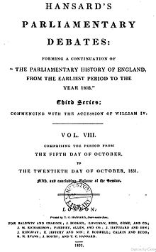
40. What policy was promoted under the name "reciprocity"?

Free trade with the US was a policy first promoted as part of John A Macdonald’s National Policy following Confederation, under the name “reciprocity”. It was, and remains, highly controversial; we know it as NAFTA today.

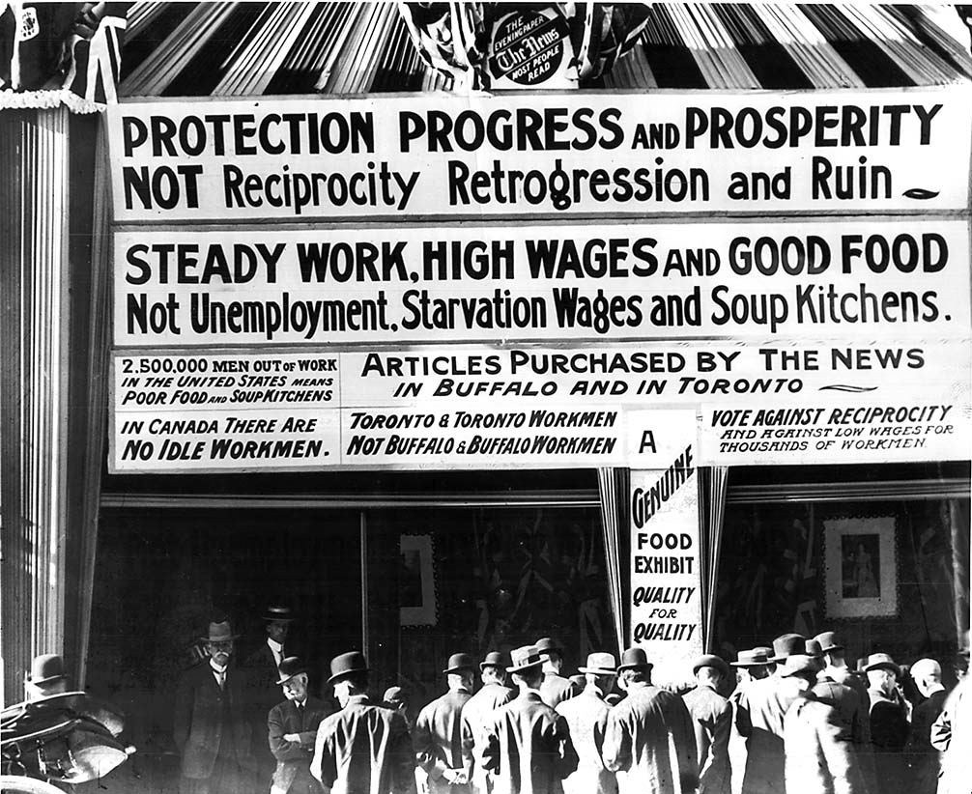
41. What happened at Little Big Horn?

Little Big Horn is the Montana battlefield where golden boy General George Custer and his 7th Cavalry were annihilated by Lakota Sioux warriors under Crazy Horse. “Custer’s Last Stand” is one of those mythological events in US culture.

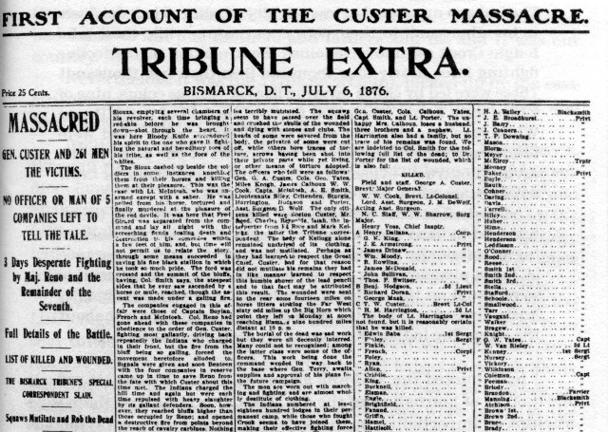

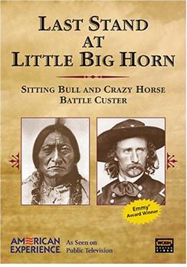
42. What is the speed at which you reach "escape velocity" and why is that important?

“Escape velocity” is the speed at which you must propel yourself in order to escape the gravity field of a massive object. Escape velocity for the Earth is about 25,000 MPH, or 40,000 KmH.

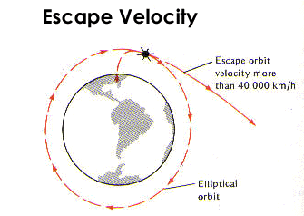
43. In what special sort of orbit do you need to place a communications satellite?

To be most useful, a communications satellite should always be in the same place in the sky as viewed from down here, so that you can continuously bounce signals off it. But of course, our planet spins on its axis, and anything in orbit spins round the earth, so this would seem to be awfully difficult to do, but it turns out if you put something in an orbit about 22,000 miles up, its orbital speed will allow it to track the Earth’s rotation perfectly. From our perspective it isn’t moving, and is thus in “geo-stationary” or “geosynchronous” orbit. This was first suggested by sci-fi writer Arthur C Clarke.

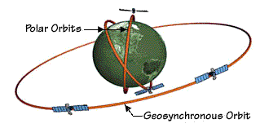

44. Who said "give me a lever big enough and I could move the world"?

Archimedes. The exact quote is “give me a lever long enough and a place to stand and I shall move the world” according to some sources.

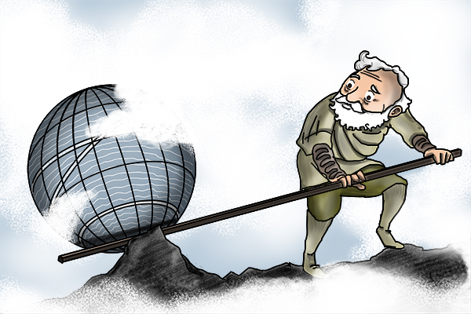
45. What's a Yeti?

That’s the local name for the Bigfoot-like creature that is said to haunt the Himalayas, also called the “Abominable Snow Man”. Intriguing evidence, difficult to fake, has been found at high altitude.




46. What are you measuring with a Carbon 14 test?

Carbon 14 is a radioactive isotope of Carbon – the “14” is its atomic number, indicating the contents of its nucleus, in this case, 8 neutrons and 6 protons. Isotopes are unstable, and Carbon 14 is one that tends to break down over time, “decaying” like all radioactive elements do, until it has shed a couple of neutrons and becomes “normal” Carbon 12, with an equal number of protons and neutrons.

Anything organic, plant or animal, has some Carbon 14 mixed in with its atoms, ingested with organic nutrients. When that organism dies, and stops replenishing itself from outside sources, the isotope will slowly start to disappear from the remains. You can thus measure the age of anything organic and dead by how much Carbon 14 exists in its remains, and the same holds true for any products made of organic things, like wooden objects, paper, cloth and such. They call this “carbon dating”, and it’s a boon to archaeology.

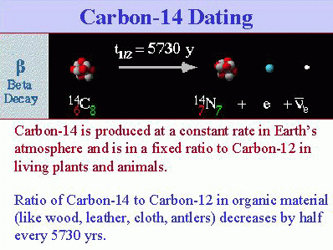
47. What is a Geiger Counter counting, anyway?

We were just talking about radioactive decay. A radioactive element is one that is unstable, with a nucleus that lacks the binding force to hang on to all of its sub-atomic parts. It will thus spontaneously shed parts until it changes to become something more stable, and what we call “atomic radiation” is that process of shedding parts, as if the atom is throwing stuff away until it can settle down into a more stable state. Another term for it is “particle radiation”.

“Radiation” is just a word that means emission of energy, and much radiation is fairly innocuous, like sunlight, or radio waves. Other types of radiation can be dangerous, owing to higher levels of energy – x-rays and gamma rays, for example, are deadly. The high energy stuff is called “ionizing radiation”. An “ion” is an atom with either more or fewer electrons than protons, such that it has a negative or positive electrical charge (remember protons are positive, electrons negative, and in a regular atom an equal number of each creates an overall neutral charge). High energy “ionizing” radiation is powerful enough to knock electrons out of their orbits around atomic nuclei, turning atoms into ions.

Radioactive decay of atoms tends to fall in the dangerous “ionizing” category because the particles being tossed out by the unstable atom tend to have high energy and are like little bullets that can kill or damage cells and the DNA they contain when they pass through your body.

Geiger Counters are devices that use a tube full of inert gas like argon or neon (a “Geiger-Müller” tube, named after the scientists who developed it) to detect the ionization that is caused by dangerous radiation. When the radiation hits the gas it will ionize some of it, and this creates an electric charge that the device then detects, and uses a sort of amplifier to turn that charge into a noise. The device typically has a display showing the count of radiation strikes, which is why it’s a “counter”. 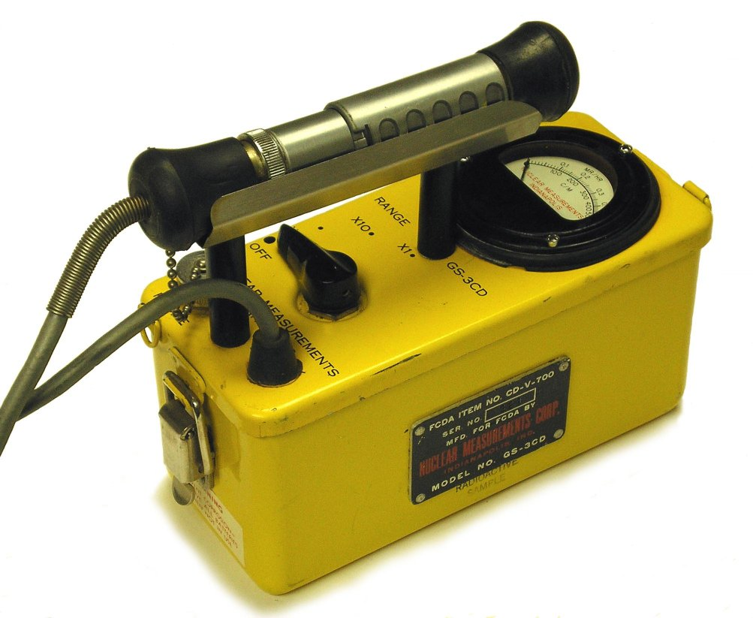
48. What animal reaches the highest speeds attained by any living thing?

A Peregrine Falcon, which can fly level at 100 MPH, and can reach 200 MPH when it dives to make a kill.


49. Should you be scared of an architeuthis?

If you’re swimming, and an architeuthis is lurking about, yes, be very afraid. Its non-scientific name is “giant squid”.

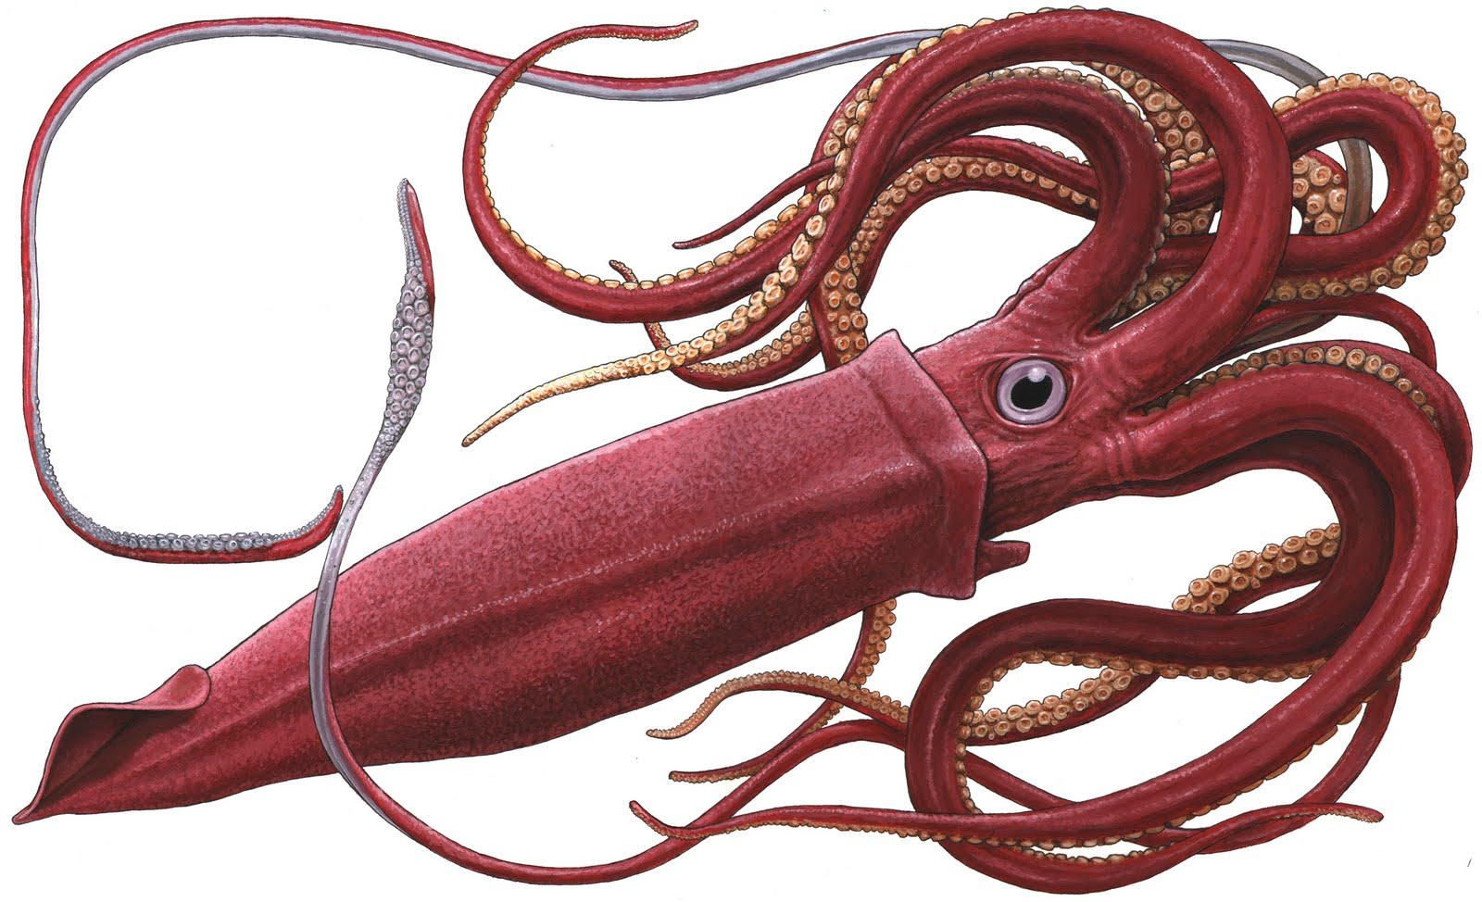
50. Who said "nobody ever lost a buck by underestimating the intelligence of the American public"?

P.T. Barnum, the 19th century circus impresario, is supposed to have said that. His travelling circuses typically featured human “freak shows” and outright hoaxes, like fake mermaids. His “Greatest Show on Earth” was mostly utter crap, and the public just ate it with a spoon. He did, however, evoke quite legitimate wonder with an elephant named “Jumbo” – which is the origin of the word “jumbo” as an adjective for “huge”.

