1. What is the largest animal to ever live?

As far as we know, the modern Blue Whale is the largest creature to ever exist, being bigger than anything yet found in the fossil record. They get to as big as 100 feet long, and over 2000 tons. Its primary arteries are big enough for a person to swim inside.

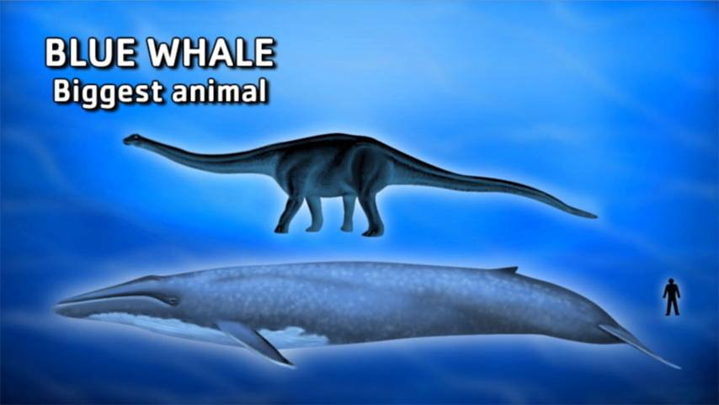

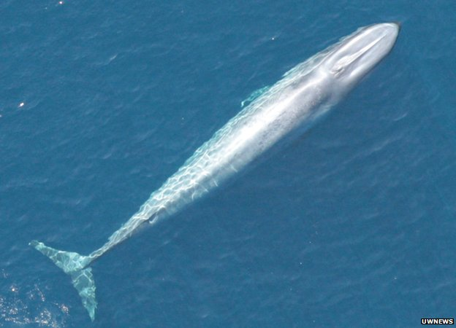
2. In WW II, who was Supreme Allied Commander, European Expeditionary Force?

Dwight Eisenhower, later a two-time President of the US, had the tricky diplomatic job of commanding both British and US Forces. Like most senior officers who know what a war really looks like, “Ike” was a bit of a pacifist, and coined the term “military-industrial complex” in a cautionary speech given upon his retirement:

This conjunction of an immense military establishment and a large arms industry is new in the American experience. The total influence -- economic, political, even spiritual -- is felt in every city, every State house, every office of the Federal government. We recognize the imperative need for this development. Yet we must not fail to comprehend its grave implications. Our toil, resources and livelihood are all involved; so is the very structure of our society.

In the councils of government, we must guard against the acquisition of unwarranted influence, whether sought or unsought, by the military-industrial complex. The potential for the disastrous rise of misplaced power exists and will persist.

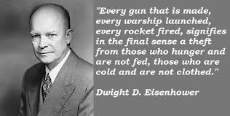
3. What did Lyndon Johnson call his domestic legislative program?

The “Great Society”. Johnson passed more liberal social legislation in his first hundred days in office than any other President, and he was determined to address poverty, inequality and injustice. A veteran of Congress, Johnson variously arm-twisted, cajoled, sweet-talked, flattered and threatened legislators in order to get his way. He knew where everybody’s skeletons were buried, and if you wouldn’t take a bribe, well, maybe your wife needed to hear about that cute little intern you seemed to like so much. He was a supporter of Martin Luther King, and wanted to be remembered as the greatest domestic reformer since FDR.

Instead, his administration was haunted by the Viet Nam war, with Lyndon carrying out policies he inherited, on the advice of his predecessor’s most trusted advisors. We’ll never know whether Kennedy would have avoided the quagmire when it became apparent that the war would be hugely costly and perhaps unwinnable – perhaps JFK would have cut his losses early.

Perhaps not.

I’ve always had a soft spot for Lyndon, he was a crude man in many ways, but the war was personally harrowing, and the deaths of young men in South East Asia tormented him terribly. The Tet Offensive in 1968 shook him to his core, and drove him from politics.

He’d hoped for so much more.

One episode stands out in my mind that I always thought was so revealing of his character. During Tet, reinforcements were necessary, and if memory serves the 101st Airborne was dispatched to join the fight. Johnson personally attended their departure, shaking the hand, and looking in the eyes, of every soldier that boarded the transport plane.

They were going off to war at his command. Many would not return. He owed it to them to face them, personally.

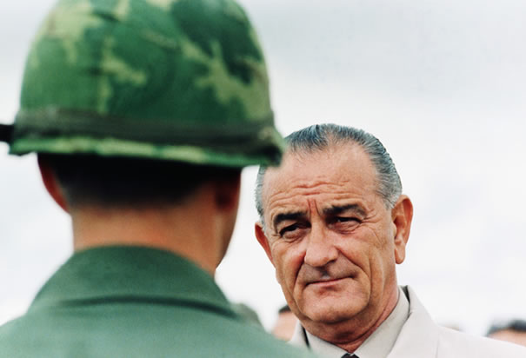

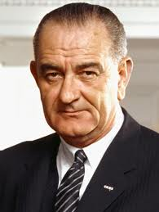
4. What canal was once crucial to the shipment of goods in the US Northeast?

Back before railways took over the job, barges on canals were the best, most efficient way to transport large quantities of goods. One of the greatest was the Erie Canal, which opened in 1825, and stretched almost 400 miles across upstate New York, from Albany on the Hudson to Buffalo. It’s still there of course. In its heyday, it spurred rapid economic and population growth.

There’s something romantic about canals. It’s such an elegant, efficient way of doing the job.

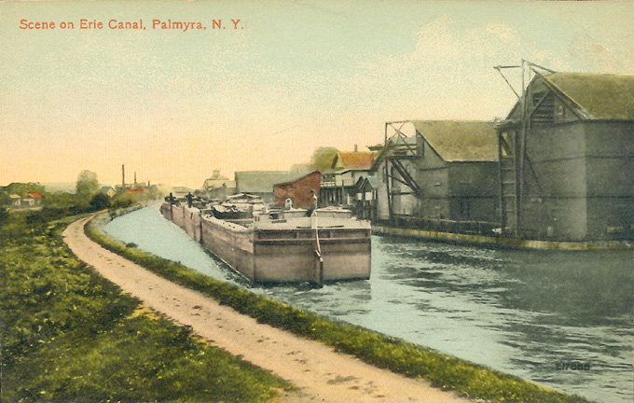
5. What was the first successful jet airliner?

It should have been the De Havilland Comet, an advanced British design that was the first jet airliner to fly, and was racking up orders when a series of mysterious crashes derailed the project. Metal fatigue from the rigours of the pressurization/depressurization cycles experienced by high-flying jets caused structures around the windows to fail, resulting in explosive decompression at altitude.

This opened up the field for Boeing to take the lead with its remarkable, pioneering 707. The 707 set the essential pattern for every airliner to fly since, and everything that hauls the mail, straight through to all today’s Airbus variants and the new 787 Dreamliner, has 707 in its DNA.

It was an amazing thing to be able to cross the Atlantic at 600 MPH and 40,000 feet. Those who could afford the tickets became known as “the jet set”, and flying was a classy and luxurious affair, hard as that is to believe today. People dressed up to ride in jets. While aboard, they sat in big comfy chairs, ate off real china, were plied with free liquor, and charmed by stewardesses who tended to be young, single, attractive, and provocatively dressed.

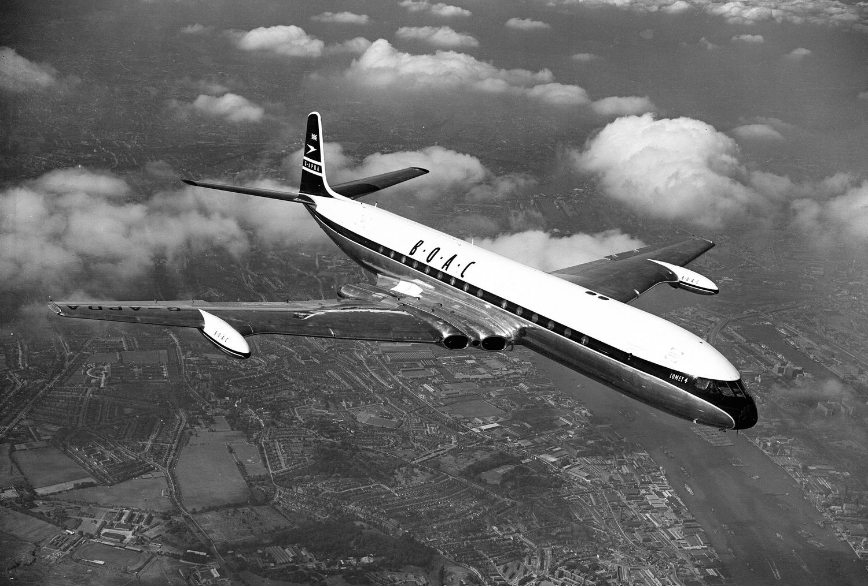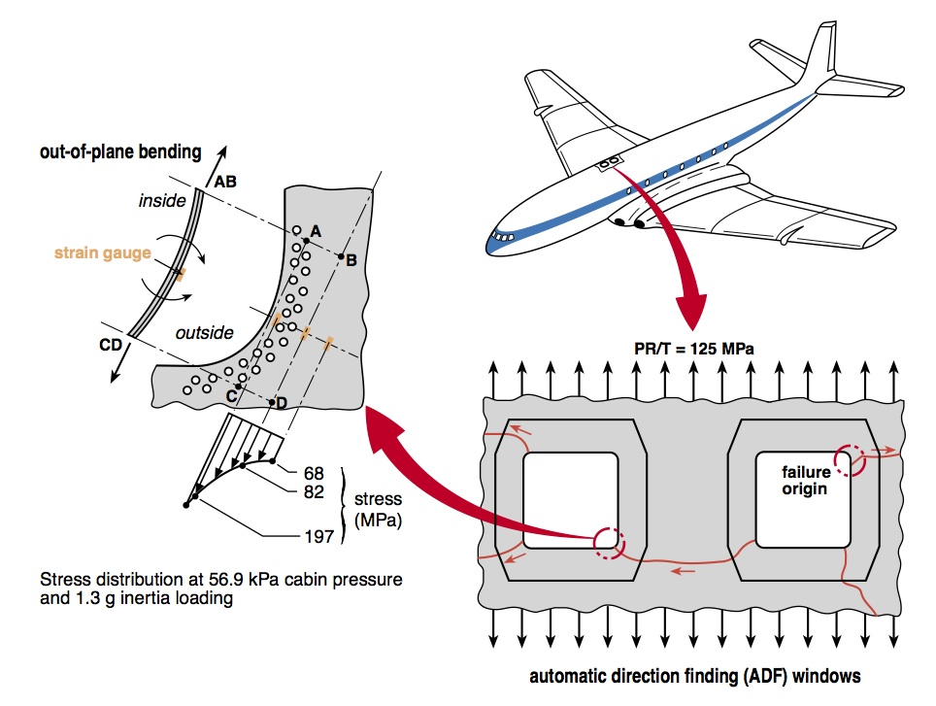

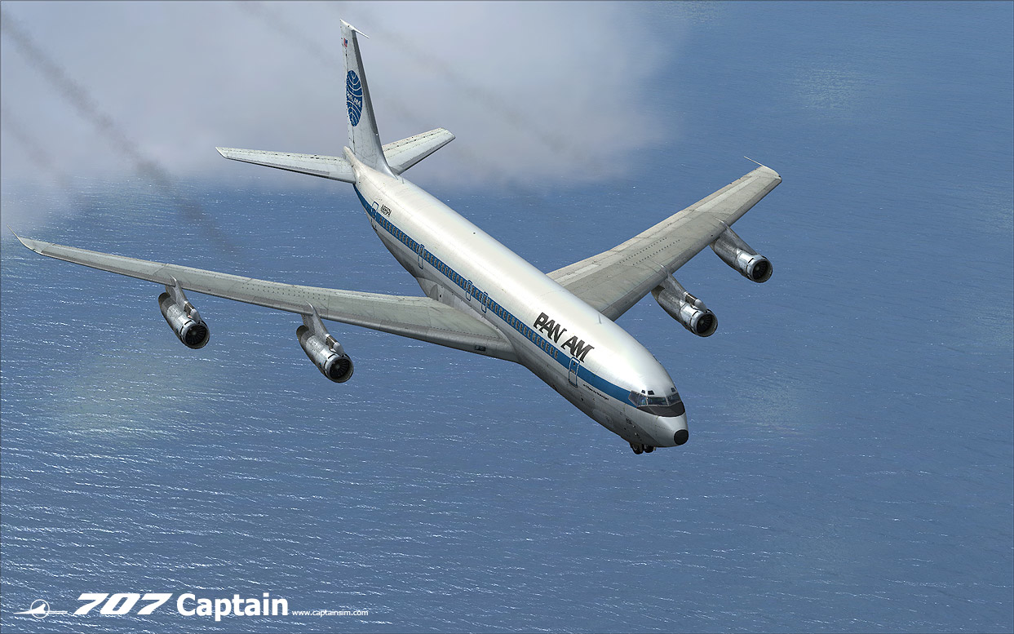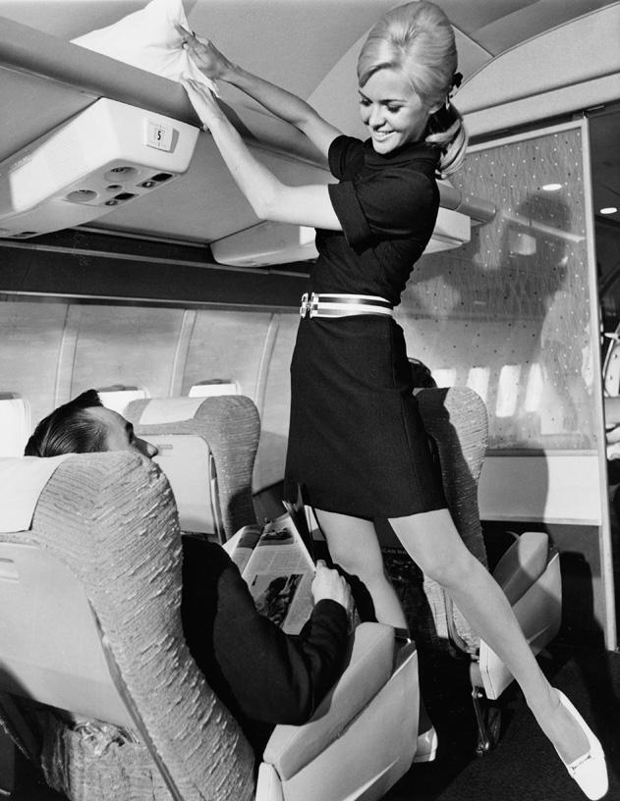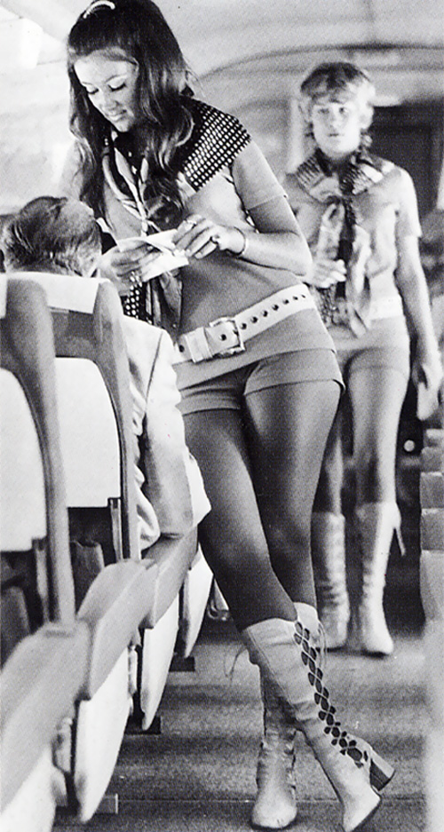
6. What is meant by “radioactive half life”?

As discussed somewhere else in these quizzes, radioactive elements are unstable atoms that decay by expelling particles from their nuclei. Some do it fast, some much slower, and the speed of decay is expressed scientifically according to how long it will take half of the atoms in any sample of the element to transmute into something more stable and non-radioactive. That’s its “half life”.


7. What are the names for the two ends of the spectrum that are outside the range of human sight?

Infrared at one end, ultraviolet at the other.

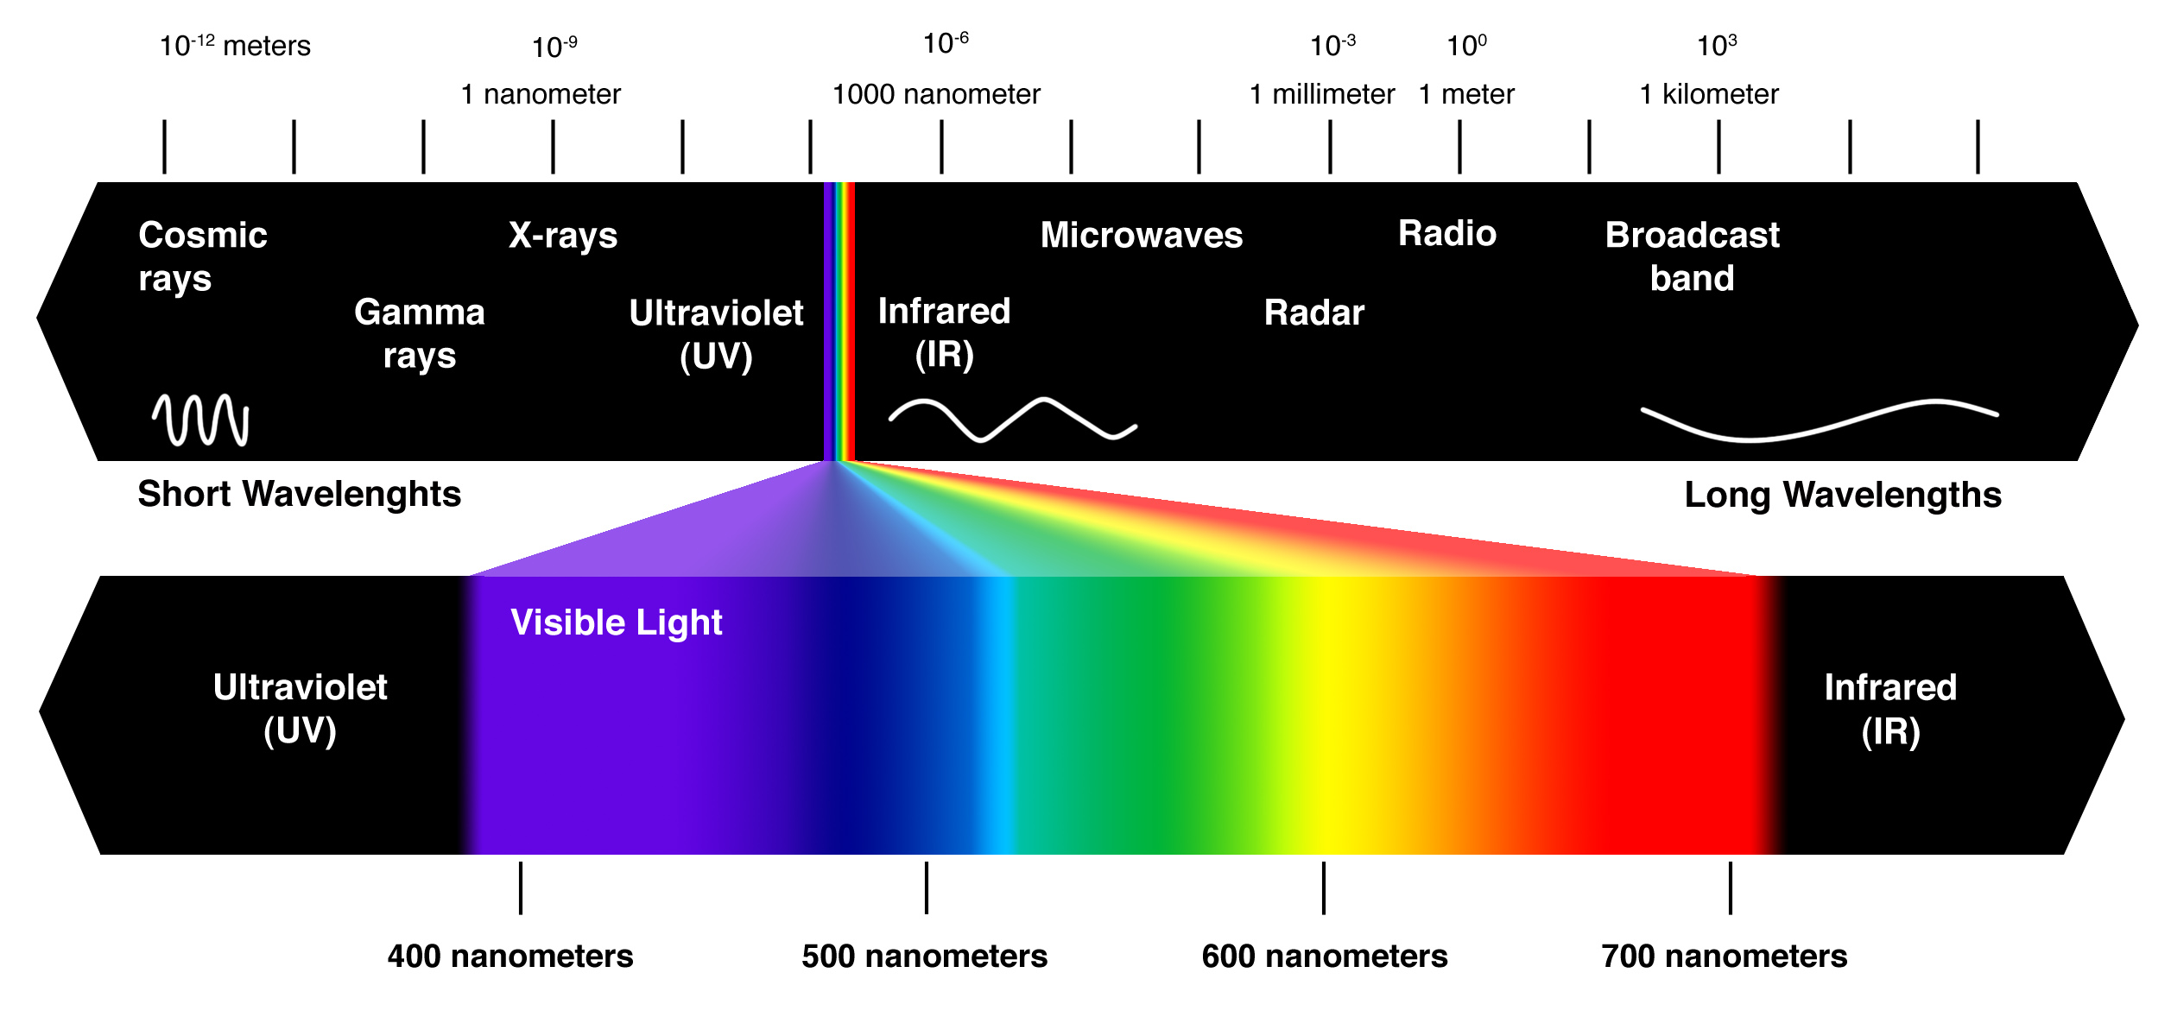
8. Name three types of clouds.

Lets go with Nimbus, Cirrus, and Cumulous; you could go for Cumulo-Nimbus too, and many others that are less well-known. My favourites are High Cirrus.

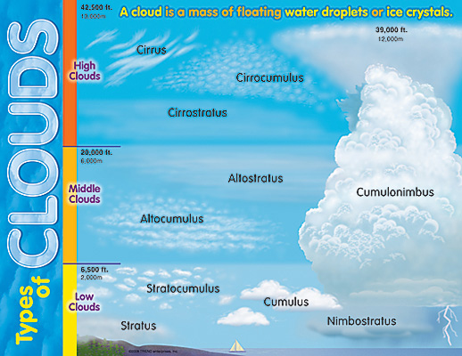



9. What has been called “a river inside of the ocean”?

The Gulf Stream, so crucial to the weather patterns of the Western Hemisphere and Europe.

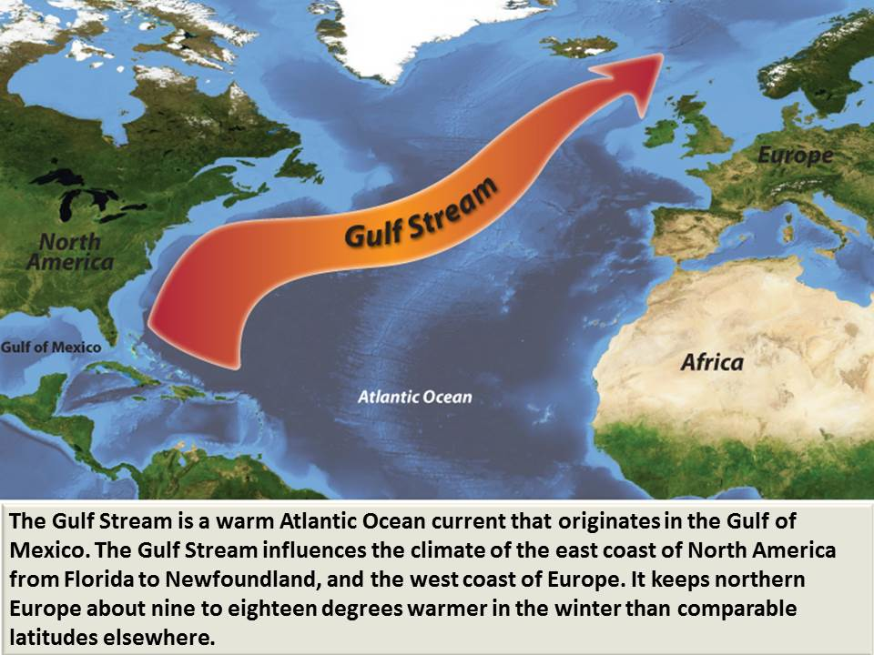

10. A "mustang” could be a car or a plane, but what is it really?

It’s the Spanish term for a wild horse. The horse evolved in North America, but went extinct here thousands of years before the Spanish reintroduced the creatures to this side of the water. Natives had never seen anything like them. Terrified Aztecs wondered if men on horseback might be a single organism, like a centaur; Algonquins and Hurons wondered how the French managed to train moose to carry you around.

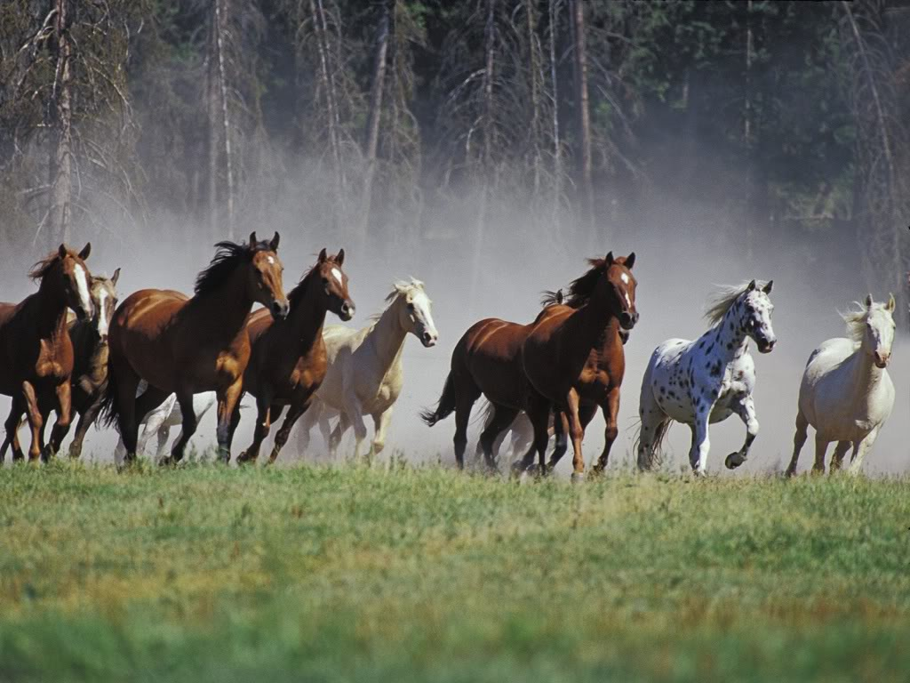
11. Name three hominid ancestors of modern humans.

I’ll go for Australopithecus, Homo Erectus, and Homo Neanderthalensis.

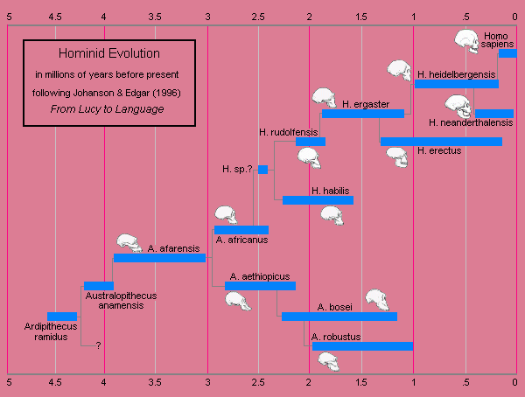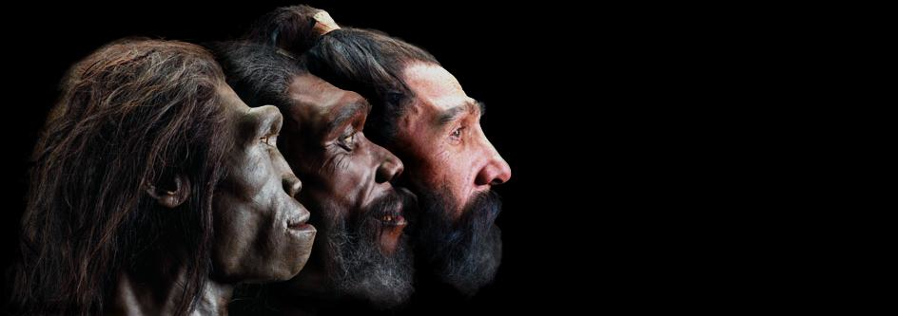
12. What’s the actual scientific name for a Brontosaurus?

Brontosaurus is now known as “Apatosaurus”.

In the mad rush to collect fossils in the 19th century (see the discussion of Cope and Marsh in another of these quizzes) one of the first Apatosaurus skeletons assembled was actually given the wrong head. Fossil hunting maniac Marsh had guessed, finding the bulk of the skeleton in one place, and a plausible-looking head in another. They had to replace it, about a century later, when they realized the mistake! With the proper head, it was revealed that the thing they’d named Brontosaurus was actually the same kind of animal that had previously been classified as Apatosaurus.

http://www.nytimes.com/1981/10/26/nyregion/yale-brontosaurus-gets-head-on-right-at-last.html

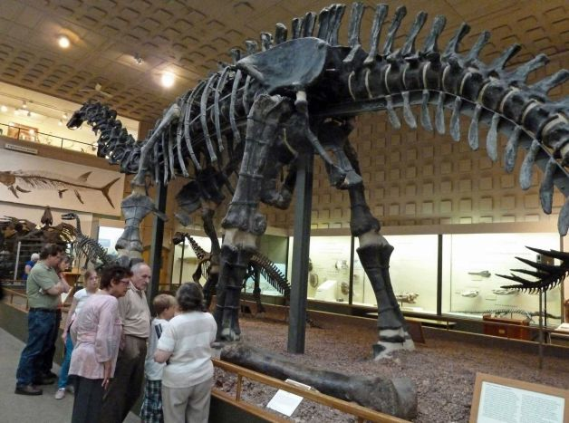
13. What US river is pretty much the same length as the Mississippi?

The Missouri River flows all the way from Montana to feed the Mississippi river, and is over 2300 miles long. The Mississippi is also about 2300 miles long.

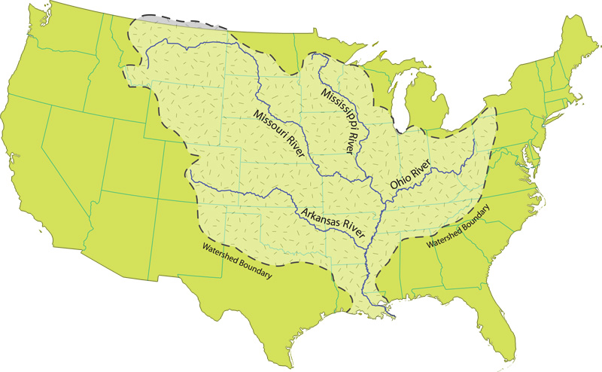
14. What is NORAD?

It’s the North American Air Defence Command, a huge institution back at the height of the Cold War. Its headquarters was buried underneath Cheyenne Mountain in Colorado, there were actually whole buildings mounted on shock-absorbing springs inside the rock formation, designed to withstand nuclear attack. Huge radar systems in the Arctic like the “DEW Line” (the Distant Early Warning line of radar stations) and BMEWS (the Ballistic Missile Early Warning System) kept (and still keep) an unblinking watch of the approaches to North American air space.

The Cheyenne facility is semi-mothballed (no longer fully manned but kept at “warm ready” status), but NORAD itself, once rendered less important by the collapse of the Soviet Union, is now as important as ever, owing to 9/11, and a growing level of Russian belligerence.

The blast door at the entrance weighs 25 tons.

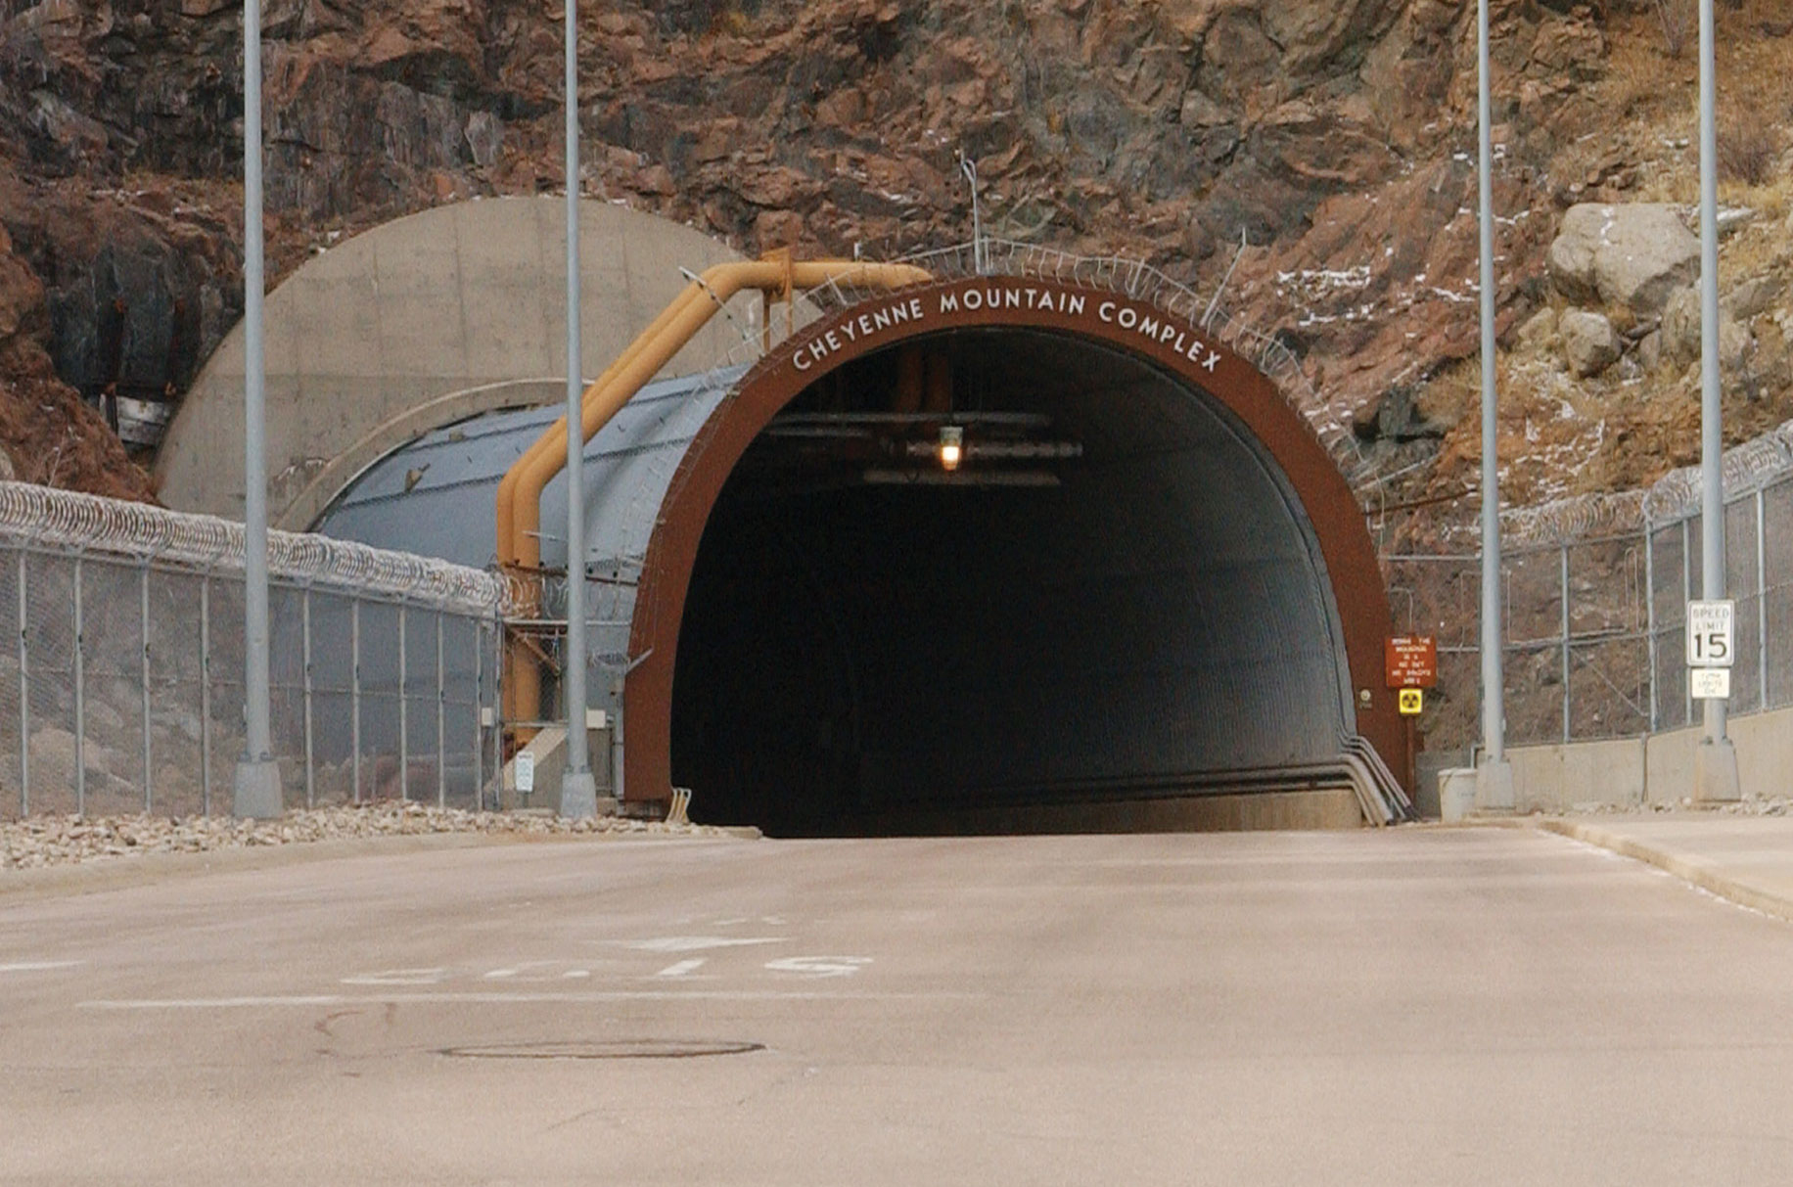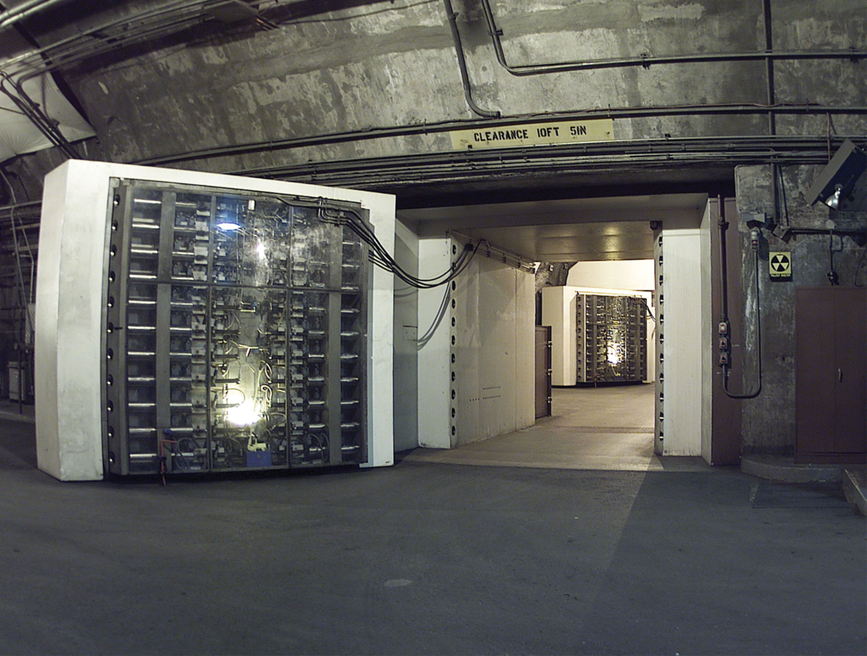
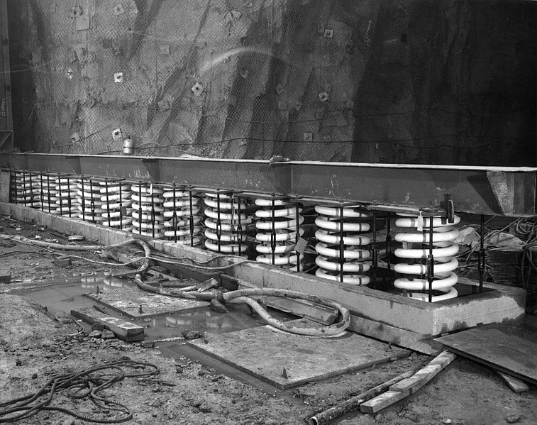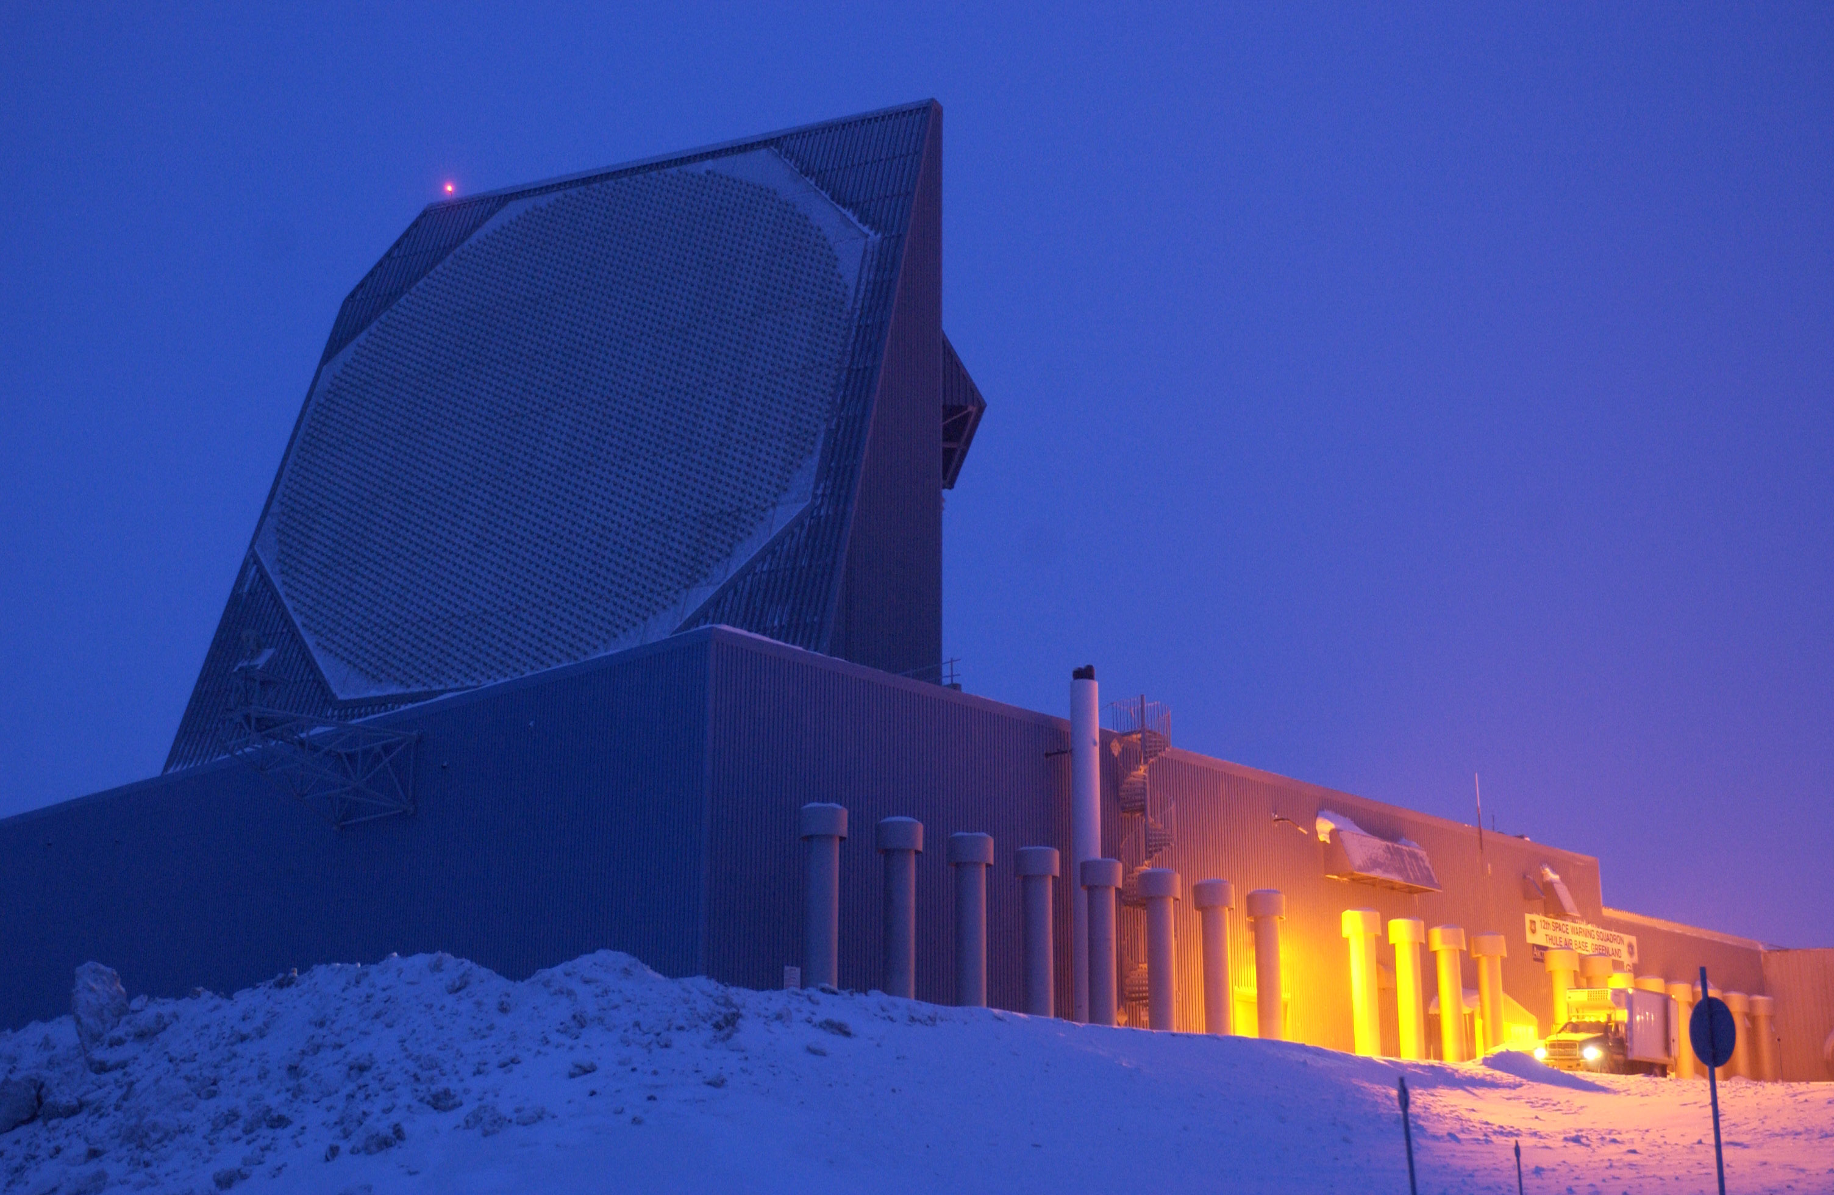

15. What was Operation Overlord?

That was the code name for the invasion of Nazi-occupied Europe at Normandy in France, better known to us as “D-Day”. By the by, the “D” in “D-Day” just means “the day of invasion”, so a week prior to going it was “D minus 7”, and a week after was “D plus 7”. Every major military operation had a “D-Day”.

The landing beaches had code names too, Omaha, Utah, Gold, Sword and Juno (Juno Beach was where Canadian forces landed). Incredible story: British intelligence, monitoring any sign that invasion plans had been leaked, noticed several crossword puzzles in the London Daily Telegraph, published just weeks before the invasion, the answers to which contained many of those code words, as well as the classified name for artificial harbours we would be bringing with us, a vital secret (“Mulberry”) and our code word for amphibious invasion (“Neptune”). It was just a coincidence.

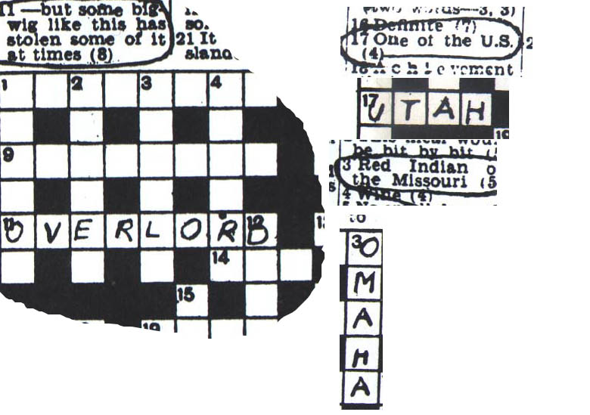

Extraordinary efforts were made to convince the Germans that Calais, not Normandy, was the planned invasion site. The Allies created false documents for spies to find, broadcast fictitious signal traffic so spies would eavesdrop, appointed our best tank commander, General George Patton, to command a fictitious invasion force that left a huge paper trail all over the military bureaucracy, and best of all, assembled a phony army directly across the English Channel from Calais, composed of fake inflatable tanks and aircraft! General Rommel, planning the defence, wasn’t fooled, but the German High Command was.

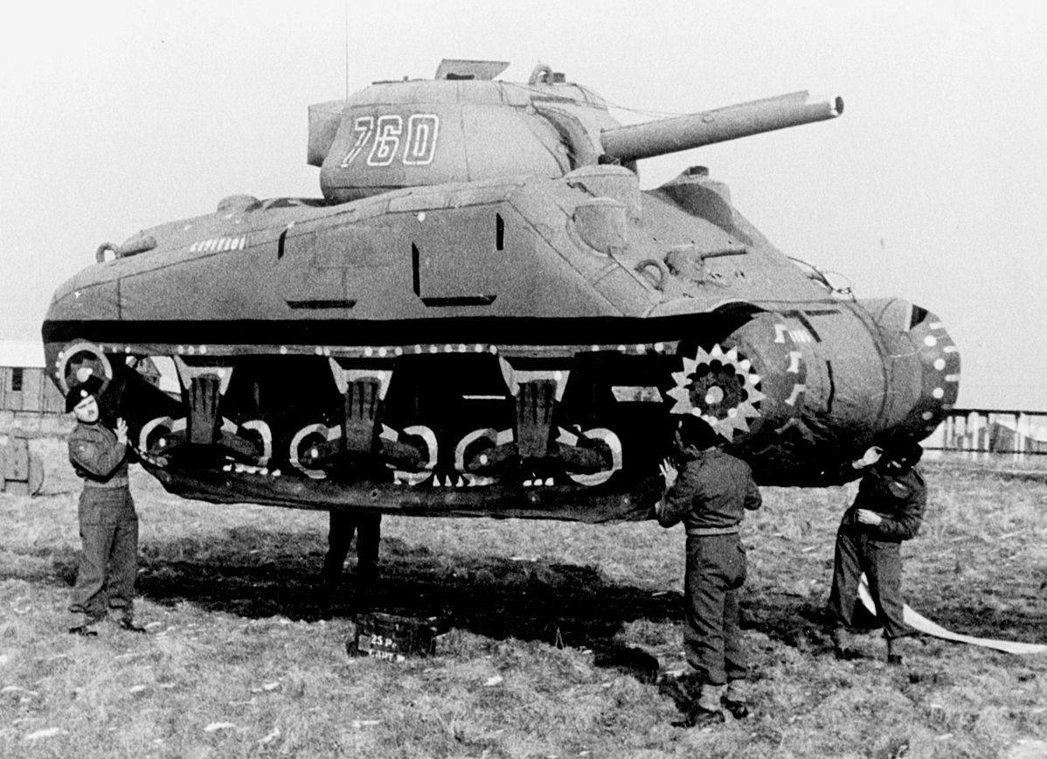
16. Who invented the system of numerals we use today? What is so special about this system compared to Roman Numerals?

We call our system of numbers “Arabic Numerals”, but Arabic civilization actually derived the system from an earlier set of numbers devised in India. The key innovation was a numeral that stood for nothing – “0”! There is no zero in Roman numerals. No sort of advanced math can function without 0s.

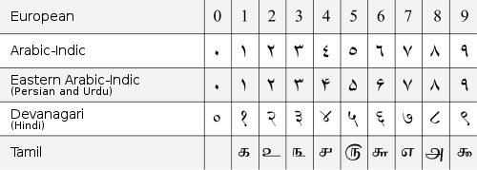
17. What was wrong with the Julian calendar? What calendar do we use today?

The Roman calendar developed during the reign of Julius Caesar (hence “Julian”), was almost correct, but it assumed that a solar year was exactly 365.25 days long, and thus had a “leap year” with an extra day tacked on every four years. The actual solar year is just a little shorter than that, and astronomers and clerics began to notice that the calendar was getting out of whack – the solstices and equinoxes as indicated by the calendar didn’t match with observation. Under Pope Gregory, in the late 1500s, a slight modification was made, so that there were leap years every 4 years except only if:

1. The year is evenly divisible by 4; BUT

2. If the year can be evenly divided by 100, it is NOT a leap year: UNLESS

3 The year is also evenly divisible by 400.

The “Gregorian” calendar is the one most of use today.

Some religious sects still use the Julian, which is why those of the Eastern Orthodox faith think Christmas comes later than we do. The Julian calendar creates an error of about 1 day every 130 years.

As an aside, the names we give to months of the year are purely Roman, reflecting Roman gods like Janus (“January”) or simply the month’s number in the calendar (“September” is the seventh month, “October” is the eighth, “November” the ninth). There used to be 10 months, which is why “December” is the last month of the year, but a couple of emperors, Julius Caesar and Caesar Augustus, decided that they should have months named after them, giving us July and August.

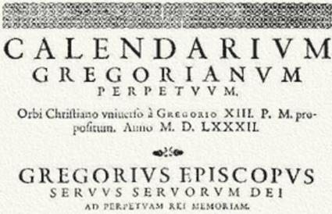
18. Why on Earth have you never heard of Pete Quesada?

Pete Quesada is a personal hero, and it’s a crime against history that he isn’t famous. Pete was the US Army Air Force General who was given command of all US fighter aircraft in the European Theatre in 1944, when he was just 40 years old. His 9th air force had over 1,500 fighters.

Single seat fighters were known as “tactical” aircraft, in that their role was to win individual instances of air combat, but not achieve any broad “strategic” objectives, that is, they didn’t deliver the weapons designed to destroy the enemy’s ability to fight (though they would certainly defend against the planes that did). “Strategic” aircraft were bombers, typically big four-engine jobs, and in WW II the Allies invested enormous resources in a strategic bombing campaign designed to flatten German cities and cripple German industry. By that yardstick, the strategic bombing campaign was, ultimately, a failure, killing hundreds of thousands, but doing too little to curtail German industrial output. It did stress and wear down Germany’s war machine in various ways, but certainly didn’t win the war all on its own, as its proponents had claimed it would.

Quesada alone was visionary enough to see that his “tactical” aircraft were actually the ones that could make the greatest contribution toward the strategic objective of defeating Germany. The advent of the 2,000 horse power engine meant that his fighters, monsters like the P-47 Thunderbolt, could be big, rugged, fast, and yet carry a significant bomb load – they were “fighter-bombers”. The best way to grind the German Army to a decimated halt was not to fly huge aircraft over Berlin and Hamburg in vain and costly attempts to destroy factories. Factory output wasn’t the point. Pete realized that no matter how many planes and tanks and artillery pieces the Germans could build, none of them would make any difference if the Germans couldn’t move them or supply them.

Quesada sent his fighters on roving low level missions to rip across the European countryside at 400 MPH, strafing and bombing every train, barge, truck, horse-drawn cart, airfield, train station, bridge, highway intersection, and military vehicle they could find. If you were a guy on a bicycle, you were liable to get blasted by eight .50 calibre machine guns. Sorry pal, you might have been a Kraut. If you were a goddamed cow, sorry, Bossy, but how do I know you’re not a Nazi cow? Best to just fill you full of hot lead. The effect was that the Germans couldn’t move their forces in daylight, couldn’t get them supplies, couldn’t do much of anything except keep their heads down. Tanks that never get ammo and gas delivered to them are useless. Un-fueled planes shot up on their runways are useless. Troops that can’t be moved by truck or train are useless. Quesada’s fighters had a destructive and utterly paralyzing effect on the enemy. His 9th Air Force was doing what the bombers of the 8th Air Force could not, and at the cost of infinitely fewer lives on both sides. Nobody wanted to admit it, the dogma was that strategic bombing was the way to go, but Pete and his fighter aircraft were the ones creating the conditions for victory. Were we in this just to kill people, or did we want to win?

In the run-up to D-Day, Quesada was summoned to a high level meeting at which everyone from Eisenhower and Churchill to the King of England himself demanded an answer to a simple, crucial question. An amphibious invasion would be cut to ribbons if the German Air Force, the “Luftwaffe”, could mount sufficient attacks. We needed total air superiority over the English Channel on D-Day. What did he intend to do to stop the Luftwaffe on June 6, 1944?

Pete answered, calmly: “There won’t be any Luftwaffe over the Channel that day”.

Churchill said something like “aghh – how can you be so sure, young man?”.

Pete again responded, calmly, that his fighter forces wouldn’t be doing much of anything on D-Day to stop the Luftwaffe, because his men were going to see to it that by D-Day, there would be, for the practical purposes of the invasion, no such thing. “They just aren’t going to be able to be there on June 6”, he told them. “I’m sure of it”. What planes his pilots hadn’t shot to pieces on the ground would be stranded on the tarmac from lack of the fuel the Germans couldn’t transport any more. Woe to any that straggled aloft.

So it proved. On D-Day, the Luftwaffe was nowhere to be seen, I think only two German planes even managed to buzz over the beaches.

So why isn’t Pete Queseda the most celebrated air force officer in history?

Beats the hell out of me, but if you’ve read this, maybe you’ll remember him, and what he did to save Western Civilization.

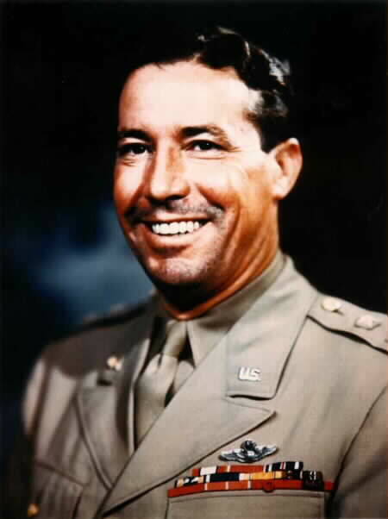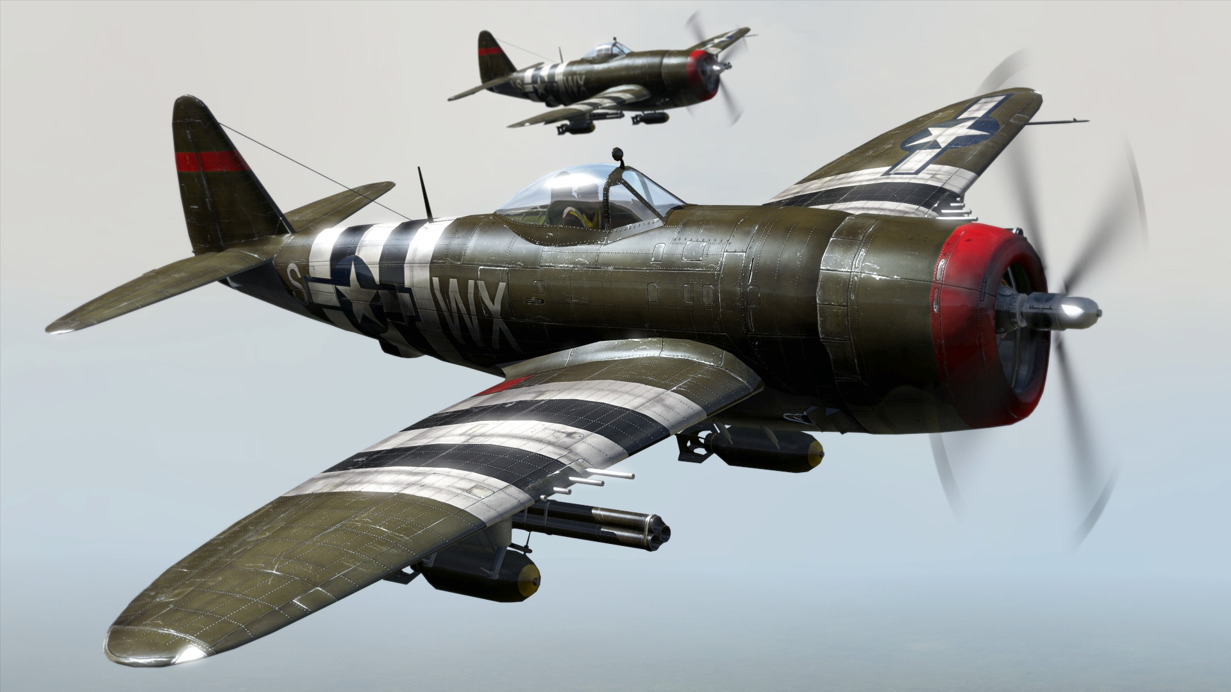

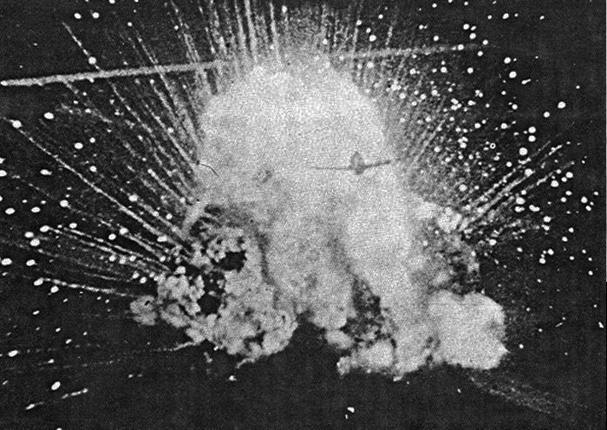
19. What name do paleontologists give to the sudden burst of animal evolution that occurred about 530 million years ago?

This comes up somewhere else in this mess of questions, when we deal with a critter called a “trilobite”. Anyway, the term is “Cambrian Explosion”.

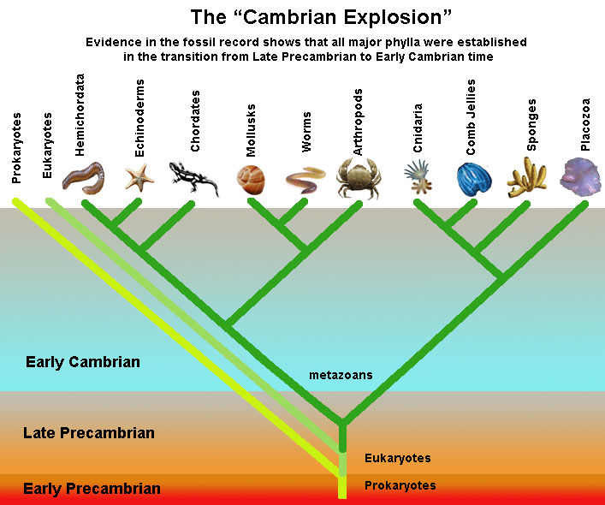
20. What was the world’s first purpose-built recording studio?

Britain’s EMI company built a facility in the 1930s that you may have heard of, called Abbey Road Studios.

A group that was almost as big as One Direction did a lot of recording there.

Here’s what’s really weird: every day, people by the dozen, from all over the world, thousands a year, every year, go there just to walk across the street. Damndest thing. You can even watch them do it on this webcam:

http://www.abbeyroad.com/crossing

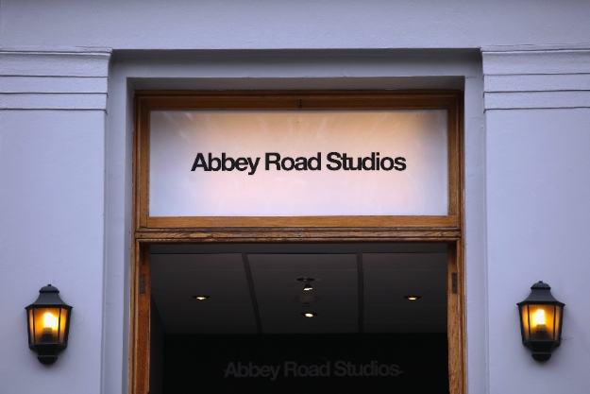
21. What proposed policy initiative did Pierre Trudeau ridicule, only to adopt it once he was elected?

The early 1970s were years of punishingly high inflation, prompted initially by the 1973 Oil Crisis in which the Arab nations of OPEC, enraged at US support for Israel in the 1973 Yom Kippur War, established an oil embargo, driving the cost of fuel through the roof – and everything else with it. Prices spiraled upwards in a sort of feedback loop; higher costs meant people demanded higher wages, at which point they had more money, and employers needed more to pay them, so prices rose. A box of cereal would cost more next week than it did today. Nobody was quite sure how to break the cycle.

Conservative leader Robert Stanfield, the best and most decent Prime Minister this country never had, campaigned on the idea that the government should intervene with a program to legally prohibit wage and price rises for a period: “wage and price controls”. Trudeau mocked this mercilessly, portraying Stanfield as a buffoon who didn’t understand macro-economics. “What am I going to say to the Arabs?” he asked. “ZAP, you’re frozen?” Yuk yuk yuk. That Stanfield. What a rube. What a nincompoop. Hyuk.

As soon as he won the election, Trudeau, after checking with the Supreme Court that he had the constitutional authority to do it, instituted comprehensive wage and price controls, just as Stanfield had advocated.

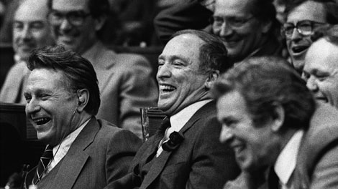
22. Who was Pierre Laporte?

He was a minister in the Quebec Provincial government, Deputy Premier I think, who was kidnapped in 1970 by the Front de libération du Québec (the “FLQ”, or in English, the “Quebec Liberation Front”) along with a British consular official named James Cross. The FLQ was, plain and simple, a home-grown terrorist organization. When Laporte was found murdered, PM Trudeau invoked an old statute, the War Measures Act, through which he instituted what most of us would call Martial Law. Arbitrary search and seizure, arrest without charges, denial of habeas corpus and so on proceeded on a massive scale. The systematic and comprehensive suspension of civil liberties in 1970’s “October Crisis” was among the most popular moves in the history of governance; something like 90+% of Canadians approved of it. Conservative leader Robert Stanfield’s dismayed opposition was shouted down. That Stanfield. What a dinkledorf.

We had no Charter of Rights back then, but it might not have mattered. There sure was a Charter when the cops declared a police state in Toronto a couple of years back so we could host the G-20 summit, and in that mess we finally surpassed the FLQ crisis for the largest mass arrest in Canadian history.

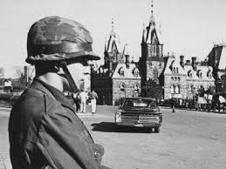
23. What heiress famously joined the Symbionese Liberation Army?

The Symbionese Liberation Army was a home-grown terrorist outfit in the US. I don’t even remember what it was the SLA wanted, or what the heck “Symbionese” meant. Who cares? In 1974, in order to gain a hostage they could trade for some of their members then in prison, they kidnapped 19 year old Patty Hearst. This was high profile stuff, and one of the most sensational stories of the decade, since Patty was a granddaughter of William Randolph Hearst, whose media conglomerates controlled newspaper, radio and TV stations all over America.

Patty was eventually freed - she was caught and arrested, actually, because in the interim she was raped, brutalized and brainwashed by her captors, and began to identify with their cause, and help them commit crimes. The whole world was shocked when pretty young Patty, sophomore, sorority girl, high society heiress to the Hearst family fortune, now calling herself Tania, showed up in a propaganda photo holding a machine gun in front of the SLA logo. Security cameras caught her and her SLA buddies robbing a bank. Inconceivable!!

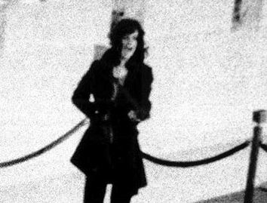

The SLA itself prompted the predictable authoritarian response, and most were killed in a memorable shootout with the LAPD, then perhaps the most vicious, violent and corrupt police force in the Western World. I’ve always loved this quote from the Atlantic Magazine, in an article a few years back about Patty called “Girl Interrupted”:

…the SLA made its decisive and fatal blunder, the one that exposed its members to a force more powerful and unilateral than anything in their collective experience of racism, sexism, incarceration in the California prison system, or the hammer fist of capitalist imperialism could have possibly prepared them for: the LAPD.

The idea that an abductee could be brainwashed into supporting her captors was a new one at the time. Patty was widely reviled. She did prison time. Eventually, what came to be known as “Stockholm Syndrome” (from a hostage incident in Sweden) was better understood, and Ms. Hearst received a Presidential Pardon from Bill Clinton in 2001.

For those of us of a certain age, this image is indelible:

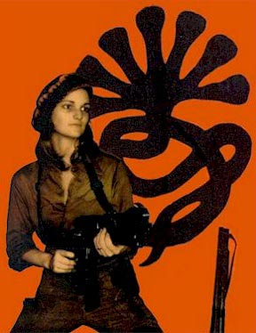
24. During the Cuban Missile crisis JFK, who had recently read The Guns of August, Barbara Tuchman’s famous account of the chain of events leading to WW I, said he didn’t want some future historian to write a book called - what?

JFK said he didn’t want anyone ever to read a book called The Missiles of October. This became the title of a pretty good movie a few years later:

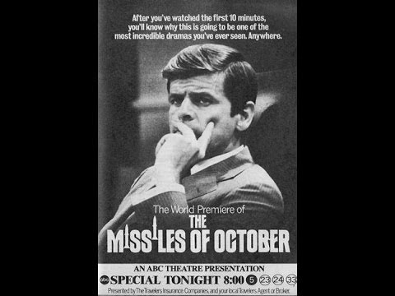
25. What is the name of the biggest and most modern Mars Rover now in operation?

My vote for the most wonderful device in existence: Curiosity, looking for all the world like Wall-E, is now roaming the Martian surface looking for water and the signs of life. The amazing robot is as big as a small car, and landing it on Mars required an elaborate seven-minute sequence of steps that bid fair to be too complex to succeed. Heat shields protected it from intense atmospheric friction and were then ejected, parachutes deployed, retro-rockets fired, and the whole thing came off brilliantly. Curiosity packs all sorts of advanced instruments, and may just find the answers to intriguing questions that have haunted us for centuries.

Look at this animation of the landing, the final step was for the retro-pack to lower it on a rope, it’s fantastic:

https://www.youtube.com/watch?v=gwinFP8_qIM

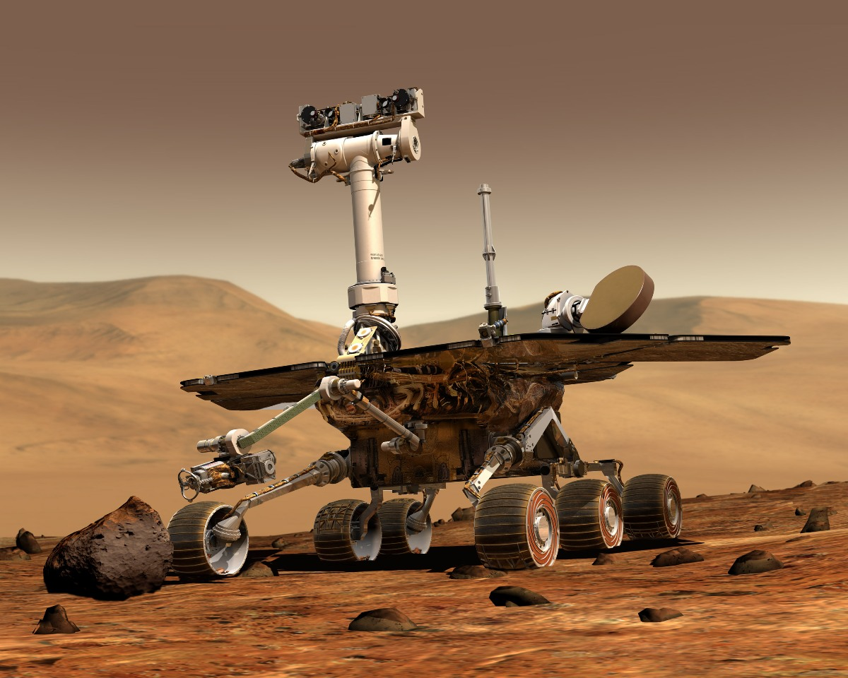
26. What was “Seward’s Folly”?

US Secretary of State William Seward negotiated the purchase of Alaska from Russia in 1867. A lot of people thought it was nutty at the time. Not so much a hundred years later when it was USAF interceptors, not Soviet bombers, parked on airfields in Anchorage.

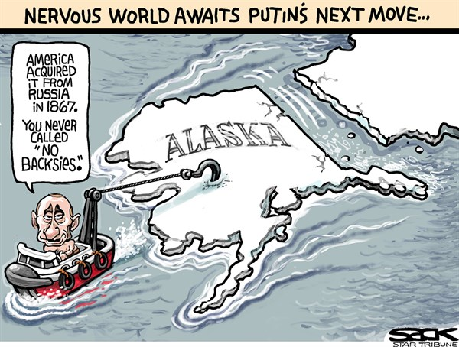
27. Name the three geological periods that composed the "Age of Reptiles".

The Triassic, Jurassic and Cretaceous periods together make up the Mesozoic era, which ended with a bang 65 million years ago (see other quiz). We’re in the Cenozoic era now.

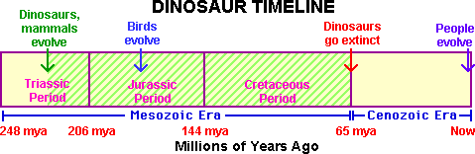

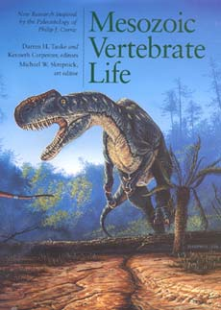
28. Who was the first American in space?

NOT John Glenn, who became more famous. Glenn took the first US orbital flight. Alan Shepard was first US Astronaut in space, fired up on a ballistic sub-orbital arc by a little Redstone rocket. The Russians beat us to the punch, a Cosmonaut named Yuri Gagarin having been the first man in space in April 1961, in a mission that featured a full orbit to boot. Unlike either Gagarin or Glenn, Shepard later made it the Moon, in Apollo 14, during which mission he famously hit a couple of golf balls with an improvised club, just to see them go. One went over a mile.

http://io9.com/5654009/apollo-astronaut-really-did-hit-lunar-golf-ball-for-miles-and-miles-and-miles

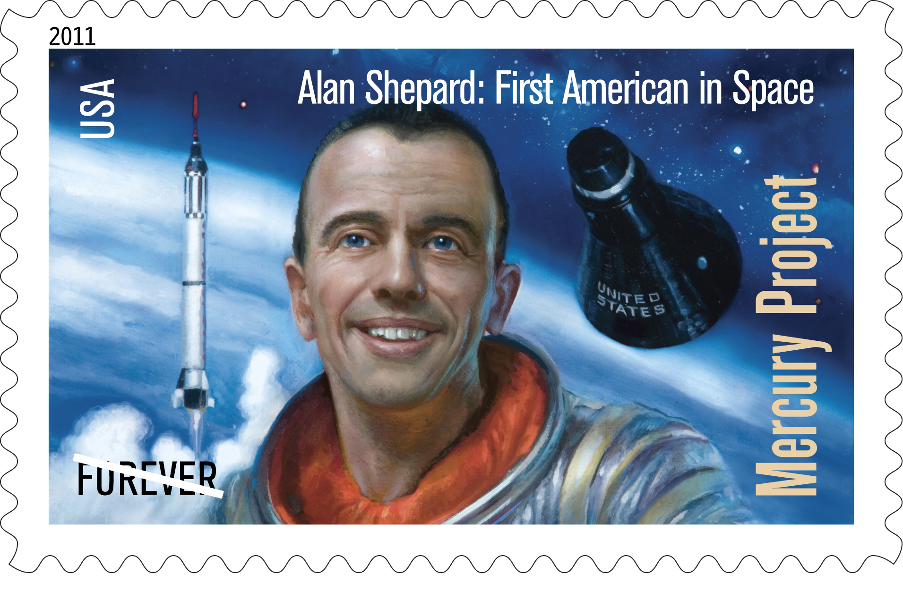
29. Ships do not, properly speaking, have a weight. What do they have instead?

Displacement, that is, the tonnage of water they shunt aside with their floating hulls, as first explained by Archimedes.

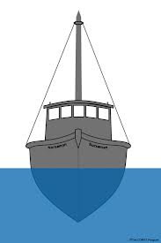
30. About how many barrels of oil does Canada consume in a day (ballpark)?

About 1.5 million barrels. We export about 2.5 million a day.

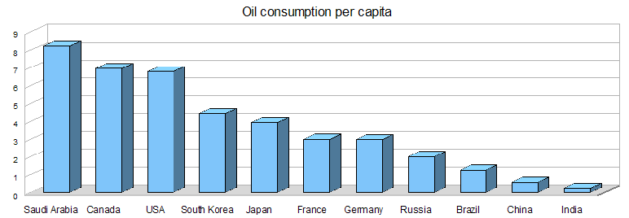
31. Who has sold more records than the Beatles?

Trick question!! Nobody has, not Elvis, not Michael Jackson, nobody. Beatles total record sales are measured in billions, not millions. Of course, various sources conflict and quote different numbers, but the Beatles are always on top of any reputable list. You can find any number of fan boys claiming different, naturally, but trust me.

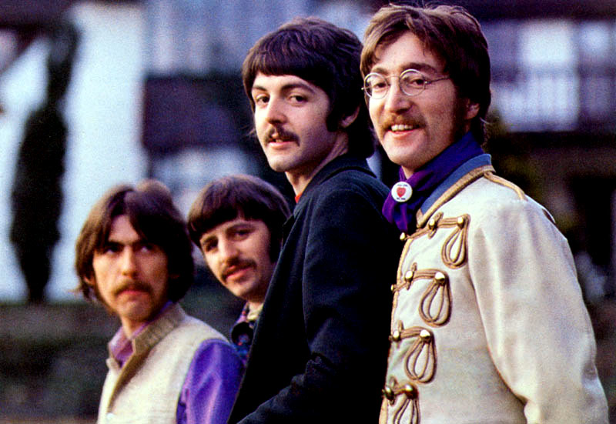
32. Why is Pink Floyd’s “Dark Side of the Moon” a silly name for an album?

There is no dark side of the moon. There’s a far side, but as the moon goes around the earth, its backside gets lit. That’s why there are phases of the Moon, from our perspective; when it’s mostly dark from our vantage point, its far side is bathed in light.

The Moon always points one face to us because our planet’s gravity distorts its shape, forcing the Moon to bulge a bit our way, and that skews its rotation on its axis. This is called a “tidal lock”.

http://scienceblogs.com/startswithabang/2008/04/29/why-do-we-only-see-one-side-of-the-moon/

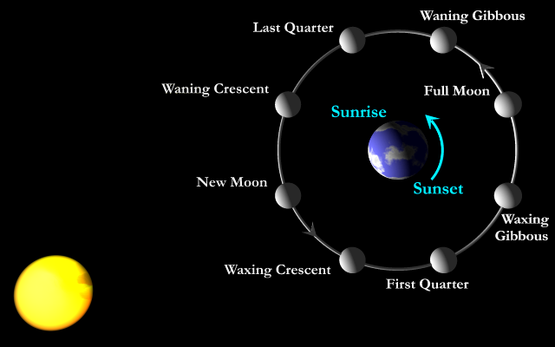
33. What results from the Earth being tilted on its axis?

Seasons! As we orbit the Sun, being tilted changes the angle of light as it hits the planet. In the Northern hemisphere, our elliptical orbit actually places us a bit closer to the sun in winter. The angle is everything.

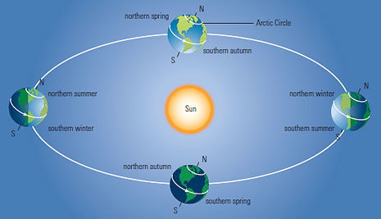
34. What did Ronald Reagan famously tell Mr. Gorbachev to do?

Tear down this wall! He meant the Berlin Wall, and we never thought it would happen. Then, one day in 1989…


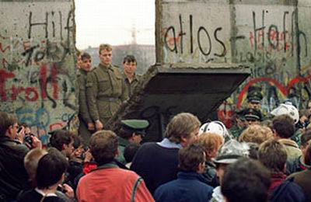
35. What do Siberian Tigers think of wolves, bears and dogs?

Dogs are a delicacy. Leave a dog tied up outside in the Siberian Tiger’s range, and you’ll find a leash in the morning with no pooch attached. Wolves are tasty too; as potential competitors, they all have to be killed anyway, so that’s what the tigers do. Bears – well, bears have to go. One naturalist commented that Siberian Tigers kill bears “on what can only be described as principle”.

That’s one scary kitty.


36. Ben Franklin thought the Bald Eagle was a lousy choice as a national symbol. What bird did he prefer?

Bald Eagles are predators and bullies. Ben thought the Wild Turkey was a much better symbol, and after all, Wild Turkey fed many a settler and pioneer – those birds were useful.

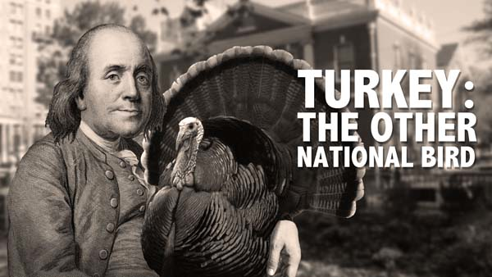
37. The Global Positioning System was initially developed for a rather sinister purpose. What?

It was once called NAVSTAR, and the GPS was created to make missile targeting by submarines more accurate. To fire a ballistic missile with pinpoint precision, you must know exactly where you are on the globe, not easy in a sub. NAVSTAR solved the problem. Using GPS, Trident subs were able to target things as small as enemy missile silos, not just major cities.

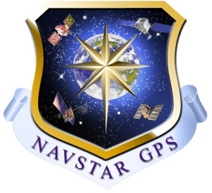
38. About how many Toronto Subway platforms equal the length of a Nimitz Class aircraft carrier?

I paced it out one time. You’d have to string two subway platforms and a chunk of a third together to equal the 1,100 ft. length of a Nimitz. A platform is about 500 feet long. If I count correctly…

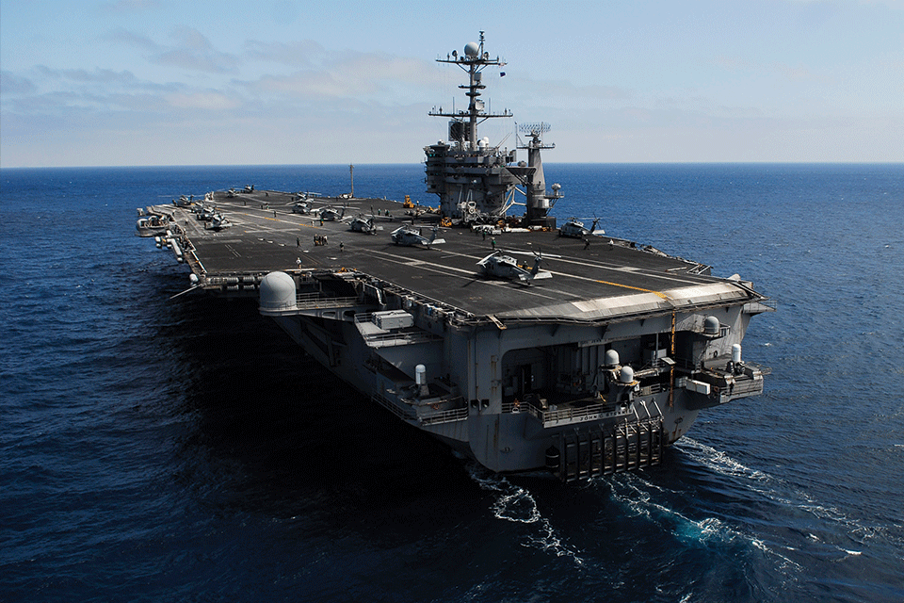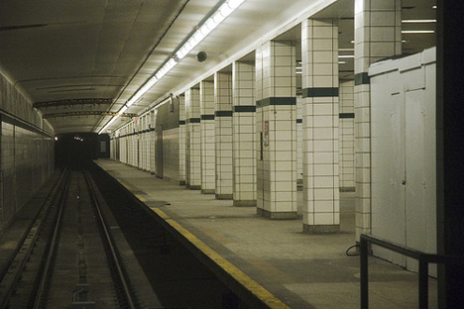
39. What causes the tides?

The Moon. Its gravity pulls our oceans around like water sloshing in a bowl being tilted. That’s why the tides are linked to the phases of the Moon.

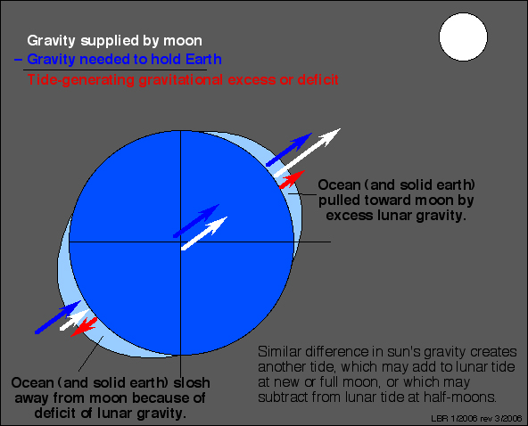
40. What did Abraham Lincoln write to Union General McClellan, who didn’t seem to be doing anything to take the battle to the Confederacy?

My dear McClellan:

If you don't need the army this weekend, might I borrow it? I should like to use it.

yours respectfully,
A. Lincoln

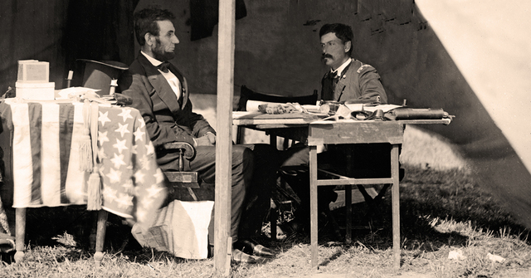
41. What is the range (best case) of human hearing, measured in Hertz (frequency)?

When you’re young, you may be able to hear frequencies from 20 hertz to 20 kilohertz. Not very good, as animal hearing goes. A cat can’t hear quite as low, bottoming out at about 55 hertz, but it can hear up to over 60 kilohertz. The better to hear little mice squeaking.

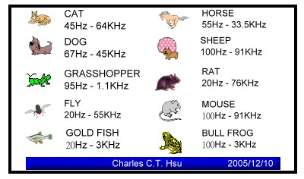
42. What did the Romans call the Mediterranean Sea?

Another repeat! “Mare Nostrum”, Latin for “Our Sea”.

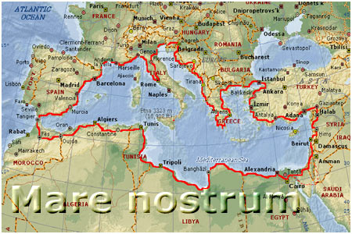
43. What part of the Moon was the landing zone for Apollo 11?

In a smooth area clearly visible from here called the Sea of Tranquility.

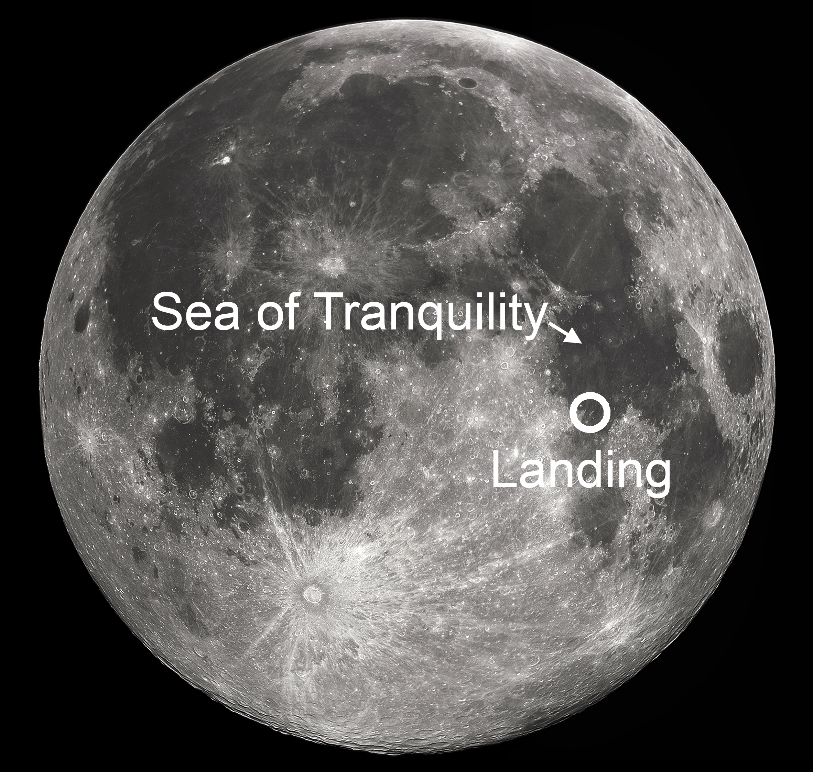
44. Which space probes have traveled farther than any other man-made object?

The plucky Voyager probes went far beyond any local planet years ago, and either have, or are just about to, cross the point where nothing produced by our Sun exerts any force. One of the most moving and sobering pictures ever taken was snapped by Voyager 1 in 1990, as it was leaving the Solar System. Carl Sagan had them turn the cameras around and take one final parting shot, from a distance of 6 billion kilometers. They call it the “Pale Blue Dot”. As Carl once said, Earth is a pixel-sized dust mote floating in a sun beam. Nothing more. Nothing except everything that we ever were, are, know, and have.


45. What is “Ogopogo”.?

Supposedly we have a Canadian equivalent to the Loch Ness monster right here in Lake Okanagan, BC, nicknamed “Ogopogo”.

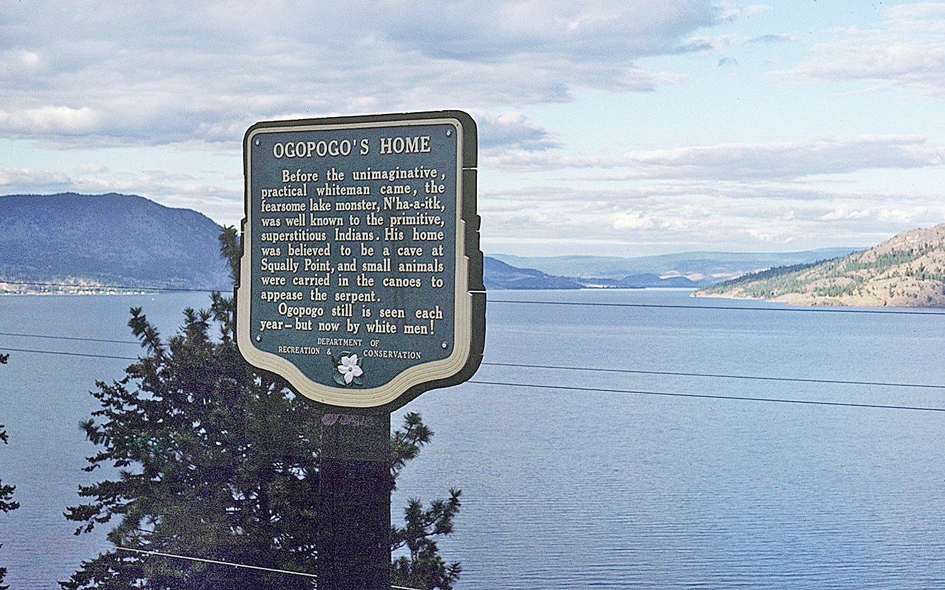
46. Name three civilizations that once flourished in Central or South America before Europeans arrived.

Lets say the Maya, Aztecs, and Inca, and toss in Olmecs and Toltecs for fun.

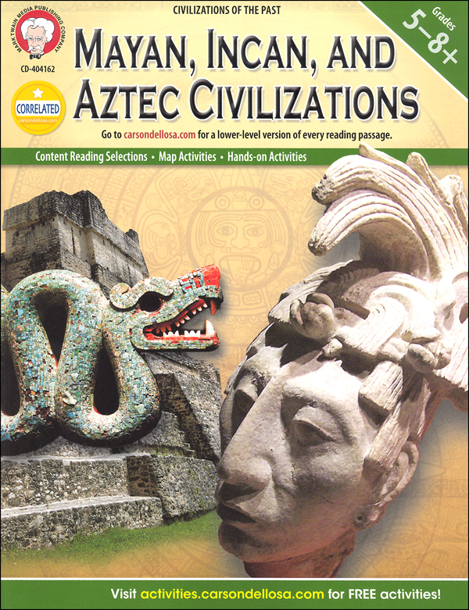
47. In what country did the incident that came to be known as “Black Hawk Down” occur?

It happened in Somalia, in the capital, Mogadishu. US troops were sent there at the urging of the UN to try to stop a horrible civil war in which denial of food supplies was being used as a weapon, leading to mass starvation. The Americans restored order, supplied food, and starting going after the warlords who were behind the atrocities.

One raid went horribly wrong, when two Black Hawk helicopters from an assault team were shot down. The warlord they were chasing, a real bastard named Mohamed Farrah Hassan Aidid, had a sizable army of well-armed and brutal soldiers, who spent most of their time, when not shooting and starving people, chewing on a plant that contained a natural stimulant, which they called “kat”. Most days, they were amped up to the extreme on kat.

As US forces struggled to get to the crash zones and recover their dead and wounded, it was like the whole city turned out to shoot at them from around every corner, off every roof, and out of every door and window. It was a massive, day-long firefight, and the US soldiers, Army Rangers and Delta Force commandos, fought with the utmost tenacity and discipline. Of about 100 men, 18 were killed, and pretty much everybody else was wounded, but they killed about 1500 of Aidid’s militia; some think as many as 3,000. Civilians were caught in the crossfire too, of course, but comparatively few were killed by Americans, and fewer still of those were unarmed innocents.

It looked like a disaster on the News, especially the searing image of a dead US pilot being dragged naked through the streets by an exultant, celebrating crowd. American public opinion turned on the mission, and US forces were withdrawn. It’s too bad. They were making a real difference there, and the Battle of Mogadishu, which looked like such a fiasco on TV was, in fact, one of the greatest feats of arms in military history.

As morning dawned on the second day of the fight, other UN forces in armoured vehicles finally arrived to rescue the pinned-down Rangers, holed up and surrounded in several different buildings, but there wasn’t space for all of them, and several had to break cover and simply run to reach safe territory. That run has become legendary, and is known as the “Mogadishu Mile”.

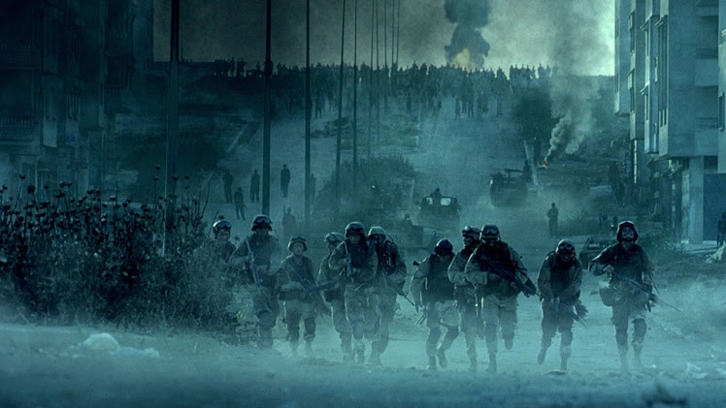
48. What happened at Khe Sanh?

More brilliant feats of military prowess, wasted in a useless war that couldn’t be won. A force of a few hundred Marines was surrounded in a fire base near the DMZ, as part of the larger Tet Offensive in 1968. In similar circumstances years earlier, at a battle in a place called Dien Bien Phu, French colonial forces had been surrounded and wiped out, a pivotal defeat that effectively put an end to French Indochina. It was widely expected that Khe Sanh would be a repeat, especially when whole divisions surrounded the base and laid siege.

Yeah, except the Marines had air support. Lots and lots. Even great huge B-52 bombers were thrown into the fray. We figure about 10,000 North Vietnamese soldiers were killed, and the rest just melted away into the jungle at the end.

President Johnson was so concerned while the battle raged that he had a scale topographical model of Khe Sanh built and set up in the White House situation room, on which the progress of the fight was continually plotted. Late at night, as sleep eluded him, Lyndon would pad down to the situation room in his house coat and fret about his boys.

Back home on TV, Khe Sanh looked like a narrow escape, much as the overall Tet Offensive looked like a disaster for US forces. In fact, Tet as a whole was the most lopsided victory in US military history prior to Desert Storm, and the poor NVA never had a prayer at Khe Sanh. In his brilliant account of the war, Dispatches, Michael Herr devotes many chapters to the siege at Khe Sanh – he was there, as a reporter, hunkered down with the grunts. He therefore saw with his own eyes what was really happening, unlike the hacks filing stories from their bar stools back in Saigon, and he felt sad for the enemy troops. This is his description of the violence wrought by the gunships that would patrol at night and hose the terrain with tremendous amounts of fire from electric-powered Gatling guns:

Nights were when the air and artillery strikes were heaviest, because that was when we knew the NVA was above ground and moving. At night you could lie out on some sand bags and watch the C-47s mounted with Vulcans doing their work. The C-47 was a standard prop flareship, but many of them carried .20 millimeter and .762 millimeter guns on their doors, Mike-Mikes that could fire 300 rounds per second, Gatling Style, “a round in every square inch of a football field in less than a minute”, as the handouts said. They used to call it Puff the Magic Dragon, but the Marines knew better: they named it Spooky. Every fifth round was a tracer, and when Spooky was working, everything stopped while solid streams of violent red poured down out of the black sky…if you watched at close range, you couldn’t believe that anyone would have the courage to deal with that night after night, week after week, and you cultivated respect for the Viet Cong and NVA who had crouched under it every night now for months. It was awesome, worse than anything the Lord had ever put down on Egypt…

That’s some fine writing. Really paints it for you. As the Marines often say of such situations, “the poor bastards had us surrounded”.

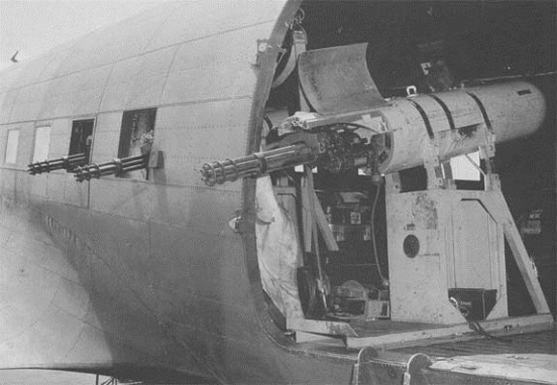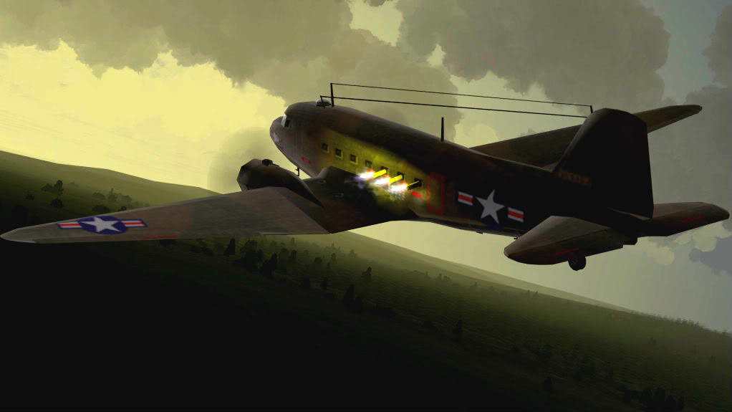
49. Who invented the first weapon that could be considered a sort of “machine gun”?

The Gatling guns carried by “Spooky”, just described, were descendents of a weapon designed by an inventor of that name for the Union Army to use in the Civil War. You cranked it by hand and the barrels rotated. The modern variety are among the most terrifying instruments of havoc ever devised, none more so than the .30 mm “Avenger” cannon carried by the A-10 attack plane, which fires rounds the size of Coke bottles at a rate of about 60 per second.

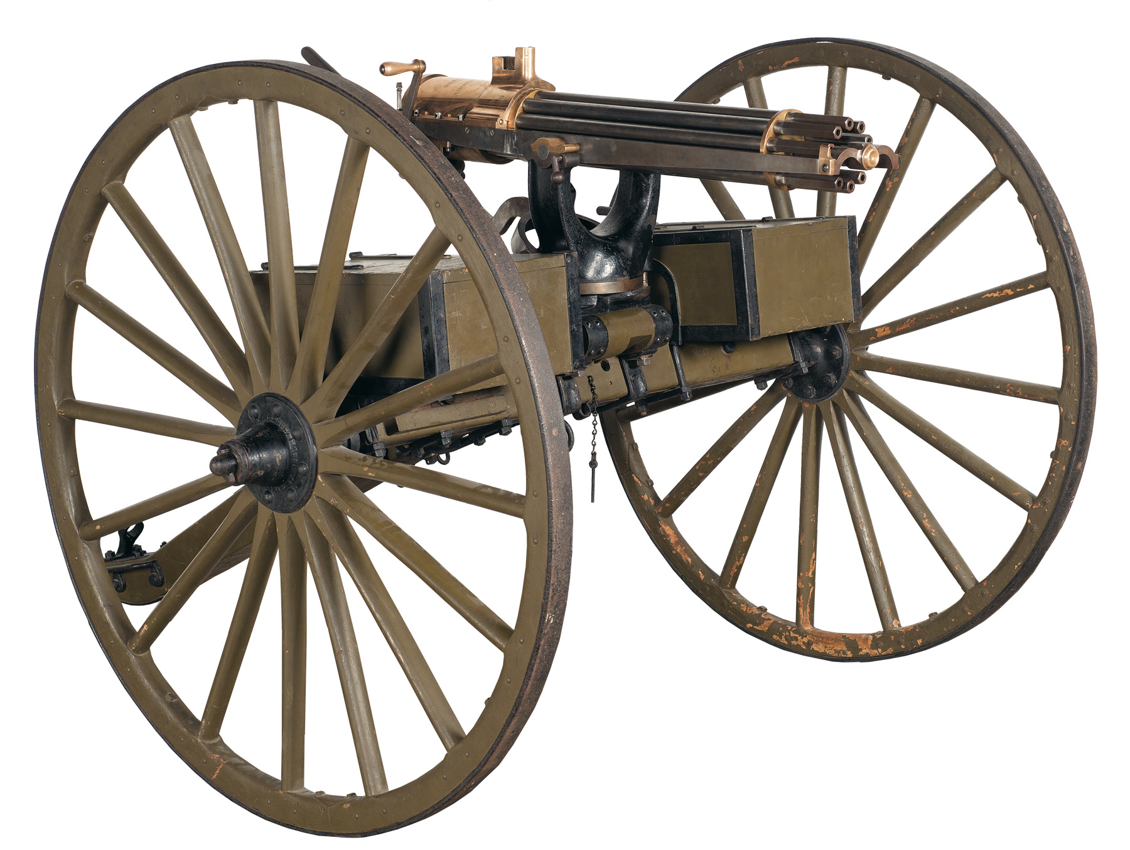

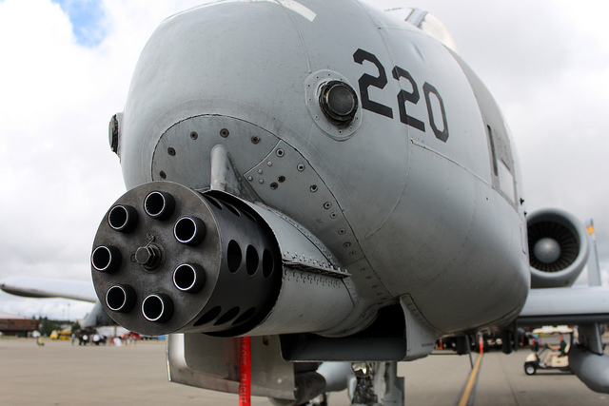
50. What goes on at CERN?

I know we did this one before, but since we’re back at CERN why don’t I give you a condensed overview of quantum physics and the search for the elusive Higgs Boson? Think of the fun we’ll have.

OK, so, trying to explain particle physics while making any sort of sense is impossible, but…

In the "Standard Model", which was the brain child of Plank and Heisenberg and all those guys back in the early 20th century, all matter is composed of particles. These particles, it turns out, are smaller than atoms, and smaller than the familiar things that make up atoms (protons, neutrons and electrons, which we once thought were as small as things got) - they are in fact the building blocks of things like protons and electrons.

These "matter particles" exist in two broad groups ,"quarks" and "leptons", and there are six varieties of each, so 12 fundamental matter particles. Another word for "matter particles", that embraces all quarks and leptons, is "Fermions". Fermion = matter.

Well and good, but these particles all interact with one another in odd ways, sticking together, repelling each other, decaying. So not only is there matter, there are "forces" that act on matter. We know of four fundamental forces in nature: gravity, electromagnetism, the "strong" force (which holds particles together) and the "weak" force, (which causes things to fall apart).

The problem we in the laity can never quite wrap our minds around is that "forces" - things we think of as simply being there, they simply are, invisible and intangible - represent something quite tangible in particle physics, something physical interacting with the Fermions. In this theory, all forces are communicated - "mediated" - to the Fermions by particles, so it's particles of force acting on particles of matter. The particles of force go by the name "Bosons" (so now we have two broad categories of particle, Fermions and Bosons) and each force has its own type of Boson. Electromagnetism is a property imparted to matter by photons. The strong force is mediated by "gluons". They imagine that gravity is mediated by "gravitons". And the weak force is transmitted by what they call "W" and "Z" Bosons. Boson = force that acts on matter.

Now, this is an extremely freaky way of looking at the universe. The premise is that the Fermions, the particles that make up matter, wouldn't do any of the things they do - like clump together to form protons, which in turn have a positive charge that attracts negatively charged electrons, which in turn make atoms - except that other particles that communicate forces interact with them. But how can "forces" be particles?? We think of forces as existing in fields - the sun has a gravitational field, a magnet has a magnetic field - and since this can be proven, how can a field also be a particle?????

Well, and here I no doubt over-simplify, fields and Bosons are two sides of the same coin in quantum physics, much as bosons like photons can be shown to be particles and waves at the same time. Quantum physics has no problem with these dualities. So a force may exist as a field that permeates space, but the field itself manifests in particles that interact with other particles.

So this is where we stood: all matter is composed of fundamental particles. All the things that matter does is a result of interacting with other particles that transmit forces. Fine.

The problem this left us with was that none of this explained why matter should have a crucial property - mass. Even if we embrace gravity in our theory, gravity and mass are not the same thing - an object that is weightless in space still has the same mass - so where does mass come from? Moreover, not everything has mass - a photon, for example, is mass-less - and many things, like electrons, have mass, but only in negligible amounts, while others, like protons, have plenty of mass. What gives?

Recall that forces come in fields, this we know, so apart from the four fundamental forces and their fields, there must be some other sort of field that affects Fermions - right? The existence of this field was worked out as a mathematical possibility by several physicists more or less at the same time back in the sixties, but it became associated with one fellow named Higgs, hence the "Higgs Field". But fields are themselves the other side of the coin with particles. Every field has its own particle, and every force that a field imparts to a Fermion is mediated by a particle. So if there is a "Higgs Field", there must be an associated boson (force transmitting particle) - thus the "Higgs Boson". And mass must be the property that emerges when Fermions travel through the Higgs Field and interact with Higgs Bosons. The weightless and very light particles must interact less with the Higgs Field than the heavy particles (for reasons they understand, but I don't). Moreover, the Higgs Field must permeate all of space - there should be Higgs Bosons all over.

Over the years, by smashing protons and electrons and other things made of Fermions together in particle accelerators, physicists had great success proving the existence of quarks and leptons and so on; they had a firm grip on the Fermions, and on most of the Bosons, BUT they could never smash anything together with enough force to cough up the postulated Higgs Boson. They reckoned they needed a particle accelerator with more power, something that propelled the Fermions at a velocity high enough - very near the speed of light - to create a collision with enough violent energy to approximate, on a sub-atomic scale, the conditions of the Big Bang. This should pop out a Higgs.

That’s what they were doing at CERN with the Large Hadron Collider (a "Hadron" is a bunch of quarks stuck together by the Strong Force, and the idea is to accelerate these toward each other at tremendous velocities). This new toy would find the Higgs, if, please God, there was such a thing.

They were keen - desperate? - to find the Higgs, because without it they were at a loss to explain mass, and without that the whole Standard Model starts to crumble, because it's obviously missing something. No Standard Model, and not only is it back to the drawing board, but they have to figure out why the Standard Model, if it's all messed up, was so very good at predicting the existence and behaviour of most of the sub-atomic universe. What other model can they develop to do as well? Where to begin? This is why they were so overjoyed when whaddya know, they found it.

So the discovery of the Higgs Boson demonstrates that the Standard Model is accurate, as far as it goes. The Standard Model isn't a full answer, because despite theorizing the existence of "gravitons" to mediate gravity, the math can't really account for gravity if we assume, as they do, that all the four fundamental forces were once, in the high energy state of the early universe in the immediate aftermath of the Big Bang, fused into one force. This is the "grand unified theory" that still eludes them. Gravity is a force that works on the macro level, and is well understood within the framework of Einsteinian physics - to Einstein, gravity is the movement of objects through curved space, and space is curved by the presence of massive objects. This, too, can be proven, but it doesn't mesh at all with the quantum world of forces mediated by particles. So, still much to do.

